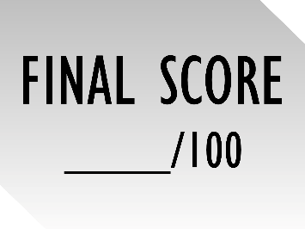
Is the New Testament Historically Reliable?
Final Exam

True or False (5 pts each)

True of False | True | False
- Critics like Bart Ehrman argue that the names of Matthew, Mark, Luke, and John were invented 100 years after the gospels were written in order to give them a “much needed authority.”
- According to the lecture, there is good evidence that the book of Acts was written before AD 62.
- We possess 36 manuscripts of Tacitus.
- We possess 5,856 manuscripts of the New Testament.
- The John Rylands Fragment dates to AD 200.

Multiple Choice (5 pts each)

_________ 6: What percentage of the New Testament is disputed by textual scholars?
- 8%
- 5%
- 1%
- 17%

_________ 7: What percentage of textual variants are spelling errors?
- 20%
- 70%
- 80%
- 99%

8. What do we know about the Pool of Bethesda?
☐  It is mentioned in Mark 5. | ☐  It had healing properties. | ☐  All five porticoes were found.

9. What biblical figures do we know from archaeology? (PICK TWO out of the three)
☐  Herod the Great: King of Judea (72 BC to 4 BC). | ☐  Pontius Pilate: Governor of Judea (AD 26 to 36). | ☐  John the Baptist: Preacher in Judea (5 BC to AD 31)

Scripture Memorization (5 pts each)

10. “Whatever was written in earlier times was written for our instruction, so that through perseverance and the encouragement of the Scriptures we might have hope.”
☐ 2 Peter 1:16 | ☐ Luke 1:1-3
☐ John 19:35 | ☐ 1 John 1:1
☐ Romans 15:4 | ☐ Proverbs 30:5-6

11. “Every word of God proves true. He is a shield to all who come to him for protection. ⁶ Do not add to his words, or he may rebuke you and expose you as a liar.”
☐ 2 Peter 1:16 | ☐ Luke 1:1-3
☐ John 19:35 | ☐ 1 John 1:1
☐ Romans 15:4 | ☐ Proverbs 30:5-6

12. “Many have undertaken to draw up an account of the things that have been fulfilled among us, ² just as they were handed down to us by those who from the first were eyewitnesses and servants of the word. ³ With this in mind, since I myself have carefully investigated everything from the beginning, I too decided to write an orderly account for you.”
☐ 2 Peter 1:16 | ☐ Luke 1:1-3
☐ John 19:35 | ☐ 1 John 1:1
☐ Romans 15:4 | ☐ Proverbs 30:5-6

13. Write down a memory verse that responds to this statement: “The apostles never claimed to be eyewitnesses in their writings.”

14. Write down a verse that responds to this statement: “Christianity was a small movement. Jesus never intended it to spread across the world.”

Short Answer (10 pts each)

15. What is the Nazareth Inscription?

16. Name TWO non-Christian authors who mention Jesus.

17. What are TWO reasons for dating the gospels before AD 70?

Bonus Question (5 PTS)
18. What is “interlocking”? Give one example from the reading.

