Did God Really Say?
The Inspiration and Canonicity of the Bible
Student Handout

Table of Contents
Pre-Homework 3
Week 1: Verbal Plenary Inspiration 4
Discussion Questions 6
Scripture Memorization 7
Homework 7
Week 2: The Inerrancy of Scripture 7
Discussion Questions 10
Scripture Memorization 10
Homework 10
Week 3: The Definition of the Canon 12
Discussion Questions 14
Scripture Memorization 14
Homework 14
Week 4: The Canon of the New Testament 15
Discussion Questions 17
Scripture Memorization 17
Homework 18
Week 5: What about the Gnostic Gospels? 18
Discussion Questions 20
Scripture Memorization 20
Homework 20
Study Guide 21

Pre-Homework
(1) What do you hope to gain from taking this course?

(2) What goals do you have to use this equipping that you’re going to receive?

(3) How do you hope to put this material into practice?

Week 1: Verbal Plenary Inspiration

Definition of VPI
God so moved the human authors of Scripture that the resulting product was the Word of God, written totally without error in all that it affirms in the original autographs.

Defending VPI
#1. “The Bible is inspired because it claims to be inspired.”

#2. “The Bible is internally consistent.”

#3. “The Bible resonates with me.”

#4. “The Bible contains fulfilled predictive prophecy.”

#5. “The Bible is historically and archaeologically reliable.”

#6. “There is good historical evidence for the Resurrection.”

Cumulative Case for VPI

#1. The Gospels are relatively reliable historical documents.

#2. In the Gospels, Jesus claimed to be God.

#3. Several lines of evidence identify Jesus as supernatural (vindicating his claim to be God).

#4. Therefore, Jesus (God) taught Verbal Plenary Inspiration (VPI).

Jesus affirmed:

(1) The past inspiration of the Old Testament Scriptures
The entire OT (Mt. 5:17-18; Lk. 24:44)
Adam and Eve (Mt. 19:4-5)
Noah (Mt. 24:37)
Sodom & Gomorrah (Mt. 10:15; Lk. 17:28)
Jonah (Mt. 12:39-41)
Moses (Mk. 12:26)
Isaiah (Mt. 15:7)
Daniel (Mt. 24:15)

(2) The present inspiration of His own words

(3) The future inspiration of apostolic writings

(4) Confirmation of Jesus’ views of inspiration

Did the Apostles think their writings to be inspired by God?

Conclusions

Discussion Questions
(1) Define Verbal Plenary Inspiration (VPI). What does this mean, and how does it define the nature of biblical inspiration and authority?
(2) What are some key biblical passages that support the concept of VPI, and how do these passages contribute to our belief in the complete inspiration of Scripture?
(3) Is this case for VPI a case of circular reasoning?
(4) What might happen if we minimized the importance of VPI?

Scripture Memorization
(2 Tim. 3:16-17) All Scripture is inspired by God and is useful to teach us what is true and to make us realize what is wrong in our lives. It corrects us when we are wrong and teaches us to do what is right. God uses it to prepare and equip his people to do every good work.
(2 Pet. 1:20-21) Above all, you must realize that no prophecy in Scripture ever came from the prophet’s own understanding, or from human initiative. No, those prophets were moved by the Holy Spirit, and they spoke from God.

Homework
It is crucial to understand this argument for Verbal Plenary Inspiration (VPI). Otherwise, we can be held guilty of circular reasoning. Below, list the four steps that we used in class to argue for VPI. Briefly explain these steps and how the argument builds upon itself:
(1)

(2)

(3)

(4)

Week 2: The Inerrancy of Scripture

Deductive Argument for the Inerrancy of Scripture
(1) God cannot communicate any errors.
(2) The Bible is God’s communication.
(3) Therefore, the Bible does not communicate any errors.

What is partial inerrancy?
The Bible is inerrant in regards to morality and spirituality—not history, geography, science, etc.

Chicago Statement on Biblical Inerrancy (1978)

Key qualifications and nuances
Inspiration was not by dictation.
God used “distinctive personalities” (CSBI, 8).
The “mode of divine inspiration remains largely a mystery” (CSBI, 12).

Inerrancy is not a salvation issue.
(CSBI, 19)

Inerrancy does not apply to copies.
(CSBI, 10) 2 Kings 8:26; 2 Chron. 22:2 (22 or 42?)

Inerrancy does not require “modern technical precision.”
(CSBI, 13)
Round numbers
2 Chronicles 4:2
Numbers 25:9 & 1 Corinthians 10:8
Accurate spelling and grammar
“Eloi” (Mk. 15:34) or “Eli” (Mt. 27:46)
Ephesians 3:1; 1 Timothy 3:15-16
Observational language
Matthew 5:45; Joshua 1:15; 8:29
Paraphrase
ipsissima vox (“his own voice”)
ipsissima verba (“his own words”)
Genesis 18:12-13; Acts 5:8; 2 Kings 5:4; 9:12
Non-chronological arrangement
Matthew 8-9

Science and Scripture
General revelation shouldn’t contradict specific revelation.
(CSBI, 12)
(CSBH, 19, 21)

Genesis 1-11 is factual—not mythical.
“Genesis 1-11 is factual, as is the rest of the book” (CSBH, 22).
“We deny that the teachings of Genesis 1-11 are mythical” (CSBH, 22).

Historical Objection
“Inerrancy is a new doctrine that was created by fundamentalists in the 20th century.”

Philosophical Objections
“Since humans are sinful, doesn’t this mean that they corrupted the Bible when they wrote it?”

“Why does inerrancy matter if we don’t have the autographs?”

“What is the difference between the Chicago Statement and an authoritative ruling by a pope?”

Practical Objection
“If one error is found, it would destroy Christianity. Therefore, inerrancy leads people to lose their faith.”

Conclusions

Discussion Questions
(1) What are some of the biggest challenges to biblical inerrancy?
(2) What might happen if we minimized the importance of biblical inerrancy?
(3) What should someone do if they are convinced that they have found an error in the Bible?

Scripture Memorization
(Jn. 17:17) Your word is truth.
(Ps. 12:6) The words of the LORD are pure words; as silver… refined seven times.
(Ps. 119:160) The sum of Your word is truth.

Homework
Respond to these statements from various Christian scholars. What is your assessment of his view of inerrancy?
Michael Bird: “The American inerrancy tradition is not an essential facet of the faith, because most of us outside of North America get on with our mission without it, and we are none the worse for not having it!”
WHAT IS YOUR ASSESSMENT?

Michael Bird: “I’m trying to fight the good fight of the faith against people who deny that God even speaks in Scripture and who advocate that Scripture is not and should not be our authority. So when I look at the American evangelical scene, where people want to divide denominations over ‘infallible’ versus ‘inerrancy,’ the whole thing looks kind of piddly and pathetic in comparison. It’s like I’m fighting the barbarians at the gate while some of you guys back in your mega-seminary sanctuaries are engaging in a ferocious fratricide over the proper length of church candles.”
WHAT IS YOUR ASSESSMENT?

Michael Licona: “[The Chicago Statement on Biblical Inerrancy or CSBI] and the doctrine of biblical inerrancy are not the same. CSBI is neither Scripture nor is it the product of a Church council. It is not authoritative. And with the exception of the faculty members at a few seminaries, evangelicals are not bound by it. One can hold to the inerrancy of Scripture without embracing CSBI. In fact, it’s worth observing that it may very well be the case that more evangelicals worldwide define biblical inerrancy as it’s articulated in the Lausanne Covenant than by CSBI. John Stott and Billy Graham are prominent examples of those subscribing to the Lausanne Covenant.”
WHAT IS YOUR ASSESSMENT?

Michael Licona: “In order to prove the Gospels are inerrant, one would have to start by proving there are no errors (this means adequately resolving all discrepancies), and then corroborating everything reported in the Gosples [sic] as being true. Good luck with that task!”
WHAT IS YOUR ASSESSMENT?

Week 3: The Definition of the Canon

“The canon is the list of accepted biblical books.”

“In what church council did bishops create the Canon?”

“When did all Christians agree on which books belong in the Bible?”

An Inadequate Definition of the Canon
The Canon is “the list of the writings acknowledged by the Church as documents of the divine revelation.”

(1) This would mean that Christians did not have a Bible for at least three centuries.

(2) The need for a canonical list leads to an infinite regress.

(3) This makes a philosophical error that confuses the BEING of Scripture with the KNOWING of Scripture.

How should we DEFINE the Canon?
The biblical canon refers to those books which are:
(1) uniquely inspired by God
(2) quickly recognized by followers of God
(3) eventually collected into one book which is the word of God.

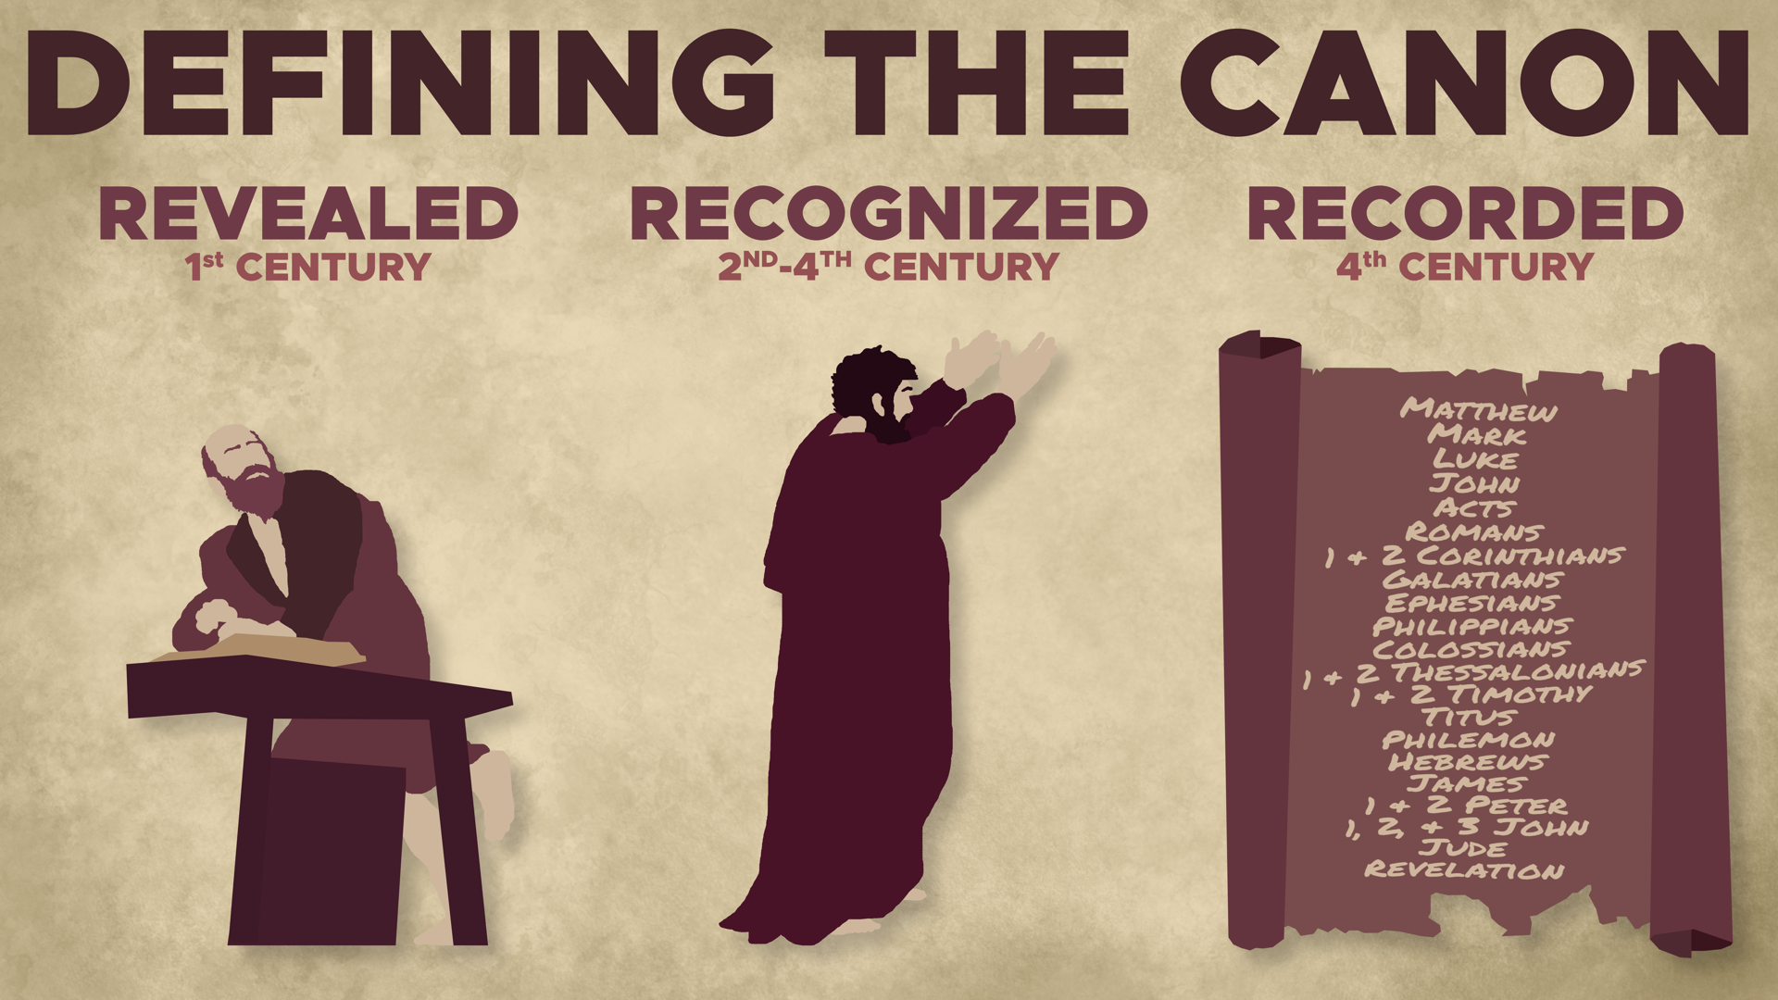

Revealed (1st century)

Recognized (2nd to 4th century)

Recorded (4th century)

What are the CRITERIA for identifying canonical books?
The primary basis is __________.

Questions to Consider

Discussion Questions
(1) Why is the definition of the canon so important to studying this subject?
(2) Why is looking for a “list” of canonical books an illegitimate way to define the canon?
(3) What was the central criterion for canonicity? Why was this so important to the early Christians?

Scripture Memorization
(2 Pet. 3:2) You should remember the words spoken beforehand by the holy prophets and the commandment of the Lord and Savior spoken by your apostles.

Homework
Respond to these statements from various Christian scholars. What is your assessment of his view of inerrancy?
Roman Catholic apologists argue that we cannot know what the Bible is unless a church council tells us.
Peter Kreeft and Ronald K. Tacelli: “If the Church is not authoritative, how can we know the Bible is? …A principle of logic and common sense is that you cannot have more in the effect than in the cause. You can’t give what you don’t have. So if the Church is not infallible, how can the Bible she wrote be infallible? Stop and think about that! …Protestants and Catholics alike know which books are in the Bible only because the Catholic Church decreed it: the Church defined the canon. And an infallible effect can come only from an infallible cause. If the Church is fallible, we cannot be sure that John’s Gospel is true and Thomas’s is not.”
Tim Staples: “Show me where the canon of Scripture is in the Bible! …If we did not have Scripture, we would still have the Church. But without the Church, there would be no New Testament Scripture. It was members of this kingdom, the Church, who wrote Scripture, preserved its many texts, and eventually canonized it. Scripture alone could not do any of this.”
WHAT IS YOUR ASSESSMENT?

Week 4: The Canon of the New Testament

What is the key criterion for canonicity?

The church fathers treated the New Testament documents as inspired
Didache

Clement of Rome (AD 95)

Polycarp (AD 110)

Justin Martyr (AD 150)

Dionysius of Corinth (AD 170)

Theophilus of Antioch (AD 177)

Irenaeus (AD 180)

Early Citations
(1) Clement of Rome (AD 96)
(2) Ignatius (AD 108)
(3) Polycarp (AD 110)
They cite 25 of the 27 NT books (all except 2 John and Jude).

Harmonizing Four Gospels
Tatian’s Diatessaron (AD 170).
Theophilus of Antioch (Jerome Epistles, 121.6.15).
Citing Four Gospels (+)
Irenaeus (AD 180, Haer. 3.11.8)
Clement of Alexandria (AD 198, EH, 6.14.5-7)
Listing the NT Books
Muratorian Fragment (AD 170)
Origen (AD 250, Hom. Jos. 7.1)
Athanasius (AD 367, 39th Paschal Letter)

Muratorian Fragment (AD 170)
22 of 27 NT books

Origen (AD 250)
(27 of 27 NT books) Homilies on Joshua 7.1

Athanasius (AD 367)
(27 of 27 NT books) 39th Paschal Letter

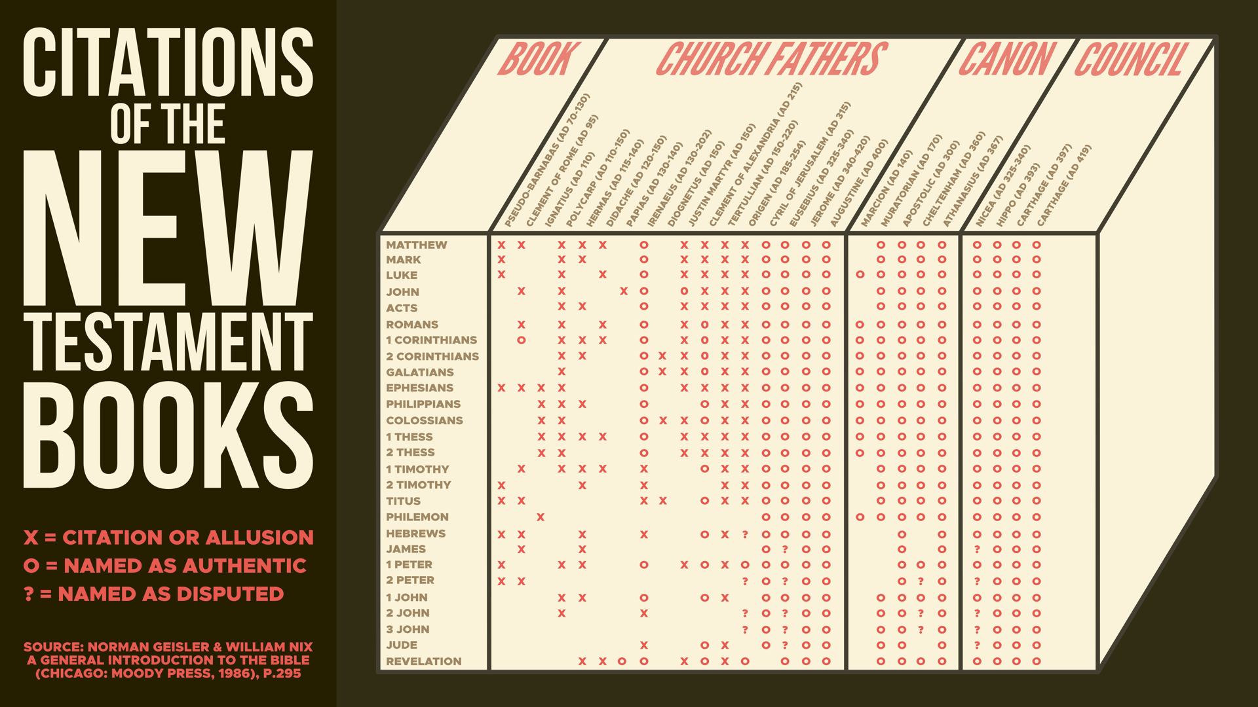

Questions to Consider

Discussion Questions
(1) How did early church councils and influential church figures contribute to the establishment of the New Testament canon, and what role did they play in confirming the canonical books?
(2) In your opinion, what is the strongest line of evidence for the canon of the New Testament?
(3) What are ways that we could overstate or exaggerate this evidence for the New Testament canon?
(4) How does understanding the process of New Testament canonization impact our view of the Bible’s authority and reliability today?

Scripture Memorization
(Jn. 14:26) The Holy Spirit will teach you all things, and bring to your remembrance all that I said to you.
(Jn. 16:13) The Spirit of truth will guide you into all the truth… He will disclose to you what is to come.

Homework
Why didn’t God give us a list of the inspired books in the canon?

Why wasn’t the canon of Scripture identified earlier? Why did it take so much time and debate to recognize the canon?

Week 5: What about the Gnostic Gospels?

Gnostic Writings Date Late

Earliest Gnostic Gospel?

Date of the Gnostic Gospels?
Darrell Bock, The Missing Gospels (Nashville, TN: Thomas Nelson, 2006), p249.
Gospel(s) of Bartholomew—5th century
Gospel of Judas—2nd century
Gospel of Mary Magdalene—2nd century
Gospel of Peter—mid-2nd century
Gospel of Philip—late 2nd century
Gospel of the Egyptians—3rd century
Gospel of the Savior—2nd century
Gospel of Thomas—2nd century
Thomas the Contender—early 3rd century
Gospel of Truth—mid-2nd century

How many Gnostic Gospels are there?

Were Gnostic texts Considered for the Canon?

Do Gnostic Texts deny Jesus’ Deity?

Does Gnosticism have a high view of women?

Was Jesus Married?

Gnostic Writings contain absurdities

Questions to Consider

Discussion Questions
(1) What are the Gnostic gospels, and how do they differ from the canonical New Testament gospels?
(2) What are some examples of early Christian writings or gospels that were debated but ultimately not included in the New Testament canon? Why were these books excluded?
(3) What were the primary reasons that early Christians rejected the Gnostic gospels?

Scripture Memorization
(1 Jn. 4:2-3) Every spirit that acknowledges that Jesus Christ has come in the flesh is from God, ³ but every spirit that does not acknowledge Jesus is not from God. This is the spirit of the antichrist.

Homework
Research the subject of Gnosticism this week. What are some of the core beliefs of Gnosticism? How does this compare to Christianity? List three key differences:
(1)

(2)

(3)

Study Guide
What are the four steps to defend Verbal Plenary Inspiration?
#1. The Gospels are relatively reliable historical documents.
#2. In the Gospels, Jesus claimed to be God.
#3. Several lines of evidence identify Jesus as supernatural (vindicating his claim to be God).
#4. Therefore, Jesus (God) taught Verbal Plenary Inspiration (VPI).
What is partial inerrancy? The Bible is inerrant in regard to morality and spirituality—not history, geography, science, etc.
What is the Chicago Statement? 313 of the greatest theological minds signed this document to define biblical inerrancy.
Was the Bible dictated by God? No. God and the human authors spoke together.
Why does inerrancy matter if we don’t have the original autographs?
(1) Many copies could spread much faster and not one person or church could control the originals.
(2) Key distinction: If the originals were flawed, then God created an error—not humans.
What is a good definition for the canon of Scripture? The biblical canon refers to those books which are: (1) uniquely inspired by God, (2) quickly recognized by followers of God, and (3) eventually collected into one book which is the word of God.
Give one reason why this definition of the canon is problematic: “The canon is the list of accepted biblical books.”
(1) This would mean that Christians did not have a Bible for at least three centuries.
(2) The need for a canonical list leads to an infinite regress.
(3) This makes a philosophical error that confuses the BEING of Scripture with the KNOWING of Scripture.
What are the CRITERIA for identifying canonical books? The primary basis is authorship: Apostolicity (NT) or propheticity (OT).
What are some reasons for rejecting the Gnostic gospels?
(1) The Gnostic writings date late.
(2) There are only 10 Gnostic gospels.
(3) The Gnostic gospels were never even considered for the canon.
(4) The Gnostic gospels contain absurdities.

Scripture Memorization
(2 Tim. 3:16-17) All Scripture is inspired by God and is useful to teach us what is true and to make us realize what is wrong in our lives. It corrects us when we are wrong and teaches us to do what is right. God uses it to prepare and equip his people to do every good work.
(2 Pet. 1:20-21) Above all, you must realize that no prophecy in Scripture ever came from the prophet’s own understanding, or from human initiative. No, those prophets were moved by the Holy Spirit, and they spoke from God.
(Jn. 17:17) Your word is truth.
(Ps. 12:6) The words of the LORD are pure words; as silver… refined seven times.
(Ps. 119:160) The sum of Your word is truth.
(2 Pet. 3:2) You should remember the words spoken beforehand by the holy prophets and the commandment of the Lord and Savior spoken by your apostles.
(Jn. 14:26) The Holy Spirit will teach you all things, and bring to your remembrance all that I said to you.
(Jn. 16:13) The Spirit of truth will guide you into all the truth… He will disclose to you what is to come.
(1 Jn. 4:2-3) Every spirit that acknowledges that Jesus Christ has come in the flesh is from God, ³ but every spirit that does not acknowledge Jesus is not from God. This is the spirit of the antichrist.

Michael F. Bird, “Inerrancy Is Not Necessary for Evangelicalism Outside the USA,” in Five Views on Biblical Inerrancy, ed. J. Merrick, Stephen M. Garrett, and Stanley N. Gundry, Zondervan Counterpoints Series (Grand Rapids, MI: Zondervan, 2013), 146.
Michael F. Bird in Five Views on Biblical Inerrancy, J. Merrick, S. M. Garrett, eds. (Grand Rapids: Zondervan, 2013), 68 note 52.
Michael Licona, “On Chicago’s Muddy Waters.” (posted June 2, 2014. www.risenjesus.org.
Michael Licona, “On Chicago’s Muddy Waters.” (posted June 2, 2014. www.risenjesus.org.
F.F. Bruce, The Canon of Scripture (Downers Grove, IL: InterVarsity Press, 1988), p.17.
Peter Kreeft and Ronald K. Tacelli, Handbook of Catholic Apologetics: Reasoned Answers to Questions of Faith (San Francisco: Ignatius, 2009), 444.
Tim Staples, “According to Scripture.” This Rock (Volume 18. Number 1. 2007).

