The Evidence for Jesus
Student Handout

Table of Contents
Pre-Homework 3
Week 1: Messiah, Myth, Moral Teacher, Menace, or Mentally Ill? 4
Discussion Questions 6
Scripture Memorization 6
Homework 6
Week 2: Did Jesus Rise from the Dead? 8
Discussion Questions 10
Scripture Memorization 10
Homework 10
Week 3: Isaiah 53 12
Discussion Questions 15
Scripture Memorization 15
Homework 15
Week 4: Psalm 22 17
Discussion Questions 20
Scripture Memorization 21
Homework 21
Week 5: Daniel 9 23
Discussion Questions 25
Scripture Memorization 25
Homework 26
Study Guide 27

Pre-Homework
(1) What do you hope to gain from taking this course?

(2) What goals do you have to use this equipping that you’re going to receive?

(3) How do you hope to put this material into practice?

Week 1: Messiah, Myth, Moral Teacher, Menace, or Mentally Ill?

Myth?
New Testament Biographies

Moral Teacher?

Jesus claimed to be God

Menace?

Mentally Ill?

Messiah?

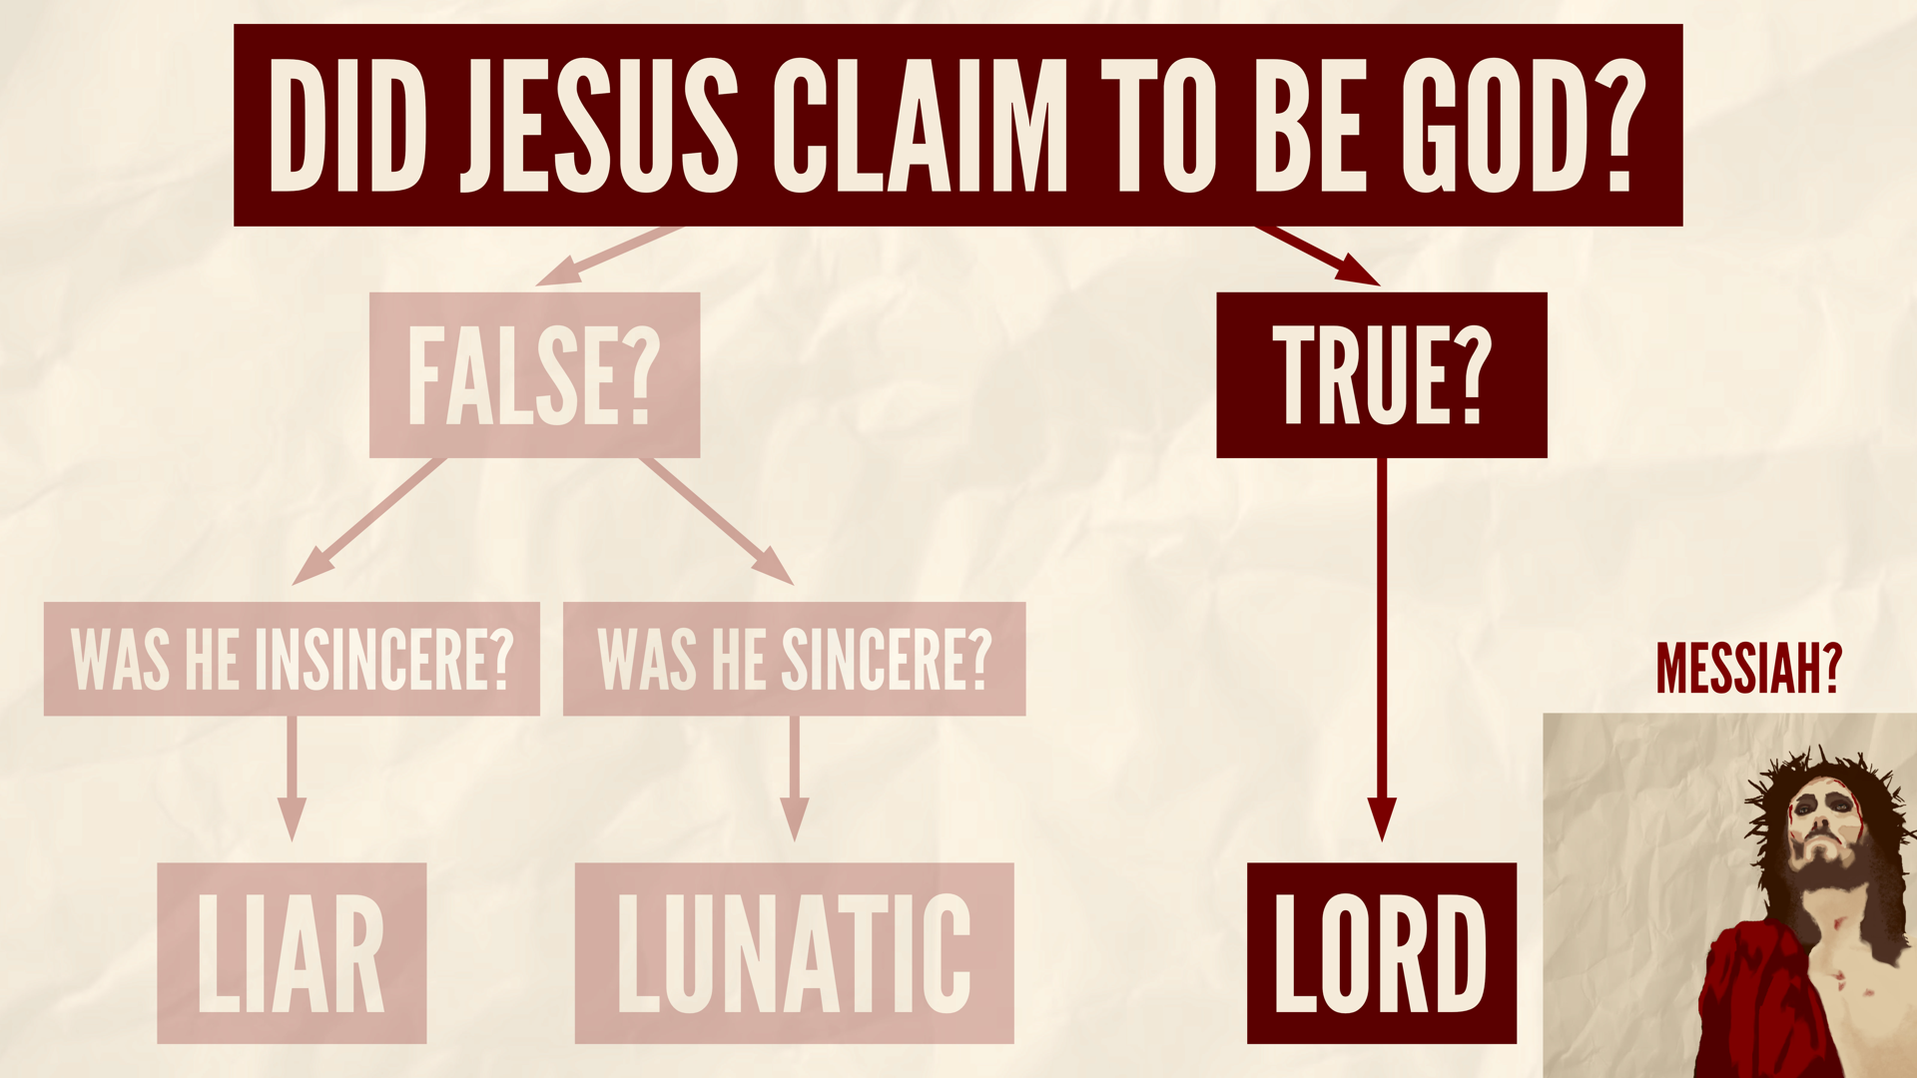

Discussion Questions
(1) What are the strengths of this argument? What are the weaknesses?
(2) What are ways we could overstate or exaggerate this argument?
(3) Are there any other options besides the ones listed above for Jesus’ identity?

Scripture Memorization
(Prov. 30:5-6) Every word of God proves true. He is a shield to all who come to him for protection. ⁶ Do not add to his words, or he may rebuke you and expose you as a liar.

Homework
Respond to these objections from skeptic Jim Perry. Be prepared to discuss your thoughts next week:
“It is still quite possible to consider Jesus a sound moral teacher even if one doesn't accept the claim of divinity… Such sayings can be judged independently of other opinions concerning Jesus.”

“Another, separate, possibility is that of the ‘noble lie.’ Jesus may have felt that his teachings on behavior were so important as to validate falsely claiming special authority from (or at an extreme, as) God in order to persuade people to follow them.”

“There is the question of the nature of mental illness and delusion… There are many kinds of delusional mental illness, with varying effects. Some of these occur sporadically rather than constantly–the term lunacy itself refers to a form of insanity intermixed with periods of clear thinking.”

Week 2: Did Jesus Rise from the Dead?

1. Early Sources

2. Execution

Ancient hostile sources
Cornelius Tacitus, Annals 15.44.
Lucian, The Death of Peregrine (p.11-13).
Babylonian Talmud, Sanhedrin 43a.
Josephus, Antiquities of the Jews 18:63-64.

Modern medical analysis
William D. Edwards, “On the Physical Death of Jesus Christ,” JAMA vol. 255, No. 11, 21 March 1986.

3. Empty Tomb

Evidence for the Empty Tomb?
Women witnesses: Embarrassing!
Talmud, Sotah 19a. Kiddushin 82b. Rosh Hashannah 1.8
Josephus, Antiquities, 4.8.15; Origen, Contra Celsus 2.55
Luke 24:11

Sanhedrists bury Jesus: Embarrassing!
Mark 14:55, 64; 15:1; John 3:1; 19:38-40.

The “Nazareth Inscription.”
Dates to Tiberius (AD 14-37) or Claudius (AD 41-54).

The earliest counter-explanations presuppose an empty tomb.
Matthew 28:11-15; Justin Martyr, Dialogue with Trypho, ch.108; cf. Tertullian, De Spectaculis, 30.

4. Expectation of Resurrection
Where did this concept originate?

Judaism?

Paganism?

5. Eyewitnesses

Group appearances

Individual appearances

Paul

James

Peter

Discussion Questions
(1) In your opinion, which lines of evidence for the resurrection are the strongest? Which are the weakest?
(2) Skeptics say that the four gospels contain contradictions about the resurrection accounts. How would you respond to this claim?
(3) Play devil’s advocate for the stolen body theory, hallucination theory, and the swoon theory. Ask the group to refute these theories.

Scripture Memorization
(1 Cor. 15:17-19) If Christ has not been raised, your faith is futile; you are still in your sins. ¹⁸ Then those also who have fallen asleep in Christ are lost. ¹⁹ If only for this life we have hope in Christ, we are of all people most to be pitied.

Homework
Skeptics try to argue that another hypothesis would explain the historical facts better than the resurrection. Respond to these alternate perspectives below. Be prepared to discuss your thoughts next week:
(1) HALLUCINATION THEORY: “The disciples had hallucinations or visions of Jesus risen from the dead.”

(2) CONSPIRACY THEORY: “The Disciples Stole the Body.”

(3) SWOON THEORY: “Jesus didn’t really die… He revived in the tomb.”

(4) WRONG TOMB THEORY: “The women visited the wrong tomb and though Jesus rose.”

(5) TWIN BROTHER THEORY: “Jesus had an identical twin who replaced him after he died on the Cross.”

Week 3: Isaiah 53
(Isa. 52:13) See, my Servant will act wisely. He will be raised and lifted up and highly exalted.
(Isa. 52:14) There were many who were appalled at him. His appearance was so disfigured beyond that of any man and his form marred beyond human likeness.
(Isa. 52:15) He will sprinkle many nations. Kings will shut their mouths because of him. For what they were not told, they will see, and what they have not heard, they will understand.

(Isa. 53:1) Who has believed our message and to whom has the arm of the LORD been revealed?

(Isa. 53:2) He grew up before him like a tender shoot, and like a root out of dry ground. He had no beauty or majesty to attract us to him, nothing in his appearance that we should desire him.

(Isa. 53:3) He was despised and rejected by men, a man of sorrows, and familiar with suffering. Like one from whom men hide their faces he was despised, and we did not esteem him.

(Isa. 53:4) Surely he took up our infirmities and carried our sorrows, yet we considered him stricken by God, smitten by him, and afflicted.

(Isa. 53:5) But he was pierced for our transgressions, he was crushed for our iniquities. The punishment that brought us peace was upon him. By his wounds we are healed.

(Isa. 53:6) We all, like sheep, have gone astray, each of us has turned to his own way. And the LORD has laid on him the iniquity of us all.

(Isa. 53:7) He was oppressed and afflicted, yet he did not open his mouth. He was led like a lamb to the slaughter, and as a sheep before her shearers is silent, so he did not open his mouth.

(Isa. 53:8) By oppression and judgment he was taken away. And who can speak of his descendants? For he was cut off from the land of the living. For the transgression of my people he was stricken.

(Isa. 53:9) His grave was assigned with wicked men, yet he was with a rich man in his death. He had done no violence, nor was there any deceit in his mouth.

(Isa. 53:10) Yet it was the LORD’s will to crush him and cause him to suffer. Though the LORD makes his life a guilt offering, he will see his offspring and prolong his days, and the will of the LORD will prosper in his hand.

(Isa. 53:11) After the suffering of his soul, he will see the light of life and be satisfied. By his knowledge my righteous Servant will justify many, and he will bear their iniquities.

(Isa. 53:12) Therefore I will give him a portion among the great. He will divide the spoils with the strong, because he poured out his life unto death, and was numbered with the transgressors. For he bore the sin of many, and made intercession for the transgressors.

Is the Servant JESUS or ISRAEL?

#1. Historical problem

#2. Interpretive problems

#3. Theological problem

Why did Isaiah originally blend the Servant with the nation of Israel?

Common Questions

Was this prediction written after the NT was written?

Is this a case of circular reasoning: The Bible fulfilling the Bible?

What if Jesus (or the disciples) self-fulfilled these predictions?

Conclusions

Discussion Questions
(1) Respond to the assertion that Isaiah 53 is referring to the nation of Israel.
(2) Respond to the assertion that Isaiah 53 could refer to lots of people in history—not just Jesus.
(3) Respond to the assertion that the disciples or Jesus self-fulfilled this prophecy.

Scripture Memorization
(Isa. 46:10) Only I can tell you the future before it even happens. Everything I plan will come to pass, for I do whatever I wish.

Homework
Print out Isaiah 53 without the verse divisions (see below). Give this to a friend who needs to read this. Ask them, “Who do you think this is describing?”
See, my Servant will act wisely. He will be raised and lifted up and highly exalted. There were many who were appalled at him. His appearance was so disfigured beyond that of any man and his form marred beyond human likeness. He will sprinkle many nations. Kings will shut their mouths because of him. For what they were not told, they will see, and what they have not heard, they will understand.
Who has believed our message and to whom has the arm of the LORD been revealed? He grew up before him like a tender shoot, and like a root out of dry ground. He had no beauty or majesty to attract us to him, nothing in his appearance that we should desire him. He was despised and rejected by men, a man of sorrows, and familiar with suffering. Like one from whom men hide their faces he was despised, and we did not esteem him. Surely he took up our infirmities and carried our sorrows, yet we considered him stricken by God, smitten by him, and afflicted.
But he was pierced for our transgressions, he was crushed for our iniquities. The punishment that brought us peace was upon him. By his wounds we are healed. We all, like sheep, have gone astray, each of us has turned to his own way. And the LORD has laid on him the iniquity of us all. He was oppressed and afflicted, yet he did not open his mouth. He was led like a lamb to the slaughter, and as a sheep before her shearers is silent, so he did not open his mouth. By oppression and judgment he was taken away. And who can speak of his descendants? For he was cut off from the land of the living. For the transgression of my people he was stricken. His grave was assigned with wicked men, yet he was with a rich man in his death. He had done no violence, nor was there any deceit in his mouth.
Yet it was the LORD’s will to crush him and cause him to suffer. Though the LORD makes his life a guilt offering, he will see his offspring and prolong his days, and the will of the LORD will prosper in his hand. After the suffering of his soul, he will see the light of life and be satisfied. By his knowledge my righteous Servant will justify many, and he will bear their iniquities. Therefore I will give him a portion among the great. He will divide the spoils with the strong, because he poured out his life unto death, and was numbered with the transgressors. For he bore the sin of many, and made intercession for the transgressors.

Week 4: Psalm 22

(Ps. 22:1-2) My God, my God, why have You forsaken me? Far from my deliverance are the words of my groaning. ² O my God, I cry by day, but You do not answer. And by night, but I have no rest.

(Ps. 22:3-5) Yet You are holy, O You who are enthroned upon the praises of Israel. ⁴ In You our fathers trusted. They trusted and You delivered them. ⁵ To You they cried out and were delivered. In You they trusted and were not disappointed.

(Ps. 22:6) But I am a worm and not a man, a reproach of men and despised by the people.

(Ps. 22:7-8) All who see me sneer at me. They separate with the lip, they wag the head, saying, ⁸ “Commit yourself to the LORD; let Him deliver him. Let Him rescue him, because He delights in him.”

(Ps. 22:9-10) Yet You are He who brought me forth from the womb. You made me trust when upon my mother’s breasts. ¹⁰ Upon You I was cast from birth. You have been my God from my mother’s womb.

(Ps. 22:11) Be not far from me, for trouble is near. For there is none to help.

(Ps. 22:12-13) Many bulls have surrounded me. Strong bulls of Bashan have encircled me. ¹³ They open wide their mouth at me, as a ravening and a roaring lion.

(Ps. 22:14) I am poured out like water, and all my bones are out of joint. My heart is like wax. It is melted within me.

(Ps. 22:15) My strength is dried up like a potsherd. My tongue cleaves to my jaws. And You lay me in the dust of death.

(Ps. 22:16) For dogs have surrounded me. A band of evildoers has encompassed me. They pierced my hands and my feet.

(Ps. 22:17-18) I can count all my bones. They look, they stare at me. ¹⁸ They divide my garments among them, and for my clothing they cast lots.

(Ps. 22:19-21) But You, O LORD, be not far off. O You my help, hasten to my assistance. ²⁰ Deliver my soul from the sword, my only life from the power of the dog. ²¹ Save me from the lion’s mouth. From the horns of the wild oxen You answer me.

(Ps. 22:22) I will tell of Your name to my brethren. In the midst of the assembly I will praise You.

(Ps. 22:23) You who fear the LORD, praise Him. All you descendants of Jacob, glorify Him. Stand in awe of Him, all you descendants of Israel.

(Ps. 22:24) For He has not despised nor abhorred the affliction of the afflicted. Nor has He hidden His face from him. But when he cried to Him for help, He heard.

(Ps. 22:25) From You comes my praise in the great assembly. I shall pay my vows before those who fear Him.

(Ps. 22:26) The afflicted will eat and be satisfied. Those who seek Him will praise the LORD. Let your heart live forever!

(Ps. 22:27-28) All the ends of the earth will remember and turn to the LORD. All the families of the nations will worship before You. ²⁸ For the kingdom is the LORD’S and He rules over the nations.

(Ps. 22:29-30) All the prosperous of the earth will eat and worship. All those who go down to the dust will bow before Him, even he who cannot keep his soul alive.

(Ps. 22:31) They will come and will declare His righteousness to a people who will be born, that He has performed it.

Is this psalm about David?
(1)

(2)

(3)

“They pierced my hands and feet.”

Oldest Jewish translation

Oldest Hebrew copy

“Pierced” makes grammatical sense

Common Questions
Was this prediction written after the NT was written?

Is this a case of circular reasoning: The Bible fulfilling the Bible?

What if Jesus (or the disciples) self-fulfilled these predictions?

Conclusions

Discussion Questions
(1) Respond to the assertion that Psalm 22 is referring to David.
(2) Respond to the assertion that Psalm 22 is poetry—not prophecy.
(3) Respond to the assertion that the disciples or Jesus self-fulfilled this prophecy.

Scripture Memorization
(1 Pet. 2:21) Christ suffered for you, leaving you an example, that you should follow in his steps.

Homework
Print out Psalm 22 without the verse divisions (see below). Give this to a friend who needs to read this. Ask them, “Who do you think this is describing?”
My God, my God, why have You forsaken me? Far from my deliverance are the words of my groaning. O my God, I cry by day, but You do not answer. And by night, but I have no rest.
Yet You are holy, O You who are enthroned upon the praises of Israel. In You our fathers trusted. They trusted and You delivered them. To You they cried out and were delivered. In You they trusted and were not disappointed.
But I am a worm and not a man, a reproach of men and despised by the people. All who see me sneer at me. They separate with the lip, they wag the head, saying, “Commit yourself to the LORD; let Him deliver him. Let Him rescue him, because He delights in him.” Yet You are He who brought me forth from the womb. You made me trust when upon my mother’s breasts. Upon You I was cast from birth. You have been my God from my mother’s womb. Be not far from me, for trouble is near. For there is none to help. Many bulls have surrounded me. Strong bulls of Bashan have encircled me. They open wide their mouth at me, as a ravening and a roaring lion.
I am poured out like water, and all my bones are out of joint. My heart is like wax. It is melted within me. My strength is dried up like a potsherd. My tongue cleaves to my jaws. And You lay me in the dust of death.
For dogs have surrounded me. A band of evildoers has encompassed me. They pierced my hands and my feet.
I can count all my bones. They look, they stare at me. They divide my garments among them, and for my clothing they cast lots.
But You, O LORD, be not far off. O You my help, hasten to my assistance. Deliver my soul from the sword, my only life from the power of the dog. Save me from the lion’s mouth. From the horns of the wild oxen You answer me.
I will tell of Your name to my brethren. In the midst of the assembly I will praise You. You who fear the LORD, praise Him. All you descendants of Jacob, glorify Him. Stand in awe of Him, all you descendants of Israel. For He has not despised nor abhorred the affliction of the afflicted. Nor has He hidden His face from him. But when he cried to Him for help, He heard. From You comes my praise in the great assembly. I shall pay my vows before those who fear Him. The afflicted will eat and be satisfied. Those who seek Him will praise the LORD. Let your heart live forever! All the ends of the earth will remember and turn to the LORD. All the families of the nations will worship before You. For the kingdom is the LORD’S and He rules over the nations. All the prosperous of the earth will eat and worship. All those who go down to the dust will bow before Him, even he who cannot keep his soul alive. They will come and will declare His righteousness to a people who will be born, that He has performed it.

Week 5: Daniel 9
(Dan. 9:24) Seventy weeks have been decreed for your people and your holy city, to finish the transgression, to make an end of sin, to make atonement for iniquity, to bring in everlasting righteousness, to seal up vision and prophecy and to anoint the most holy place.

(Dan. 9:25) So you are to know and discern that from the issuing of a decree to restore and rebuild Jerusalem until Messiah the Prince there will be seven weeks and sixty-two weeks; it will be built again, with plaza and moat, even in times of distress.

(Dan. 9:26) Then after the sixty-two weeks the Messiah will be cut off and have nothing, and the people of the prince who is to come will destroy the city and the sanctuary.

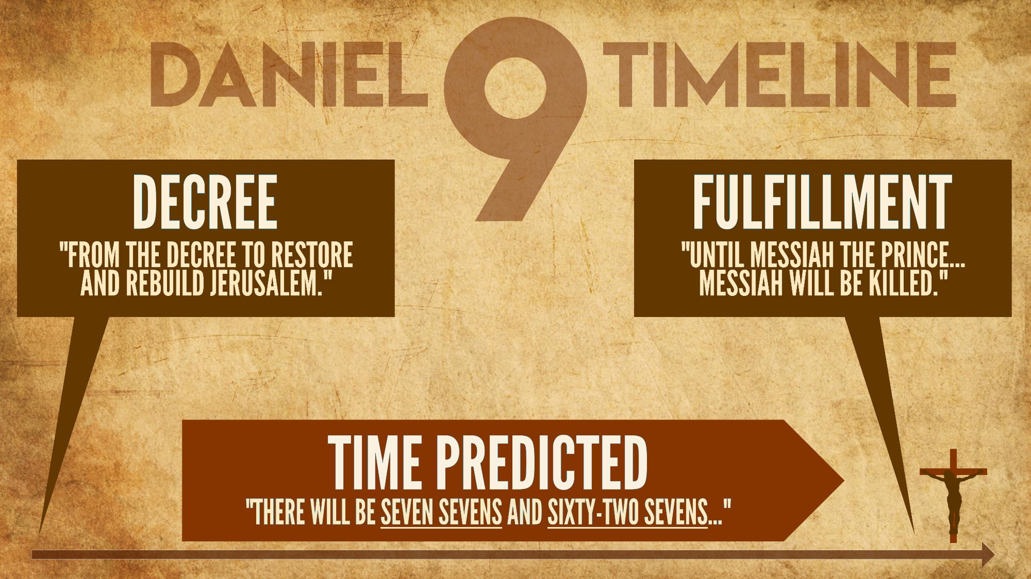

Decree
(Neh. 2:1-8)

Time predicted

“Sevens” or “Weeks”?
(1)

(2)

(3)

Jewish calendar
Religiously: 30-day months

Historically: 30-day months

Prophetically: 360-day years

Culturally: 360-day years

Jonathan Ben-Dov, “A 360-Day Administrative Year in Ancient Israel.” Harvard Theological Review (Cambridge University Pres, 2021).



Discussion Questions
(1) Respond to this statement: “Daniel 9 is too confusing to refer to Jesus. If God really made a prediction this good, then why didn’t he make it easier to understand?”
(2) Respond to this statement: “Modern critical scholars date the book of Daniel to 167 BC. So, this prophecy was NOT made 500 years in advance!”
(3) Respond to the assertion that the disciples or Jesus self-fulfilled this prophecy.

Scripture Memorization
(Lk. 24:44) Jesus said, “When I was with you before, I told you that everything written about me in the law of Moses and the prophets and in the Psalms must be fulfilled.”

Homework
With just a Bible and a calculator, explain the prophecy of Daniel 9 in your own words below.

Study Guide
What are some reasons that we know Jesus wasn’t a myth?
The Four Gospels date to the first century AD.
The manuscripts were accurately transmitted.
The gospels are supported by archaeology.
Non-Christians corroborate the Gospels (e.g. Tacitus, Josephus, Pliny, Suetonius, Lucian, Thallus, etc.)
The New Testament authors were honest in their historical reportage (e.g. embarrassment, dissimilarity, multiply attested, etc.).
What is one reason the Jesus wasn’t merely a good moral teacher? A good moral teacher couldn’t claim to be God (Dan. 7:13-14).
What is one reason the Jesus wasn’t a menace?
Deceivers buckle under pressure.
Deceivers don’t defend victims.
Deceivers need a sufficient motive (e.g. money, power, sex).
What is one reason the Jesus wasn’t mentally ill?
Jesus made this claim in a first-century Jewish context where deity was unique.
The NT includes this accusation (Jn. 7:20; 10:20; Mt. 12:22-29; Mk. 3:21).
Was the world transformed by a delusional, narcissistic maniac?
Psychotic, megalomaniacs are not difficult to identify.
What are five lines of evidence that Jesus rose from the dead?
(1) Early sources
(2) Execution
(3) Empty tomb
(4) Expectation of resurrection
(5) Eyewitnesses
What passage details the death, resurrection, and appearances of Jesus and dates within 2-3 years of Jesus’ death? 1 Corinthians 15:3-8.
How do we know that Isaiah’s Suffering Servant is referring to Jesus, rather than the nation of Israel?
#1. Historical problem: Jewish rabbis rejected the national interpretation for 1,000 years.
#2. Interpretive problems: After Isaiah 49:6, the Servant doesn’t refer to the nation of Israel.
#3. Theological problem: God promised to bless Israel if they were righteous, and curse the nation if they were unrighteous (Leviticus 26; Deuteronomy 28).
How do we know that Psalm 22 isn’t about David?
(1) David died peacefully (1 Kin. 2:10).
(2) Many of David’s psalms were predictive (e.g. Ps. 2, 110).
(3) David’s death didn’t have a global impact.
Does Psalm 22:16 say “pierced” or “like a lion”?
(1) The oldest Jewish translation says “pierced.”
(2) The oldest Hebrew copy says “pierced.”
(3) Pierced makes grammatical sense.
In Daniel 9, how do we date the decree of Artaxerxes to rebuild the city? Nehemiah 2.
Name some reasons that the Jewish calendar used 360-day years.
(1) Religiously: New moon calendar.
(2) Historical: Genesis 8:3-4.
(3) Prophetically: Revelation 11:2-3
(4) Culturally: Egyptians, Romans, Babylonians
How do we know that the NT authors didn’t distort Isaiah 53, Psalm 22, or Daniel 9? We have manuscripts of these passages that predate the New Testament.
What if Jesus (or the disciples) self-fulfilled these predictions?
(1) This shows that these passages do sound like Jesus. (This is a huge admission!)
(2) Crucifixion was not in Jesus’ self-interest!
(3) No one expected a crucified Messiah before Jesus lived.
(4) Jesus’ closest disciples paid the ultimate price for this.
(5) They couldn’t have self-fulfilled the worldwide impact.

Scripture Memorization
(Prov. 30:5-6) Every word of God proves true. He is a shield to all who come to him for protection. ⁶ Do not add to his words, or he may rebuke you and expose you as a liar.
(1 Cor. 15:17-19) If Christ has not been raised, your faith is futile; you are still in your sins. ¹⁸ Then those also who have fallen asleep in Christ are lost. ¹⁹ If only for this life we have hope in Christ, we are of all people most to be pitied.
(Isa. 46:10) Only I can tell you the future before it even happens. Everything I plan will come to pass, for I do whatever I wish.
(1 Pet. 2:21) Christ suffered for you, leaving you an example, that you should follow in his steps.
(Lk. 24:44) Jesus said, “When I was with you before, I told you that everything written about me in the law of Moses and the prophets and in the Psalms must be fulfilled.”

Jim Perry “The Trilemma—Lord, Liar, or Lunatic?” (1995). https://infidels.org/library/modern/the-trilemma-lord-liar-or-lunatic/

