Is the New Testament Historically Reliable?
Student Handout

Table of Contents
Pre-Homework 3
Week 1: The Authorship of the Gospels 4
Discussion Questions 8
Scripture Memorization 8
Homework 8
Week 2: The Early Dating of the Gospels 15
Discussion Questions 18
Scripture Memorization 18
Homework 18
Interlocking in the Gospels 18
Week 3: Textual Transmission: Do we Read what they wrote? 23
Discussion Questions 26
Scripture Memorization 26
Homework 26
Week 4: The Gospels and Archaeology 27
Discussion Questions 30
Scripture Memorization 30
Homework 30
Week 5: Jesus Outside the New Testament 31
Discussion Questions 33
Scripture Memorization 33
Homework 33
Study Guide 34

Pre-Homework
(1) What do you hope to gain from taking this course?

(2) What goals do you have to use this equipping that you’re going to receive?

(3) How do you hope to put this material into practice?

Week 1: The Authorship of the Gospels

The Critical View
The gospels were anonymous, and the names were added a century later. The names were only added to give them a “much needed authority.”

Manuscript Evidence

Impractical

Implausible

Unhistorical

Matthew

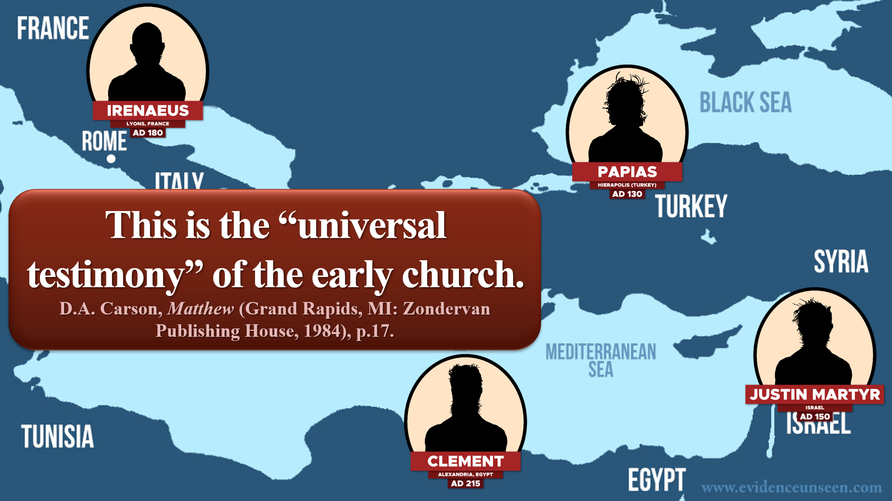

Mark

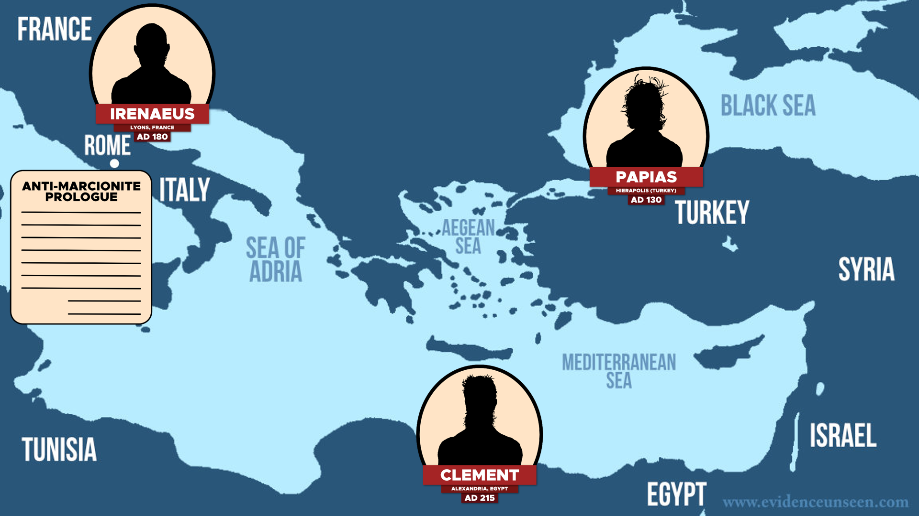

Internal Evidence

Luke

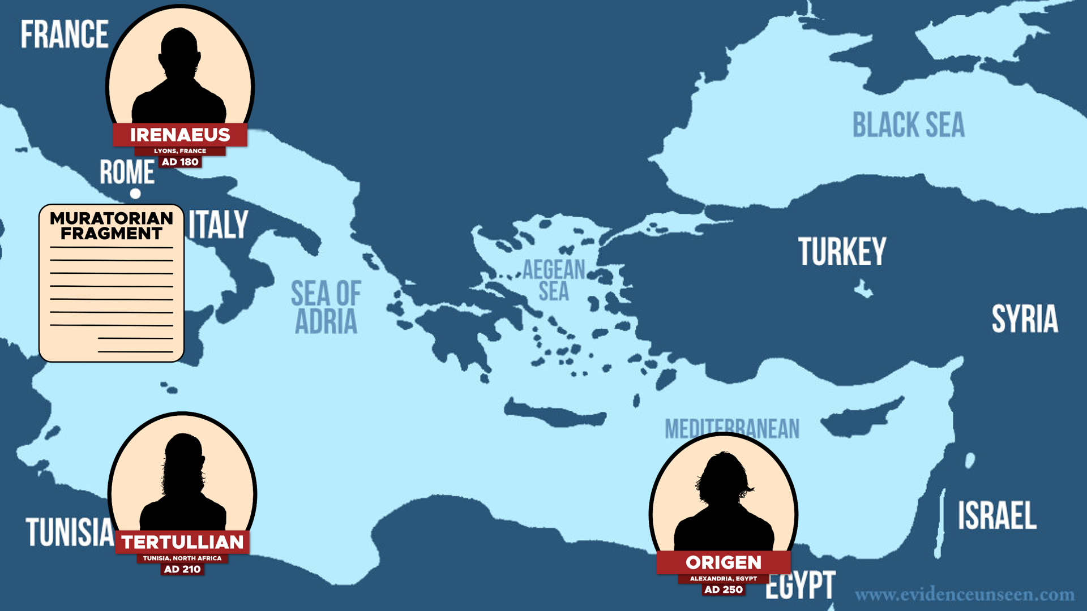

Internal Evidence

John

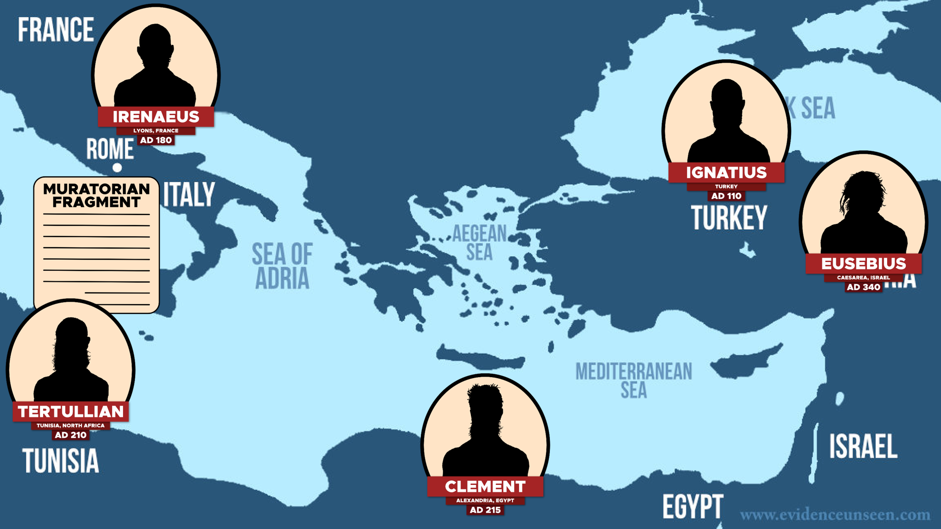

Internal Evidence

Clear Communication
(1)

(2)

(3)

(4)
Discussion Questions
(1) How could you use this argument in everyday conversation? How can we present it in a way that is respectful and approachable?
(2) What are ways that we could exaggerate or overstate this evidence for God? What should we say instead?
(3) What are some of the responses to the argument from fine-tuning that you’ve heard from skeptics? (List these out.) How would you respond to each of these?

Discussion Questions
(1) What is the difference between “internal evidence” and “eternal evidence”?
(2) In your opinion, how important is the subject of the authorship of the gospels? If we found out that Matthew didn’t actually write the first gospel, how serious would this be?
(3) What is one line of evidence that you found to be the most persuasive for the traditional authorship of the gospels?

Scripture Memorization
(2 Pet. 1:16) We were not making up clever stories when we told you about the powerful coming of our Lord Jesus Christ. We saw his majestic splendor with our own eyes.
(Lk. 1:1-3) Many have undertaken to draw up an account of the things that have been fulfilled among us, ² just as they were handed down to us by those who from the first were eyewitnesses and servants of the word. ³ With this in mind, since I myself have carefully investigated everything from the beginning, I too decided to write an orderly account for you.
(Jn. 19:35) The man who saw it has given testimony, and his testimony is true. He knows that he tells the truth, and he testifies so that you also may believe.

Homework
Read this article below. Highlight 2-3 of the key arguments that you want to remember for a conversation. Be prepared to discuss these arguments next week:

Were the Gospels created like the Game of Telephone?
By James M. Rochford
Decades passed between the events of Jesus’ life and the writing of the four Gospels. During this time, Christians spread the stories of Jesus’ messages, miracles, and overall ministry. But did they transmit these accounts accurately? How do we know if these stories were passed with precision, rather than with exaggeration or embellishment? Critic Bart Ehrman asserts,
Nearly all of these storytellers had no independent knowledge of what really happened [to Jesus]. It takes little imagination to realize what happened to the stories. You are probably familiar with the old birthday party game ‘telephone.’ A group of kids sits in a circle, the first tells a brief story to the one sitting next to her, who tells it to the next, and to the next, and so on, until it comes back full circle to the one who started it. Invariably, the story has changed so much in the process of retelling that everyone gets a good laugh. Imagine this same activity taking place, not in a solitary living room with ten kids on one afternoon, but over the expanse of the Roman Empire (some 2,500 miles across), with thousands of participants.
Ehrman compares the transmission of the historical traditions of Jesus to the children’s game of Telephone. If we were to be generous, we might think that Bart Ehrman’s “analogy well” was dry the day he wrote this. However, this is not the case. He really likes this illustration, and continues to use it over and over. Indeed, despite repeated criticisms of this analogy, Ehrman even included it in the fifth edition his textbook on the history of the New Testament (2012). Sadly, many people have adopted this view.

The early Christians had excellent RECALL
The children’s game of Telephone is a deeply distorted way of describing the transmission of the earliest accounts of Jesus. As we will see, the historical accounts of Jesus’ life were communicated, collected, and conserved with accuracy and integrity. To help the reader remember the ways in which the early Christians communicated about the life and teachings of Jesus, we will use the acronym RECALL:
- REPEATED TEACHINGS: Jesus repeated his teachings over and over which aided memorization.
- EARLY EYEWITNESSES: The Gospels preserved early, eyewitness testimony.
- COLLECTIVE COMMUNICATION: Entire Christian communities—not individuals—received and delivered these historical accounts.
- APOSTOLIC OVERSIGHT: The apostles supervised and corrected the spread of the message.
- LIFE-CHANGING & LIFE-AND-DEATH TEACHING: This type of teaching led the early Christians to handle it accurately.

REPEATED TEACHINGS: Jesus repeated his teachings over and over which aided memorization
As an itinerant teacher, Jesus constantly taught in new cities and to new audiences. Think about it: Are we honestly supposed to believe that Jesus created brand new teachings every time he entered a new city? If the audience was entirely new, he likely repeated his teachings. This would mean that Jesus’ disciples heard his teachings over and over and over and over and over and over and…. (Well, you get the idea.) After 3.5 years of following Jesus, these teachings would have been seared into their minds!
The Gospels themselves give evidence of this practice of repetition. Even in the same Gospel, we see that Jesus repeated himself. A few examples of this will suffice:
(1) Oft-repeated riddles. Jesus said, “He who has found his life will lose it, and he who has lost his life for My sake will find it” (Mt. 10:39; 16:25; Mk. 8:35; Lk. 9:24; 17:33; Jn. 12:25). This little riddle appears in all four gospels at least once, and in Matthew and Luke twice. Moreover, Jesus spoke this aphorism in different settings, which shows that he clearly repeated this little teaching: He used this teaching on his tour of Galilee (Mt. 10:39), in Caesarea Philippi (Mt. 16:25; Mk. 8:35; Lk. 9:24), on his way to Jerusalem (Lk. 17:33), and on the last week of his life (Jn. 12:25). Other examples would include:
“He who has ears to hear, let him hear” (Mt. 11:15; 13:9, 43; Mk. 4:9, 23; 7:16; Lk. 8:8; 14:35).
“Many who are first will be last; and the last, first” (Mt. 19:30; 20:16).
“If your right eye makes you stumble, tear it out and throw it from you; for it is better for you to lose one of the parts of your body, than for your whole body to be thrown into hell. ³⁰ If your right hand makes you stumble, cut it off and throw it from you; for it is better for you to lose one of the parts of your body, than for your whole body to go into hell” (Mt. 5:29-30; 18:8-9).
(2) Jesus’ prediction of his death and resurrection. In Mark alone, we see that Jesus predicted his death and resurrection five times (Mk. 8:31; 9:9, 31-32; 10:33-34; 14:28). He had no problem repeating this important prediction over and over.
(3) Receiving the kingdom like a child. Jesus used the humility of children to describe how to come to faith. He did this twice in Matthew (Mt. 18:13; 19:14), which again demonstrates his use of repetition (cf. Mk. 10:15; Lk. 18:17).
(4) The Lord’s Prayer. Jesus most likely used this model prayer multiple times. For one, it was given as a pattern of prayer (Mt. 6:9), so we would expect him to reuse it. Second, Jesus used this model prayer in different locations: Matthew places the Lord’s Prayer in the middle of the Sermon on the Mount (Mt. 6:9-13), while Luke places it after Jesus had finished praying in solitude (Lk. 11:1-4). Third, Luke’s version is shorter than Matthew’s, and it isn’t likely for Luke to cut from such an important prayer as this.
After hearing these “reruns” several dozen times, Jesus’ disciples could probably rehearse Jesus’ teachings in their sleep. Indeed, the disciples memorized Jesus’ teachings enough for Jesus to send them out to teach without supervision (Mt. 10:7; Mk. 6:12; Lk. 9:2; 10:9). In our modern world we get a sense of what this would be like when we memorize song lyrics or lines from our favorite movies. Memorization—even of large amounts of material—is not improbable.
How does this compare to the Game of Telephone? It doesn’t. How fun would Telephone be if the person sitting next to you was allowed to repeat the message dozens of times? Not even little kids would want to play the game if this was the case, because you’d get it exactly right every time!

EARLY EYEWITNESSES: The Gospels preserved early, eyewitness testimony
The sources for the Gospels were EARLY. Luke writes that he composed his Gospel by going back to those who were with Jesus “from the beginning,” and Luke states that he “investigated everything carefully from the beginning” (Lk. 1:2-3).
After the death of Judas, the apostles needed to choose a replacement. By what criteria did they pick an apostle? Good looks? High IQ? People skills? No, none of these. Luke records that the replacement needed to be with Jesus from the “beginning” of his ministry. Peter stated, “It is necessary to choose one of the men who have been with us the whole time the Lord Jesus went in and out among us, ²² beginning from John’s baptism to the time when Jesus was taken up from us. For one of these must become a witness with us of his resurrection” (Acts 1:21-22 NIV).
The apostles likely got this idea from Jesus himself. John records that Jesus told his disciples, “You [i.e. the apostles] will testify also, because you have been with Me from the beginning” (Jn. 15:27).
The sources for the Gospels were EYEWITNESSES. The early Christians placed a high premium on getting “eyewitness” sources:
Luke: “Many have undertaken to compile an account of the things accomplished among us, ² just as they were handed down to us by those who from the beginning were eyewitnesses and servants of the word, ³ it seemed fitting for me as well, having investigated everything carefully from the beginning, to write it out for you in consecutive order” (Lk. 1:1-3).
John: “What was from the beginning, what we have heard, what we have seen with our eyes, what we have looked at and touched with our hands, concerning the Word of Life— ² and the life was manifested, and we have seen and testify and proclaim to you the eternal life, which was with the Father and was manifested to us— ³ what we have seen and heard we proclaim to you also, so that you too may have fellowship with us; and indeed our fellowship is with the Father, and with His Son Jesus Christ” (1 Jn. 1:1-3).
John: “He who has seen has testified, and his testimony is true; and he knows that he is telling the truth, so that you also may believe” (Jn. 19:35; cf. Jn. 21:24).
Peter: “We did not follow cleverly devised tales when we made known to you the power and coming of our Lord Jesus Christ, but we were eyewitnesses of His majesty” (2 Pet. 1:16).
Paul: “Am I not an apostle? Haven’t I seen Jesus our Lord with my own eyes?” (1 Cor. 9:1 NLT)
Hebrews: “This salvation, which was first announced by the Lord, was confirmed to us by those who heard him” (Heb. 2:3 NIV).
Don’t miss the point. The Gospels were not based on late legends or exaggerated embellishments. The authors were either eyewitnesses themselves (Matthew & John), or they interviewed “eyewitnesses” who were with Jesus “from the beginning” (e.g. Mark & Luke).
How does this compare to the Game of Telephone? Again, it doesn’t. No one would play the game of Telephone if you were allowed to ask the first person in line what the message was. But as we have seen, the historical accounts of Jesus went back to the beginning and to the eyewitnesses themselves—not through a long line of convoluted communication.

COLLECTIVE COMMUNICATION: Entire Christian communities—not individuals—received and delivered these historical accounts
The historical accounts of Jesus’ words and works were given to groups of people—not single individuals. Indeed, the NT describes the early churches as communities of people—not individuals practicing spirituality alienated and alone. The early Christians met regularly for times of reading (1 Tim. 4:13; Col. 4:16; 1 Thess. 5:27), prayer (Acts 2:42), fellowship (1 Cor. 11:18ff; Jude 12), and the celebration of the Lord’s Supper (1 Cor. 11:23ff). During these times, they must have shared the stories about the life of Jesus. But unlike our individualistic society today, these stories were shared in communities—not from one isolated individual to another.
Early Christianity emphasized true teaching about Jesus. The apostles instructed the earliest Christians to recognize false teaching, watch out for it, and actively refute it.
Refuting false teaching was a major emphasis to the early Christians. Indeed we see this in 18 out of the 22 letters in the NT, which speak against false teaching. Truth was very important to these early Christians.
Christian groups would correct each other in the context of community. While the apostles themselves oversaw local churches, they also taught Christians to evaluate one another in what they taught. James wrote to correct anyone who “strays from the truth” (Jas. 5:19-20). Paul told the Colossians to “teach and admonish one another” (Col. 3:16 NIV). In the context of having accurate “doctrine,” Paul stated that the early Christians needed to “speak the truth in love” (Eph. 4:14-15). When people taught publicly, the entire church would judge whether their teaching was accurate. As Paul wrote, “Let two or three prophets speak, and let the others pass judgment” (1 Cor. 14:29), and he also stated, “Examine everything carefully; hold fast to that which is good” (1 Thess. 5:21). The apostle John used stronger language for false teachers, when he wrote, “Do not believe every spirit, but test the spirits to see whether they are from God, because many false prophets have gone out into the world” (1 Jn. 4:1).
How does this compare to the Game of Telephone? Telephone would be an incredibly boring game if you could say the catchphrase out loud to the entire room at FULL VOLUME! In fact, doing so would ruin the game. But this is precisely what we see in the transmission of the accounts of Jesus’ messages, ministry, and miracles—namely, these were entrusted to entire groups, not individuals.

APOSTOLIC OVERSIGHT: The apostles supervised and corrected the spread of the message
Christians shared about Jesus’ life before the Gospels were written. However, the apostles supervised the sharing of these accounts to keep them free from embellishment, exaggeration, or error.
We see examples of the apostles supervising and correcting the message about Jesus. The early Christians listened directly to the apostles’ teachings (Acts 2:42). As Christianity grew outward geographically, the apostles would visit new churches. For instance, when a large group of Samaritans came to faith, the Jerusalem apostles “sent… Peter and John” (Acts 8:14), who probably wanted to make sure that the Samaritans were believing accurately. Likewise, the apostles visited churches to teach them face to face (2 Jn. 12; Rom. 1:11), and also to refute false teaching and false teachers (3 John 9-10; 1 Cor. 4:21; 2 Cor. 13:2, 10).
Collective communication with apostolic oversight was very reliable and stable. Dr. Kenneth Bailey refers to this as an “informal controlled oral tradition.” The sharing of the content is “informal” in the sense that anyone can share it (1 Cor. 11:2, 15:2; 2 Thess. 2:15). But it is also “controlled” in the sense that these Christian communities had eyewitnesses who could prevent errors from creeping in. This form of oral tradition is very reliable. Even today, entire communities can memorize huge swaths of material. In fact, in some cultures, it isn’t uncommon for Muslims to memorize the entire Qur’an—sometimes without even knowing Arabic!
Because we don’t live in a culture of orality, some are skeptical of the reliability of oral tradition. But even though we aren’t a culture that has honed this ability, other cultures have. It is simple ethnocentrism to think that other cultures are incapable of passing along accurate teaching from memory. In fact, even in our culture, many can remember phone numbers from growing up (before we stored these numbers in smart phones). We also memorize long lines from movies or lyrics from our favorite songs. Those in theatre memorize entire scripts with some dedication and practice. In oral cultures, memorization is developed, trained, and highly valued.
How does this compare to the Game of Telephone? Just imagine playing Telephone if you could speak the phrase to the entire group (i.e. collective communication), and the person who created the phrase could correct the players if they were wrong (i.e. apostolic oversight). This change in the rules completely changes the game. The two concepts simply aren’t comparable.

LIFE-CHANGING and LIFE-AND-DEATH teaching: This type of teaching led the early Christians to handle it accurately
We probably don’t need to persuade anyone of this point, but Jesus clearly taught life-changing and life-and-death concepts. Indeed, the early Christians held Jesus’ words to be a matter of life and death. We can see why when we read his words:
“Everyone who hears these words of Mine and acts on them, may be compared to a wise man who built his house on the rock” (Mt. 7:24).
“Heaven and earth will pass away, but My words will not pass away” (Mk. 13:31; cf. Mt. 24:35).
“Jesus said to the twelve, “You do not want to go away also, do you?” ⁶⁸ Simon Peter answered Him, “Lord, to whom shall we go? You have words of eternal life” (Jn. 6:67-68).
“He who rejects Me and does not receive My sayings, has one who judges him; the word I spoke is what will judge him at the last day” (Jn. 12:48).
How does this compare to the Game of Telephone? We hate to be a broken record, but there’s simply no comparison. After all, the phrases in Telephone are childish and silly—not life-changing or life-threatening. Just imagine if you were playing a game of Telephone at a work party, and someone whispered, “There’s a bomb in the room… Get out!” A message like this would have a much greater chance of being communicated clearly!

Conclusion
Does any of this sound like the game of Telephone? Not at all! First, Jesus’ teachings were repeated over and over, rather than whispered once. Second, the writers of the Gospels went back to the early eyewitnesses, rather than getting the message at the end of a long chain of people. Third, the eyewitnesses taught the message to entire groups, rather than whispering it from one person to another. Fourth, the apostles corrected the message as it was passed along, rather than distorting the message every time it was told. And fifth, the message was incredibly important—not childish and meaningless.

Week 2: The Early Dating of the Gospels

Majority Dating
Mark: AD 70
Matthew: AD 80-90
Luke: AD 80-90
John: AD 90-100

Early manuscript evidence



Early citations

Early date for Acts (AD 62)
Jewish War and Temple (AD 66-70).
1.1 million killed and 200,000 enslaved.

Nero’s persecution (AD 64).

No mention of major martyrdoms.

Theological disputes (pre AD 70).

Legal protection of Christianity.

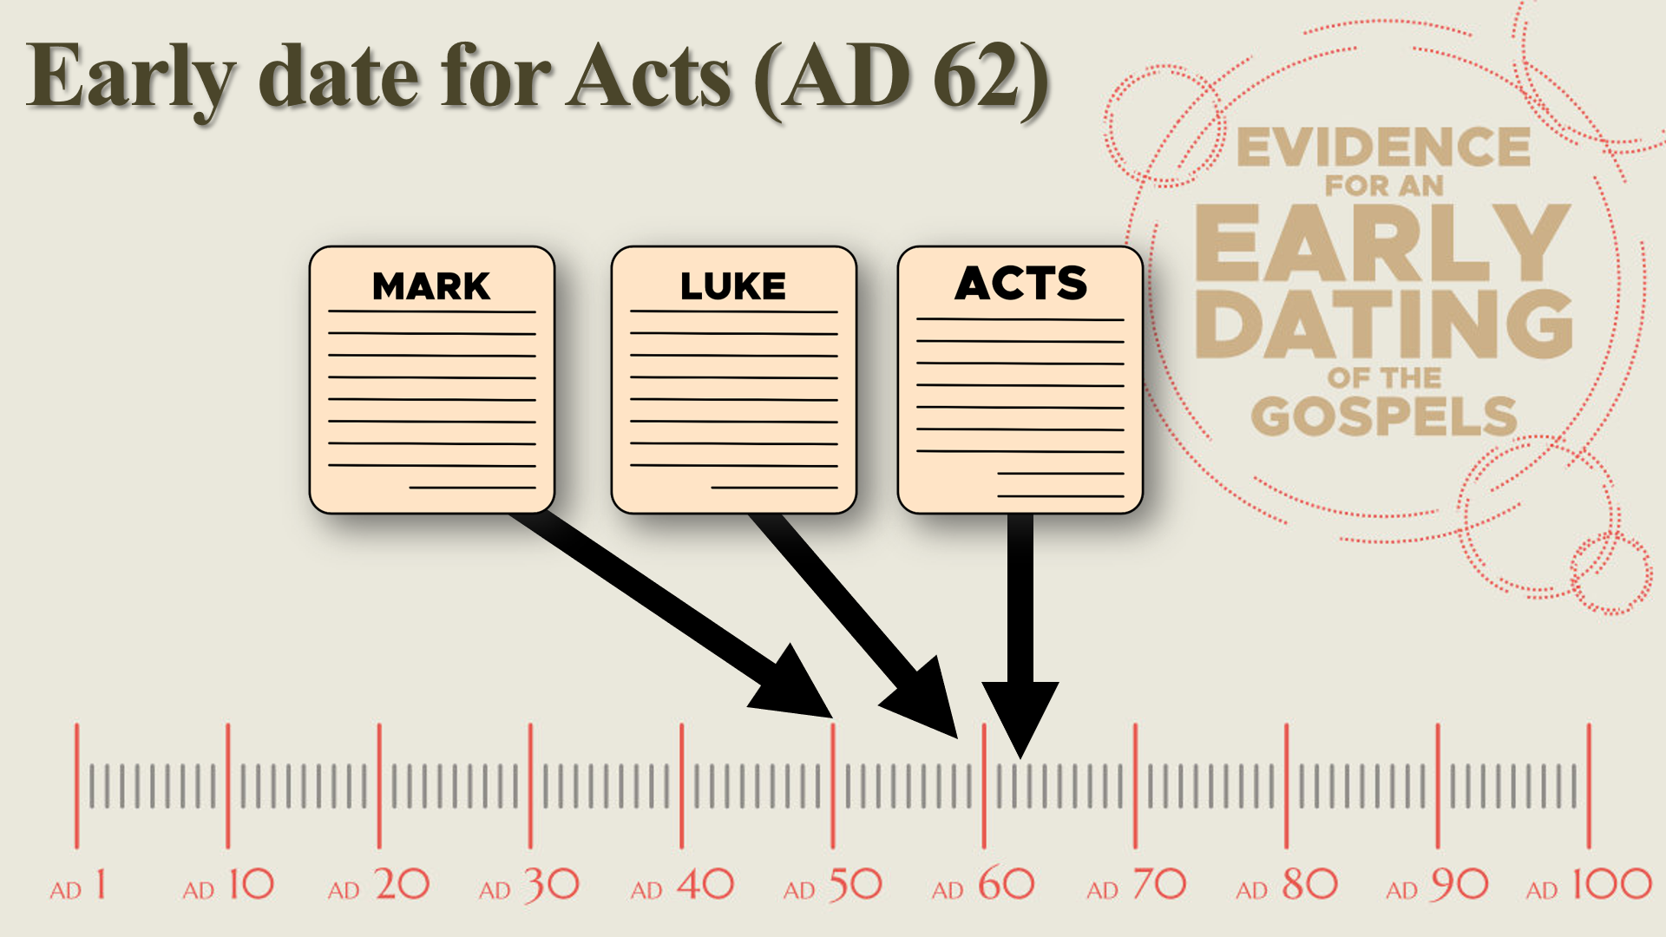

Early citations from Paul
(1 Cor. 7:10) “To the married I give instructions, not I, but the Lord, that the wife should not leave her husband.”

(1 Cor. 9:14) “The Lord directed those who proclaim the gospel to get their living from the gospel.”

(1 Cor. 11:23) For I received from the Lord that which I also delivered to you, that the Lord Jesus in the night in which He was betrayed took bread.
(1 Cor. 11:24) When He had given thanks, He broke it and said, “This is My body, which is for you; do this in remembrance of Me.”
(1 Cor. 11:25) In the same way He took the cup also after supper, saying, “This cup is the new covenant in My blood; do this, as often as you drink it, in remembrance of Me.”

(1 Tim. 5:18) Scripture says, “You shall not muzzle the ox while he is threshing,” and “The laborer is worthy of his wages.”

Conclusion

Discussion Questions
(1) What is the significance of dating the Gospels early in the first century, and how does this impact our understanding of their historical reliability and authenticity?
(2) What are some key pieces of evidence that support an early date for the Gospels, such as manuscript discoveries, historical references, or internal textual clues?
(3) What argument do “late date” scholars offer for a later dating of the Gospels? How can these arguments be evaluated in light of the evidence for early dating?

Scripture Memorization
(1 Jn. 1:1) We proclaim to you the one who existed from the beginning, whom we have heard and seen. We saw him with our own eyes and touched him with our own hands. He is the Word of life.

Homework
Read this article below. After you are finished, answer these questions:
(1) What is interlocking?

(2) What are your two favorite examples of interlocking? Why?

Be prepared to discuss these arguments next week.

Interlocking in the Gospels
By James M. Rochford
“Interlocking” occurs when two independent sources resolve one another’s historical difficulties without meaning to—what some scholars have called “undesigned coincidences.” When two sources confirm one another (without intending to), this supports their veracity, showing that they were both reliably recounting concrete events from different angles.

The birth of Jesus
Why do the religious leaders accuse Jesus of being born “of fornication”? This interlocks with the virgin birth of Christ. John doesn’t mention the virgin birth, but he includes this mention of being born of fornication (Jn. 8:41).

The calling of Peter
Why does Peter “immediately” drop his fishing net when he sees Jesus in Matthew 4:18-20? This account makes more sense when we realize that this wasn’t Jesus’ first encounter with Peter: the two had already met in John 1:40-42.

The calling of John and James
Why are John and James “mending their nets” in Matthew 4:21? This is a throw away comment that seems unimportant. But when we compare it with Luke’s account, we discover that Peter had called his business partners to come help with the large catch of fish. Luke records, “They [Peter and Andrew] signaled to their partners in the other boat for them to come and help them. And they came and filled both of the boats, so that they began to sink” (Lk. 5:7). In other words, James and John’s boat was also overwhelmed with fish, and their nets were presumably ripping as well. This would make perfect sense as to why they were “mending their nets.” However, Matthew only mentions the mending of the nets, while Luke only mentions the large catch. When we put both accounts together, we see an interlocked account.

The feeding of the 5,000
Why does Mark mention the “green grass”? Wouldn’t mentioning the green grass be redundant (see Mk. 6:39)? John explains this indirectly by noting that this event (the feeding of the 5,000) occurred just before the Passover (Jn. 6:4). Interestingly, the grass near this region around the Sea of Galilee is not typically green throughout the year—only in spring—only during the time of the Passover. Thus John explains Mark’s comment about green grass.
Why does Jesus ask Philip where to buy bread? In the account of the feeding of the 5,000, Jesus asks Philip, “Where are we to buy bread, so that these may eat?” (Jn. 6:5). Why does Jesus ask a relatively obscure apostle like Philip, rather than Peter, James, or John? Philip only appears in three places in John’s gospel (Jn. 1:43ff; Jn. 12:21ff; Jn. 14:8ff), so why is he singled out here?
The feeding of the 5,000 occurred near Bethsaida (Lk. 9:10), but John never mentions this. However, John does mention that Philip was from Bethsaida (Jn. 1:43-44; 12:21). McGrew comments, “One can… picture Jesus asking the question in a slightly teasing manner. The fact that Philip was from that vicinity makes the question (and the joke) more pointed. If Philip is from the nearby town, Jesus is in essence saying, ‘Philip, you’re from around here. Where can we get bread for all these people?’”

Knowledge of Herod’s private conversations
How could the gospels know what Herod was thinking about Jesus being a resuscitated John the Baptist? Matthew records that Herod spoke about this “to his servants” (Mt. 14:2).
Luke explains that one of Jesus’ disciples was “Joanna… the manager of Herod’s household” (Lk. 8:3 NIV). Thus Luke explains how we could know what was happening behind Herod’s closed doors.

The Last Supper
Why does Jesus wash the disciples’ feet at the Last Supper? John records this event (Jn. 13), but John contains no explanation for why Jesus did this.
When we turn to the gospel of Luke, we discover that the disciples had just been bickering over who was the greatest on this very night (Lk. 22:24), and Jesus corrected them by saying, “Who is greater, the one who reclines at the table or the one who serves? Is it not the one who reclines at the table? But I am among you as the one who serves” (Lk. 22:27).
Again, Luke doesn’t explain the foot washing, and John doesn’t explain the bickering of the disciples. However, once these two stories are placed side by side, they reveal a more robust explanation of the historical event.

Jesus’ trial
Why does Pilate ask if Jesus is the ‘king of the Jews’ if this accusation never appears by the Pharisees? John’s account of the trial of Jesus under Pontius Pilate mentions nothing of the religious leaders’ charges that Jesus was the king of the Jews. We only find a blunt question from Pilate out of the blue in John 18: “Are you the king of the Jews?” (v.33) Where did Pilate come up with this question? John doesn’t explain this to us.
It’s only as we read Luke’s account that we discover that the Jewish leaders were raising this charge to Pilate earlier in the trial (Lk. 23:1-3).
How could Jesus say that his followers wouldn’t fight to make him king, when Peter chopped off the ear of Malchus that very night? Jesus claims that his followers would not fight to make him King Messiah (Jn. 18:36). However, this contradicts the earlier record in John that Peter did fight by chopping off Malchus’ ear (Jn. 18:10). If we only read John, this is a glaring difficulty.
When we read Luke, we find a resolution: Jesus healed the man’s ear after it was chopped off (Lk. 22:47-53). Therefore, Malchus couldn’t be produced as a witness to Pilate, because Jesus had healed him.
Why does Pilate not care that Jesus claims to be the King of the Jews? Pilate asks Jesus, “Are You the King of the Jews?” (Lk. 23:3) Here, Pilate was asking Jesus, “Are you leading a rebellion against Rome? Are you guilty of treason and sedition?”
Jesus calmly replies, “It is as you say” (Lk. 23:4, NASB) or “You have said so” (ESV) or “Yes, it is as you say” (NIV) or “You have said it” (NLT).
Does Pilate have him beaten, tortured, and crucified on the spot? No, Pilate immediately tells the chief priests, “I find no guilt in this man” (Lk. 23:5). How odd! Why would Pilate respond in this way?
John explains this difficulty (Jn. 18:33-38). In John’s account, he explains that Jesus told Pilate, “My kingdom is not of this world. If My kingdom were of this world, then My servants would be fighting so that I would not be handed over to the Jews; but as it is, My kingdom is not of this realm” (Jn. 18:36). Once Pilate discovers that Jesus is no political or military threat, it would make sense for him to absolve Jesus of guilt.
Why do false witnesses claim that Jesus would ‘destroy the Temple’? The witnesses brought against Jesus claimed that he would “destroy this Temple… and in three days [he] will build another” (Mk. 14:58; cf. Mt. 26:60-61; Acts 6:14). Where did these witnesses hear Jesus make this claim? The Synoptics never mention Jesus making this claim.
Only John records this statement from Jesus. In John, Jesus claimed, “Destroy this temple, and in three days I will raise it up” (Jn. 2:19). Of course, Jesus was referring to his bodily resurrection—not the destruction of the literal Temple (Jn. 2:21).
Interestingly, the Synoptics contain the accusation of the witnesses, but omit the verbal statement from Jesus. On the other hand, John contains the verbal statement from Jesus, but omits the accusation. It doesn’t seem that these sources are trying to collude with one another, but are simply writing independent histories that interlock together like a pieces of a jigsaw puzzle.
Furthermore, since this event in John was years prior, it would make sense as to why the witnesses distort Jesus’ statement, and couldn’t give “consistent testimony” (Mk. 14:59).
Why would the religious leaders ask Jesus to “prophesy” who hit him? Matthew records, “Then they spat in His face and beat Him with their fists; and others slapped Him, and said, “Prophesy to us, You Christ; who is the one who hit You?’” (Mt. 26:67-68).
Luke records that Jesus was “blindfolded” (Lk. 22:64).
How did Peter gain access to the high priest’s courtyard? It seems odd that Peter—a Galilean fisherman—could cavalierly walk right into this restricted area (Mk. 14:54, 66). Yet John explains that one of Jesus’ disciples knew the high priest, and let him in (Jn. 18:15-16).

Can’t we explain these “coincidences” by claiming that the NT authors colluded and weren’t really independent sources?
Critics repeatedly claim that the four gospels were too oblivious or idiotic to notice the alleged contradictions between themselves. However, when we point to examples of interlocking, they claim that the authors were sly and subtle enough to write these features into their works. So, which is it? The critic cannot have it both ways.
Most of these undesigned coincidences are found between the Synoptics and John, which have long been pitted against one another. Lydia McGrew observes, “It is entirely possible that the author of John had read the earlier Gospels. He may have had access to them while writing his own work. But this fact does very little to help a skeptic to account for the undesigned coincidences I have noted here. Think what a subtle and almost pointless form of deception it would be for the author of a non-factual book of John to leave out information in his own account, to raise questions by his own somewhat incomplete stories, in order that his stories might appear truthful because a really alert reader might find the explanations in earlier Gospels. That would be an extremely strange form of fakery. Many readers will not notice such coincidences at all.”

Further Reading
Lydia McGrew, Hidden in Plain View: Undesigned Coincidences in the Gospels and Acts (Chillicothe, OH: DeWard Publishing Co., 2017).

Week 3: Textual Transmission: Do we Read what they wrote?

#1. The NT documents have far more manuscripts and far closer manuscripts to the originals



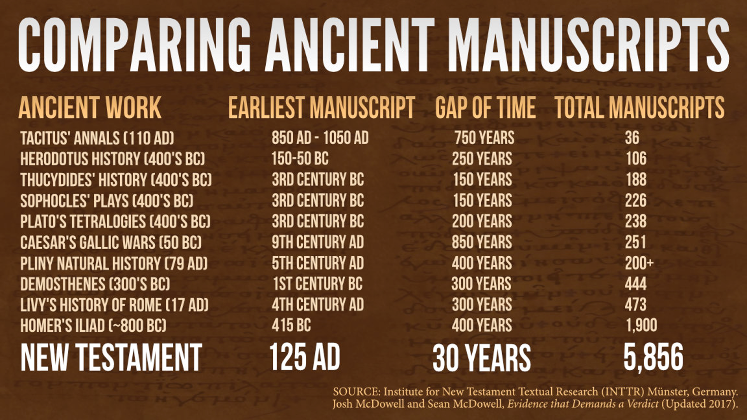

#2. The NT documents have far more citations

#3. NT documents have a wide geographical distribution

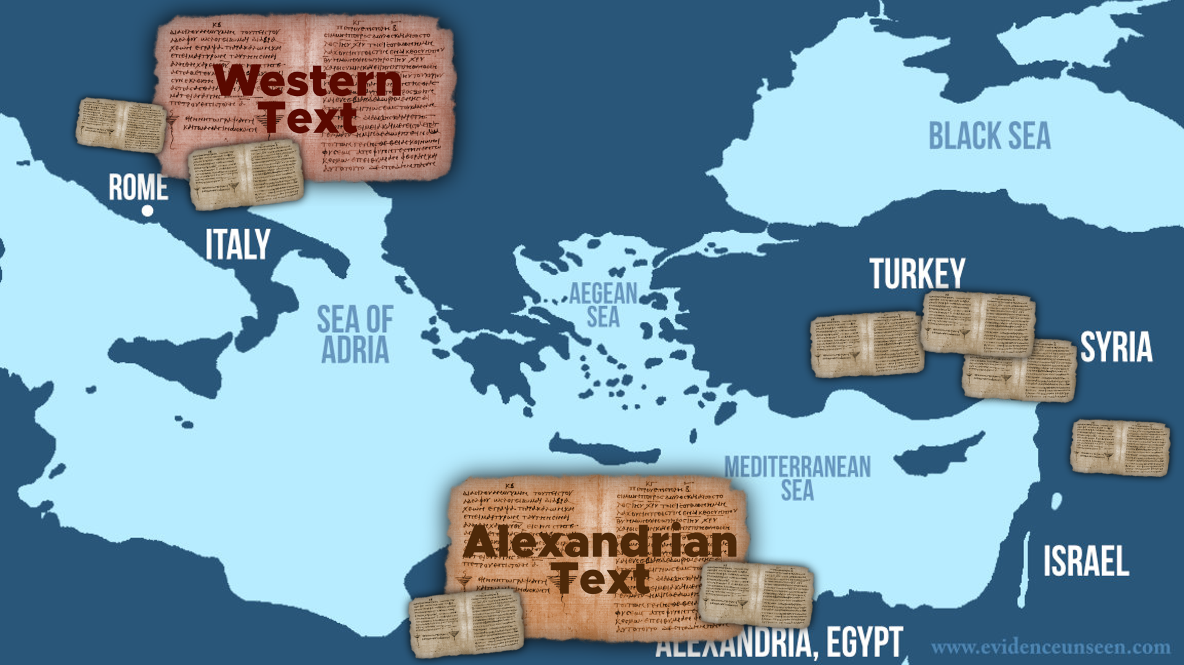

Conclusion

What about the 400,000 variants in the NT?
(1)

(2)

(3)

(4)

Clear Communication

Discussion Questions
(1) Define is textual criticism.
(2) How can a study of textual criticism enhance our appreciation of the Bible?
(3) How should textual criticism influence our approach to reading and interpreting the Bible today?
(4) What are some examples of textual variants in the New Testament? How have they been addressed by scholars to maintain the integrity of the biblical message?
(5) How do textual variants (differences among manuscripts) impact our understanding of biblical texts, and what is the significance of these variants for the overall message of the Bible?

Scripture Memorization
(Rom. 15:4) Whatever was written in earlier times was written for our instruction, so that through perseverance and the encouragement of the Scriptures we might have hope.

Homework
Answer these questions below, offering 2-3 possible reasons. Be prepared to discuss your thoughts next week:
(1) Why didn’t God choose to preserve the original manuscripts? What are some possible reasons that he preferred to give many copies with small errors, rather than the original manuscript?

(2) Why didn’t God choose to give us perfectly preserved copies of the original manuscripts? What are some possible reasons that he preferred to give many copies with small errors, rather than one perfect copy?

Week 4: The Gospels and Archaeology



Geography

Topography

Cities

Sea of Galilee Boat

The Pool of Bethesda (John 5:2)

The Pool of Siloam (John 9:7)

Tal Ilan: (Israeli scholar of Onomastics)

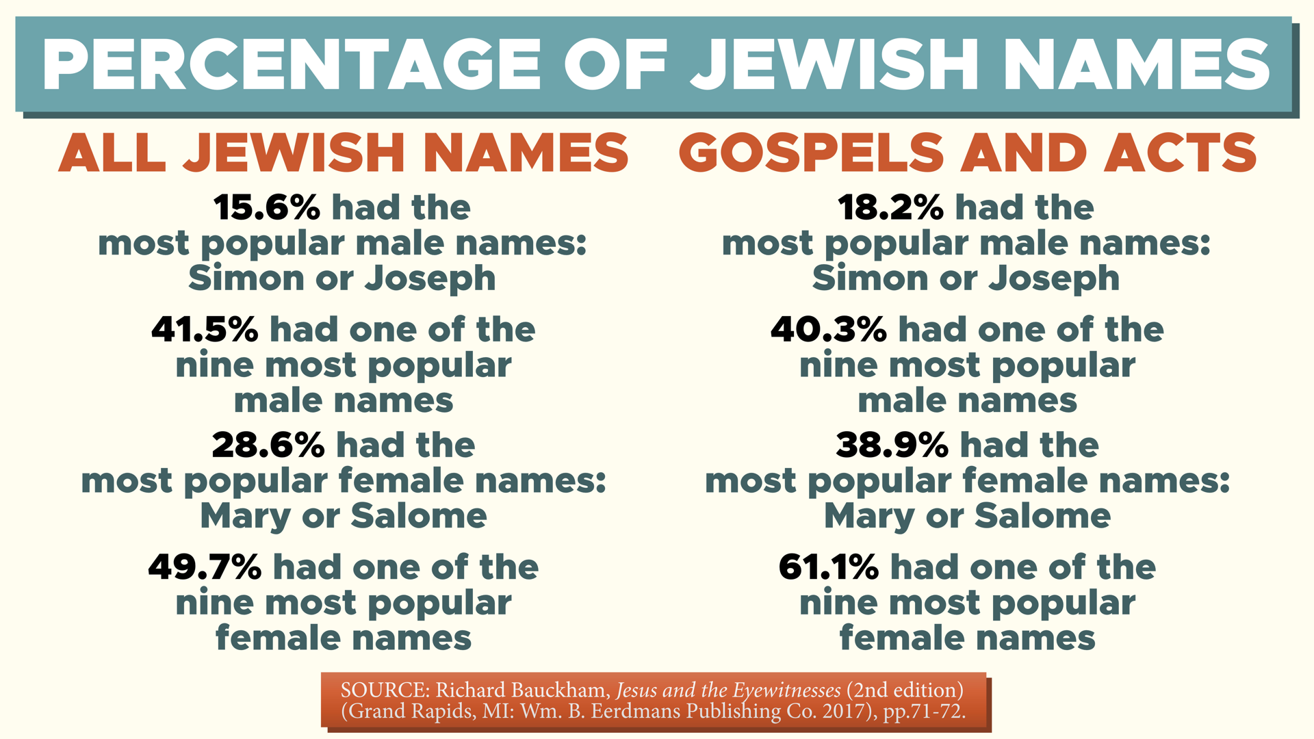

Famous People

Herod the Great
King of Judea (72-4 BC)

Archelaus
Ethnarch of Judea (23 BC-AD 18)

Herod Antipas
Tetrarch of Judea (20 BC-AD 39)

Pontius Pilate
Governor of Judea from AD 26-36

Caiaphas
High priest in Israel 14 BC-AD 46

James
Half brother of Jesus (died AD 62)

Life, death, and Resurrection of Jesus
Crucifixion
Yehohanan ben Hagkol (First century AD)

Reaction to a Crucified Messiah
“Alexamenos Graffito” dates between AD 90 and 200
Paedagogium on the Palatine Hill

The Resurrection?
“Nazareth Inscription” (AD 41-54) under Claudius.

What does archaeology confirm about the NT?

Discussion Questions
(1) Is it possible to overstate or exaggerate the evidence from biblical archaeology? How should we nuance our use of this subject when talking to others?
(2) How does biblical archaeology contribute to our understanding of the historical and cultural context of the Bible?
(3) Name some key archaeological discoveries that have had a significant impact on our understanding of biblical events or figures.

Scripture Memorization
(Prov. 30:5-6) Every word of God proves true. He is a shield to all who come to him for protection. ⁶ Do not add to his words, or he may rebuke you and expose you as a liar.

Homework
Answer these questions below. Be prepared to discuss your thoughts next week:
(1) How does archaeology help support the biblical record?

(2) What are the limits of using archaeology in supporting the historical reliability of the Bible? In other words, in what ways should we be careful not to exaggerate this sort of evidence?

Week 5: Jesus Outside the New Testament

Cornelius Tacitus
Annals, 15:44 (AD 55-117)
“Consequently, to get rid of the report, Nero fastened the guilt and inflicted the most exquisite tortures on a class hated for their abominations, called Christians by the populace.”
“Christus, from whom the name had its origin, suffered the extreme penalty during the reign of Tiberius at the hands of one of our procurators, Pontius Pilatus.”
“A most mischievous superstition, thus checked for the moment, again broke out not only in Judea, the first source of the evil, but even in Rome, where all things hideous and shameful from every part of the world find their centre and become popular.”
“Accordingly, an arrest was first made of all who pleaded guilty; then, upon their information, an immense multitude was convicted, not so much of the crime of firing the city as of hatred against mankind.”
“Mockery of every sort was added to their deaths. Covered with the skins of beasts, they were torn by dogs and perished, or were nailed to crosses, or were doomed to the flames and burnt, to serve as a nightly illumination when daylight had expired.”
“Nero offered his gardens for the spectacle, and was exhibiting a show in the circus while he mingled with the people in the dress of a charioteer or stood aloft on a car.”
“Hence, even for criminals who deserved extreme and exemplary punishment, there arose a feeling of compassion. For it was not, as it seemed, for the public good but rather to glut the cruelty of one man that they were being destroyed.”

Gaius Suetonius Tranquillas
Life of Claudius, 25:4 (AD 69-122)
“Because the Jews at Rome caused continuous disturbances at the instigation of Chrestus, he [Emperor Claudius] expelled them from the city.”

Lucian of Samosata
The Death of Peregrinus, 11-13 (AD 165)
“The Christians, you know, worship a man to this day—the distinguished personage who introduced their novel rites, and was crucified on that account…”
“You see, these misguided creatures start with the general conviction that they are immortal for all time, which explains the contempt of death and voluntary self-devotion which are so common among them.”
“And then it was impressed on them by their original lawgiver that they are all brothers, from the moment that they are converted, and deny the gods of Greece, and worship the crucified sage, and live after his laws.”
“All this they take quite on faith, with the result that they despise all worldly goods alike, regarding them merely as common property.”

Flavius Josephus
Antiquities of the Jews, 20:197-203 (AD 37-100)
“The judges of the Sanhedrin… brought before them a man named James, the brother of Jesus who was called the Christ, and certain others.”

Antiquities of the Jews, 18:63-64 (AD 37-100)
“At this time there was a wise man who was called Jesus. His conduct was good and (he) was known to be virtuous. Many people from among the Jews and the other nations became his disciples. Pilate condemned him to be crucified and to die.”
“Those who had become his disciples did not abandon his discipleship. They reported that he had appeared to them three days after his crucifixion, and that he was alive; accordingly he was perhaps the Messiah, concerning whom the prophets have recounted wonders.”

Summary of the Data

Discussion Questions
(1) How do the writings of non-Christian authors contribute to the historical evidence for the New Testament?
(2) What are ways that we could overstate or exaggerate this evidence?
(3) In your opinion, which non-Christian author offers the best support for the historicity of the Bible? Which offers the least support?

Scripture Memorization
(Acts 1:8) Jesus said, “You will receive power when the Holy Spirit comes upon you. And you will be my witnesses, telling people about me everywhere—in Jerusalem, throughout Judea, in Samaria, and to the ends of the earth.”

Homework
Answer these questions below. Be prepared to discuss your thoughts next week:
(1) Why don’t Jewish sources mention Jesus more?

(2) Why don’t Roman sources mention Jesus more?

Study Guide
Name reasons why the gospels were written by Matthew, Mark, Luke, and John:
(1) Why invent Mark and Luke?
(2) Why don’t we have any contrary manuscripts?
(3) Why do early authors all agree on the authorship—even though they were hundreds of miles away?
(4) How could they use these gospels for 100 years without names or titles?
Name reasons why the book of Acts dates before AD 62: There is no mention of these five major events:
(1) No mention of the Jewish War and Temple (AD 66-70).
(2) No mention of Nero’s persecution of Christians (AD 64).
(3) No mention of major martyrdoms.
(4) No mention of theological disputes that related to the Temple.
How many manuscripts do we possess of Tacitus? 36 manuscripts.
How many manuscripts do we possess of the New Testament? 5,856 manuscripts.
What is the earliest New Testament manuscript? The John Rylands Fragment dates to AD 125 (John 18:31-33, 37-38).
What percentage of the New Testament is in dispute by textual scholars? One percent. And no core doctrines are affected.
What percentage of textual variants are spelling errors? 70 percent.
What do we know about the Pool of Bethesda? The pool is mentioned in John 5, and all five porticoes were found.
What biblical figures do we know from archaeology?
Herod the Great: King of Judea (72-4 BC)
Archelaus: Ethnarch of Judea (23 BC-AD 18)
Herod Antipas: Tetrarch of Judea (20 BC-AD 39)
Pontius Pilate: Governor of Judea from AD 26-36
Caiaphas: High priest in Israel 14 BC-AD 46
James: Half brother of Jesus (died AD 62)
What is the Nazareth Inscription? It was a decree from Emperor Claudius (AD 41-54) that increased grave robbery from a fine to capital punishment.
Which non-Christian authors mention Jesus? Tacitus, Suetonius, Josephus, Lucian of Samosata, and Pliny the Younger.

Memory Verses
(2 Pet. 1:16) We were not making up clever stories when we told you about the powerful coming of our Lord Jesus Christ. We saw his majestic splendor with our own eyes.
(Lk. 1:1-3) Many have undertaken to draw up an account of the things that have been fulfilled among us, ² just as they were handed down to us by those who from the first were eyewitnesses and servants of the word. ³ With this in mind, since I myself have carefully investigated everything from the beginning, I too decided to write an orderly account for you.
(Jn. 19:35) The man who saw it has given testimony, and his testimony is true. He knows that he tells the truth, and he testifies so that you also may believe.
(1 Jn. 1:1) We proclaim to you the one who existed from the beginning, whom we have heard and seen. We saw him with our own eyes and touched him with our own hands. He is the Word of life.
(Rom. 15:4) Whatever was written in earlier times was written for our instruction, so that through perseverance and the encouragement of the Scriptures we might have hope.
(Prov. 30:5-6) Every word of God proves true. He is a shield to all who come to him for protection. ⁶ Do not add to his words, or he may rebuke you and expose you as a liar.
(Acts 1:8) Jesus said, “You will receive power when the Holy Spirit comes upon you. And you will be my witnesses, telling people about me everywhere—in Jerusalem, throughout Judea, in Samaria, and to the ends of the earth.”

Bart D. Ehrman, How Jesus Became God: The Exaltation of a Jewish Preacher from Galilee (San Francisco: HarperOne, 2014), p.90.
Bart Ehrman, The New Testament: A Historical Introduction to the Early Christian Writings, 5th ed. (New York: Oxford University Press, 2012), pp. 72-74.
Every NT letter mentions false teaching with the exception of 1 Thessalonians, Philemon, James, and 1 Peter (Rom. 16:17-18; 1 Cor. 15:12; 2 Cor. 2:17; 11:13-15; Gal. 1:6-9; 5:10-12; Eph. 4:14; Phil. 3:2; Col. 2:16-23; 2 Thess. 2:1-2; 1 Tim. 1:3ff.; 4:1-5; 6:3-5; 2 Tim. 3:1-8; Titus 1:10-16; 3:9-11; Heb. 13:9; 2 Pet. 2:1-22; 1 Jn. 2:18-26; 4:1-6; 2 Jn. 1:7-9; 3 Jn. 1:9-10; Jude 1:4ff.; cf. Rev. 2:2, 15, 20).
Kenneth Bailey was a former missionary to Bedouins and a research professor of Middle Eastern NT studies.
K. E. Bailey, “Informal Controlled Oral Tradition and the Synoptic Gospels,” Themelios 20.2 (January 1995), pp.4-11.
Bailey was a missionary to the Bedouin people, and he discovered that this community could “create (over the centuries) and sustain in current usage up to 6,000 wisdom sayings.” K. E. Bailey, “Informal Controlled Oral Tradition and the Synoptic Gospels,” Themelios 20.2 (January 1995), p.8.
Those who memorize the Qur’an are called a Hafiz (meaning “guardian” or “memorizer”). The Qur’an is roughly two-thirds the size of the New Testament, so this is quite a feat of memorization.
Josephus, Jewish War, 6.5.271-73; 6.9.420; 7.5.118; 7.5.138; 7.5.154.
Tacitus, Annals, 15.44. Luke recorded other persecutions (Acts 8:1; 11:19).
Lydia McGrew, Hidden in Plain View: Undesigned Coincidences in the Gospels and Acts (Chillicothe, OH: DeWard Publishing Co., 2017), Kindle Location 1552.
Lydia McGrew, Hidden in Plain View: Undesigned Coincidences in the Gospels and Acts (Chillicothe, OH: DeWard Publishing Co., 2017), Kindle Locations 880-885.

