Chapters taken from James Rochford, Endless Hope or Hopeless End: The Bible and the End of Human History (New Paradigm Publishing, 2016)

Chapter 7. Revelation: Hindsight or Foresight?
Most Christians assume that the book of Revelation describes the distant future when it refers to Jesus’ climactic return. But what if we’re wrong? What if we’re taking an entirely misguided approach? Some theologians believe that most of the NT’s predictions of Jesus’ return don’t describe the future; instead, these predictions were largely fulfilled in the past.
Theologians call this perspective Preterism. The preterite in English is the past tense of a verb, and the Latin term praeteritus means “gone by” or “past.” Thus Preterism holds that most of the book of Revelation has already been fulfilled. Preterist David Chilton explains, “The great majority of the Revelation is history: It has already happened… The Book of Revelation is not about the Second Coming of Christ. It is about the destruction of Israel and Christ’s victory over His enemies.” Therefore, instead of looking in the newspaper headlines for the fulfillment of the book of Revelation, Preterism looks in history books to discover their fulfillment.
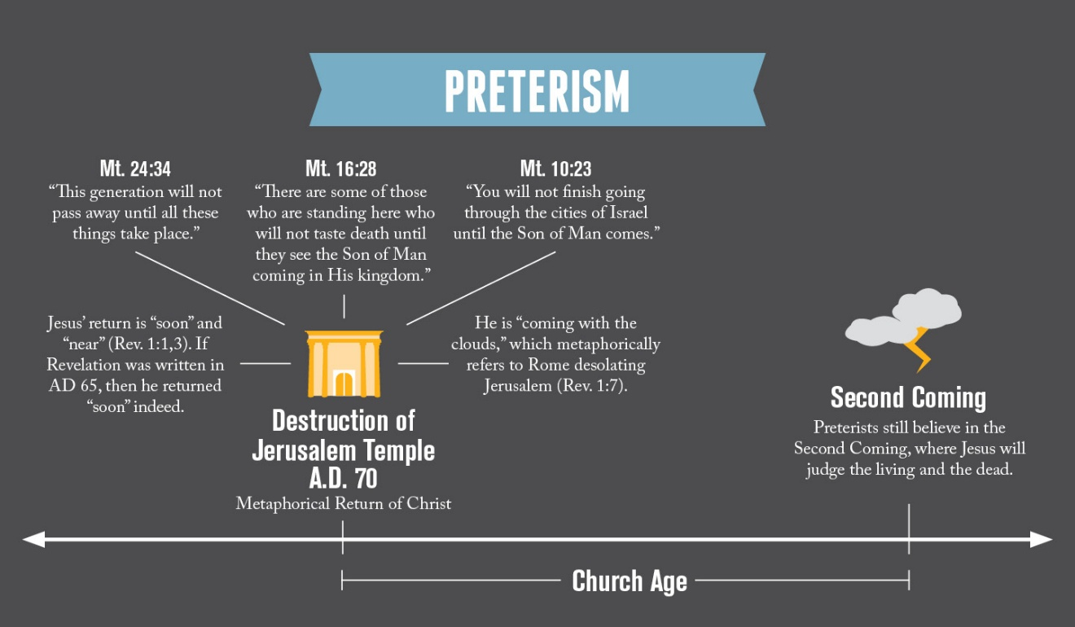

Hyper Preterism goes further, teaching that the Bible has absolutely nothing to say about the Second Coming of Christ or the end of history:

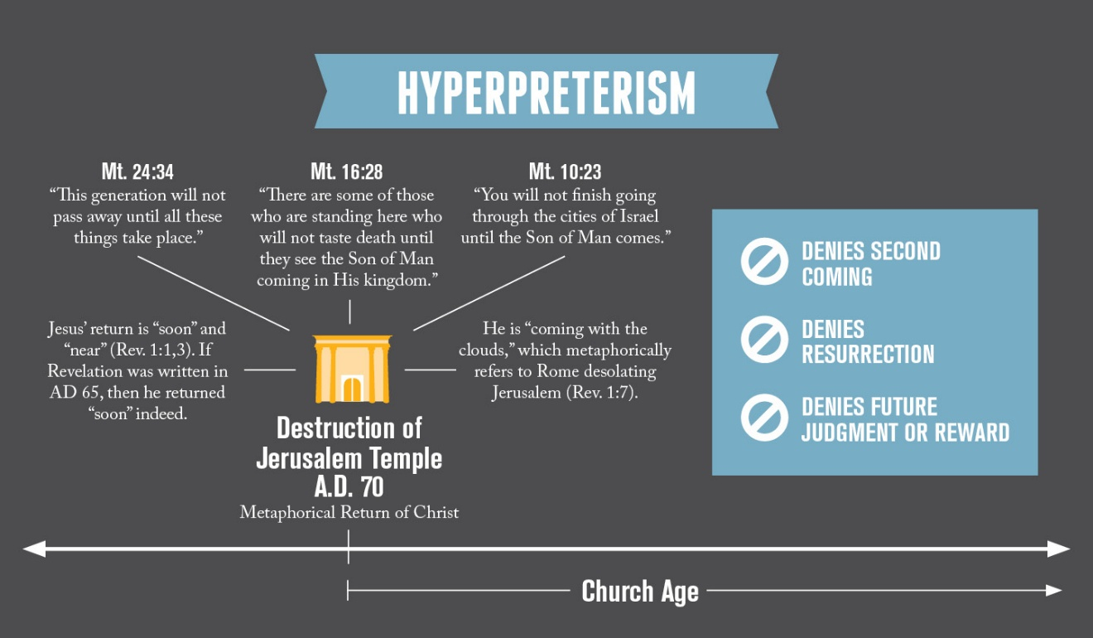

Of course, this view stands entirely at odds with core Christian teaching. Paul writes about false teachers like this “who have gone astray from the truth saying that the resurrection has already taken place, and they upset the faith of some” (2 Tim. 2:18). He calls this perspective “ungodliness” and “gangrene” in the Christian community (2 Tim. 2:16-17). Surely Hyper Preterism stands outside of classical Christian teaching, denying the return of Christ and the resurrection of the dead.
Others, however, hold to a more moderate form of Preterism. They believe that the book of Revelation generally describes the destruction of Jerusalem in AD 70, and yet, they still affirm Jesus’ return at the end of human history as well as the future resurrection of the dead.
Theologians call this Moderate or Partial Preterism, although adherents of this view often dislike this title, preferring to call their view simply “Preterism.” Thus when we refer to Preterism in this book, we are assuming this Moderate or Partial Preterism, rather than Hyper Preterism. To repeat, Preterism affirms the Second Coming of Christ and the general resurrection of the dead at the end of history—yet it believes that many passages in the NT do not refer to this event, but rather refer to a metaphorical coming of Christ in AD 70.

Futurism or Preterism?
Other interpreters (like myself) hold to Futurism, rather than Preterism, when interpreting the NT predictions about the future. As the term suggests, Futurists believe that the majority of prophecies describe the future—namely, the end of human history. Compare these views side by side:

Futurism versus Preterism
Subject | Futurism | Preterism
Antichrist, Beast, Man of Lawlessness | Future World Tyrant: Persecutes Christians (2 Thess. 2:3; 1 Jn. 2:18; Rev. 13:1) | Emperor Nero (AD 54-68): Persecuted Christians  (1 Jn. 2:18; Rev. 13:1)
The Temple | Third Temple: Will be built and then destroyed in the future (2 Thess. 2:4; Rev. 11:1-2; Mt. 24:15) | Second Temple: Destroyed in AD 70 (2 Thess. 2:4; Rev. 11:1-2; Mt. 24:15)
Apostasy: Falling away from Christ | Occurs throughout history but especially before Jesus returns (2 Thess. 2:3) | Occurred before destruction of the Temple (2 Thess. 2:3)
Tribulation | Tribulation occurs throughout the Church Age (Jn. 16:33; Acts 14:22; Rev. 1:9)  Yet “the tribulation” occurs at the end of history for a seven year period (Dan. 9:27; Mt. 24:21; Rev. 11:2-3; 12:6; 13:5) | Tribulation occurs throughout the Church Age (Jn. 16:33; Acts 14:22; Rev. 1:9)  Yet “the tribulation” occurred during the destruction of Jerusalem for a seven year period (Dan. 9:27; Mt. 24:21; Rev. 11:2-3; 12:6; 13:5)
The “coming” of Christ | Occurs at the end of history, when Jesus returns to judge humanity (Mt. 24:3, 27, 30) | Occurred in AD 70 when Jesus metaphorically destroyed the Temple through the Roman army (Mt. 24:3, 27, 30). Jesus will also return at the end of history
Appearing on the clouds? | Jesus will return just as he left—on the clouds (Acts 1:9-11) | In the OT God often delivered judgment in a symbolic way through “clouds” (Ps. 104:3; Isa. 19:1)
Appearing like lightning? | Jesus will appear physically and bodily in a climactic way (Mt. 24:27) | In the OT, God came metaphorically to judge nations with “lightning” (Ex. 19:16; 20:18; Job 36:30; Ezek. 21:15, 28; Zech. 9:14). Jesus returned in AD 70 through the Roman armies

Which view makes the most sense of the book of Revelation? Many lines of evidence support Futurism. That is, the book of Revelation describes the future of human history—not the past.

The Book of Revelation does not predate AD 70
The book of Revelation claims to be a book of “prophecy” about events in the future (Rev. 1:3; 22:7, 19). Therefore, in order for this book to be prophetic to the Preterist, it would need to be written before the destruction of Jerusalem in AD 70. If the book wasn’t written before this time, then it would be a book of history—not prophecy. Thus if Revelation dates after AD 70, then Preterism is simply false. Preterist Ken Gentry admits this key fact:
If the late-date of around A.D. 95-96 is accepted, a wholly different situation would prevail. The events in the mid to late 60s of the first century would be absolutely excluded as possible fulfillments. The prophecies within Revelation would be opened to an abundance of speculative scenarios, which could be extrapolated into the indefinite future. Revelation might… focus exclusively on the end of history, which would begin approaching thousands of years after John’s time, either before, after, or during the tribulation or the millennium. The purpose of Revelation would then be to show early Christians that things will get worse, that history will be a time of constant and increased suffering for the Church.
Likewise, Preterist R.C. Sproul writes,
If the book was written after A.D. 70, then its contents manifestly do not refer to events surrounding the fall of Jerusalem—unless the book is a wholesale fraud, having been composed after the predicted events had already occurred… The burden for Preterists then is to demonstrate that Revelation was written before A.D. 70.
On the other hand, if a person believes that the book of Revelation predicts the end of human history, it wouldn’t matter when it was dated. For instance, Futurist Zane Hodges holds to the early date of Revelation, but this doesn’t affect his Futurist interpretation of Revelation at all. The dating of Revelation is inconsequential for the Futurist interpreter, but it is essential for the Preterist.
Surprisingly, many Preterists do not address this key issue. For instance, in his 700-page commentary on Revelation, Preterist David Chilton only spends three and a half pages securing the early date for the book (whereas he spends nine pages interpreting the “666” of Revelation 13:18).

Dating the book of Revelation: AD 65 or 95?
When should we date the book of Revelation? Tremendous evidence supports a late dating of AD 95 under the Roman Emperor Domitian, rather than AD 65 under the Roman Emperor Nero:
First, the early theologians of the Church held to the late date—not the early date. Irenaeus (AD 180) states that John wrote “at the end of the reign of Domitian.” Irenaeus was the disciple of Polycarp (who was the disciple of John, the author of Revelation). Irenaeus also lived in Smyrna where the book of Revelation circulated. In his book Against Heresies (5:30), Irenaeus devotes an entire chapter to the number of the beast (Rev. 13:18), so the context clearly speaks of the end of history. Since Domitian died in AD 96, this would date the book of Revelation around AD 95.
Preterists argue that Irenaeus isn’t a reliable authority, because he also claimed Jesus was 40 when he died. If Irenaeus could be wrong about this, why would we trust him in the dating of Revelation? Gentry writes that this example “should demonstrate clearly that he could (he did at least once!) err on matters of historical detail—even when he claimed the authority of eyewitness accounts.”
However, Irenaeus primarily based this conclusion on a misinterpretation of John 8:57 (“You are not yet fifty years old”). In other words, this was an interpretive error—not a historical one. What student of Scripture cannot be guilty of interpreting the Bible erroneously from time to time?
Besides this error regarding Jesus’ age, Irenaeus typically offers very reliable historical testimony. Even early date advocates will speak of Irenaeus’ other historical testimony as typically “clear and weighty.” Moreover, in one breath, Preterist Hank Hanegraaff will appeal to the historical reliability of Irenaeus when supporting the historicity of the NT documents, but will repeal his trust in Irenaeus’ reliability when dating the book of Revelation. This sort of inconsistency could make your head spin!
In addition to Irenaeus, Victorinus (AD 304) wrote the earliest known commentary on Revelation, and he held to the late date, as did the church historian Eusebius (AD 260-340). Gentry argues that these sources don’t add up as separate witnesses, but merely repeat the first witness: Irenaeus. Yet, Gentry shoots himself in the foot when he also notes that the “church fathers did not accept necessarily Irenaeus’s authority as conclusive” in other areas. Gentry goes on to note that Eusebius didn’t believe Irenaeus in two key areas: (1) Papias meeting John and (2) the apostle John’s authorship of Revelation. He can’t have it both ways.
In contrast to the evidence for the late date, the early date isn’t affirmed until centuries later. Theologian Mark Hitchcock writes, “The first clear, accepted, unambiguous witness to the Neronic date is a one-line superscription in two Syriac versions of the New Testament in the sixth and seventh centuries.”
Second, if the early date is true, then John and Paul would have both served in Ephesus at the same time. At the end of 2 Timothy, Paul references 17 coworkers by name, but he never mentions the apostle John. Why wouldn’t Paul tell the struggling and timid Timothy to get help from such a powerful Christian leader like John? Likewise, Jesus names several leaders in his letters to the seven churches of Revelation 2 and 3, but he never mentions Paul or Timothy when he speaks to the church of Ephesus (Rev. 2:1-7). This would be similar to writing a letter to the White House about American politics without mentioning the President. Of course, these are arguments from silence, but they are conspicuous silences. We would expect to read about these key Christians leaders if they were leading alongside one another.
Third, the late date makes sense of the church of Smyrna. Polycarp (AD 110) states that Smyrnaeans weren’t believers during the time of Paul. Jesus, however, speaks to an established church in Revelation 2:8-11, dating the book sometime after Paul’s death (AD 67).
Fourth, the late date makes sense of John’s banishment to Patmos (Rev. 1:9). Clement tells us that John came back from Patmos (due to a banishing?) after “the death of the tyrant.” If the early date for Revelation is true (AD 65), then why didn’t Nero simply execute John, as he did with Peter and Paul? By contrast, the Roman emperor Domitian was far more likely to banish John, as he did with Flavia Domitilla in AD 95 to the island of Pandeteria. Blomberg writes, “John’s brief exile on the island of Patmos (1:9) fits the mid-90s well, whereas there is no evidence of Christians being banished from their homelands by the government prior to this date.”

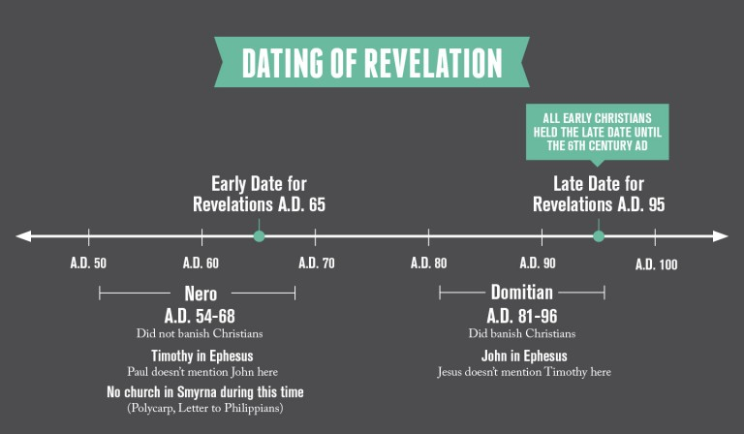

The early Christian theologians and leaders didn’t hold to Preterism
Remember, under the Preterist view, Christians in the first century would have been keenly aware that the predictions in the book of Revelation had already been fulfilled at the destruction of Jerusalem in AD 70. Yet the early Christians didn’t interpret Revelation in this way. They believed it referred to the end of human history—not the destruction of Jerusalem. Theologian Alan Johnson writes, “[Preterism] did not appear till 1614, when a Spanish Jesuit named Alcasar developed its main lines.”
The Didache (an early 2nd century document) holds that Jesus’ teaching about the future called the Olivet Discourse (Mt. 24; Mk. 13; Lk. 21) is about “the last days.” It claims that the “false prophets” and the “world deceiver” (i.e. the Antichrist) haven’t appeared. It also states, “Then shall appear the signs of the truth… the resurrection of the dead—yet not of all, but as it is said: ‘The Lord shall come and all His saints with Him.’ Then shall the world see the Lord coming upon the clouds of heaven.”
Papias (AD 60-130) was one of John’s disciples (the author of Revelation). He writes, “There will be a millennium after the resurrection of the dead, when the kingdom of Christ will be set up in material form on this earth.”
The Epistle of Barnabas (2nd century) interprets the Temple of Daniel 9:27 as being fulfilled spiritually in the Church, while the Preterist view holds that Daniel 9:27 refers to the destruction of the Temple in Jerusalem. The epistle states, “Ten kingdoms will reign over the earth, and after a little king will arise, who will subdue three of the kings with a single blow.”
The Shepherd of Hermas (an early 2nd century document) speaks of the Tribulation as a future event—not a past event: “Happy is he who endures the great tribulation that is coming.”
Justin Martyr (AD 150) writes, “He shall come from heaven with glory, when the man of apostasy, who speaks strange things against the Most High, shall venture to do unlawful deeds on the earth against us the Christians… the rest of the prophecy shall be fulfilled at His Second Coming.” Elsewhere he writes, “But I and others, who are right-minded Christians on all points, are assured that there will be a resurrection of the dead, and a thousand years in Jerusalem, which will then be built, adorned, and enlarged, as the prophets Ezekiel and Isaiah and others declare.”
Irenaeus (AD 180) interpreted the events in Daniel 9:27 and 2 Thessalonians 2:3-5 in the future tense—not the past. He writes that the kingdom of Daniel 2 will be split up into ten parts, and then wait for the Antichrist to appear. While Preterists believe that Emperor Nero was the Antichrist, Irenaeus states that the Antichrist has not appeared, writing, “It is therefore more certain, and less hazardous, to await the fulfillment of the prophecy.” He claims that we cannot know who the Antichrist is: “We will not, however, incur the risk of pronouncing positively as to the name of Antichrist; for if it were necessary that his name should be distinctly revealed in this present time, it would have been announced by him who beheld the apocalyptic vision.”
Irenaeus believed in a future Temple in Jerusalem, and he claimed that the Antichrist will reign “for three years and six months, and sit in the temple at Jerusalem.” Irenaeus referred to the “first resurrection” (Rev. 20:6) as being fulfilled at the end of human history. He writes, “All these and other words were unquestionably spoken in reference to the resurrection of the just, which takes place after the coming of Antichrist.” Crutchfield notes, “As a resident teacher in Ephesus in his declining years, John must be reckoned the cause of the uncommon fertility of millenarianism [a future thousand year reign of Christ] in Asia Minor. His views were championed by his immediate disciples Polycarp and Papias, who in turn influenced the eschatological views of other Church leaders until the Council of Nicea.”
Commodianus (AD 250) wrote that some will be “living again in the world for a thousand years” and “they, who make God of no account when the thousandth year is finished, shall perish by fire.”
Lactanius (AD 300) wrote that Christ “will Himself reign with them on the earth, and will build the holy city, and this kingdom of the righteous shall be for a thousand years.”
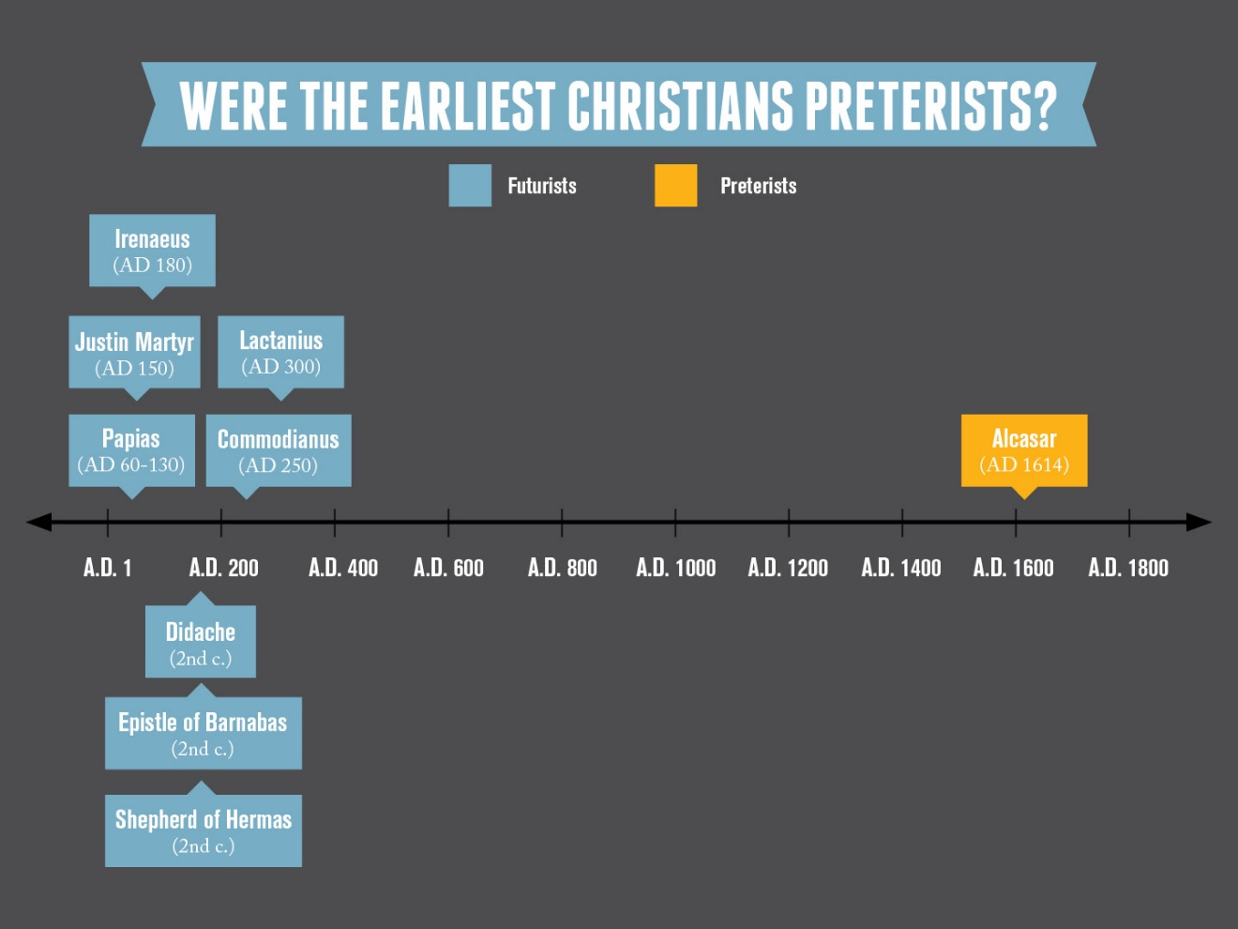
Surely, all of these early Christian leaders and theologians could be wrong. But here is the central question that confronts the Preterist interpreter: If Preterism was so clear to the original historical audience, why didn’t the earliest Christians adopt this view?

What about Jesus claiming that he’s coming “soon” and his return is “near” (Rev. 1:1, 3)?
If Jesus wouldn’t return for at least two millennia, why would Revelation state that the events “must soon take place” (Rev. 1:1) and are “near” (Rev. 1:3). Preterists argue that these terms should be taken at face value: Jesus did come “soon,” in AD 70 to destroy Jerusalem and the Temple.
However, these terms “soon” (tachos) and “near” (eggus) occur at the beginning of the book of Revelation, and also at the end (Rev. 22:6, 10). They form bookends (or what is called an inclusio) that makes the entire vision “soon” or “near.” Can we really believe that the entire book of Revelation has already been fulfilled—including Jesus’ Second Coming, the resurrection of the dead, and the New Heavens and Earth (Rev. 19-22)? Gentry consistently interprets Revelation in exactly this way. He sees Revelation 21 as a picture of “the gospel era, the church age… because of her heavenly source, divine blessing, redemptive promises, and future glory.” Thus we experience no more tears, death, mourning, crying, or pain “in principle” according to Gentry.
Futurists reject such a bizarre interpretation. Instead, the term “soon” comes from the Greek tachos which is where we get our term tachometer (a device that measures the RPM’s of car engines). This Greek word can also be rendered as “quickly” (Lk. 18:8; Acts 12:7). In other words, when the first domino falls, the rest will fall quickly after them. Benware writes, “These words are not to be understood as chronological indicators telling the reader when the Lord is returning. Rather, they are to be taken as qualitative indicators describing how the Lord Jesus will return. He will return ‘suddenly.’” Moreover, since God views time differently as an eternal being, these terms (“soon” and “near”) could be relative to God’s perspective of time. In the context of writing about the delay of Jesus’ return, Peter writes, “With the Lord one day is like a thousand years, and a thousand years like one day” (2 Pet. 3:8; cf. Ps. 90:4).

What about Jesus appearing to “those who pierced him” (Rev. 1:7)?
At the beginning of Revelation, John writes, “[Jesus] is coming with the clouds, and every eye will see Him, even those who pierced Him; and all the tribes of the earth will mourn over Him” (Rev. 1:7). Gentry writes, “John’s reference to Christ’s piercing demands a first-century focus if the theme is to be relevant and true, for those who pierced him are now long since deceased.” Of course, Preterists acknowledge that Jesus never appeared literally on the clouds in AD 70, but they argue that the OT uses this language of “coming on the clouds” to symbolically refer to God’s divine judgment (Isa. 19:1; Ps. 18:7-15; 104:3; Joel 2:1-2; Mic. 1:3-4). Thus this passage refers to all of the first century Jews “seeing Christ” when he invisibly judged Jerusalem. Moreover, when he writes that Jesus would appear to “all the tribes of the earth,” Preterists hold that this should not be translated earth, but land instead.
However, this interpretation has serious problems. Just two verses earlier, John refers to Jesus as “the ruler of the kings of the earth (Greek ge)” (Rev. 1:5). John definitely uses this word to refer to the entire globe—not just Israel. In Revelation 3:10, he equates “those who dwell on the earth” with “the whole world.” While “earth” (ge) can be translated as “land,” there is no justification for that rendering in this context—especially when the rest of the book of Revelation is global in scope (Rev. 3:10; 6:10; 8:13; 11:10; 13:8, 12, 14; 14:6; 15:4; 17:2, 8). Interestingly, Chilton interprets Revelation 1:5 (“the kings of the earth”) as referring to the entire globe, but interprets Revelation 1:7 (“all the tribes of the earth”) to refer only to Israel.
Furthermore, in Revelation 1:7, John quotes from Zechariah 12:10 (“every eye will see Him, even those who pierced Him; and all the tribes of the earth will mourn over Him”). Preterists interpret this passage to refer to Jesus’ destruction of Jerusalem, but in context, Zechariah predicts the protection of Israel from the pagan nations. Zechariah 12:9 states, “I will set about to destroy all the nations that come against Jerusalem.” Thus the Preterist interpretation directly contradicts Zechariah’s prediction.
John claims that Jesus’ return will be a visible event. He writes that “every eye will see Him” (Rev. 1:7), which matches Jesus’ statement in Matthew 24:27 (“Just as the lightning comes from the east and flashes even to the west, so will the coming of the Son of Man be”). The angels even told the disciples that Jesus would return in the same way that he left Earth: “Jesus, who has been taken up from you into heaven, will come in just the same way as you have watched Him go into heaven” (Acts 1:11). Since Jesus left visibly into the clouds, we should expect him to return visibly from the clouds.
When John refers to “those who pierced him,” this probably refers to the Jewish people in general—not those first-century people in particular. Only a relatively few people literally pierced Jesus on the Cross by driving the nails into his hands and feet. So a non-literal interpretation is warranted. It’s interesting how Preterists take the time frame as literal, the city as literal, and the piercers as literal; but nothing else is taken literally.

Is the Temple of Revelation 11:2 the Temple of AD 70?
John writes of a Jewish temple in Jerusalem in Revelation 11:1-2. Because of this, Preterists argue that John must have been describing the Temple in Jerusalem in AD 70. Hanegraaff writes, “If the apostle John were indeed writing in AD 95, it seems incredible that he would make no mention whatsoever of the most apocalyptic event in Jewish history—the demolition of Jerusalem and the destruction of the temple at the hands of Titus.”
But this does not necessarily follow. Remember, when Daniel and Ezekiel wrote their books, the Jewish Temple lay in ruins. Yet both of these authors predicted a future temple (Ezek. 40-48; Dan. 9:24-27). Similarly, since John was writing “prophecy” (Rev. 1:3; 22:7, 19), we might very easily see him writing about a future temple as well. Moreover, since the seven (Gentile) churches of Revelation 2 and 3 existed several hundred miles from Jerusalem, he may have felt no need to write about the destruction of the Temple. While the destruction of Jerusalem in AD 70 was surely cataclysmic for Jerusalem Christians, these Gentile believers were far away from these events.

Doesn’t a Futurist interpretation deny first-century readers any understanding or application?
Preterists argue that a Futurist interpretation ignores the original context in which John was writing. In John’s day, Rome ruthlessly persecuted the Church, and these believers surely needed encouragement for their suffering. Thus if John was writing a book about the end of human history, wouldn’t this neglect the needs of his original audience? J. Stuart Russell writes, “If the book were meant to unveil the secrets of distant times, must it not of necessity have been unintelligible to its first readers—and not only unintelligible, but even irrelevant and useless?”
While this objection seems to carry some weight, we need to remember that Revelation does contain material for first-century churches. This is found in chapters 2 and 3. But once we reach chapter 4, John makes it clear that he is directing his focus to the future. Just as chapters 2 and 3 can impact us retrospectively, chapters 4 through 22 impact us prospectively—even if we don’t live during the time period in which these events take place.
Like the OT prophets before him, John wrote about events in the future, even as his audience was suffering in the present. For instance, as Israel suffered massive persecution, Jeremiah predicted a 70 year exile for a future generation (Jer. 25:11-12). While this did not exactly help Jeremiah’s current audience, Daniel lived a century later, and he took great comfort from this prediction (Dan. 9:2-3). Likewise, Isaiah predicted the coming of King Cyrus to a generation 150 years later (Isa. 45:1). Those who read their Bibles quickly discover that many prophecies did not impact the current audience in the slightest, but these predictions had ramifications for future generations. Even on the Preterist view, hundreds of predictions in the OT didn’t refer to Israel, but to the future Church.
Surely the people of John’s day didn’t understand everything in the book of Revelation, but why should we assume that they would? Even the prophets themselves didn’t always know the meaning of their own prophecies. Peter writes, “This salvation was something even the prophets wanted to know more about when they prophesied about this gracious salvation prepared for you. They wondered what time or situation the Spirit of Christ within them was talking about when he told them in advance about Christ’s suffering and his great glory afterward” (1 Pet. 1:10-11 NLT). Even the prophet Daniel explained that the content of his own prophecies brought him considerable confusion (Dan. 12:4, 9-10).

Conclusion
The Preterist interpretation of the book of Revelation fails on multiple fronts: (1) The book of Revelation is dated to AD 95—not AD 65; in order for Revelation to be a book of “prophecy” (Rev. 1:3), it cannot be describing past events in AD 70; (2) the earliest Christian theologians did not hold the Preterist view—even though they were closer to the events of the destruction of the Temple; and (3) the passages used to support a near fulfillment do not carry weight when considered closely. Since these predictions in the book of Revelation haven’t been fulfilled, we should expect them to occur toward the end of human history.

Chapter 8. Was Jesus a Preterist?
Jesus seems to have made several predictions about his Second Coming that needed to be fulfilled in the first century:
You will not finish going through the cities of Israel until the Son of Man comes. (Mt. 10:23)
There are some of those who are standing here who will not taste death until they see the Son of Man coming in His kingdom. (Mt. 16:28)
This generation will not pass away until all these things take place. (Mt. 24:34)
These predictions stumble skeptics. Jesus seems to be claiming that he would return during the lifetime of his disciples, but because he never returned, skeptics assume that Jesus made false predictions. Regarding Matthew 24:34, even C.S. Lewis wrote, “He was wrong. He clearly knew no more about the end of the world than anyone else. It is certainly the most embarrassing verse in the Bible.”
Preterism offers an intriguing answer to these difficulties: If Jesus believed that he would symbolically return to judge Jerusalem in AD 70, then all of these predictions were fulfilled. Thus Preterists argue that their view helps us in appealing to critics of Christianity. Is this the case?

The Olivet Discourse
After fiercely rebuking the hypocritical religious authorities (Mt. 23), Jesus predicted that God would destroy the Temple. As he left the Temple, he gave a private teaching to his disciples on the Mount of Olives, which is why theologians call this the “Olivet Discourse.” Preterists believe that Jesus fulfilled most of these predictions in AD 70, when he judged Jerusalem and the Temple via the armies of Rome. Matthew, Mark, and Luke all record Jesus’ Olivet Discourse, while John does not. Some interpreters believe that John omitted it, because he would later write his magnum opus—the book of Revelation.
Futurists believe that most of the Olivet Discourse relates to the end of history—not to the fall of Jerusalem in AD 70. At the same time, they agree that the first half of Luke’s account refers to the destruction of Jerusalem in AD 70, but after Luke 21:25, Jesus directs his predictions to the distant future. While Luke’s account and Matthew’s account are certainly similar to one another, they are not the same.

Comparing and Contrasting Matthew and Luke’s account
Luke 21 | Matthew 24
Many are misled (v.8) | Many are misled (v.4) by false Christs (v.5)
Rumors of wars (v.9) | Rumors of wars are “not yet the end” (v.6)
Wars (v.10) | Wars (v.7)
Plagues, famines, great signs from heaven (v.11) | Famines and earthquakes (v.7) called “birth pangs” (v.8)
Persecution in the synagogues (vv.12-16) | Persecution (v.9) and apostasy (v.10)
———————— | More false prophets (v.11)
———————— | Love will grow cold (v.12)
Divine protection for committed believers (vv.17-18) | Divine protection for committed believers (v.13)
Destruction of Jerusalem and the Temple (vv.20-24) | ————————
———————— | All nations hear the gospel “and then the end will come” (v.14)
———————— | Destruction of the Temple in Jerusalem (v.15)
Command to flee Jerusalem when Judea is surrounded (v.20) | Command to flee Judea after seeing the Abomination of Desolation (vv.16-20)
———————— | “A great tribulation such as has not occurred since the beginning of the world until now, nor ever will” (v.21)
———————— | “Unless those days had been cut short, no life would have been saved; but for the sake of the elect those days will be cut short” (v.22)
———————— | More false teaching predicting the Second Coming (vv.23-26)
Second Coming of Christ with signs in heaven (vv.25-27) | Second Coming of Christ with signs in heaven (vv.27-31)
Fig tree illustration (vv.29-31) | Fig tree illustration (vv.32-33)
“Truly I say to you, this generation will not pass away until all things take place” (v.32) | “Truly I say to you, this generation will not pass away until all these things take place” (v.34)
“Heaven and earth will pass away, but My words will not pass away” (v.33) | “Heaven and earth will pass away, but My words will not pass away” (v.35)

In their accounts of the Olivet Discourse, Luke emphasizes the destruction of the Temple in AD 70, but Matthew emphasizes the destruction of the Temple at the end of human history. Luke fails to mention three key components to Jesus’ sermon: (1) no human would’ve survived these days unless God cut them short, (2) this was the greatest tribulation the world had ever seen or will see, and (3) the abomination of desolation would occur—only mentioning “its desolation.”
These are significant omissions on Luke’s behalf. Darrell Bock comments, “What do these differences mean? They indicate that Luke emphasizes a different element in Jesus’ teaching at this point. He focuses on the nearer fulfillment in the judgment pattern described here, the fall of Jerusalem in AD 70, rather than the end (which he will introduce directly in 21:25).”
The destruction of the Temple in AD 70 serves as a type (or foreshadowing) for the future destruction at Jesus’ Second Coming. Since the Temple of AD 70 was destroyed in a literal way, the future Temple at the end of history will also be destroyed in the same way. Bock explains, “What happens to Jerusalem as AD 70 approaches will be like the real end, which brings the return. In these descriptions Jesus answers the disciples’ short-term question about the temple, but he also sets up a long-term discussion about the end. The two events mirror each other in their terror.” Similarly, predictions about Jerusalem’s first destruction by the Babylonians (6th century BC) are similar to her second destruction by the Romans (1st century AD). But these are not the same events. Instead, the fulfillment of the one offers confidence that the second will be fulfilled later in history.
Futurists see a gap somewhere in both accounts, but they aren’t the only ones. Even some Preterists like Kenneth Gentry see a gap in Matthew 24 between verses 34 and 36. In fact, Gentry believes that verse 36 refers to Jesus’ Second Coming at the end of human history. Thus for most interpreters, the question isn’t whether a gap exists in Jesus’ teaching, but where it occurs.

Critique of the Preterist view of the Olivet Discourse
As we read through the Olivet Discourse from a Preterist interpretation, we discover many major interpretive problems and inconsistencies:

Matthew 23:38-39
Behold, your house [the Temple] is being left to you desolate! ³⁹ For I say to you, from now on you will not see Me until you say, ‘Blessed is He who comes in the name of the Lord!’ (Mt. 23:38-39)
On a Preterist view, when did the unbelieving Jewish nation ever bless the return of Christ? This prediction makes little or no sense for Preterism, but fits nicely within the Futurist view. Theologian Stanley Toussaint writes, “Jews would hardly call the horrible decimation of life in the destruction of their capital city a blessed coming of the Messiah. Rather, verse 39 describes Israel’s future repentance when they will mourn because of their great sin (Zech. 12:10).” On a Futurist view, this event will occur toward the end of human history (Zech. 12; Rom. 11:25-29).
Interestingly, Gentry has nothing to say about Matthew 23:39. In his commentary on Revelation he skips this passage, jumping from Matthew 23:38 to 24:1. Other Preterists attempt to explain Jesus’ statement by arguing that the expression “until you say” is not a certainty in the future. Instead, this is an “indefinite possibility.” R.T. France writes, “There is no promise that the condition will be fulfilled.” To support this interpretation, Preterist Gary DeMar cites four passages that demonstrate how this Greek word may not refer to a certain fulfillment (Mt. 5:26; 18:30; 18:34; Acts 23:12).
While DeMar cites multiple passages to support his “indefinite possibility” reading, it’s more interesting to note the passages he does not cite. Matthew uses the word “until” (heos) in several other predictions in his gospel (cf. Mt. 5:18; 17:9; 26:29):
For truly I say to you, you will not finish going through the cities of Israel until the Son of Man comes. (Mt. 10:23)
Truly I say to you, there are some of those who are standing here who will not taste death until they see the Son of Man coming in His kingdom. (Mt. 16:28)
Truly I say to you, this generation will not pass away until all these things take place. (Mt. 24:34)
Do these passages look familiar? Preterists stake their view particularly on these three passages above. They claim that the preaching of the disciples (10:23), the coming of Christ (16:28), and the events of the destruction of Jerusalem (24:34) all needed to be fulfilled in the first century, during the lives of the disciples. But if Matthew’s use of the word “until” only refers to an “indefinite possibility,” then this would nullify the three most crucial passages that support the Preterist position!
Moreover, Jesus claims that the Jewish people need to say, “Blessed is He who comes in the name of the Lord!” (Mt. 23:39). DeMar holds that this refers to Jewish converts before AD 70. Thus these believing Jewish people could “bless” Christ’s symbolic coming in AD 70, because this would mean that Jesus had fulfilled his promise to judge the hypocrisy of the Temple. But just three chapters earlier, we see what Jesus meant by having the crowds shouting such a praise. When Jesus came into the city of Jerusalem in Matthew 21:9, the crowds literally sang Psalm 118:26 and Jesus literally and physically entered the Temple—not figuratively or symbolically as Preterists contend.

Matthew 24:1-3
Jesus came out from the temple and was going away when His disciples came up to point out the temple buildings to Him. ² And He said to them, ‘Do you not see all these things? Truly I say to you, not one stone here will be left upon another, which will not be torn down.’ ³ As He was sitting on the Mount of Olives, the disciples came to Him privately, saying, ‘Tell us, when will these things happen, and what will be the sign of Your coming, and of the end of the age?’ (Mt. 24:1-3)
As the disciples looked at the Temple, Jesus predicted “not one stone here will be left upon another, which will not be torn down” (v.2). Preterists and Futurists agree that this refers to the Temple in AD 70. Josephus recorded, “It was so thoroughly laid even with the ground by those that dug it up to the foundation, that there was left nothing to make those that came [near] believe it had ever been inhabited.” Thus the destruction of the Temple in AD 70 fulfilled Jesus’ prediction with precision.
The Jerusalem Temple stood as a massive monument to Israel’s religious life. Josephus writes that the stones were 40 feet long, 18 feet deep, and 12 feet tall. The Talmud records, “He who has not seen the Temple of Herod has not seen a beautiful thing.” Thus when Jesus predicted its destruction, this probably caused the disciples to think that Jesus was referring to the end of the world. Imagine if someone predicted that the Pentagon and White House would be burned to the ground. You’d probably assume that the world was ending!
But Preterists hold a different view: When Jesus referred to “the end of the age,” he wasn’t referring to the end of the world, but the end of the old covenant. These interpreters note that Paul used this expression (“the end of the age”) in the present tense: “[These things] were written for our instruction, upon whom the ends of the ages have come” (1 Cor. 10:11). Maybe Jesus’ prediction already came true in the destruction of the Temple?
While this interpretation might seem interesting, it doesn’t fit with Matthew’s use of the expression “the end of the age” (ounteleias). At the end of his gospel, Matthew writes that Jesus will be with the Church “until the end of the age” (Mt. 28:20; cf. Mt. 13:38-40; Lk. 20:35). Under a consistent Preterist view, this would mean that Jesus is no longer with us in fulfilling the Great Commission! Instead, his promise expired in the first century, and now, we’re on our own.

Matthew 24:14
This gospel of the kingdom shall be preached in the whole world as a testimony to all the nations, and then the end will come. (Mt. 24:14)
Jesus claimed that the gospel would reach all nations before his return. Clearly, this still hasn’t happened—even in our day. Yet Preterists claim that Jesus was using hyperbolic language, referring to the spread of the gospel in the Roman Empire—not the entire globe.
While the NT authors did use the Greek term oikoumene (“whole world”) to refer to the known world (Rom. 1:8; 10:18; 16:19; Col. 1:6, 23; Lk. 2:1), they also use it to describe the entire globe (Acts 17:31; Rom. 10:18; Rev. 12:9; Heb. 2:5). Thus the word can be understood either way. So was Jesus describing the whole world or just the known world?
The context makes this clear. Jesus says that the gospel will reach “all the nations” (ethnesin), and later in Matthew 28:19, he says, “Go… make disciples of all the nations” (ethnesin). Surely the Great Commission refers to the entire globe—not just the Roman Empire. Otherwise, we should fire the thousands of missionaries living in foreign countries today. Interestingly, DeMar neglects to connect Matthew’s use of the ethnesin (“all the nations”) with Matthew 28:19.

Matthew 24:15-16
When you see the abomination of desolation which was spoken of through Daniel the prophet, standing in the holy place (let the reader understand), ¹⁶ then those who are in Judea must flee to the mountains. (Mt. 24:15-16)
Preterists claim that this refers to the destruction of Jerusalem in AD 70. The Romans sieged Jerusalem for three years until they finally broke through the walls, killing the people and ravishing the city.
But a serious problem confronts this interpretation. Jesus tells the people to flee Judea after they see the abomination of desolation (i.e. the destruction of the Temple). Yet the Romans destroyed the Jewish Temple at the end of their three year siege—after all of the people were savagely murdered. Since this is the case, what use would it be to flee at this point? If anyone was still alive to see the destruction of the Temple, it would have only been after the wholesale slaughter of the city. This would be like telling the people of Hiroshima to flee the city when they see the mushroom cloud. It would’ve been too late to flee at this point. Everyone would’ve already been killed or sold into slavery at this time.

Matthew 24:21
There will be a great tribulation, such as has not occurred since the beginning of the world until now, nor ever will. (Mt. 24:21)
Josephus estimated that the Romans killed 1.1 million Jews in AD 70, and the descriptions of Jerusalem’s destruction horrify us to read. Yet this surely wasn’t the worst atrocity to ever occur on Earth (e.g. the Nazi Holocaust). To avoid this conclusion, DeMar argues that the language is “obviously proverbial and hyperbolic” and Jesus was only referring to Jerusalem—not the entire globe.
Yet DeMar’s interpretation cannot be held consistently, because he argued just a few verses earlier (v.14) that the entire world extends at least to the Roman Empire. If Jesus’ expression “from the beginning of the world” is hyperbolic, it’s odd to limit his expression simply to the city of Jerusalem in this passage.

Matthew 24:22
Unless those days had been cut short, no life would have been saved; but for the sake of the elect those days will be cut short. (Mt. 24:22)
Jesus says that “no life would have been saved” unless this period of history was cut short. DeMar interprets this to mean that “God also restrained the Romans from venting their anger completely.” Thus “all life” refers “to those living in Judea.”
Futurists note that the NT uses the expression (“all life”) ten times (Mt. 24:22; Mk. 13:20; Lk. 3:6; Jn. 17:2; Acts 2:17; Rom. 3:20; 1 Cor. 1:29; 15:39; Gal. 2:16; 1 Pet. 1:24), and “in every case except 1 Corinthians 15:39 the expression describes all humans. In that passage Paul was discussing the nature of the resurrection body: ‘All flesh is not the same flesh, but there is one flesh of men, and another flesh of beasts.’ Here he used the phrase in an even broader sense to designate all human and animal life.” Luke’s account is even stronger than Matthew’s. He writes, “It will come upon all those who dwell on the face of all the earth” (Lk. 21:35). This cannot merely refer to the destruction of the Temple in AD 70.

Matthew 24:27
Just as the lightning comes from the east and flashes even to the west, so will the coming of the Son of Man be. (Mt. 24:27)
DeMar argues that God often revealed his presence through “lightning” (Ex. 19:16; 20:18; Job 36:30; Ezek. 21:15, 28; Zech. 9:14), but this isn’t supposed to be interpreted literally. Moreover, he notes that even though “The LORD came from Sinai” (Deut. 33:2), this wasn’t a visible coming. He writes, “Was God physically present? He was not. Did He come? Most certainly!” He then cites Jesus coming to judge the churches of Ephesus (Rev. 2:5), Pergamum (2:16), and Sardis (3:3). He asks, “Were any of these comings the Second Coming?”
However, this interpretation seems to overlook a very important theological difference between God the Father and God the Son. God the Father is not a physical being (Jn. 4:24), but God the Son took on human flesh (Jn. 1:14). Jesus doesn’t say that God will come on the clouds; he says the Son of Man will come. The angels told the disciples that Jesus would return to Earth bodily in the same way that he left bodily (Acts 1:9-11). All of this presupposes a literal and visible return of Christ—not a symbolic one.
As for DeMar’s argument regarding Jesus “coming” to the churches in Revelation 2 and 3, this doesn’t offer a very good parallel either. The word for “coming” in Matthew 24:27 is parousia—whereas the terms used for these churches is erchomai and heko. While the English translations render these visitations as the “coming” of Christ, the original Greek language uses two different terms, describing two different types of visitations.

Matthew 24:30
The sign of the Son of Man will appear in the sky, and then all the tribes of the earth will mourn, and they will see the Son of Man coming on the clouds of the sky with power and great glory. (Mt. 24:30)
DeMar argues that in the OT God often delivered judgment in a symbolic way through “clouds” (Ps. 104:3; Isa. 19:1). However, while the “cloud” motif often refers to God’s judgment in the OT, the OT authors consistently use this symbol to explain God’s judgment against the enemies of Israel—not Israel herself. For instance, Zechariah writes, “In that day I will set about to destroy all the nations that come against Jerusalem” (Zech. 12:9). In order for the Preterist reading to stand, Zechariah would have to be dead wrong (cf. Ezek. 38). Interestingly, DeMar takes Zechariah 12:10 as fulfilled in AD 70, but mentions nothing about verse 9.

Matthew 24:31
He will send forth His angels (angelous) with a great trumpet and they will gather together His elect from the four winds. (Mt. 24:31)
DeMar interprets the angels to be human messengers, noting that the NT uses the same word (angelous) to describe John the Baptist (Mt. 11:10), the disciples (Lk. 9:52), and the Jericho spies (Jas. 2:25). Thus he interprets the “angels” to refer to the spread of the gospel.
But just a few verses later, Jesus refers to these beings as “the angels of heaven” (Mt. 24:36), rather than human messengers. Moreover, this leads to the conclusion that world evangelism did not begin until after the destruction of Jerusalem in AD 70—a bizarre inference indeed.

Matthew 24:34
Truly I say to you, this generation will not pass away until all these things take place. (Mt. 24:34)
Preterists argue that Jesus was clearly claiming that his hearers (“this generation”) would be alive when these events took place. DeMar states, “If you heard Jesus say that all these things would happen to ‘this generation,’ and in every other instance of its use ‘this generation’ meant the present generation, and you also heard Him speak of when ‘you’ see these things, what would you conclude?” How could Jesus’ prediction be true, unless he returned in AD 70? This passage serves as a key to the Preterist interpretation of the Olivet Discourse.
However, Jesus didn’t always use the term “you” to refer solely to his original audience. In the previous chapter, Jesus said, “Upon you may fall the guilt of all the righteous blood shed on earth, from the blood of righteous Abel to the blood of Zechariah, the son of Berechiah, whom you murdered between the temple and the altar” (Mt. 23:35). Of course, Jesus’ audience had not personally murdered all of the prophets from the time of Abel. Yet Jesus used the term “you” to condemn them. Moreover, Jesus claimed that his hearers would sing, “Blessed is he who comes in the name of the Lord” when he returned to the Temple (Mt. 23:39). However, as the Roman armies stabbed and burned them to death, it’s hard to imagine the unbelieving Pharisees blessing Christ’s authority! He must have believed that a future generation would bless him at his climactic Second Coming (Zech. 12; Rom. 11:25-29).
Instead, when Jesus refers to “this generation,” he is referring to those who will see “all these things,” namely all of the events he had just predicted. Mark’s parallel account states, “Even so, you too, when you see these things happening, recognize that He is near, right at the door. ³⁰ Truly I say to you, this generation will not pass away until all these things take place” (Mk. 13:29-30). Since Jesus’ audience hadn’t seen all of the events, we should expect a future generation to witness “all these things.”

What about the other statements from Jesus?
Preterists point to other key passages outside of the Olivet Discourse to support their view. For instance, Jesus said, “You will not finish going through the cities of Israel until the Son of Man comes” (Mt. 10:23). Futurists argue that this doesn’t refer to the Second Coming, noting that Jesus uses the term erchomai (“comes”), rather than the term parousia (the normal term for the Second Coming). Thus Jesus may only be communicating that he will meet with his disciples before they finish their local mission.
Likewise, when Jesus said, “There are some of those who are standing here who will not taste death until they see the Son of Man coming in His kingdom” (Mt. 16:28), this refers to the very next verse—namely, the Transfiguration (Mt. 17:1). Peter and John travelled with Jesus to the Mount of Transfiguration, and both men associated Jesus’ glory with the Transfiguration—not with the destruction of the Temple (2 Pet. 1:16-18; Jn. 1:14). Peter died before the destruction of the Temple, but he refers to the Transfiguration as the “coming” (Greek parousia) of Christ.

Conclusion
Preterists want to offer an interpretation of Jesus’ teaching which appeals to skeptical readers. But whatever they give with one hand, they take away with the other. When read carefully, a first century fulfillment of the Olivet Discourse creates more problems than it solves. Since Jesus’ predictions have not been fulfilled yet, we should expect their fulfillment in the future.

David Chilton, The Days of Vengeance: An Exposition of the Book of Revelation (Ft. Worth, TX: Dominion, 1987), 40, 43.
For an example of Hyper Preterism, see Don K. Preston, Who Is This Babylon? (Nashville, TN: Thomas Nelson, 2011.
For example, see Preterist Dee Dee Warren’s argument in her “Matthew 24 Podcasts,” specifically “Episode 3: Perfuming the Hog of Hyperpreterist Mythology.” Warren argues that the heretics deserve the qualification of Hyper Preterists—not those who hold the orthodox position.
Emphasis his. Kenneth L. Gentry, The Beast of Revelation (Tyler, TX: Dominion Press, 1994), 86.
R. C. Sproul, The Last Days According to Jesus (Grand Rapids, MI: Baker, 1998), 140.
Zane Hodges, Power to Make War (Dallas: Redencion Viva, 1995).
David Chilton, The Days of Vengeance: An Exposition of the Book of Revelation (Ft. Worth, TX: Dominion, 1987), 3-6.
Irenaeus, Against Heresies, 5.30.3.
Irenaeus, Against Heresies, 3.3.4.
Irenaeus, Against Heresies, 2.22.5-6.
Kenneth Gentry, Before Jerusalem Fell: Dating the Book of Revelation (Tyler, TX: Institute for Christian Economics, 1989), 64.
Philip Schaff, History of the Christian Church (New York: C. Scribner’s, 1907), 2:750-751.
Hanegraaff writes that Irenaeus sheds “significant light on the historical accuracy of the New Testament.” Hank Hanegraaff, Christianity in Crisis: 21st Century (Nashville, TN: Thomas Nelson, 2009), 337. See also Hank Hanegraaff, Has God Spoken?: Memorable Proofs of the Bible’s Divine Inspiration (Nashville, TN: Thomas Nelson, 2011), 193-194. See also Hank Hanegraaff, “20. Is The New Testament Canon Authoritative or Authoritarian?” in The Bible Answer Book. Vol. 2. (Nashville, TN: Thomas Nelson, 2006),
Hanegraaff follows Gentry in challenging the “credibility” of Irenaeus, because “in the same volume [Irenaeus] contends that Jesus was crucified when he was about fifty years old.” Hank Hanegraaff, The Apocalypse Code (Nashville, TN: Thomas Nelson, 2007), 153.
Victorinus writes, “When John said these things he was in the island of Patmos, condemned to the labor of the mines by Caesar Domitian. There, he saw the Apocalypse; and when grown old, he thought that he should at length receive his quittance by suffering, Domitian being killed, all his judgments were discharged. And John being dismissed from the mines, thus subsequently delivered the same Apocalypse which he had received from God.” Victorinus, Apocalypse, 10:11 [PL 5:333].
Eusebius writes, “For [the name of the Antichrist] was seen, not long ago, but almost in our generation, toward the end of the reign of Domitian. He states these things concerning the Apocalypse in the work referred to.” Eusebius, Ecclesiastical History, 5.8.5-7.
Kenneth Gentry, Before Jerusalem Fell: Dating the Book of Revelation (Tyler, TX: Institute for Christian Economics, 1989), 66.
Emphasis mine. Kenneth Gentry, Before Jerusalem Fell: Dating the Book of Revelation (Tyler, TX: Institute for Christian Economics, 1989), 62-63.
Eusebius, Ecclesiastical History, 3:39.
Eusebius, Ecclesiastical History, 3:24:17-18; 5:8:5-7; 7:25:7-8, 14.
Mark Hitchcock, “A Defense of the Domitianic Date of the Book of Revelation.” Dissertation for Dallas Theological Seminary (December, 2005), 74.
Polycarp, Letter to the Philippians, 11.3.
Clement of Alexandria, Who is the Rich Man that Shall be Saved? Section 42.
Craig Blomberg, From Pentecost to Patmos: an Introduction to Acts through Revelation (Nashville, TN: B & H Academic, 2006), 510.
Alan Johnson, Revelation. In F. E. Gaebelein (Ed.), The Expositor’s Bible Commentary, Volume 12: Hebrews through Revelation (Grand Rapids, MI: Zondervan Publishing House, 1981), 409.
Didache, 16:3.
Didache, 16:3.
Didache, 16:4.
Didache, 16:6-7. Varner writes, “From the earliest commentators on the Didache down to current times, this expression of limited resurrection has been taken by many as indicating the chiliasm, or millennarianism, of the author.” Though he adds we should avoid dogmatism on this issue, because the book ends so abruptly. William Varner, “The Didache ‘Apocalypse’ and Matthew 24.” Bibliotheca Sacra. 165 (July-September, 2008), 318.
Eusebius, Church History, 3.39.12.
The Epistle of Barnabas, 16:9.
The Epistle of Barnabas, 4:5.
Shepherd of Hermas, Second Vision, Chapter Two.
Justin Martyr, Dialogue with Trypho, Chapter 110.
Justin Martyr, Dialogue with Trypho, Chapter 81.
Irenaeus, Against Heresies, 5.30:1.
Irenaeus, Against Heresies, 5.30:3.
Irenaeus, Against Heresies, 5.30:3.
Irenaeus, Against Heresies, 5.30:4.
Irenaeus, Against Heresies, 5.34:2.
Irenaeus, Against Heresies, 5.35:1.
Larry V. Crutchfield, “The Apostle John and Asia Minor as a Source of Premillennialism in the Early Church Fathers.” JETS 31/4 (December, 1988), 427.
Commodianus, The Instructions of Commodianus: In Favor of Christian Discipline, Against the Gods of the Heathen, “The Name of the Man of Gaza.” 80.
Lactanius, The Divine Institutes, 72 “Of Christ Descending from Heaven to the General Judgment, and of the Millennial Reign.”
Kenneth L. Gentry, The Book of Revelation Made Easy: You Can Understand Bible Prophecy (Powder Springs, GA: American Vision, 2008), 116-117.
Kenneth L. Gentry, The Book of Revelation Made Easy: You Can Understand Bible Prophecy (Powder Springs, GA: American Vision, 2008), 118.
Paul N. Benware, Understanding End Times Prophecy (Moody: Chicago, 2006), 172.
Kenneth Gentry, “A Preterist View of Revelation.” In S. N. Gundry & C. M. Pate (Eds.), Four Views on the Book of Revelation (Grand Rapids, MI: Zondervan, 1998), 48.
Gentry writes, “We should probably translate the Greek word hē gē as ‘the land’ rather than ‘the earth’ in the great majority of the cases where this word occurs in Revelation.” Kenneth Gentry, “A Preterist View of Revelation.” In S. N. Gundry & C. M. Pate (Eds.), Four Views on the Book of Revelation (Grand Rapids, MI: Zondervan, 1998), 48.
David Chilton, The Days of Vengeance: An Exposition of the Book of Revelation (Ft. Worth, TX: Dominion, 1987), 63, 66.
Hank Hanegraaff, The Apocalypse Code (Nashville, TN: Thomas Nelson, 2007), 153.
J. Stuart Russell, The Parousia (Grand Rapids, MI: Baker Book House: [1887] 1993), 366. Cited in David Chilton, The Days of Vengeance: An Exposition of the Book of Revelation (Ft. Worth, TX: Dominion, 1987), 41.
For example, see Bertrand Russell, Why I Am Not a Christian: and Other Essays on Religion and Related Subjects (New York: Simon & Schuster, 1967), 16. Tim Callahan, Bible Prophecy: Failure or Fulfillment? (Altadena, CA: Millennium, 1997), 185-189. Gerald Larue, “The Bible and the Prophets of Doom,” Skeptical Inquirer (January/February, 1999), 29.
C.S. Lewis, The World’s Last Night and Other Essays (New York: Harcourt Brace & Company, 1973), 97-98.
Gary DeMar, Last Days Madness (Atlanta, GA: American Vision, 1999), 46.
This might refer to the fact that when the temple burned (AD 70), a bright star appeared over the Jewish Temple (see Josephus, Jewish War, 6.5.1-3).
Darrell Bock, Luke: 9:51—24:53. Vol. 2. (Grand Rapids, MI: Baker Academic, 1996), 1675.
Darrell Bock, Luke: 9:51—24:53 (Grand Rapids, MI: Baker Academic, 1996),. Vol. 2., 1668.
D. L. Turner, Matthew (Grand Rapids, MI: Baker Academic, 2008), 566.
Stanley Toussaint, “A Critique of the Preterist View of the Olivet Discourse” Bibliotheca Sacra 161 (October-December, 2004), 472-473.
Kenneth L. Gentry, The Book of Revelation Made Easy: You Can Understand Bible Prophecy (Powder Springs, GA: American Vision, 2008), 40.
R. T. France, Matthew: An Introduction and Commentary. Vol. 1. (Downers Grove, IL: InterVarsity Press, 1985), 336.
Gary DeMar, Last Days Madness (Atlanta, GA: American Vision, 1999), 61.
Josephus, The Wars of the Jews, 7:1:1.
To be more accurate, he states that the dimensions were 25 cubits long, 12 cubit deep, and 8 cubits tall. A cubit is thought to be 18 inches long. Josephus, Antiquities, 15:392.
Baba Bathra, 4a.
Gary DeMar, Last Days Madness (Atlanta, GA: American Vision, 1999), 87-89.
Josephus, The Wars of the Jews, 6.9.3.
He cites Ezekiel 5:9 to support this conclusion. Gary DeMar, Last Days Madness (Atlanta, GA: American Vision, 1999), 120.
Gary DeMar, Last Days Madness (Atlanta, GA: American Vision, 1999), 122.
Gary DeMar, Last Days Madness (Atlanta, GA: American Vision, 1999), 122.
Stanley Toussaint “A Critique of the Preterist View of the Olivet Discourse” Bibliotheca Sacra 161 (October—December, 2004), 481.
Gary DeMar, Last Days Madness (Atlanta, GA: American Vision, 1999), 124.
Gary DeMar, Last Days Madness (Atlanta, GA: American Vision, 1999), 160-161.
Gary DeMar, Last Days Madness (Atlanta, GA: American Vision, 1999), 167.
Gary DeMar, Last Days Madness (Atlanta, GA: American Vision, 1999), 175.
Gary DeMar, Last Days Madness (Atlanta, GA: American Vision, 1999), 58-59.
Carson notes that there are at least seven different interpretations of this passage. Thus we should be cautious in being dogmatic on this difficult passage. D.A. Carson, The Expositor’s Bible Commentary with the New International Version. Vol. 8. (Grand Rapids, MI: Zondervan, 1984), 250.
This is a foretaste of his ultimate coming in glory (Acts 1:11; Rev. 1:7). Note also that Jesus said, “There are some of those who are standing here…” This language fits better with the three disciples (Peter, James, and John) who saw him on the Transfiguration, rather than with the Resurrection, Ascension, Pentecost, or the Church Age. All of the disciples saw these other events. Finally, even according to the Preterist view, no one “saw” Jesus at his coming in AD 70, because it was an invisible coming. This wouldn’t fit with the language of Matthew 16:28 either.

