Eschatology: The Study of the End Times
Student Handout

Table of Contents
Episode 1: Introduction to Eschatology 2
Episode 2: Hermeneutics 4
Episode 3: Future Israel 12
Episode 4: Questions for Covenant Theology 16
Episode 5: Three Views of the Millennium 22
Episode 6: Revelation 20 and Answering Objections 26
Episode 7: In Defense of the Pre-Trib Rapture (Pt.1) 38
Episode 8: In Defense of the Pre-Trib Rapture (Pt.2) 43
Episode 9: Introduction to the Antichrist 48
Episode 10: The Power of the Antichrist 51
Episode 11: Armageddon and the Second Coming 56

Episode 1: Introduction to Eschatology

What is Eschatology?
Eschatology is the study of the…
The Rapture
The Tribulation and Armageddon
The Antichrist (or the “Beast”)
The Second Coming
The Millennium
Satan’s Final Revolt
The New Heaven and Earth

Why study Eschatology?
1. This is a biblical emphasis.
27% of the Bible is predictive prophecy.
The NT predicts the 2nd Coming 300x.
The OT predicts the 2nd Coming 8x more than the 1st Coming.

2. God expects us to know this subject.
Revelation 1:3; 1 Thessalonians 5:1-2; 2 Thessalonians 2:5

3. False teachers will attack this topic.
Matthew 24:4-5; cf. 24:24; 2 Thessalonians 2:3; 2 Peter 3:3-4

4. It gives practical motivation.
1 Peter 4:7; 2 Peter 3:10-14; 1 Thessalonians 4:13-5:11

5. People want to know the Bible’s view of the end of the world.

Episode 2: Hermeneutics

How do we study Eschatology?
1. Assume a Literal Reading
Not literalism or literalistic.
The burden of proof rests on the reading that is not plain sense or straightforward or face-value.

2. Context
Immediate context? Revelation 1:20; 17:12, 15
The book as a whole? Revelation 13:1; 17:9-10
The same author? Revelation 21:6; John 4:10-14; 7:37-39; Revelation 5:6; John 1:29
Old Testament? Revelation 12:1; Genesis 37:9-11; Matthew 24:15-16; Daniel 9:27
Extrabiblical literature? 1 Enoch; 2 Baruch; 4 Ezra/2 Esdras; Book of Jubilees; Qumran Literature

3. Symbolism
(1) Contradictions or nonsense? (Rev. 1:16) Out of Jesus’ mouth came a sharp two-edged sword.
(2) Immediate context? (Rev. 17:1) I will show you the judgment of the great harlot who sits on many waters. (see v.15)
(3) Greater context? (Rev. 12:14) The two wings of the great eagle were given to the woman. (cf. Ex. 19:4; Deut. 32:11)
(4) Historical context? (Rev. 2:17) I will give him a white stone. In Pergamum, white stones recognized acquittal.
(5) The spirit of the symbol? (Rev. 8:8) A third of the sea became blood.

4. Historical Context
(Rev. 3:15-16) I know your deeds, that you are neither cold nor hot. I wish that you were cold or hot. So because you are lukewarm, and neither hot nor cold, I will spit you out of My mouth.

5. Semantic Range
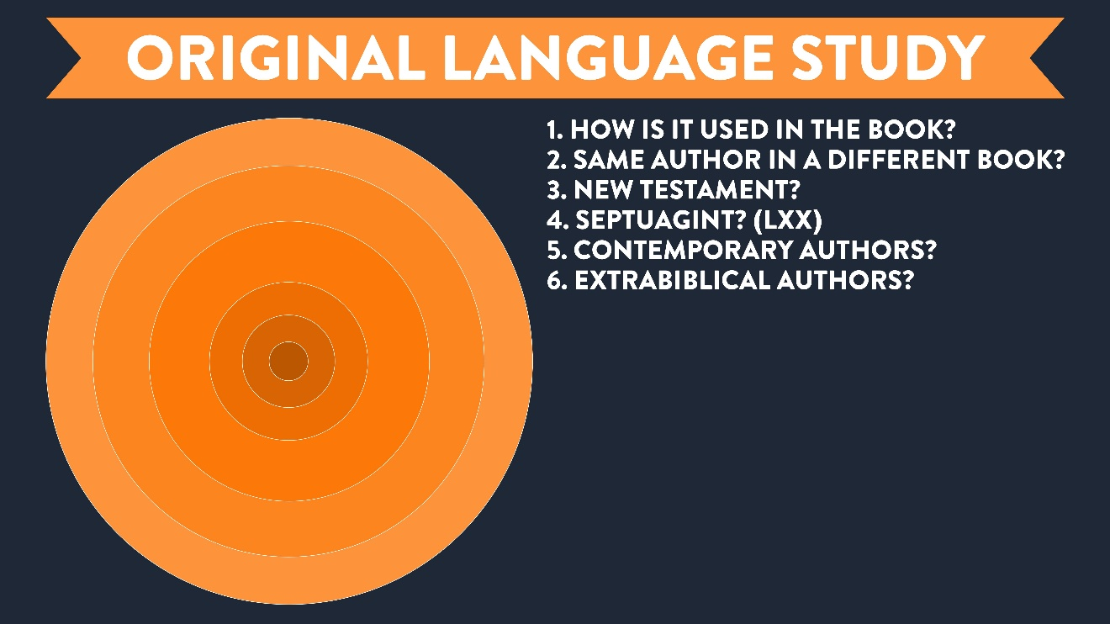

What’s better than knowing Greek?

6. Genre
Genre is identified through careful comparison of similarities and differences with contemporary literature.
The use of the genre could be different, depending on the author.

7. Time-Gap Prophecy

(Luke 4:18-20) Jesus said, “The Spirit of the Lord is on me, because he has anointed me to proclaim good news to the poor.
He has sent me to proclaim freedom for the prisoners and recovery of sight for the blind, to set the oppressed free, to proclaim the year of the Lord’s favor.”
Then he rolled up the scroll, gave it back to the attendant and sat down. The eyes of everyone in the synagogue were fastened on him.

(Isaiah 61:1-2) The Spirit of the Lord GOD is upon me, because the LORD has anointed me to bring good news to the afflicted. He has sent me to bind up the brokenhearted, to proclaim liberty to captives and freedom to prisoners. ² To proclaim the favorable year of the LORD and the day of vengeance of our God.

First Coming and Second Coming (Zech. 9:9-10; Ps. 110:1-2, 5; Isa. 9:6-7; 11:1-5)
Ancient Rome and a future Roman Empire (Dan. 2:43-44; 7:7-8)
Usually skips the Church Age

8. Type-Gap Prophecy

Antiochus Epiphanes IV and the Antichrist (Daniel 11:35-36).
Babylon as a type for the whole world being judged (Isaiah 13).
Armies (“locusts”) move from local to global (Joel 1-2).

9. Unforeseen Partial Prophecy
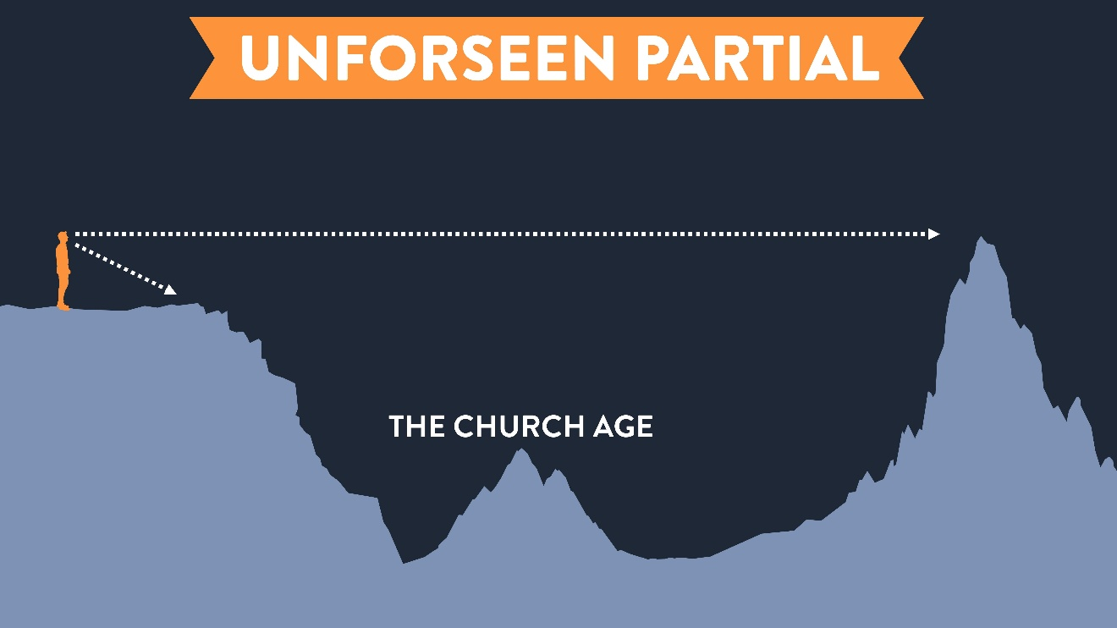
(Gal. 3:7-9) It is those who are of faith who are sons of Abraham. ⁸ The Scripture, foreseeing that God would justify the Gentiles by faith, preached the gospel beforehand to Abraham, saying, “All the nations will be blessed in you.” ⁹ So then those who are of faith are blessed with Abraham, the believer.
(Gen. 12:1-3) The LORD said to Abram, “Go… to the land which I will show you. ² And I will make you a great nation, and I will bless you, and make your name great. And so you shall be a blessing. ³ And I will bless those who bless you, and curse those who curse you. And in you all the families of the earth will be blessed.”

Conclusions

Homework
Read these passages and answer the following questions:

1 Thessalonians 4
QUESTION: According to 1 Thessalonians 4:13-18, list 5 things you can know about the rapture.
13 But we do not want you to be uninformed, brethren, about those who are asleep, so that you will not grieve as do the rest who have no hope.
14 For if we believe that Jesus died and rose again, even so God will bring with Him those who have fallen asleep in Jesus.
15 For this we say to you by the word of the Lord, that we who are alive and remain until the coming of the Lord, will not precede those who have fallen asleep.
16 For the Lord Himself will descend from heaven with a shout, with the voice of the archangel and with the trumpet of God, and the dead in Christ will rise first.
17 Then we who are alive and remain will be caught up together with them in the clouds to meet the Lord in the air, and so we shall always be with the Lord.
18 Therefore comfort one another with these words.
List your observations about the rapture below.
(1)

(2)

(3)

(4)

(5)

1 Thessalonians 5
QUESTION: According to 1 Thessalonians 5:1-11, what will happen after the rapture occurs?
1 Now as to the times and the epochs, brethren, you have no need of anything to be written to you.
2 For you yourselves know full well that the day of the Lord will come just like a thief in the night.
3 While they are saying, “Peace and safety!” then destruction will come upon them suddenly like labor pains upon a woman with child, and they will not escape.
4 But you, brethren, are not in darkness, that the day would overtake you like a thief;
5 for you are all sons of light and sons of day. We are not of night nor of darkness;
6 so then let us not sleep as others do, but let us be alert and sober.
7 For those who sleep do their sleeping at night, and those who get drunk get drunk at night.
8 But since we are of the day, let us be sober, having put on the breastplate of faith and love, and as a helmet, the hope of salvation.
9 For God has not destined us for wrath, but for obtaining salvation through our Lord Jesus Christ,
10 who died for us, so that whether we are awake or asleep, we will live together with Him.
11 Therefore encourage one another and build up one another, just as you also are doing.
QUESTION: What is the practical application of this teaching on the rapture? Why did Paul primarily write about this to the original audience?

2 Thessalonians 2
QUESTION: According to 2 Thessalonians 2:1-15, reconstruct the order of the major events that will happen in the end times.

What is the “day of the Lord”? (v.2)

Is the rapture before or after the Tribulation?

List 5 things you can know about the Antichrist (or “man of lawlessness”) from this passage?
(1)

(2)

(3)

(4)

(5)

1 Now we request you, brethren, with regard to the coming of our Lord Jesus Christ and our gathering together to Him,
2 that you not be quickly shaken from your composure or be disturbed either by a spirit or a message or a letter as if from us, to the effect that the day of the Lord has come.
3 Let no one in any way deceive you, for it will not come unless the apostasy comes first, and the man of lawlessness is revealed, the son of destruction,
4 who opposes and exalts himself above every so-called god or object of worship, so that he takes his seat in the temple of God, displaying himself as being God.
5 Do you not remember that while I was still with you, I was telling you these things?
6 And you know what restrains him now, so that in his time he will be revealed.
7 For the mystery of lawlessness is already at work; only he who now restrains will do so until he is taken out of the way.
8 Then that lawless one will be revealed whom the Lord will slay with the breath of His mouth and bring to an end by the appearance of His coming;
9 that is, the one whose coming is in accord with the activity of Satan, with all power and signs and false wonders,
10 and with all the deception of wickedness for those who perish, because they did not receive the love of the truth so as to be saved.
11 For this reason God will send upon them a deluding influence so that they will believe what is false,
12 in order that they all may be judged who did not believe the truth, but took pleasure in wickedness.
13 But we should always give thanks to God for you, brethren beloved by the Lord, because God has chosen you from the beginning for salvation through sanctification by the Spirit and faith in the truth.
14 It was for this He called you through our gospel, that you may gain the glory of our Lord Jesus Christ.
15 So then, brethren, stand firm and hold to the traditions which you were taught, whether by word of mouth or by letter from us.

Episode 3: Future Israel

Promises for Future Israel
Abrahamic Covenant (Genesis 12:1-3; 15:1-21; 17:3-11).
(1) God stated the everlasting covenant
(Gen. 12:1-3) The LORD had said to Abram, “Go from your country, your people and your father’s household to the land I will show you. “I will make you into a great nation, and I will bless you. I will make your name great, and you will be a blessing. I will bless those who bless you, and whoever curses you I will curse. And all peoples on earth will be blessed through you.”

(2) God signed the everlasting covenant
(Gen. 15:7) God told Abram, “I am the LORD, who brought you out of Ur of the Chaldeans to give you this land to take possession of it.” But Abram said, “Sovereign LORD, how can I know that I will gain possession of it?” The LORD said to him, “Bring me a heifer, a goat and a ram, each three years old, along with a dove and a young pigeon.”
(Gen. 15:18-21) On that day the LORD made a covenant with Abram and said, “To your descendants I give this land, from the Wadi of Egypt to the great river, the Euphrates—the land of the Kenites, Kenizzites, Kadmonites, Hittites, Perizzites, Rephaites, Amorites, Canaanites, Girgashites and Jebusites.”

(3) God gave a symbol of the everlasting covenant
(Gen. 17:7-8) God said, “I will establish my covenant as an everlasting covenant between me and you and your descendants after you for the generations to come, to be your God and the God of your descendants after you. The whole land of Canaan, where you now reside as a foreigner, I will give as an everlasting possession to you and your descendants after you. And I will be their God.”
(Gen. 17:9-11) “You must keep my covenant, you and your descendants after you for the generations to come. This is my covenant with you and your descendants after you, the covenant you are to keep: Every male among you shall be circumcised. You are to undergo circumcision, and it will be the sign of the covenant between me and you.”
Walter Kaiser: “The conditionality was not attached to the promise but only to the participants.”

Davidic covenant (2 Samuel 7:12-16).
(2 Sam. 7:12-13) I will raise up your offspring to succeed you, your own flesh and blood, and I will establish his kingdom. He is the one who will build a house for my Name, and I will establish the throne of his kingdom forever. I will be his father, and he will be my son.
(2 Sam. 7:14-16) When he does wrong, I will punish him with a rod wielded by men, with floggings inflicted by human hands. But my love will never be taken away from him, as I took it away from Saul, whom I removed from before you. Your house and your kingdom will endure forever before me. Your throne will be established forever.”

The Prophets (Jeremiah 31:35-37; Isaiah 54:10; 60:21; Ezekiel 39:28-29; Zechariah 14:4; Psalm 105:8-11).
(Jer. 31:35-37) He who appoints the sun to shine by day, who decrees the moon and stars to shine by night… Only if these decrees vanish from my sight will Israel ever cease being a nation before me. Only if the heavens above can be measured and the foundations of the earth below be searched out will I reject all the descendants of Israel because of all they have done.
(Isa. 54:10) Though the mountains be shaken and the hills be removed, yet my unfailing love for you will not be shaken nor my covenant of peace be removed.
(Isa. 60:21) All your people will be righteous and they will possess the land forever.
(Ezek. 39:28-29) Then they will know that I am the LORD their God, for though I sent them into exile among the nations, I will gather them to their own land, not leaving any behind. I will no longer hide my face from them, for I will pour out my Spirit on the people of Israel, declares the Sovereign LORD. (cf. Ezekiel 11:17; 36:22-38; 37:1-14)
(Zech. 14:3-5) The LORD will go out and fight against those nations… On that day his feet will stand on the Mount of Olives, east of Jerusalem, and the Mount of Olives will be split in two from east to west, forming a great valley, with half of the mountain moving north and half moving south… You will flee as you fled from the earthquake in the days of Uzziah king of Judah.
(Ps. 105:8-11) He has remembered His covenant forever, the word which He commanded to a thousand generations, the covenant which He made with Abraham, and His oath to Isaac. Then He confirmed it to Jacob for a statute, to Israel as an everlasting covenant, saying, “To you I will give the land of Canaan as the portion of your inheritance.”

The New Testament (Acts 1:6-7; Matthew 19:28; Luke 21:24; Galatians 3:17-18; Romans 11:25-29; Hebrews 6:13-18; Revelation 7:4-9).
(Acts 1:6-7) When the disciples had come together, they were asking Jesus, “Lord, is it at this time You are restoring the kingdom to Israel?”
He said to them, “It is not for you to know times or epochs which the Father has fixed by His own authority.”
(Mt. 19:28) Jesus said to the apostles, “Truly I say to you, that you who have followed Me, in the regeneration when the Son of Man will sit on His glorious throne, you also shall sit upon twelve thrones, judging the twelve tribes of Israel.”
(Lk. 21:24) They will fall by the edge of the sword, and will be led captive into all the nations. Jerusalem will be trampled under foot by the Gentiles until the times of the Gentiles are fulfilled.
(Gal. 3:17-18) The Law, which came four hundred and thirty years later, does not invalidate a covenant previously ratified by God, so as to nullify the promise. For if the inheritance is based on law, it is no longer based on a promise. But God has granted it to Abraham by a promise.
(Rom. 11:25) I do not want you, brethren, to be uninformed of this mystery—so that you will not be wise in your own estimation—that a partial hardening has happened to Israel until the fullness of the Gentiles has come in.
(Rom. 11:26-27) So all Israel will be saved. Just as it is written, “The Deliverer will come from Zion, He will remove ungodliness from Jacob. This is My covenant with them, when I take away their sins.” [Isa. 59:20-21]
(Rom. 11:28-29) From the standpoint of the gospel they are enemies for your sake, but from the standpoint of God’s choice they are beloved for the sake of the fathers. For the gifts and the calling of God are irrevocable.
(Rev. 7:4-5) I heard the number of those who were sealed, 144,000 were sealed from every tribe of the sons of Israel: From the tribe of Judah, 12,000. From the tribe of Reuben, 12,000. From the tribe of Gad, 12,000…
(Rev. 7:9) After these things I looked, and behold, a great multitude which no one could count, from every nation and all tribes and peoples and tongues, standing before the throne and before the Lamb.
Why don’t the NT authors talk more about the regathering of Israel?

Episode 4: Questions for Covenant Theology

Questions to Consider
1. Is this view consistent? (Luke 1:31-33; Micah 5:2-3; Zechariah 9:9-10)
(Lk. 1:31-33) Gabriel said, “You will conceive and give birth to a son, and you are to call him Jesus. He will be great and will be called the Son of the Most High. The Lord God will give him the throne of his father David, and he will reign over Jacob’s descendants forever. His kingdom will never end.”
(Mic. 5:2-3) You, O Bethlehem, are only a small village among all the people of Judah. Yet a ruler of Israel whose origins are in the distant past, will come from you on my behalf. ³ The people of Israel will be abandoned to their enemies until the woman in labor gives birth. Then at last his fellow countrymen will return from exile to their own land.
(Jer. 32:42) Just as I brought all this great disaster on this people, so I am going to bring all the good that I am promising them.

2. What is your view of OT prophecy? They don’t have a positive framework.
Loraine Boettner: “A whole continent of prophecies [are left] unexplained, many of which then become quite meaningless.”
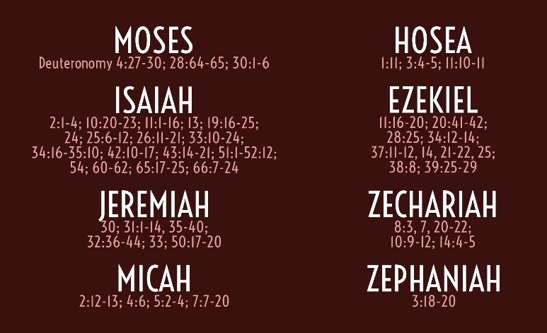

3. What are the origins of this view?
Simon bar Kokhba had Christians tortured and killed if they wouldn’t renounce Christ (Justin Martyr, First Apology, 31).
If anyone celebrated the Passover with the Jewish people, “he is a partaker with those that killed the Lord and His apostles” (Ignatius, Letter to the Philippians, 14).
The Jews are “unfit for work, they are fit for killing” (Chrysostom, Homily One, 2:6).

4. Can we sin our way out of God’s unconditional promises?
Gary Burge: “Possession of the land is tied to obedience to the covenant.”
(Lev. 18:26) You must obey all my decrees and regulations. You must not commit any of these detestable sins… ²⁸ So do not defile the land and give it a reason to vomit you out, as it will vomit out the people who live there now. ²⁹ Whoever commits any of these detestable sins will be cut off from the community of Israel.
(Lev. 26:14-16) If you do not listen to me or obey all these commands, and if you break my covenant by rejecting my decrees, treating my regulations with contempt, and refusing to obey my commands, I will punish you.
(Lev. 26:33-34) I will scatter you among the nations and bring out my sword against you. Your land will become desolate, and your cities will lie in ruins. ³⁴ Then at last the land will enjoy its neglected Sabbath years as it lies desolate while you are in exile in the land of your enemies.
(Lev. 26:44-45) Despite all this, I will not utterly reject or despise them while they are in exile… I will not cancel my covenant with them by wiping them out, for I am the LORD their God. ⁴⁵ For their sakes I will remember my ancient covenant with their ancestors.
(Jer. 3:8, 12, 14) “I divorced faithless Israel because of her adultery. But that treacherous sister Judah had no fear, and now she, too, has left me and given herself to prostitution…” ¹² This is what the LORD says: “O Israel, my faithless people, come home to me again, for I am merciful. I will not be angry with you forever… ¹⁴ Return home, you wayward children,” says the LORD, “for I am your master. I will bring you back to the land of Israel—one from this town and two from that family—from wherever you are scattered.”

5. How did Israel regather herself? (Leviticus 26; Deuteronomy 28)
Was the destruction of Jerusalem a divine judgment on Israel in AD 70? (Lk. 13:34-35; 19:41-44)
Has the nation repented to God? The vast majority haven’t turned to Christ.
Could the Jewish people regather themselves even though they were unrepentant and under the curse and judgment of God?

Conclusions
1.

2.

3.

Homework
Read “The Problems with Preterism” which are chapters from Rochford from Endless Hope or Hopeless End. Use this reading to answer how to respond to the Preterist reading of the various passages listed.

(Rev. 1:1-3) The Revelation of Jesus Christ, which God gave Him to show to His bond-servants, the things which must soon take place; and He sent and communicated it by His angel to His bond-servant John, ² who testified to the word of God and to the testimony of Jesus Christ, even to all that he saw. ³ Blessed is he who reads and those who hear the words of the prophecy, and heed the things which are written in it; for the time is near.
WHAT IS THE PRETERIST INTERPRETATION?

WHAT IS THE FUTURIST RESPONSE?

(Rev. 1:7) [Jesus] is coming with the clouds, and every eye will see Him, even those who pierced Him; and all the tribes of the earth will mourn over Him.
WHAT IS THE PRETERIST INTERPRETATION?

WHAT IS THE FUTURIST RESPONSE?

(Mt. 23:38-39) Behold, your house [the Temple] is being left to you desolate! ³⁹ For I say to you, from now on you will not see Me until you say, ‘Blessed is He who comes in the name of the Lord!’
WHAT IS THE PRETERIST INTERPRETATION?

WHAT IS THE FUTURIST RESPONSE?

(Mt. 24:14) This gospel of the kingdom shall be preached in the whole world as a testimony to all the nations, and then the end will come.
WHAT IS THE PRETERIST INTERPRETATION?

WHAT IS THE FUTURIST RESPONSE?

(Mt. 24:21) There will be a great tribulation, such as has not occurred since the beginning of the world until now, nor ever will.
WHAT IS THE PRETERIST INTERPRETATION?

WHAT IS THE FUTURIST RESPONSE?

(Mt. 24:22) Unless those days had been cut short, no life would have been saved; but for the sake of the elect those days will be cut short.
WHAT IS THE PRETERIST INTERPRETATION?

WHAT IS THE FUTURIST RESPONSE?

(Mt. 24:27) Just as the lightning comes from the east and flashes even to the west, so will the coming of the Son of Man be.
WHAT IS THE PRETERIST INTERPRETATION?

WHAT IS THE FUTURIST RESPONSE?

(Mt. 24:30) The sign of the Son of Man will appear in the sky, and then all the tribes of the earth will mourn, and they will see the Son of Man coming on the clouds of the sky with power and great glory.
WHAT IS THE PRETERIST INTERPRETATION?

WHAT IS THE FUTURIST RESPONSE?

(Mt. 24:31) He will send forth His angels (angelous) with a great trumpet and they will gather together His elect from the four winds.
WHAT IS THE PRETERIST INTERPRETATION?

WHAT IS THE FUTURIST RESPONSE?

(Mt. 24:34) Truly I say to you, this generation will not pass away until all these things take place.
WHAT IS THE PRETERIST INTERPRETATION?

WHAT IS THE FUTURIST RESPONSE?

(Mt. 10:23) You will not finish going through the cities of Israel until the Son of Man comes.
WHAT IS THE PRETERIST INTERPRETATION?

WHAT IS THE FUTURIST RESPONSE?

Episode 5: Three Views of the Millennium

Introduction
The “Millennium” refers to the period between the Church Age and the New Heavens and Earth.
Theologians fall into three major categories:
(1) Premillennialism
(2) Amillennialism
(3) Postmillennialism

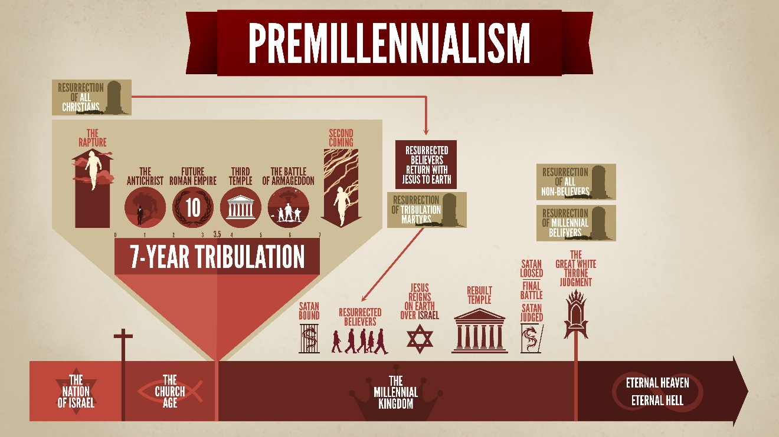

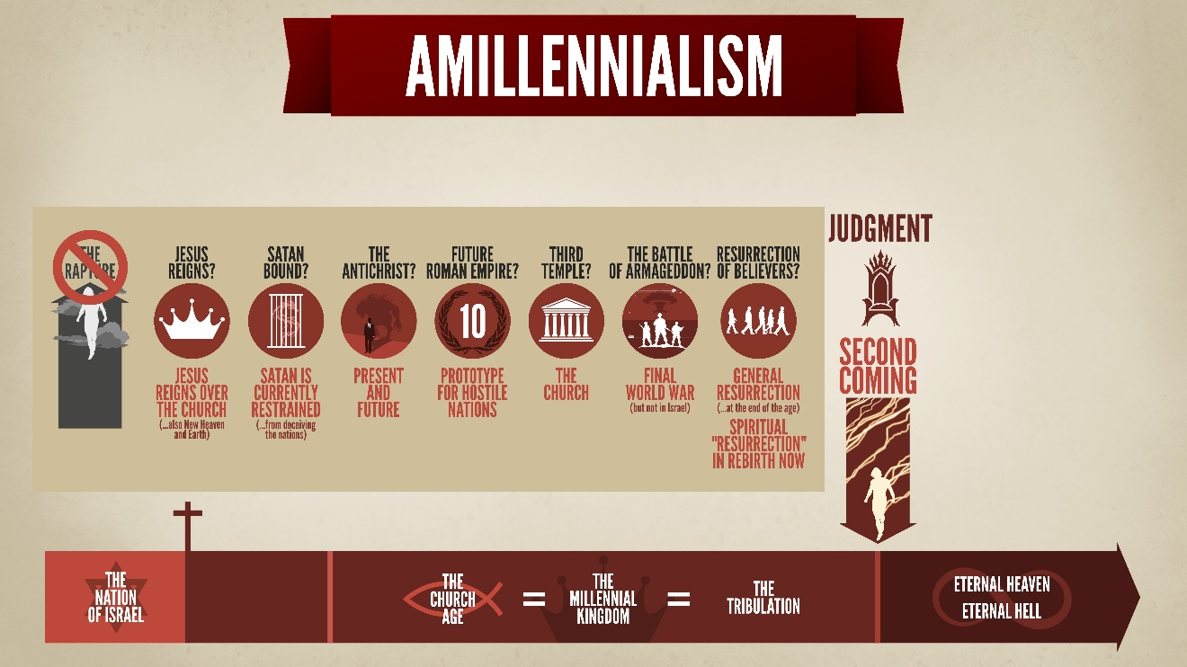

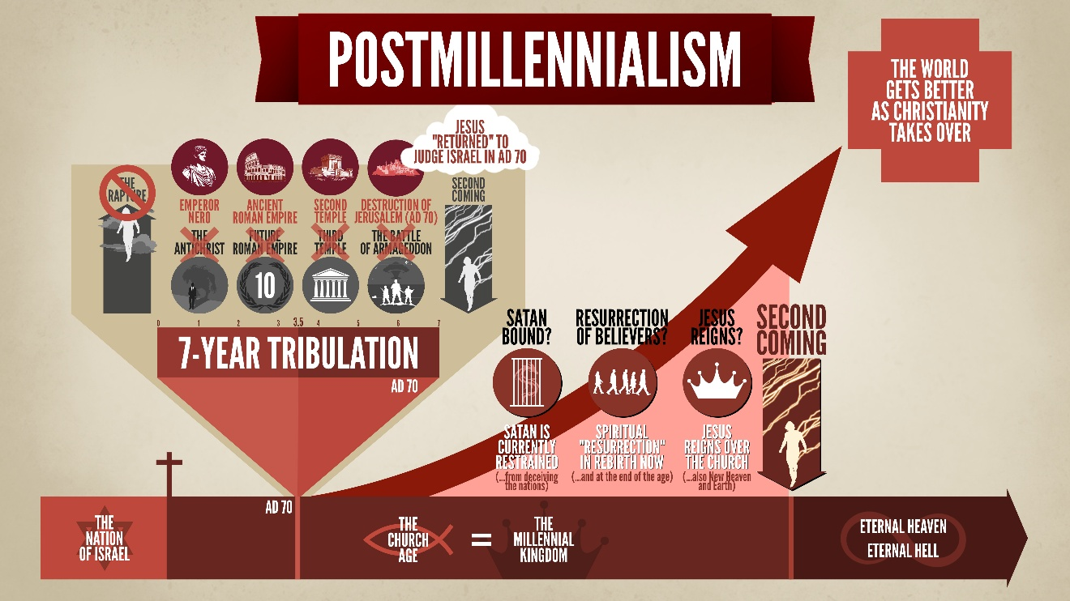

Difficulties?
(1) First appeared in the 18th century. Unitarian Daniel Whitby (1638-1726).
(2) The world will get better. This went into decline after two World Wars.
(3) Requires Preterism. Matthew 24; 1 Timothy 4; 2 Timothy 3:1-5; Romans 8:19-37
(4) Theonomy. “God” (theos) and “law” (nomos)
Circumcision? (Gen. 17:14; Acts 15:23-29)
False teaching? (Deut. 13:5; 18:20; Lev. 19:26; Ex. 22:18; Acts 8:9-13; 13:10-11)
Adultery? (Lev. 20:10; 1 Cor. 5)
Secular government? (Rom. 13:1; 1 Pet. 2:17; Jn. 18:36; Mk. 12:17; Phil. 3:20).

Episode 6: Revelation 20 and Answering Objections

(Rev. 20:1) I saw an angel coming down out of heaven, having the key to the Abyss and holding in his hand a great chain.
(Lk. 8:31) The demons begged Jesus repeatedly not to order them to go into the Abyss. (cf. Revelation 9:1, 11)
(Jude 6) [God] has kept [these fallen angels] in darkness, bound with everlasting chains for judgment on the great Day.

(Rev. 20:2) He seized the dragon, that ancient serpent, who is the devil, or Satan, and bound him for a thousand years.

(Rev. 20:3) The angel threw Satan into the Abyss. He locked and sealed it over him, to keep him from deceiving the nations anymore until the thousand years were ended. After that, he must be set free for a short time.
G.K. Beale: Being sealed “could just as well connote the general idea of ‘authority over,’ which is its primary meaning also in Dan. 6:17 and Matt. 27:66.”
Satan is bound from stopping the gospel? Satan “deceives the whole world” (Revelation 12:9). “All the nations were deceived” by Babylon’s sorcery (Revelation 18:23).
Enters the hearts of believers (Acts 5:3; 2 Timothy 2:24-26).
“Schemes” (2 Corinthians 2:11).
“Hinders” (1 Thessalonians 2:18).
“Devours” (1 Peter 5:8).
“Blinds the minds of the unbelieving” (2 Corinthians 4:4).
“The whole world lies in the power of the evil one” (1 John 5:19).
(Mt. 12:29) “How can anyone enter the strong man’s house and carry off his property, unless he first binds (deō) the strong man?”
(Rev. 20:4) I saw thrones on which were seated those who had been given authority to judge. And I saw the souls of those who had been beheaded because of their testimony about Jesus and because of the word of God. They had not worshiped the beast or its image and had not received its mark on their foreheads or their hands. They came to life and reigned with Christ a thousand years.
(Revelation 5:10) You have made them to be a kingdom and priests to serve our God, and they will reign on the earth.
There are “thrones” (v.4) because we will rule alongside Jesus (Daniel 7:18, 27; Matthew 19:28; 1 Corinthians 6:2-3; 2 Timothy 2:12; Revelation 5:10).

(Rev. 20:5) The rest of the dead did not come to life until the thousand years were ended. This is the first resurrection.

(Rev. 20:6) Blessed and holy are those who share in the first resurrection. The second death has no power over them, but they will be priests of God and of Christ and will reign with him for a thousand years.
If we’re in the Millennium right now, then what does this “resurrection” refer to? Receiving Christ!
The same word (anastasis) refers to both resurrections.
The word is never used for spiritual birth (anastasis, 41x).
How could beheaded Christian martyrs later be spiritually born?

Why is the length only in Revelation 20?
(1)

(2)

(3)

How can immortal believers live with mortal people?
(1)

(2)

(3)

How do we interpret Ezekiel’s Third Temple? (Ezekiel 40-48)
(1) These sacrifices are a memorial. Paul writes, “As often as you eat this bread and drink the cup, you proclaim the Lord’s death until He comes” (1 Cor. 11:26).

(2) Sacrifices never made atonement. Ezekiel predicts “atonement” (Ezek. 43:20, 26; 45:15, 17, 20), but Leviticus also referred to “atonement” (Lev. 4:20, 26, 31, 35).

(3) Major change in the Third Temple. The Ark, manna, Aaron’s rod, the Law, cherubim, veil, Holy of Holies, and the high priest all disappear.

How do others interpret Ezekiel’s Third Temple? (Ezekiel 40-48)
(1) This refers to the Church.

(2) This refers to a Temple in Heaven.

(3) This refers to the second Temple.

(4) This was a false prediction.

How do we interpret Isaiah 65:20?
(Isaiah 65:20) “No longer will there be in it an infant who lives but a few days, or an old man who does not live out his days. For the youth will die at the age of one hundred and the one who does not reach the age of one hundred will be thought accursed.”
(1) Skip it?

(2) New Heavens and Earth?

(3) Church Age?

(4) Late gloss?

What will happen in the Millennial Kingdom?
Perfect Government: Led by Jesus (Daniel 2:44; Isaiah 2:4; 9:6-7; Luke 1:32; Zechariah 14:17).

Ecological harmony (Isaiah 11:6-8; 35:6ff).

Extremely good health and long life (Isaiah 35:5-6; 65:20, 22).

Many babies will be born (Isaiah 65:23).

Satan will be imprisoned! (Revelation 20:1-3)

Conclusions

Homework
Read the Olivet Discourse in Matthew 24. Answer the questions as you read through the text. At the end, write down the basic outline of what Jesus predicts about the future.

Matthew 24 (The Olivet Discourse)
[The parallel passages are found in Mark 13:1-37 and Luke 21:5-36. John doesn’t contain this teaching of Jesus, but he did write an entire 22-chapter book dedicated to the end of human history: Revelation.]
All three versions of the Olivet Discourse have their own focus and emphases. Luke conspicuously omits Jesus’ teaching that (1) all life would be destroyed, (2) this is the greatest tribulation the world has ever seen, and (3) this period is connected with “the abomination of desolation.” Luke seems to focus on the destruction of the Temple in AD 70, and he doesn’t flash forward to the end of history until after verse 25.
(24:1-2) Jesus left the temple area and was going on His way when His disciples came up to point out the temple buildings to Him. ² But He responded and said to them, “Do you not see all these things? Truly I say to you, not one stone here will be left upon another, which will not be torn down.”
Why doesn’t Matthew (or Mark) describe the destruction of the Temple?

(24:3) And as He was sitting on the Mount of Olives, the disciples came to Him privately, saying, “Tell us, when will these things happen, and what will be the sign of Your coming, and of the end of the age?”
What were the disciples asking with these questions?

(24:4) And Jesus answered and said to them, “See to it that no one misleads you.”
(24:5) For many will come in My name, saying, ‘I am the Christ,’ and they will mislead many people.
Is Jesus referring to the first century or to the end of human history? Preterists may very well be correct in seeing this period as referring to the history leading up to AD 70. There are many examples of false prophets and false messiahs (Josephus, Antiquities, 20.97-99; 169-172, 20.188; Wars of the Jews, 2.448; 6.285-287; Acts 5:36-37; 21:38).
This theme of false teachers comes up again in verse 11 and verses 23-27, as well as in the rest of the NT. Therefore, we hold that these examples above are the beginnings of a process that continues throughout the entire Church Age.

(24:6) And you will be hearing of wars and rumors of wars. See that you are not alarmed, for those things must take place, but that is not yet the end.
The history leading up to the destruction of the Temple in AD 70 fits with Jesus’ words as well. However, Jesus specifically says, “That is not the end.” Such a short-term fulfillment fits both a Futurist and a Preterist reading.

(24:7) For nation will rise against nation, and kingdom against kingdom, and there will be famines and earthquakes in various places.
Famines (Acts 11:28) and earthquakes (Acts 16:26) are recorded in the book of Acts. Therefore, this could again refer to the first century world—not the end of history. We take these predictions about false teachers (vv.4-5), wars (v.6), famines (v.6), and earthquakes (v.6) as occurring in the first century, and continuing to get worse and worse throughout the Church Age. This seems to be Jesus’ point in the subsequent verse…
(24:8) But all these things are merely the beginning of birth pains.
A first century fulfillment wouldn’t preclude the Futurist reading, because Jesus continues to say that “these things are merely the beginning of birth pangs.” That is, these things could start in the first century and continue to increase in frequency and in severity until Jesus returns. Hence, the point is that these signs show us that the end is not here. These lead up to the end.
(24:9) Then they will hand you over to tribulation and kill you, and you will be hated by all nations because of My name.
Many of the disciples were martyred for their faith—not the least of which are James of Zebedee (Acts 12:2), Peter (1 Clement 5:4-5), Paul (1 Clement 5:4-5), and James—the brother of Jesus (Antiquities 20). While we have had “tribulation” throughout the Church Age (Rev. 1:9), this is different than the “great tribulation” mentioned later.

(24:10) And at that time many will fall away, and they will betray one another and hate one another.
Apostasy has occurred in every age. Apparently, it will get worse as history progresses (“many will fall away”). Perhaps it gets worse because of the sheer number of people who are alive at the end of history. We’re not sure.

(24:11) And many false prophets will rise up and mislead many people.
In addition to the comments on verses 4-5, notice how false teaching leads to an increase in “lawlessness” and a lack of love (v.12; cf. 2 Tim. 3:4). False teaching will inevitably produce a lack of love.

(24:12) And because lawlessness is increased, most people’s love will become cold.
Futurists sometimes argue that this could refer to the end times, where moral relativism is increased. Surely, it was also true in the first century when people persecuted Christians en masse.

Excursus: Does this refer to the first century, or can it apply to the end of history?
So far, Jesus’ teaching could all fit before AD 70. We have no problem with a Preterist reading so far. Our chief objection with Preterism is its rigidity in forcing everything Jesus says through a first century, historical grid. This has all the markings of trying to squeeze a round peg into a square hole: it simply doesn’t fit. That being said, why couldn’t these things have begun in the first century and continue on to this day?
We aren’t exactly sure where a gap occurs in Jesus’ teaching that definitively places us at the end of history. Verse 13 may be the place of the gap, because it mentions “the end.” However, verse 14 is definitely a gap, because the gospel has not reached the “whole world” and “all nations.” Consequently, “the end” has not come.

(24:13) But the one who endures to the end is the one who will be saved.
The “end” lacks the article, so it could simply refer to the end of this period.

(24:14) This gospel of the kingdom shall be preached in the whole world as a testimony to all the nations, and then the end will come.
This may refer to the Church spreading the gospel to the “whole world” and “all the nations” before Jesus returns. On the other hand, it’s possible that angels will fulfill this commission. John writes, “I saw another angel flying in midheaven, having an eternal gospel to preach to those who live on the earth, and to every nation and tribe and tongue and people” (Rev. 14:6).

(Mt. 24:15-21) Is this the Fall of Jerusalem in AD 70…? Not at all!
D.A. Carson holds that this section (vv.15-21) reverts back to the Fall of Jerusalem in AD 70. In other words, the context up until this point has referred to the Church Age (vv.4-14), and verse 22 and following refer to the Second Coming. However, these verses in between refer to the Fall of Jerusalem. (vv.15-21) His central argument is that these verses are “too limited geographically and culturally.”
Do you agree?

(24:15) Therefore when you see the abomination of desolation which was spoken of through Daniel the prophet, standing in the holy place—let the reader understand.
Daniel writes about the “abomination of desolation” in four passages: Daniel 8:13, 9:27, 11:31, and 12:11. To which passage is Jesus referring?

In Mark’s account, we see that Mark uses the masculine singular to refer to a person standing in the Temple (“when you see the abomination of desolation standing where he ought not to be” Mk. 13:14 ESV). This shows that the Futurist reading of Daniel 9:27 is correct—namely, that Daniel was predicting a man (the Antichrist) desecrating the Temple (cf. 2 Thess. 2:3-5).

(24:16) Then those who are in Judea must flee to the mountains.
(24:17-18) Whoever is on the housetop must not go down to get things out of his house. ¹⁸ And whoever is in the field must not turn back to get his cloak.
(24:19) But woe to those women who are pregnant, and to those who are nursing babies in those days!
(24:20) Moreover, pray that when you flee, it will not be in the winter, or on a Sabbath.
If this is about the end times, what can we learn about this period of history?

(24:21) For then there will be a great tribulation, such as has not occurred since the beginning of the world until now, nor ever will again.
(24:22) And if those days had not been cut short, no life would have been saved; but for the sake of the elect those days will be cut short.

(24:23-24) Then if anyone says to you, ‘Behold, here is the Christ,’ or ‘He is over here,’ do not believe him. ²⁴ For false christs and false prophets will arise and will provide great signs and wonders, so as to mislead, if possible, even the elect.
(24:25) Behold, I have told you in advance.
This is the third time Jesus mentions false teachers (vv.4-5, 11).
While these predictions scare us to consider (vv.23-24), Jesus reassures us that we have the truth “in advance.” There is no good reason why a believer in Jesus should fall away, because Jesus has told us the Enemy’s plan “in advance.”

(24:26-27) So if they say to you, ‘Behold, He is in the wilderness,’ do not go out; or, ‘Behold, He is in the inner rooms,’ do not believe them. ²⁷ For just as the lightning comes from the east and flashes as far as the west, so will the coming of the Son of Man be.
What does this imagery tell us about the return of Jesus?

(24:28) Wherever the corpse is, there the vultures will gather.
What does this cryptic statement mean?

(24:29) But immediately after the tribulation of those days the sun will be darkened, and the moon will not give its light, and the stars will fall from the sky, and the powers of the heavens will be shaken.
This passage occurs “after the tribulation of those days.” This means that the “great tribulation” (v.21) has past, and this is ended with the return of Christ.

(24:30) And then the sign of the Son of Man will appear in the sky, and then all the tribes of the earth will mourn, and they will see the Son of Man coming on the clouds of the sky with power and great glory.
Jesus will literally return—just as he literally left (Acts 1:11). People will literally mourn as they see him return—specifically the nation of Israel (Zech. 12:10-12; Rev. 1:7).

(24:31) And He will send forth His angels with a great trumpet blast, and they will gather together His elect from the four winds, from one end of the sky to the other.

(24:32-33) Now learn the parable from the fig tree: as soon as its branch has become tender and sprouts its leaves, you know that summer is near; ³³ so you too, when you see all these things, recognize that He is near, right at the door.

(24:34) Truly I say to you, this generation will not pass away until all these things take place.
When these things occur (“all these things take place”), this is the final generation of the human race. Our failed experiment of human rebellion will almost be over.

(24:35) Heaven and earth will pass away, but My words will not pass away.

(24:36) But about that day and hour no one knows, not even the angels of heaven, nor the Son, but the Father alone.
Preterists often see Jesus jumping forward to his Second Coming at the end of history here. In our estimation, this shows their inconsistency, because they constantly gripe about Dispensationalists seeing “gaps” in prophetic material. Yet, everyone admits that there are gaps—even Preterists!

(24:37-39) For the coming of the Son of Man will be just like the days of Noah. ³⁸ For as in those days before the flood they were eating and drinking, marrying and giving in marriage, until the day that Noah entered the ark, ³⁹ and they did not understand until the flood came and took them all away; so will the coming of the Son of Man be.
Does this mean that humanity will be morally depraved like the time of Noah?

(24:40-41) At that time there will be two men in the field; one will be taken and one will be left. ⁴¹ Two women will be grinding at the mill; one will be taken and one will be left.
Does this refer to the Rapture?

(24:42-44) Therefore be on the alert, for you do not know which day your Lord is coming. ⁴³ But be sure of this, that if the head of the house had known at what time of the night the thief was coming, he would have been on the alert and would not have allowed his house to be broken into. ⁴⁴ For this reason you must be ready as well; for the Son of Man is coming at an hour when you do not think He will.
Since we don’t know when Jesus is returning, the best approach is to be ready at all times.

Summarize Jesus’ Teaching
Write down the basic outline of what Jesus predicts about the future. Include the verses that support your insights. Here are some examples:
There will be a lot of false teaching and false messiahs (v.5).
Before the end, wars will increase (vv.6-7).
These things will grow like birth pains (v.8).

Episode 7: In Defense of the Pre-Trib Rapture (Pt.1)

Understanding the Rapture
Where do we get this term? Latin translation (rapturo, 1 Thessalonians 4:17).
What will happen? Jesus will instantly rescue all Christians—both alive and dead (1 Thessalonians 4:13-5:11). Jesus will instantly give us resurrected bodies at this moment (1 Corinthians 15:51-53).
Do all Christians believe this? Yes!
Do all Christians agree on the timing? No!

1 Corinthians 15
⁵¹ Behold, I tell you a mystery. We will not all sleep, but we will all be changed.
⁵² In a moment, in the twinkling of an eye, at the last trumpet. For the trumpet will sound, and the dead will be raised imperishable, and we will be changed.
⁵³ For this perishable must put on the imperishable, and this mortal must put on immortality.
Mystery?
The Second Coming? (Daniel 7:13-14; Zechariah 14:1-5)
The resurrection of the dead? (Isaiah 26:19; Daniel 12:2; Job 19:25-26)
The rescue of the Church!
Sleep?
Sleep = death (1 Corinthians 15:18; John 11:12-14; Acts 7:60; 13:36; 1 Thessalonians 4:13)
“Moment” (en atomos). “Indivisible” (BDAG, p.149)
Given resurrection bodies—never to die again.
The last trumpet?
The trumpet of Revelation? This hadn’t been written yet.
The trumpet referred to “summoning the congregation” of Israel to “gather themselves” together to “set out” (Numbers 10:2-5).
Paul Benware: “It is signifying the completion of a program, namely, God’s dealings with the church on earth.”

1 Thessalonians 4
¹³ We do not want you to be uninformed about those who are asleep, so that you will not grieve as do the rest who have no hope.
¹⁴ For if we believe that Jesus died and rose again, even so God will bring with Him those who have fallen asleep in Jesus.
¹⁵ For this we say to you by the word of the Lord, that we who are alive and remain until the coming of the Lord, will not precede those who have fallen asleep.
¹⁶ For the Lord Himself will descend from heaven with a shout, with the voice of the archangel and with the trumpet of God, and the dead in Christ will rise first.
¹⁷ Then we who are alive and remain will be caught up together with them in the clouds to meet the Lord in the air, and so we shall always be with the Lord.
¹⁸ Therefore comfort one another with these words.
How will Christ rescue us?
“Caught up” (harpazō)
Jesus was “caught up” at his ascension (Revelation 12:5; cf. Acts 1:9-11).
Philip: “The Spirit of the Lord snatched Philip away, and the eunuch no longer saw him” (Acts 8:39).
Paul was “caught up” into heaven (2 Corinthians 12:2-4).
*also Enoch and Elijah (Genesis 5:24; 2 Kings 2:1, 11).
Where will Christ rescue us? We will go to the clouds in the air—not on the Earth.
When will Christ rescue us? If we read Paul’s letter chronologically, the rescue of the Church will occur before the “day of the Lord” (1 Thess. 5:2).
(1 Thess. 5:11) Therefore encourage one another and build up one another, just as you also are doing.

1 Thessalonians 5
¹ Now as to the times and the dates, you have no need of anything to be written to you.
² For you yourselves know full well that the day of the Lord will come just like a thief in the night.
³ While they are saying, “Peace and safety!” then destruction will come upon them suddenly like labor pains upon a woman with child, and they will not escape.
⁴ But you are not in darkness, that the day would overtake you like a thief.
⁵ For you are all sons of light and sons of day. We are not of night nor of darkness.
⁶ So then let us not sleep as others do, but let us be alert and sober.
⁷ For those who sleep do their sleeping at night, and those who get drunk get drunk at night.
⁸ But since we are of the day, let us be sober, having put on the breastplate of faith and love, and as a helmet, the hope of salvation.
⁹ For God has not destined us for wrath, but for obtaining salvation through our Lord Jesus Christ.
In context, what are they being saved from? “The day of the Lord” (v.2).
(1 Thess. 1:10) You wait for His Son from heaven, whom He raised from the dead, that is Jesus, who rescues us from the wrath to come.
¹⁰ He died for us, so that whether we are awake or asleep, we will live together with Him.
(1 Thess. 4:15) We who are alive and remain until the coming of the Lord, will not precede those who have fallen asleep. ¹⁷ We shall always be with the Lord.
¹¹ Therefore encourage one another and build up one another, just as you also are doing.
(1 Thess. 4:18) Therefore comfort one another with these words.

2 Thessalonians 2
¹ We request you, with regard to the coming of our Lord Jesus Christ and our gathering together to Him,
² that you not be quickly shaken from your composure or be disturbed either by a spirit or a message or a letter as if from us, to the effect that the day of the Lord has come.
What was making them “shaken” and “disturbed”?
³ Let no one in any way deceive you, for it will not come unless the apostasy comes first, and the man of lawlessness is revealed, the son of destruction.
“It” = “The day of the Lord has come” (v.2).
(1 Thess. 5:2-3) The day of the Lord will come just like a thief in the night. While they are saying, “Peace and safety!” then destruction will come upon them.
⁴ He opposes and exalts himself above every so-called god or object of worship. He takes his seat in the temple of God, displaying himself as being God.
⁵ Do you not remember that while I was still with you, I was telling you these things?
This only would comfort them if they were taught a pre-tribulation rapture. Otherwise, their suffering would indicate that they were in the Tribulation, and Jesus’ return was near.

Revelation 3
¹⁰ Because you have kept the word of My perseverance, I will keep you from the hour of testing, that hour which is about to come upon the whole world, to test those who dwell on the earth.
“I will keep you from” (tērēsō ek)
This can either mean:
(1) Protection through
(2) Removal from
Grant Osborne: “Context must show which is more likely.”
(Jn. 12:27) “My soul is troubled, and what shall I say? ‘Father, save me from (tēreō) this hour’ (hōra)? No, it was for this very reason I came to this hour.”
John used “from” (ek), even though he could’ve used “in” (en) or “through” (dia).
“The hour of testing”
Grant Osborne: “The consensus view is that it refers to the final end-time trials that precede the [end of history].”
This is removal from a period of time.
How are they “protected” if they are martyred? (Revelation 6:9-11; 7:9-14)
“The whole world.” Satan deceives “the whole world” (Rev. 12:9).
“Dwell on the earth.” “Those who dwell on the earth” refers to people who reject God (Revelation 6:10; 8:13; 11:10; 13:8, 12, 14; 17:2, 8).
¹¹ I am coming quickly. Hold fast what you have, so that no one will take your crown.
¹³ He who has an ear, let him hear what the Spirit says to the churches.
What is being promised? Jesus will rescue authentic believers in Philadelphia from the Tribulation. Jesus could return at any time: “I am coming soon” (v.11).
They are long dead, but Jesus will resurrect them along with every other authentic believer: “To the churches” (Revelation 3:13).

Episode 8: In Defense of the Pre-Trib Rapture (Pt.2)

Will we be in the Tribulation?
#1. Revelation never mentions the “church” (ekklesia) in the Tribulation.
He who has an ear, let him hear what the Spirit says to the churches (Revelation 2:7, 11, 17, 29; 3:6, 13, 22).
“If anyone has an ear, let him hear” (Revelation 13:9).
#2. Both the NT and OT predict that Israel will face the Tribulation—not the Church.
The Tribulation is for “your people” and “your holy city” (Daniel 9:24).
The Tribulation occurs “in Judea” with a Jewish “temple” (Matthew 24:15-16).
“It is a time of trouble for the descendants of Jacob” (Jeremiah 30:7).
#3. People will die after Jesus’ Second Coming… Who are these people?
Jesus gives believers “immortal” bodies—that can’t die (1 Corinthians 15:51-53).
God will judge “all” other people on Planet Earth (1 Thessalonians 5:3; 2 Thessalonians 2:12; Matthew 13:40-42, 49; 24:31, 39-41, etc.).
#4. The NT states that the rescue of the Church will be imminent.
Why are we supposed to look for specific signs that precede the Second Coming…? (Matthew 24:4-34)
…If Jesus’ return could happen at any moment? (Titus 2:13; cf. 1 Corinthians 1:7; James 5:8; Philippians 4:5)
#5. The rescue of the Church contains many differences from the Second Coming.

The removal of believers from the Earth (1 Thessalonians 4:17). | The return of believers  to the Earth (Revelation 19:14).
We will meet Jesus in the  sky and in the clouds (1 Thessalonians 4:17). | We will meet Jesus on the ground (Zechariah 14:4)
Given resurrection bodies instantly (1 Corinthians 15:52). | Given resurrection bodies after judgment (Revelation 20:1-4)

Is this from J.N. Darby? (1830s)
Irenaeus (AD 180): “When in the end the Church shall be suddenly caught up from this, it is said, ‘There shall be tribulation such as has not been since the beginning’” (Against Heresies 5.29.1).
Resurrected saints and mortals will live together (Against Heresies, 5.35.1).
Partial Pre-tribulation or “Church” is broad? (Against Heresies, 5.26.1)
Pseudo-Ephraem (7th century AD): “The elect of God are gathered together before the tribulation, which is to come, and are taken to the Lord.”
Brother Dolcino (AD 1316) affirms the mid-trib. He was the leader of the Apostolic Brethren (1316).
Morgan Edwards (AD 1722-1795) affirms the mid-trib. Two Academical Exercises… (1788), 5-6.
Time doesn’t determine truth.
This isn’t a core doctrine: it’s an inference about the unrealized future.
Paul Benware: “Once a literal approach to interpreting the Scriptures began to be rediscovered, these truths started to emerge.”
The Song of Solomon was viewed as an allegory by both Jews and Christians for millennia! (e.g. Luther, Calvin, Wesley, etc.)

Do Christians believe this because they want to avoid suffering?
This is the “Appeal to Motive” fallacy. It’s a type of genetic fallacy.
Most of the Bible’s teaching is to our personal advantage! (e.g. grace through faith and apart from works)
In the meantime, however, God does call on believers to suffer (Philippians 1:29; James 1:2; 2 Timothy 3:12; John 16:33).

Homework
Study for the Final Quiz!
(1) What is the term used for the study of the end times?
Eschatology.
(2) Give five reasons why we should study the end times?
1. This is a biblical emphasis.
2. God expects us to know this subject.
3. False teachers will attack this topic.
4. It gives practical motivation.
5. People want to know the Bible’s view of the end of the world.
(3) When interpreting a prophetic passage, what should be assumed first?
A literal/plain-sense reading.
(4) Name three levels of context in order of importance that should be considered.
(1) Immediate context?
(2) The book as a whole?
(3) The same author?
(4) Old Testament?
(5) What is a “type”?
Person, event, institution, or object that foreshadows a later and greater fulfillment.
(6) What is a time-gap prophecy? Give an example from Scripture.
The biblical author doesn’t realize there’s a gap of time in between two events (Luke 4:18-20).
(7) What is the major difference between Dispensationalism and Covenantalism?
National Israel returning.
(8) Where does Paul say that “all Israel will be saved”?
Romans 11:26
(9) Give one verse where Jesus alludes to the regathering of national Israel?
(Acts 1:6-7) “It is not for you to know times or epochs which the Father has fixed by His own authority.”
(Mt. 19:28) “You also shall sit upon twelve thrones, judging the twelve tribes of Israel.”
(Lk. 21:24) “Jerusalem will be trampled under foot by the Gentiles until the times of the Gentiles are fulfilled.”
(10) What are five questions to ask people who reject the promises to Israel?
1. Is this view consistent?
2. What is your view of OT prophecy?
3. What are the origins of this view?
4. Can we sin out of God’s promises?
5. How did Israel regather herself?
(11) What’s one problem with the idea that religious people self-fulfilled the regathering of Israel in 1948?
The movement was secular, and it took the Holocaust for it to happen.
(12) What’s wrong with citing passages about Israel losing the land temporarily?
Everyone agrees with a temporary loss of the land, but the issue is whether there’s a permanent loss.
(13) Name one unique aspect of premillennialism?
Jesus comes before the Millennium.
History gets worse.
(14) Name one unique aspect of amillennialism?
The Church Age is the Millennium.
History gets worse.
(15) Name one unique aspect of postmillennialism?
The Church Age is the Millennium.
History gets better.
(16) Name one major problem with interpreting Revelation 20 as an Amillennialist or Postmillennialist?
(1) Satan is currently bound.
(2) The “resurrection” is spiritual.
(17) Do all Christians believe in the rapture?
Yes!
(18) Do all Christians believe in the same timing of the rapture?
No!
(19) What is one problem with thinking that the Rapture and Second Coming are the same event?
#1. The removal of believers from the Earth (1 Thess. 4:17), rather than the return of believers to the Earth (Rev. 19:14).
#2. We will meet Jesus in the sky and in the clouds (1 Thess. 4:17), rather than meeting Jesus on the ground (Zech. 14:4).
#3. We are given resurrection bodies instantly (1 Cor. 15:52), rather than being given resurrection bodies later (Rev. 20:1-4).

Episode 9: Introduction to the Antichrist

What is the Tribulation?
(Matthew 24:21) “There will be a great tribulation, such as has not occurred since the beginning of the world until now, nor ever will.”
Revelation describes the “great tribulation” (Revelation 7:14).
World wars (Revelation 6:4; Matthew 24:6-7).
Famine (Revelation 6:6; Matthew 24:7).
Pandemics (Revelation 6:8; Luke 21:11).
Meteorological phenomena? (Revelation 6:12-14; 8:8; Matthew 24:29)
Darkening of the atmosphere (Revelation 6:12; Matthew 24:29).
Persecution and martyrdom (Revelation 6:9-11; Matthew 24:9, 16-22).

How long is the Tribulation?
The Tribulation will be 7-years-long.
“He will make a firm covenant with the many for one week” (Daniel 9:27)
“They will be given into his hand for a time, times, and half a time” (Daniel 7:25; Revelation 12:14).
“Forty and two months” (Revelation 11:2; 13:5).
“1,260 days” (Revelation 11:3; 12:6).
The Antichrist will betray Israel halfway through the Tribulation.
“For one week, but in the middle of the week he will put a stop to sacrifice and grain offering” (Daniel 9:27).
(Mt. 24:15-16) Jesus said, “When you see standing in the holy place ‘the abomination that causes desolation,’ spoken of through the prophet Daniel (let the reader understand) then let those who are in Judea flee to the mountains.”
(Mt. 24:21-22) There will be a great tribulation, such as has not occurred since the beginning of the world until now, nor ever will. Unless those days had been cut short, no life would have been saved.
(Dan. 9:26-27) The people of the ruler who will come will destroy the city and the sanctuary… War will continue until the end. He will confirm a covenant with many for one ‘seven.’ In the middle of the ‘seven’ he will put an end to sacrifice and offering. And at the temple he will set up an abomination that causes desolation, until the end that is decreed is poured out on him.
“Forty and two months” (Revelation 11:2; 13:5).
“1,260 days” (Revelation 11:3; 12:6).
“They will be given into his hand for a time, times, and half a time” (Daniel 7:25; Revelation 12:14).
The Amillennial View?
The final 7-year period is Jesus continued ministry. Jesus stopped the Temple sacrifice when he died “once for all” (Heb. 9:12, 26; 10:10). Christ inaugurated the New Covenant Jesus said, “This is My blood of the covenant” (Mt. 26:28).
Kim Riddlebarger: “The final three and a half years of the seventieth week… are symbolic of the church on earth during the entire time of its existence.”
C. Samuel Storms: “The destruction of Jerusalem and its temple in AD 70 is the middle of the week, and the present church age is the latter half.”
Preterist View?
Gary DeMar: “Could we not assume that a forty-year gap is much more logical than a gap of indeterminate length?”

Who leads the Tribulation?
Dispensationalists = Antichrist.
Amillennialists = Christ.
There is a gap in between Daniel 9:26-27.
(1) Why separate the 69th and 70th week?
(2) “Until the end” (v.26).
(3) The Temple is destroyed and rebuilt.
(4) Mark says it’s the Antichrist (Mk. 13:14).
“When you see the abomination of desolation spoken of by the prophet Daniel, standing in the holy place” (Matthew 24:15 NASB).
“When you see the abomination of desolation standing where he ought not to be” (Mark 13:14 ESV, masculine participle).

Episode 10: The Power of the Antichrist

(Rev. 13:1) The dragon (Satan) stood on the shore of the sea. And I saw a beast coming out of the sea. It had ten horns and seven heads, with ten crowns on its horns, and on each head a blasphemous name.
This describes the Revived Roman Empire
(Rev. 17:9-10) Here is the mind which has wisdom. The seven heads are seven mountains. ¹⁰ They are seven kings. Five have fallen, one is, the other has not yet come. When he comes, he must remain a little while.
#1. Egypt
#2. Assyria
#3. Babylon
#4. Media-Persia
#5. Greece
#6. Ancient Roman Empire
#7. Revived Roman Empire
(Rev. 17:11) The beast which was and is not, is himself also an eighth and is one of the seven. He goes to destruction.
(Rev. 17:12) The ten horns you saw are ten kings. These kings have not yet received a kingdom. They receive authority as kings with the beast for one hour.
(Rev. 13:2) The beast I saw resembled a leopard, but had feet like those of a bear and a mouth like that of a lion. The dragon (Satan) gave the beast his power and his throne and great authority.
(Dan. 7:3) Four great beasts, each different from the others, came up out of the sea.
“Why are we turning all over the Bible to interpret eschatology??” Correlation shows that we’re getting the right interpretation.
(Dan. 7:4-6) The first was like a lion, and it had the wings of an eagle… ⁵ The second beast looked like a bear. It had three ribs in its mouth… ⁶ One looked like a leopard with four wings and four heads.
(Dan. 7:7) There was a fourth beast: terrifying and frightening and very powerful… It was different from all the former beasts, and it had ten horns.
(Dan. 7:8) While I was thinking about the horns, there was another horn. It was a little one, and it came up among the other horns. Three of the first horns were uprooted before it. This horn had eyes like the eyes of a human being and a mouth that spoke boastfully.
(Dan. 7:23) The fourth beast is a fourth kingdom that will appear on earth. It will be different from all the other kingdoms and will devour the whole earth, trampling it down and crushing it.
(Dan. 7:24) The ten horns are ten kings who will come from this kingdom. After them another king will arise, different from the earlier ones. He will subdue three kings.
(Dan. 7:25) He will speak against the Most High and oppress his holy people and try to change the set times and the laws. The holy people will be delivered into his hands for a time, times and half a time.
(Dan. 9:27) Half of seven years.
(Dan. 7:25) Time, times and half a time.
(Dan. 12:7) Time, times and half a time.
(Rev. 11:2) 42 months.
(Rev. 11:3) 1,260 days.
(Rev. 12:14) Time, times and half a time.
(Rev. 13:5) 42 months.
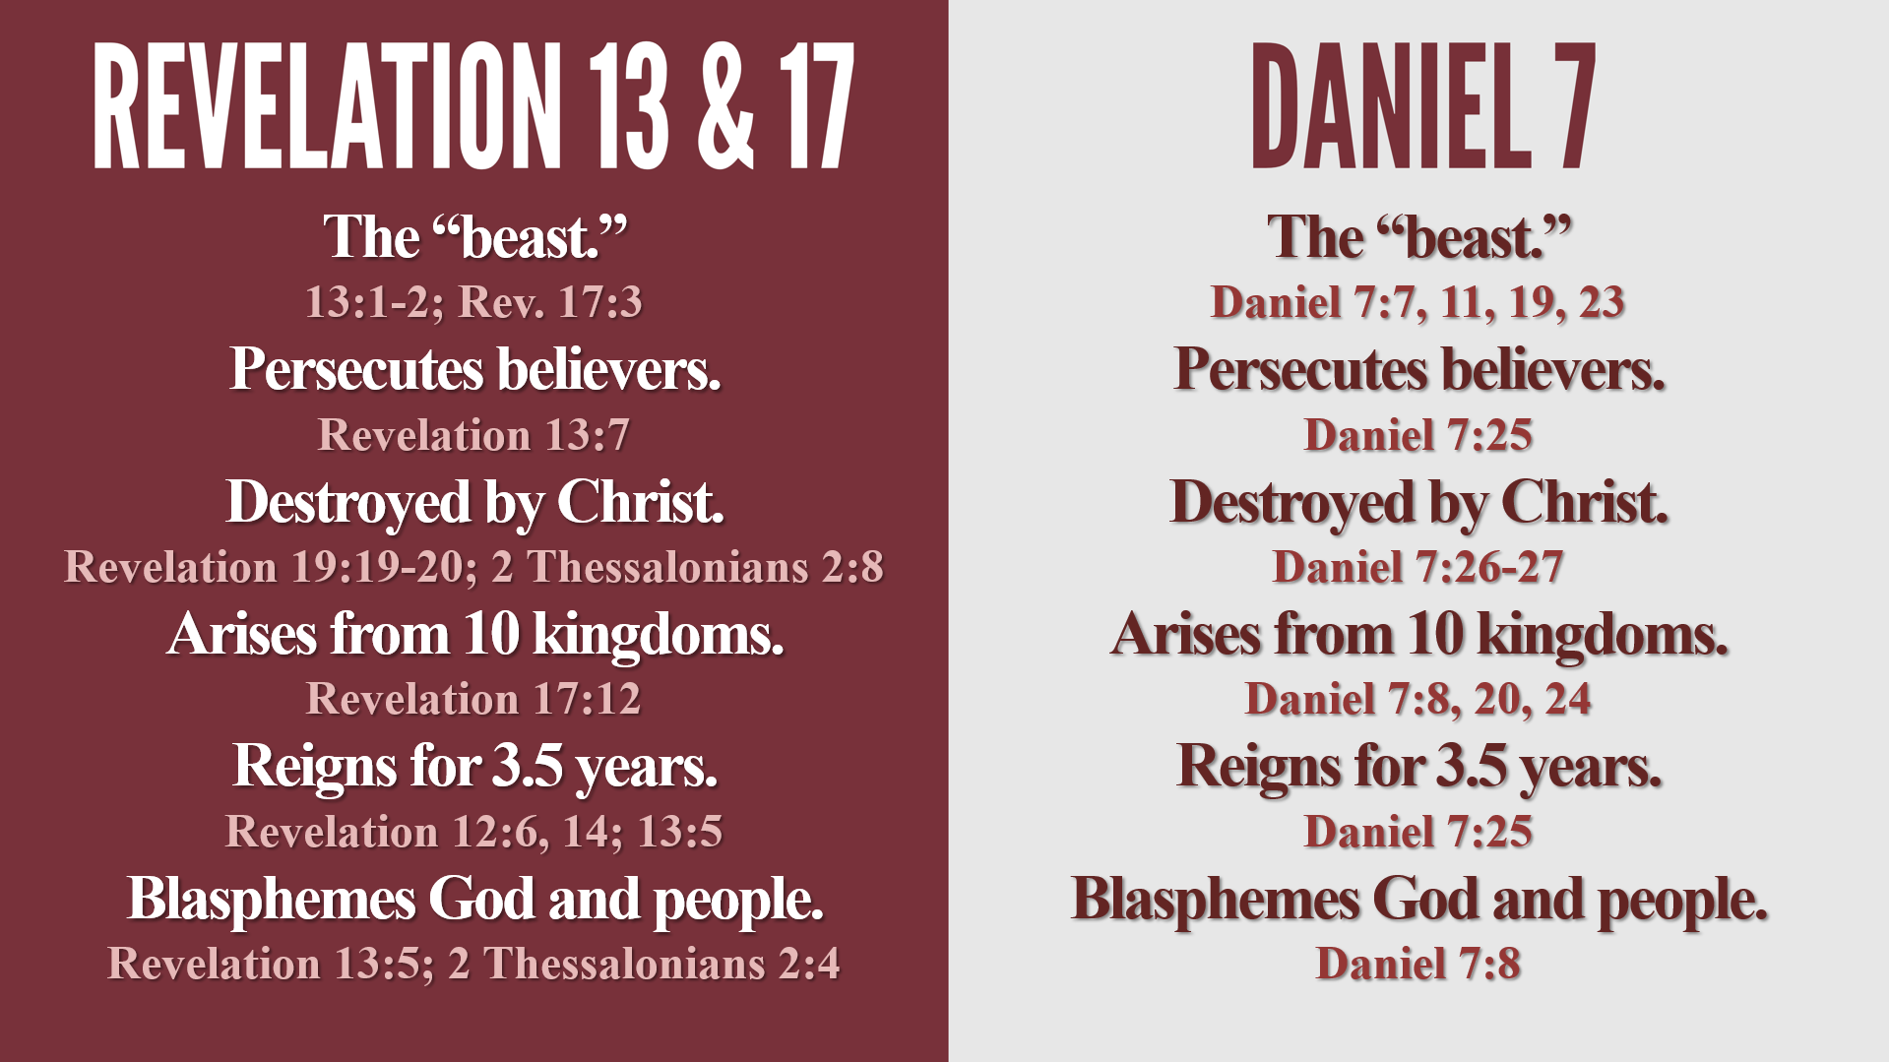
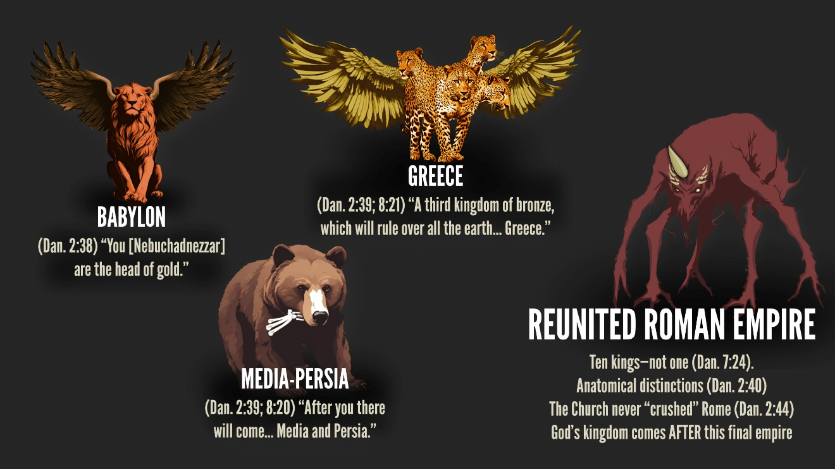

(Rev. 13:2) The beast I saw resembled a leopard, but had feet like those of a bear and a mouth like that of a lion. The dragon (Satan) gave the beast his power and his throne and great authority.
(Rev. 13:3) One of the heads of the beast seemed to have had a fatal wound, but the fatal wound had been healed. The whole world was filled with wonder and followed the beast.
(Rev. 13:4) People worshiped the dragon because he had given authority to the beast, and they also worshiped the beast and asked, “Who is like the beast? Who can wage war against it?”
(Rev. 13:5) The beast was given a mouth to utter proud words and blasphemies and to exercise its authority for forty-two months.
Daniel 7:25
(Rev. 13:6) It opened its mouth to blaspheme God, and to slander his name and his dwelling place and those who live in heaven.
Daniel 7:8
(Rev. 13:7) It was given power to wage war against God’s holy people and to conquer them. And it was given authority over every tribe, people, language and nation.
Daniel 7:25; Revelation 5:9
(Rev. 13:8) All who dwell on the earth will worship him, everyone whose name has not been written from the foundation of the world in the book of life of the Lamb who has been slain.
(Rev. 13:9) Whoever has ears, let them hear.
(Rev. 13:10) “If anyone is to go into captivity, into captivity they will go. If anyone is to be killed with the sword, with the sword they will be killed.” This calls for patient endurance and faithfulness on the part of God’s people.

What do we know about him?
He will be a Gentile, not Jewish. “No regard for the gods of his fathers” (Daniel 11:37).
He will be a powerful speaker. He “will speak monstrous things against the God of gods” (Dan. 11:36; cf. Rev. 13:5).
He will bring (and break) world peace. Daniel 9:27; 1 Thessalonians 5:2-3
He will claim to be God incarnate, and he will stand in the rebuilt Temple of God. 2 Thess. 2:4; cf. Rev. 13:8; Mk. 13:14; Dan. 11:37
“The man of lawlessness… opposes and exalts himself above every so-called god or object of worship. He takes his seat in the temple of God, and he will display himself as being God” (2 Thessalonians 2:3-4).
(Rev. 13:16-17) It also forced all people, great and small, rich and poor, free and slave, to receive a mark on their right hands or on their foreheads, so that they could not buy or sell unless they had the mark, which is the name of the beast or the number of its name.
(Rev. 13:18) This calls for wisdom. Let the person who has insight calculate the number of the beast, for it is the number of a man. That number is 666.

What is the “666”?
“Calculate the number of the beast… It is the number of a man” (v.18).
Gematria: calculates words and names based on the numerical value of letters.
Matthew 1:1-18
“Beast” (thērion) adds up to “666.”
“I love her whose number is _____.”
Found in Pompeii (phileo es arithmos phme)
Emperor Nero?
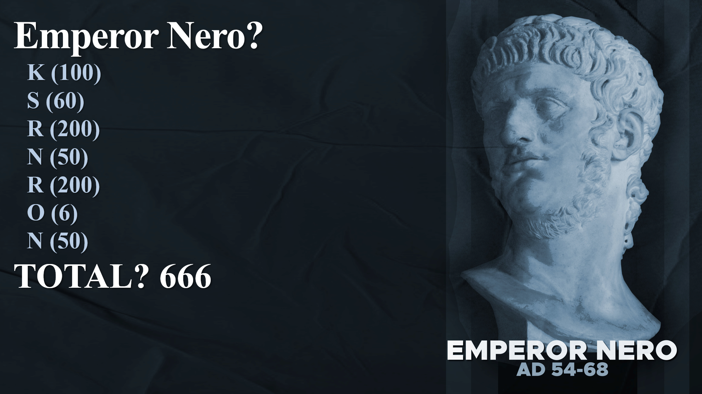
(1) Why translate into Hebrew?
(2) There’s a missing letter (yodh) that brings the number to 676.
(3) Why didn’t any early Christians make this association?
The unholy Trinity?
Fallen humanity in general? (“666”)
Falling short of Jesus? (“888”)
(2 Thess. 2:3) [The day of the Lord] will not come unless… the man of lawlessness is revealed.

Who leads the Tribulation?
The Antichrist rules a Reunited Roman Empire of 10 kingdoms (Revelation 13:1-2; Daniel 7:23-25).
Creates a one-world government (Revelation 13:4, 7-8).
Deceives the world into worshipping him through various “miracles.” (Revelation 13:12-15; 2 Thessalonians 2:3-4, 9-10)
Possesses a universal control of money (Revelation 13:16-17).

Episode 11: Armageddon and the Second Coming

Warfare in the Tribulation?
There will be world war leading up to the Second Coming of Christ.
1/3 of humans are killed (Rev. 9:16-18).
“The kings of the whole world [gathered] for war of the great day of God… to the place which in Hebrew is called Har-Magedon” (Rev. 16:14-16).
“Even to the end there will be war” (Dan. 9:26).
Many nations will attack Israel.
Ezek. 38-39; Zech. 12-14; Joel 3; Jer. 30
The nations turn on the Antichrist.
Daniel 11:40-45
Jesus ends war on Earth.

The valley of Megiddo is 20 miles long and 14 miles wide—though the larger plain is 200 miles long.
The battles are not necessarily fought here—only gathered here. John states, “They gathered the kings together to the place” (Revelation 16:16).
There isn’t one battle, but many.
Which nations will be involved?

Ezekiel 38-39
(Ezek. 38:1-2) “Son of man, set your face toward Gog of the land of Magog, the prince of Rosh, Meshech and Tubal.
The Assyrian king Gog (“Gugu”) took the throne from his master by killing him. Herodotus, Histories 1.8-13
(Ezek. 38:5-6) Persia, Cush and Put with them, all of them with shield and helmet: Gomer with all its troops. Beth-togarmah will come from the remote parts of the north with all its troops—many peoples with you.
(Ezek. 38:8) In the distant future you will swoop down on the land of Israel, which will be enjoying peace after recovering from war. This will happen after its people have returned from many lands.
(Ezek. 38:9) Your army will roll down on them like a storm and cover the land like a cloud.
Ancient Weapons?
“Horses” Ezekiel 38:4, 15
“Swords” Ezekiel 38:4, 21; 39:23
“Bows” and “arrows” Ezekiel 39:9, 3
“War clubs and spears” Ezekiel 39:9
(1) Technology could be disabled.
“I know not with what weapons World War III will be fought, but World War IV will be fought with sticks and stones.”
(2) “Send in the cavalry” or “They’re going to die by the sword.”
(3) Some weapons—not all.
(4) Perspectival language.
(Ezek. 38:11) You will say, “Israel is an unprotected land filled with unwalled villages! I will march against her and destroy these people who live in such confidence!”
(Ezek. 38:18-19) When Gog invades the land of Israel, my fury will boil over! ¹⁹ In my jealousy and blazing anger, I promise a mighty shaking in the land of Israel on that day.
(Ezek. 38:20) Mountains will be thrown down. Cliffs will crumble. Walls will fall to the earth.
(Rev. 16:18, 20) Then there came flashes of lightning, rumblings, peals of thunder and a severe earthquake. No earthquake like it has ever occurred since mankind has been on earth, so tremendous was the quake… ²⁰ Every island fled away and the mountains could not be found. Zechariah 14:5; Isaiah 24:19-20; Joel 3:16
(Ezek. 38:22) I will punish you and your armies with disease and bloodshed. I will send torrential rain, hailstones, fire, and burning sulfur!
(Rev. 16:8) The sun was allowed to scorch people with fire.
(Rev. 16:21) From the sky huge hailstones, each weighing about a hundred pounds, fell on people. cf. Revelation 19:20; 20:10; 21:8
(Ezek. 39:4) You and your army and your allies will all die on the mountains. I will feed you to the vultures and wild animals.
(Rev. 19:17-18) An angel shouted to the vultures: Eat the flesh of kings, generals, and warriors… and of all humanity.”
(Ezek. 39:29) I will never again turn my face from them, for I will pour out my Spirit upon the people of Israel. I, the Sovereign LORD, have spoken!

Walter C. Kaiser, The Promise-Plan of God (Grand Rapids, MI: Zondervan, 2008), 61.
Loraine Boettner, The Millennium (Philadelphia, PA: Presbyterian and Reformed, 1958), 119.
David Rausch, A Legacy of Hatred (1984), 16-30. Barry Horner, Future Israel (2007), 20ff.
Gary Burge, Whose Land? Whose Promise? (Cleveland, Ohio: Pilgrim, 2003), 163.
G.K. Beale, The Book of Revelation (Grand Rapids, MI. William B. Eerdmans Publishing Company, 1999), 985-986.
Iain Duguid, Ezekiel (1999), 481-482. Daniel Block, The Book of Ezekiel, 701.
Anthony Hoekema, The Bible and the Future (1979), 205.
Gary DeMar, Last Days Madness (1999), 96.
Leslie C. Allen, Ezekiel 20-48 (2002), 214.
John L. McKenzie, Second Isaiah (1968). John Goldingay, Isaiah (2001), 369. Kim Riddlebarger, A Case for Amillennialism (2013), 86.
Anthony Hoekema, The Bible and the Future (1979), 202. Cornelius Venema, The Promise of the Future (2009), 293. C. Samuel Storms, Kingdom Come (2013), 36.
Kenneth Gentry, The Book of Revelation Made Easy (2008), 115. David Chilton, The Days of Vengeance (1987), 539, 543.
Glenn Atkin’s, The Interpreter’s Bible (1956), 755.
R.T. France, Matthew: Tyndale Commentary (Downers Grove, IL: InterVarsity Press, 1985), p.342.
D.A. Carson, Matthew: The Expositor’s Bible Commentary (Grand Rapids, MI: Zondervan Publishing House, 1984), p.499.
R.T. France, Matthew: Tyndale Commentary (Downers Grove, IL: InterVarsity Press, 1985), p.350.
Paul Benware, Understanding End times Prophecy: A Comprehensive Approach (Chicago: Moody, 2006), 271.
Grant R. Osborne, Revelation, Baker Exegetical Commentary on the New Testament (Grand Rapids, MI: Baker Academic, 2002), 193.
Grant R. Osborne, Revelation, Baker Exegetical Commentary on the New Testament (Grand Rapids, MI: Baker Academic, 2002), 193.
Paul N. Benware, Understanding End Times Prophecy (Moody: Chicago, 2006), 248.
Theodore of Mopsuestia (AD 350-428) was one exception to the overwhelming rule, but he was condemned as a heretic by the Second Council of Constantinople (AD 553). Tremper Longman, Song of Songs (Grand Rapids, MI: Eerdmans, 2001), 38-39.
Kim Riddlebarger, A Case for Amillennialism (2013), 183.
C. Samuel Storms, Kingdom Come: The Amillennial Alternative (2013), 90.
Gary DeMar, Last Days Madness (Atlanta, GA: American Vision, 1999), 333.
Hank Hanegraaff, The Bible Answer Book: Volume 2 (Nashville, TN: Thomas Nelson, 2006), #78 “What is the Meaning of 666?”
Grant R. Osborne, Revelation (Grand Rapids, MI: Baker Academic, 2002), 521.
Kim Riddlebarger, A Case for Amillennialism (2013), 60. Gary DeMar, Last Days Madness (1999), 398.
Leon Morris, Revelation (1987), 168-169. David E. Aune, Revelation 6-16 (1998), 769. G.K. Beale, The Book of Revelation (1999), 722-724. George Ladd, A Commentary on the Revelation (1972), 187.
Sibylline Oracles (1.324-329) calculate Jesus’ name.
Robert L. Thomas, Revelation 8-22 (Chicago: Moody Publishers, 1995), 270-271.
Paul Benware, Understanding End Times Prophecy (Moody: Chicago, 2006) 315.
Albert Einstein in an interview with Alfred Werner. Liberal Judaism 16 (April-May, 1949), 12.
Gleason L. Archer, Daniel (Grand Rapids, MI: Zondervan Publishing House, 1986), 147.

