Exploring Eternity
Student Handout

Table of Contents
Episode 1: Why study Heaven? 2
Episode 2: What will Heaven be Like? (Revelation 21-22) 6
Episode 3: Common Questions about Heaven (Part 1) 11
Episode 4: Common Questions about Heaven (Part 2) 15
Episode 5: The Afterlife in World Religions (Part 1) 20
Episode 6: The Afterlife in World Religions (Part 2) 26
Episode 7: Evidence for the Afterlife 32
Episode 8: Evidence for the Soul 35
Episode 9: Evidence from Near-Death Experiences 37
Episode 10: Eternal Rewards (Part 1) 43
Episode 11: Eternal Rewards (Part 2) 45

Episode 1: Why study Heaven?

1. Biblical teaching and emphasis.
The Bible commands us to focus on Heaven
(Col. 3:1-2) Since you have been raised to new life with Christ, set your sights on the realities of heaven, where Christ sits in the place of honor at God’s right hand. Think about the things of heaven, not the things of earth.
(1 Pet. 1:13) With minds that are alert and fully sober, set your hope on the grace to be brought to you when Jesus Christ is revealed at his coming.
(2 Cor. 4:18) We don’t look at the troubles we can see now. Rather, we fix our gaze on things that cannot be seen. For the things we see now will soon be gone, but the things we cannot see will last forever.
(Heb. 13:14) This world is not our permanent home. We are looking forward to a home yet to come.
Our identity is in Heaven—not on Earth
(Eph. 2:6) God raised us from the dead along with Christ and seated us with him in the heavenly realms because we are united with Christ Jesus. (cf. Heb. 1:3; Rom. 8:34; Rev. 3:21)
(Phil. 3:20) We are citizens of heaven, where the Lord Jesus Christ lives. And we are eagerly waiting for him to return as our Savior. (cf. Col. 1:13; Jn. 17:16; 1 Pet. 2:11)
Our anticipation is for Heaven—not Earth
(2 Tim. 4:8) The prize awaits me—the crown of righteousness, which the Lord, the righteous Judge, will give me on the day of his return. And the prize is not just for me but for all who eagerly look forward to his appearing.
Our “reward,” “treasure,” “crown,” and “inheritance” are all being collected for us by God in Heaven (Mt. 5:11-12; 19:21; Lk. 6:23; 1 Cor. 9:25; Col. 3:23-24; 2 Tim. 4:8; Jas. 1:12; 1 Pet. 5:4).
Our desire is for Heaven—not Earth
(Phil. 1:23) I long to be with Christ, which is better by far.
(2 Cor. 5:2) We long to put on our heavenly bodies… We would rather be away from these earthly bodies, and with the Lord.
(Ps. 16:11) You will grant me the joy of your presence and the pleasures of living with you forever.
(Ps. 84:10) A single day in your courts is better than a thousand anywhere else!

2. Humans have an existential need for life after death.
(Eccl. 3:11) God has planted eternity in the human heart.

(Heb. 2:14-15) Only by dying could Jesus break the power of the devil, who had the power of death. Only in this way could Jesus set free all who have lived their lives as slaves to the fear of dying.

3. Heaven is oddly neglected.
Randy C. Alcorn, Heaven (Wheaton, IL: Tyndale House, 2004), 8.

4. Knowledge of the afterlife affects how we live this life.
“Life is about the journey—not the destination.”
Motivation: 1 Corinthians 15:58; Hebrews 6:10
Courage: Philippians 1:21
Emotions: 1 Peter 1:8
Suffering: Romans 8:18
Forgiveness: Romans 12:17-21
Persecution: Matthew 5:11-12
Death: 1 Thessalonians 4:13

5. We will search for our significance in somewhere and in something.

Objections Considered
“It’s wish-fulfillment and escapism.”
Scripture never gives this warning (Matthew 16:26; 25:26-30; Luke 12:16-21; Philippians 3:18-19; James 4:4; 1 John 2:15-17).

“If you focus on the afterlife, you’ll neglect justice in this life.”

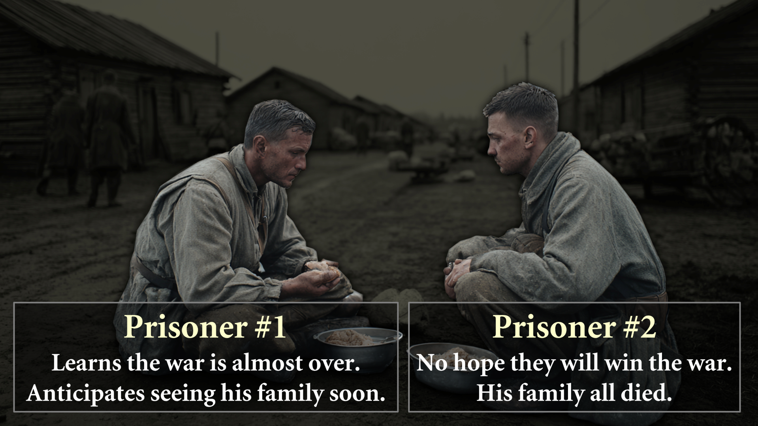

“You’ll have plenty of time to learn about Heaven when you get there.”

“Nobody can really know what Heaven will be like. Even Scripture says we cannot know.”
(1 Cor. 2:9-10) The Scriptures say, “No eye has seen, no ear has heard, and no mind has imagined what God has prepared for those who love him.” ¹⁰ But it was to us that God revealed these things by his Spirit. For his Spirit searches out everything and shows us God’s deep secrets.
(2 Cor. 12:2-4) I was caught up to the third heaven… I was caught up to paradise and heard things so astounding that they cannot be expressed in words, things no human is allowed to tell.
(Deut. 29:29) The secret things belong to the LORD our God. But the things revealed belong to us and to our sons forever, that we may observe all the words of this law.
How are we supposed to think about something we can’t picture or know? (Colossians 3:1-3; Revelation 21-22)

Conclusions

Episode 2: What will Heaven be Like? (Revelation 21-22)

We want to use a “sanctified imagination.” Yet, revelation supersedes speculation.

(Rev. 21:1) Then I saw a new heaven and a new earth, for the first heaven and the first earth had passed away. And there was no longer any sea.
Renewed and Sinless Physical Universe
We will live in a renewed universe.
“New” (kainos) refers to “qualitative newness,” not “temporal newness” (neos).
“The creation itself will be liberated from its bondage to decay” (Romans 8:21).
“The renewal of all things” (palingenesia, Matthew 19:28).
“He set them in place forever and ever. His decree will never be revoked” (Psalms 148:6 NLT; sun, moon, stars, skies, etc.).
No bodies of water?
“The river of the water of life” (Revelation 22:1).
The “sea” refers to hostile humanity in rebellion against God (Revelation 13:1; 17:15; Daniel 7:3; Isaiah 17:12; 57:20).

We will have resurrected physical bodies—like Jesus (1 Corinthians 15:49; 1 John 3:2; Philippians 3:20-21).
Physical—not ghostly (Luke 24:39; John 20:27; 1 John 1:1-4).
Eat and drink (Matthew 26:29; Luke 24:41-43).
Recognize others (Matthew 8:11; Luke 24:16, 31; 1 Thessalonians 2:19-20).
Emotional (Luke 15:10; Matthew 25:21).
Made perfect (Hebrews 12:23, No more guilt, embarrassment, awkwardness, insecurity, etc.)
We will have glorious supernatural bodies—like Jesus
Jesus (Acts 9:3-9; Rev. 1:17) and us (Dan. 12:3; 1 Cor. 15:40-42)
Continuity: “Seed…” (1 Corinthians 15:36-38)
Invincible: “Raised imperishable… immortal” (1 Corinthians 15:42, 53)
Powerful (1 Corinthians 15:43)
Beautiful and glorious (Daniel 12:3; 1 Corinthians 15:40-42)
Teleportation? (John 20:19; Luke 24:31)
Ability to fly? (Acts 1:9-11; Matthew 14:25, 29)

(Rev. 21:2) I saw the Holy City, the new Jerusalem, coming down out of heaven from God, prepared as a bride beautifully dressed for her husband.
Is this a literal city?
It is called a “city” 15 times! (Revelation 21-22). Not “like a city” or “as a city.”
Specific architectural measurements (Revelation 21:15-17).
John gives many details: Foundation stones (Rev. 21:12-14), gates (Rev. 22:14), and building materials (Rev. 21:18-21).
Is this symbolic?
Outrageous imagery! The size of the pearls? (Revelation 21:21) The size of the city.
The numbers could be symbolic. 12,000 stadia? 144 cubits thick? 12 gates?
Allusions to the OT tabernacle. The Holy of Holies (1 Kings 6:19-20; 20 cubits). Stones from the high priest (Exodus 28:17-20). “God’s dwelling place is now among the people… I did not see a temple in the city, because the Lord God Almighty and the Lamb are its temple” (Revelation 21:3, 22)

Why describe Heaven as a city?
(Revelation 7:9) After this I saw a vast crowd, too great to count, from every nation and tribe and people and language.
(Revelation 21:24) The nations will walk by its light, and the kings of the earth will bring their splendor into it.

(Rev. 21:4) He will wipe every tear from their eyes. There will be no more death or mourning or crying or pain, for the old order of things has passed away.

(Rev. 22:4) “They will see his face.”
“The Beatific Vision” or “The Beautiful Sight”
“First Day in Heaven.” Kerolos Safwat
The problem isn’t with our eyes, but our hearts.

(Rev. 21:5) He who was seated on the throne said, “I am making everything new!” Then he said, “Write this down, for these words are trustworthy and true.”

(Rev. 21:6) He said to me: “It is done. I am the Alpha and the Omega, the Beginning and the End. To the thirsty I will give water without cost from the spring of the water of life.”

(Rev. 22:12) “Look, I am coming soon! My reward is with me, and I will give to each person according to what they have done.”
(1) People are the reward
Love for others (1 Thess. 2:19; Phil. 4:1)
(2) Projects are the reward
Serving others (Lk. 19:17)
(3) Praise is the reward
God’s praise is utterly unique (Jn. 5:44).
God will praise and glorify us (1 Pet. 1:7; 1 Cor. 2:7; 4:5; Mt. 25:21, 23).

(Rev. 22:17) The Spirit and the bride say, “Come!” And let the one who hears say, “Come!” Let the one who is thirsty come, and let the one who wishes take the free gift of the water of life.

(Rev. 22:20) He who testifies to these things says, “Yes, I am coming soon.” Amen. Come, Lord Jesus. The grace of the Lord Jesus be with God’s people. Amen.

Conclusions

Homework: Meditating on a Future Moment in your Life
Many people look forward to future moments in their lives. They might think about if they will get married, and if so, what their spouse might be like. They picture their wedding day. Others think about if they will have children and what they will be like. Still others look forward to vacations or getaways.
In this exercise, you are going to meditate on a very real day in your life—the day you meet Jesus. Read this passage five times. Each time, read it more slowly than the time before.
(Matthew 25:21) The master was full of praise. ‘Well done, my good and faithful servant. You have been faithful in handling this small amount, so now I will give you many more responsibilities. Let’s celebrate together!
The longer you meditate on Jesus’ words, the more insights you will grasp. Write down 20 insights that you see in this text. Don’t quit until you record 20 insights.
(1)
(2)
(3)
(4)
(5)
(6)
(7)
(8)
(9)
(10)
(11)
(12)
(13)
(14)
(15)
(16)
(17)
(18)
(19)
(20)
What were some of the insights that you learned through this exercise that you didn’t see at first glance?

Episode 3: Common Questions about Heaven (Part 1)

Can we know we’ll be there?
God has promised this, and “it is impossible for God to lie.”
Hebrews 6:18; Titus 1:2
God paid the ultimate price to ensure the reality of Heaven.
(1 Peter 1:18-19 NLT) It was not paid with mere gold or silver, which lose their value. It was the precious blood of Christ, the sinless, spotless Lamb of God.
God wants you to know.
(1 John 5:13) I have written to you who believe in the name of the Son of God, so that you may know that you have eternal life.

Soul Sleep?
“Sleep” is symbolic for death.
John 11:11-14; Acts 7:60; 13:36; 1 Corinthians 15:51
In sleep, the body is motionless and the mind is alive.
Passages for soul sleep are weak.
Psalm 6:5; 115:17; 146:4; Ecclesiastes 3:20; 9:5, 10
Passages against soul sleep are overwhelming.
Luke 23:43; Matthew 10:28; 17:1-9; 22:32; 2 Corinthians 5:6-8; Philippians 1:21-23; Revelation 6:9-11; 2 Samuel 28:11-19

The Present Heaven?
God won’t create the New Heavens and Earth until after the Second Coming and Millennial Kingdom (Revelation 21-22; Isaiah 65-66).
Now, we go directly into God’ presence.
Flying from Columbus to Paris with a “layover” in Atlanta.
(Rev. 6:9) I saw under the altar the souls of those who had been slain because of the word of God and the testimony they had maintained. ¹⁰ They called out in a loud voice, “How long, Sovereign Lord, holy and true, until you judge the inhabitants of the earth and avenge our blood?” ¹¹ Then each of them was given a white robe, and they were told to wait a little longer, until the full number of their fellow servants were killed just as they had been.
1.

2.

3.

4.

5.

6.

7.

The Present Hell?
This is called Hades (NT) or Sheol (OT).
Acts 2:27-31; cf. Revelation 20:13-14; Matthew 11:23; 16:18; Luke 16:23; Revelation 1:18
Referred to “the grave” or “death.”
Those in Hades wait for their ultimate judgment from God.
(2 Pet. 2:9) The Lord knows how to rescue the godly from temptation, and to keep the unrighteous under punishment for the day of judgment.

Eating and drinking?
We will eat “fish” and the “best pieces of meat.”
1 John 3:2; Luke 24:42-43; Isaiah 25:6
We will drink the “finest of wines” with Jesus himself.
(Isaiah 25:6) The LORD Almighty will prepare a feast of rich food for all peoples, a banquet of aged wine—the best of meats and the finest of wines.
(Matthew 26:29 NLT) “Mark my words—I will not drink wine again until the day I drink it new with you in my Father’s Kingdom.”

Animals and pets?
There will be animals.
Isaiah 11, 60, 65; Romans 8:19-22. Genesis 1:26-28; 8:21; Psalm 8:6-8; 36:6; 145:9; Proverbs 12:10; Jonah 4:11
No, there will not be pets.
Yes, there will be pets.
But this shouldn’t be our focus!

How old will we appear?
The first humans were created as grown adults (married age).
Genesis 1:28; 2:18, 23-25
Jesus was resurrected at age 37.
5 BC to AD 33.
1 John 3:2; Philippians 3:20-21; 1 Corinthians 15:49
Will babies grow up?

Sports or Competition?
Scripture uses athletic imagery to describe serving God.
1 Corinthians 9:24-27; Hebrews 12:1-2; 1 Timothy 4:7-8; 2 Timothy 2:5; 4:7
Not all competition is selfish.
Competition can push you to greater excellence.
Competition with yourself.
Good competitors are sad when players are injured.

Space travel?
If we can achieve space travel today under the curse of a fallen world, why wouldn’t we have it in Heaven without the curse?
Flight, teleportation, indestructible.
FLIGHT: Acts 1:9-11; Matthew 14:25, 29
TELEPORTATION: John 20:19; Luke 24:31
INDESTRUCTIBLE: 1 Corinthians 15:42, 53

Episode 4: Common Questions about Heaven (Part 2)

Sex in Heaven?
No: “In the resurrection they neither marry nor are given in marriage.”
Matthew 22:30; cf. 1 Corinthians 7:8-11
Strange, because the Bible is pro-sex.
Genesis 1:28; 2:18-25; Song 2:6, 17; 5:4, 14; Proverbs 5:19; 1 Corinthians 7:3-5
Other religions focus on sex as a reward.
ISLAM: Men are given virgins (55:56, 74; 56:35-37).
“Full breasted companions of equal age” (78:33).
MORMONISM: Doctrine & Covenants 132:19-20
We are thinking far too small.
“You will fill me… with eternal pleasures” (Psalm 16:11).

Is the Afterlife in the OT?
Direct evidence of the afterlife.
Genesis 3:22; 5:24; 2 Kings 2:11; Job 19:25-27; Psalm 16:10-11; 17:15; 21:6; 49:15; 73:24-26; Isaiah 25:8; 26:19; Daniel 12:2; 1 Samuel 28:11-15
Evidence from the soul (nepeš).
God is a soul (nepeš): God’s “soul” (nepeš) can “abhor” (Lev. 26:30; Isa. 1:14) and has desires (1 Sam. 2:35).
Humans are a soul (nepeš) with a body: Death occurs when the “soul” (nepeš) leaves the body (Gen. 35:18; 1 Kings 17:21-22), and life occurs when the “soul” enters (1 Kings 17:21-22).
Like all doctrines, the afterlife was progressively revealed.

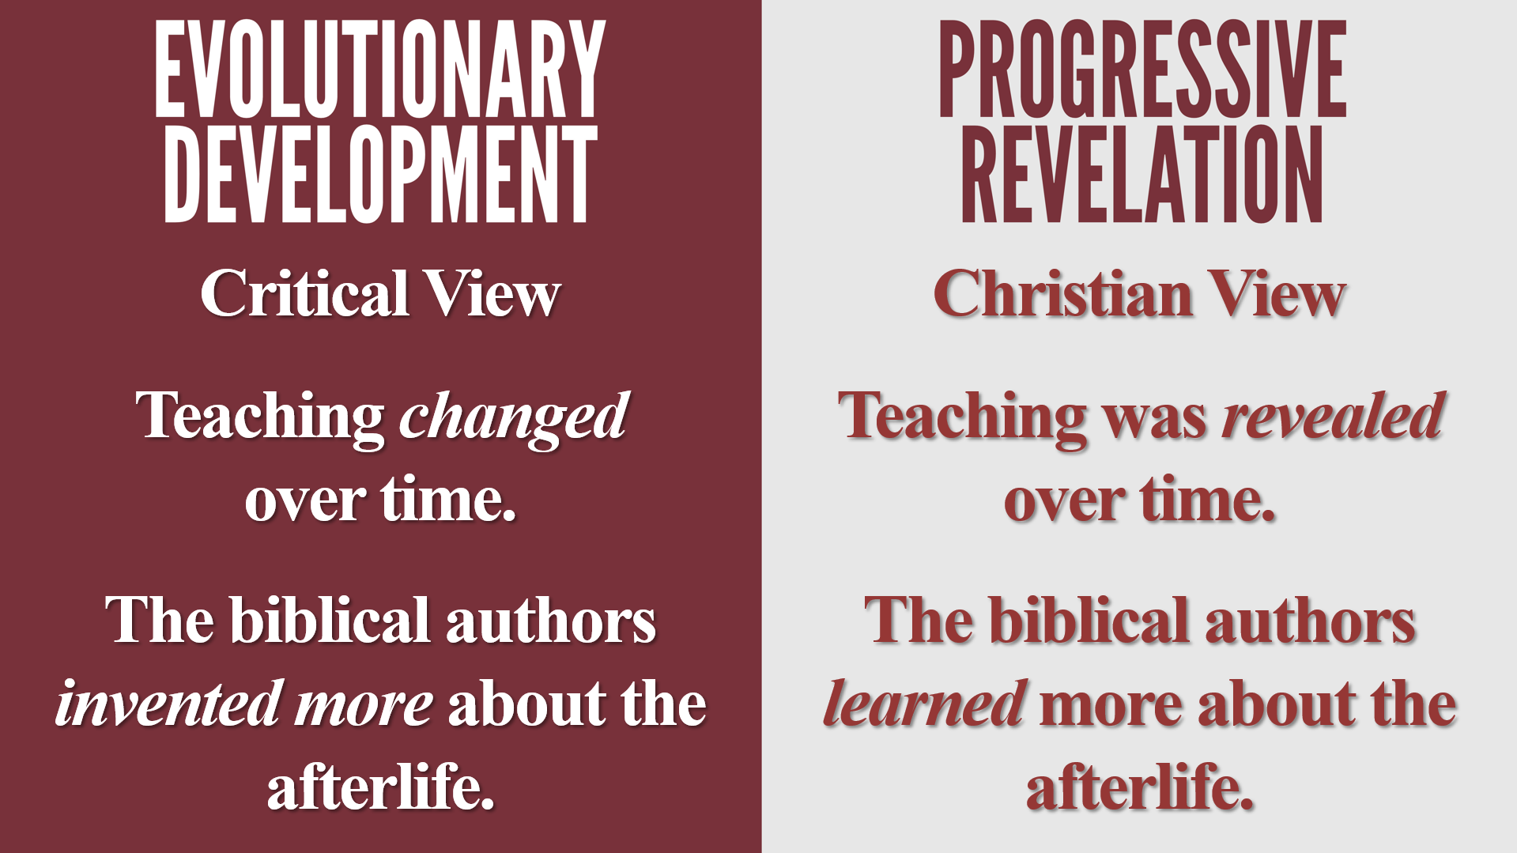

Eternal church service?
This is cultural baggage.
Contemporary church culture.
Biblical worship services.
“Shouting” more than “singing” (Rev. 5:11-12; 6:1, 10; 7:10).
Singing isn’t the only image of what we’ll do in Heaven.
Ruling and reigning (2 Timothy 2:12; 5:10; 22:15).
Leading cities (Luke 19:17-19; Matthew 25:21).
Judging angels (1 Corinthians 6:2-3).
Building and gardening (Isaiah 65:21-23).
Learning (1 Corinthains 13:12).

Will Heaven get boring?
God is eternally happy and not boring.
1 Timothy 6:15; Zephaniah 3:17; John 17:5, 24-26
Finite beings and an Infinite Being.
Are we sure we will have perfect memories, skills, and achievements?
This is an assumption—not a biblical teaching.
Repetition doesn’t mean boredom.

Free will in Heaven?
God doesn’t sin—yet has free will.
We will never freely choose to sin.
The Cross. Knowledge of a fallen world. Beatific vision
Sin will be logically possible, but it will never be actualized.
e.g. holding your newborn baby in your hands

What about totally annihilated bodies?
Sadducees (Matthew 22:23) and Corinthians (1 Cor. 15:35-36).
Cremation and cannibalism?
God is omnipotent.
He’s not the king in the nursery rhyme Humpty Dumpty!
The molecules in my body aren’t essentially me.
This would mean we currently don’t have personal identity.

Loved ones in Hell?
We don’t know if they came to Christ.
Matthew 27:44; Luke 23:43
God is the ultimate good.
Keeping any created thing, but losing God…
Everything will be revealed.
1 Corinthians 4:5
Our view of someone can change in a moment.
Everything good about them will be removed (1 Thess. 1:9).
What about future generations?
Your decision will affect your friends, kids, and grandkids.

Why do Christians grieve?
“Godly men” grieved over Stephen.
Acts 8:2
Epaphroditus was sick: Paul felt it would bring “sorrow upon sorrow.”
Philippians 2:27
Jesus was “a man of sorrows and acquainted with grief” and “wept.”
Isaiah 53:3; John 11:35
We don’t grieve that they are in Heaven, but that we are currently separated.

Do babies go to Heaven?
They are below the “age of accountability.”
We need rationality to have morality.
David: “I will go to him one day, but he cannot return to me”
2 Samuel 12:23; cf. Romans 4:6-8; Psalm 16:11
There is an age before a child is able to “know to refuse the evil and choose the good” (Isa. 7:16).
Isaiah 7:16; cf. Deuteronomy 1:39; Mk. 10:14; Mt. 18:3; 19:14

Conclusions
(1)

(2)

(3)

Homework
Write down a list of what you’re looking forward to the most in Heaven. Be specific. Pray through this list every day this week—until you feel happy.

Episode 5: The Afterlife in World Religions (Part 1)
(1)

(2)

(3)

(4)

Judaism

Areas of Agreement
Christianity arose from Judaism, and Jesus is thoroughly Jewish.
Jesus said, “Salvation is from the Jews” (Jn. 4:22).
He had a “custom” of going to synagogue (Lk. 4:16).
He celebrated Hanukkah (Jn. 10:22) and Passover (Jn. 2:13).
People called him “rabbi” (Jn. 3:2; 4:31; 6:25; 20:16).
There are various forms of Judaism.
Orthodox, Conservative, Reform
Conservative and Orthodox affirm life after death in the Messianic Age.
(Hebrew Olam Ha-Ba)

Areas of Disagreement
The afterlife is somewhat vague.
Berakhot 17a
Judgment is for rehabilitation, not retribution.
“Gehinnom” isn’t eternal for the vast majority of people.
One year maximum before entering Olam Ha-Ba
Rosh Hashanah 17a, Mishnah Eduyot 2:10; Shabbat 33b
Eternal life is through Israel, Yom Kippur, repentance, and good works.
Mishnah Sanhedrin 10:1; Yoma 8.8; Rosh Hashanah 16b;
Maimonides, Laws of Kings (Hilchot Melachim), 2.1, 3.4
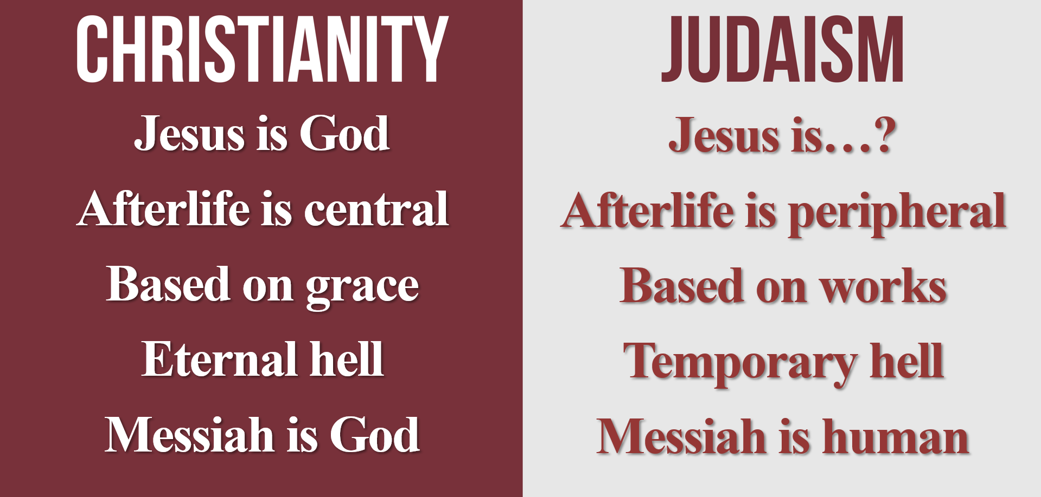

Islam

Background
Muhammad (AD 570-632) is the final prophet of God (Surah 33:40).
Received his visions from the angel Gabriel in AD 610-632 (Surah 96:1)
Battled the Meccans for 22 years. Battle of Badr (AD 624), Uhud (AD 625), and Trench (AD 627).
Died in AD 632. Pneumonia (Sunni Muslims) or poison (Shiite Muslims).

Areas of Agreement
Belief in the Bible
“This is the Book about which there is no doubt, a guidance for those conscious of Allah” (2:2).
The Bible is “guidance for the people” (3:3-4), as well as “guidance and light” (5:42-47).
Belief in Jesus
The Qu’ran mentions Jesus in fifteen chapters (surat) and 93 verses (ayat), and it names three chapters after Jesus (Surah 3, 5, 19).
Jesus performed many miracles. 2:87, 253; 3:49; 5:110
Jesus was a prophet whom Muslims should believe. 2:136; 4:163
Jesus was given honor from God. 3:45
Jesus was righteous and sinless. 3:46; 6:85
Jesus was the Word of God. Arabic Kalimat Allah; 4:171; c.f. 3:40, 45
Jesus was born of a virgin. 19:19-34
Jesus was the Messiah. 3:40, 45; 4:156-157, 169-172; 5:17, 19
Jesus was a prophet of God. 19:30-31
Jesus had a message of guidance and light, and he brought a message that people were cursed if they didn’t believe. 5:46, 78
Jesus will be at the final judgment, and he will tell people to fear and obey God. 43:61, 63
Belief in a physical Heaven.
Gardens and rivers. Surah 2:25; 55:50
Eating and drinking (no hangovers). Surah 47:15; 56:19
Restored relationships. Surah 7:43; 52:21

Areas of Disagreement
Shirk is the unforgiveable sin—namely, worshipping Jesus as God.
(5:72) “They have certainly disbelieved who say, ‘Allah is the Messiah, the son of Mary’ …Indeed, he who associates others with Allah—Allah has forbidden him Paradise, and his refuge is the Fire.’”
Good deeds must outweigh bad.
(7:8-9) “Those whose scales are heavy—it is they who will be the successful. And those whose scales are light—they are the ones who will lose themselves for what injustice they were doing toward Our verses.”
No one has assurance of salvation.
“He forgives whom He wills and punishes whom He wills.” Surah 2:284; 3:129; 48:14
“I do not know what will be done with me or with you.” Surah 46:9
“No one’s deeds will admit him into Paradise.
They said, “Not even you, O Messenger of Allah?”
He said, “Not even me, unless Allah covers me with His mercy.”
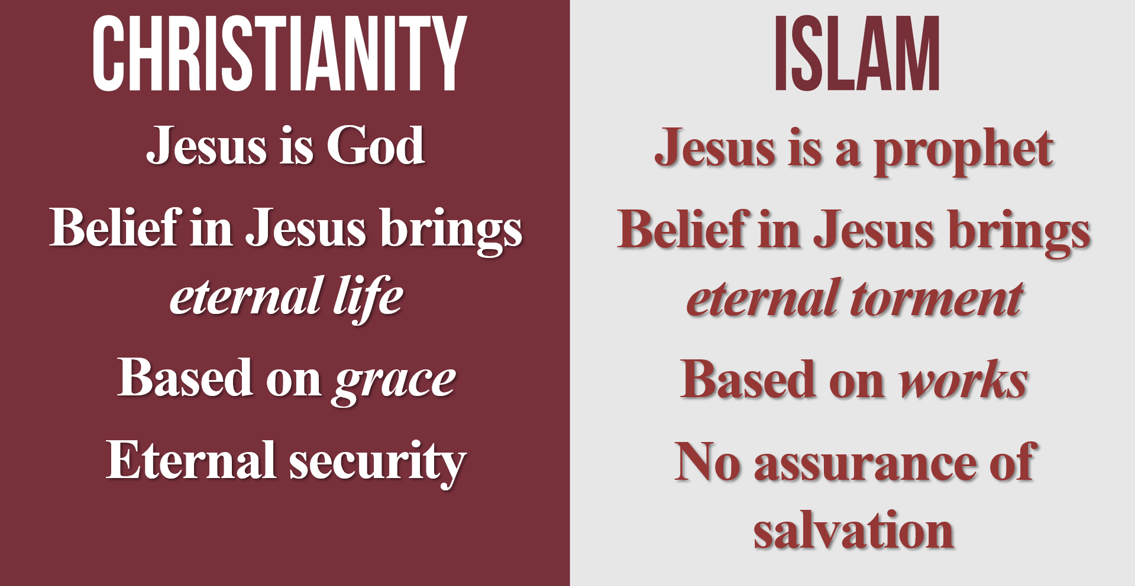

Buddhism

Background
Siddhartha Gautama was born in India (modern-day Nepal) in the 6th century BC.
At age 30, he left his wife and son in search of answers to the human condition: He became “the Buddha.”

Areas of Agreement
“Conquer anger by love.” Dhammapada 223
“Boundless heart toward all beings.” Sutta Nipāta 1.8
“From craving arises sorrow.” Dhammapada 216
“Hurt not others in ways that you yourself would find hurtful.” Udāna-Varga 5.18
“All fear death.” Dhammapada 129

Areas of Disagreement
Atheistic, agnostic, or pantheistic.

The self is an illusion.

No personal afterlife.

No beginning to the universe and no end.

Karmic law (“action”). Humans experience the consequences of their actions in previous lives, and as a result, the misfortunes plaguing people in the world were the result of their previous decisions.

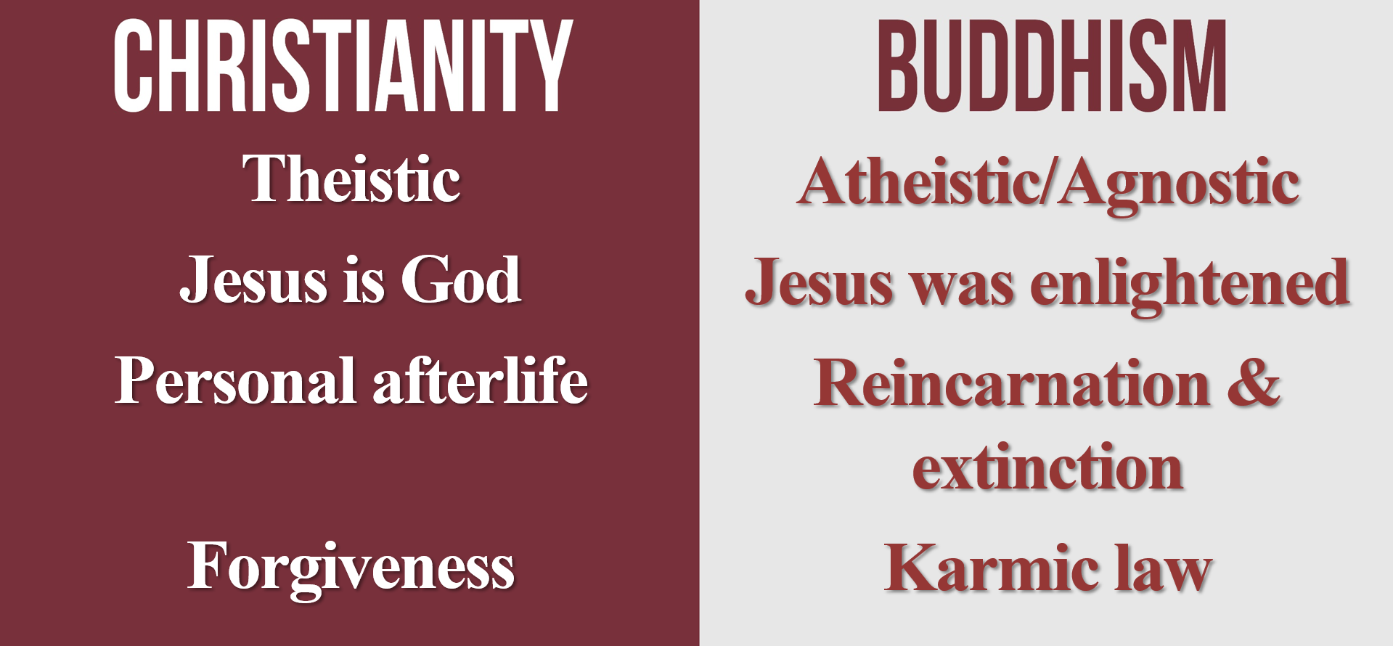

Hinduism

Background
“Hindu” comes from the Sankrit name for the Indus River: “Sindhu.” Persians had difficulty pronouncing ‘s.’
Very ancient with no identifiable founder.
Persians (Aryanianism) conquered India in the 2nd millennium BC. Dead horse worship.
Vedas, Upanishads, Bhagavad-Gita
In 600 BC, they moved the focus from animal sacrifice and priestly service to personal and private meditation.

Areas of Agreement
“This is the sum of duty: do not do to others what would cause pain if done to you.” Dhammapada 223
“When a man gives up all desires… then he is steadfast in wisdom.” Bhagavad Gita 2:55
“Fix your mind on Me, be devoted to Me, sacrifice to Me.” Bhagavad Gita 9:34

Areas of Disagreement
Pantheistic or polytheistic. 330 million gods.
History is cyclical—not linear. Bhagavad Gita 8:19; 9:7
The afterlife is extinction of the self. Moksha (“release”) is losing identity with Brahman (“the All”). Chandogya Upanishad 6.8.7; Brihadaranyaka Upanishad 1.4.10; 2.4.14
The material world is maya (“illusion”). Brihadaranyaka Upanishad 2.4.14; Chandogya Upanishad 3.14.1
The afterlife is works-based. Katha, Upanishad 2.3.14
The Upanishads compare the self to dropping a piece of salt into water. Chandogya Upanishad, 6.13.1-2
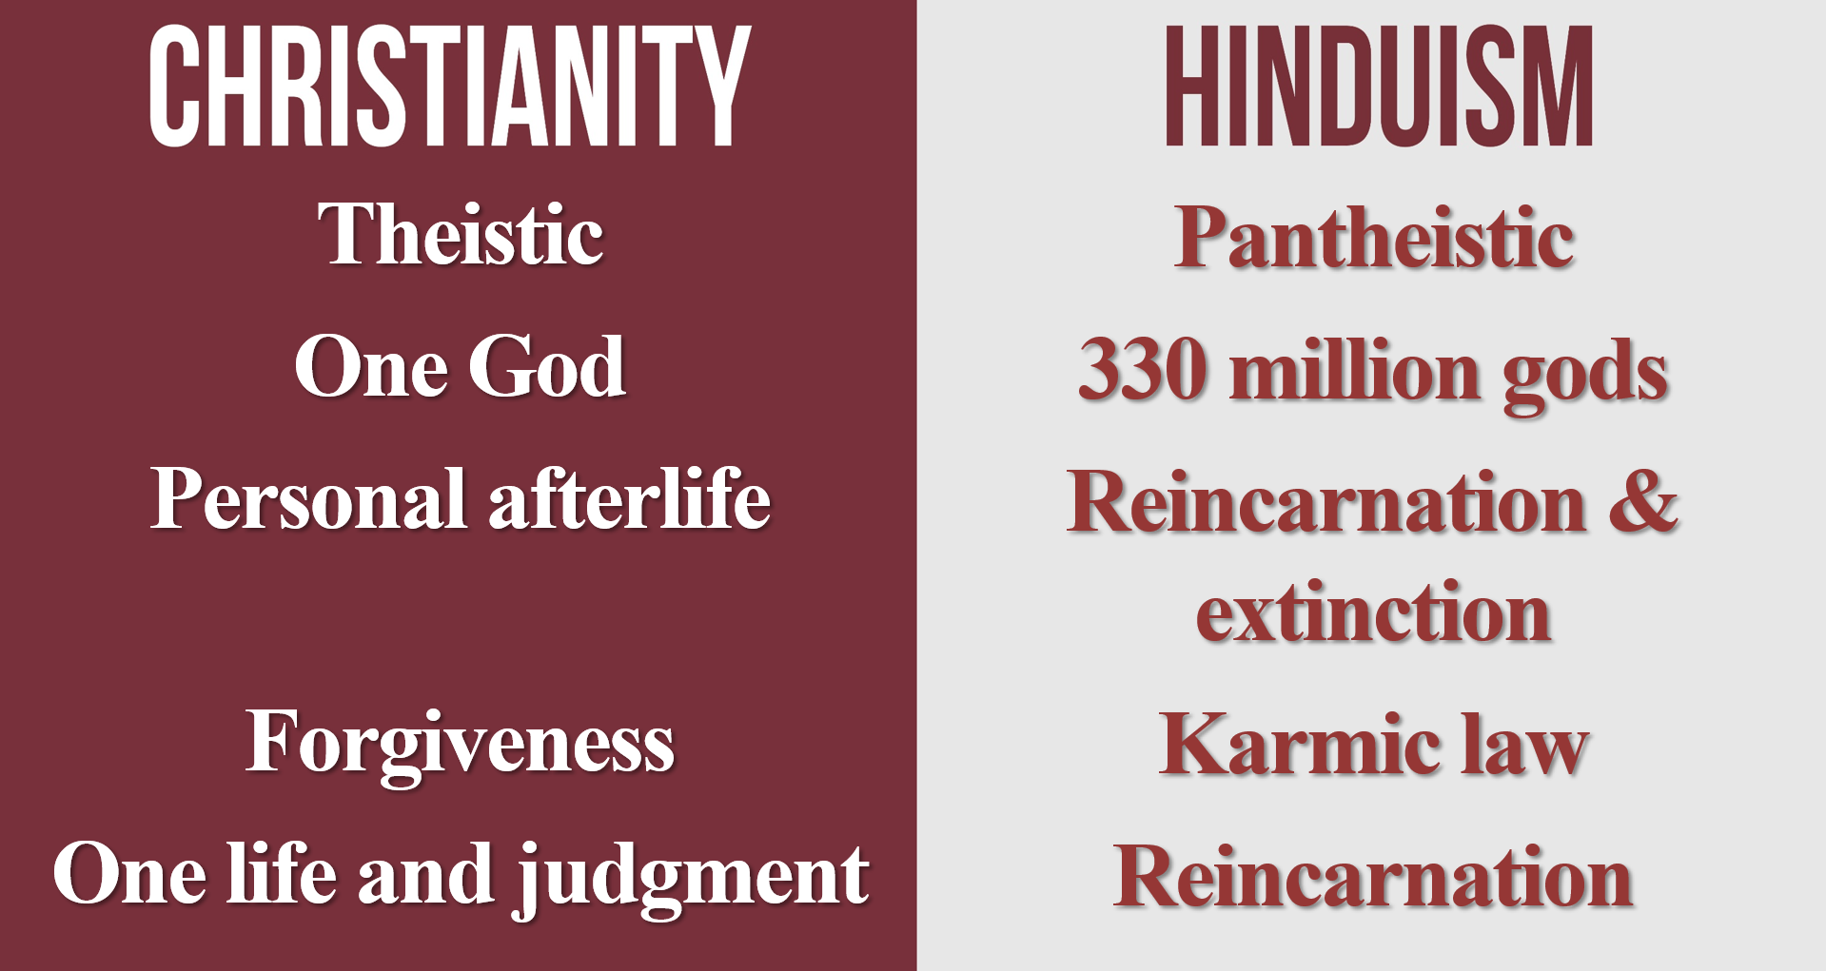

Episode 6: The Afterlife in World Religions (Part 2)

Reincarnation
One quarter (27%) of Americans believe in reincarnation is “definitely or probably true.”

(1) Biblical Problems (Philippians 1:21-23; 2 Corinthians 5:8; Luke 23:43. Matthew 11:14; 17:12; Luke 1:17; John 1:21; 9:2-3?)
(Heb. 9:27) People are destined to die once, and after that to face judgment.
Was John the Baptist reincarnated? Jesus and John were born six months apart (Luke 1:8-36), and Elijah never died (2 Kings 2:10-12).

(2) Philosophical and Moral Problems (e.g. justice, human dignity, etc.).
If karmic law is designed to cure the human condition, why hasn’t the world improved?
If people are being judged based on how they lived in previous lives, why should we help hurting people?
Aren’t these “evil people” getting what they deserve?
If souls can really transmigrate into other species, does this mean we should treat humans as equal to insect and avian life?
If birth defects are the result of karmic law, should we abstain from using modern medicine to heal newborn babies?
Isn’t it cruel for infants to be punished in this life for actions that they made as adults in past lives?
If they are supposed to learn their lesson, why can’t they remember what they did wrong in order to learn from their mistake?
(3) Evidential Problems (Evidentially conflicting reports. What about déjà vu?)
Evidential Conflicts
Why do people often think they were unique, famous people? (e.g. Napoleon, Jesus Christ, Alexander the Great)
Why don’t more people believe that they were a latrine cleaner in an earlier existence? It’s impossible for hundreds of living people to have all been Napolean. Either all of them are mistaken, or only one of them is correct. On a purely logical basis, most (if not all) of these reports must be false.
What about déjà vu?
(1) People often sense déjà vu in places that are younger than the person!
(2) We shouldn’t trust our worldview to a fleeting sensation (e.g. Mandela Effect).
(3) Sometimes explained by naturalistic explanations (e.g. seeing similar situations, pictures, or delayed processing).

Scientific Evidence
(1) Geographically close. “Nearly all the cases…” were 5 miles away, same family, family friends (p.247).
(2) Dated interviews. They share between ages 2-5 (p.102), but they forget between ages 5-8 (p.106, 120).
(3) Parents and interpreters. The parents speak for the child (pp.132-133). Stevenson wrote, “I have to use interpreters for many interviews” (p.129, e.g. India, Sri Lanka, Burma, etc.).
(4) Higher caste in previous life (e.g. Shanti Devi, Jasbir Case, Swarnlata Mishra).

Purgatory

Areas of Agreement
Roman Catholics and Evangelicals have much on which to agree. God, Christ, sin, heaven, hell, and the Bible.
Purgatory is one area of disagreement. Martin Luther, C.S. Lewis, John Polkinghorne, Jerry Walls, George MacDonald, J.B. Phillips, William Barclay.
This is a disagreement with Catholicism—not Catholic people.

What is Purgatory?
Purgatory comes from the Latin term purgatorio. This means “cleansing” or “purifying” or “purging.” The “fire” could be metaphorical. The CCC calls it “temporal punishment for sin” (1472).
Venial sins (venia) are “pardonable.” CCC, 1862-76
Mortal sins (mortalis) are “lethal.” CCC, 1862-76
Bathtub illustration.
Mortal sins are not covered by the sacrament of the Eucharist—only through confession and penance.

Problems with Purgatory
Absent from Scripture.
(2 Maccabees 12:46) “Thus he made atonement for the dead that they might be freed from this sin.”
Not Scripture and not good history. 1 Maccabees 9:27 denies its own prophetic inspiration. Melito of Sardis (2nd century), Athanasius of Alexandria (AD 367), and Jerome (AD 420) rejected the Apocrypha.
These soldiers committed a mortal sin without penance (2 Maccabees 12:40).
They were praying for resurrection at the final state—not purgatory in the intermediate state (2 Maccabees 12:43-44).
(Matthew 12:32) “Whoever speaks against the Holy Spirit, it shall not be forgiven him, either in this age or in the age to come.”
In Purgatory, the sin is forgiven.
(Mk. 3:29) “Whoever blasphemes against the Holy Spirit never has forgiveness, but is guilty of an eternal sin.”
(1 Corinthians 3:13-15) Each man’s work will become evident. For the day will show it. It is to be revealed with fire, and the fire itself will test the quality of each man’s work. If any man’s work which he has built on it remains, he will receive a reward. If any man’s work is burned up, he will suffer loss. But he himself will be saved, yet so as through fire.
Evaluation
(1) Context: “work.” This is mentioned four times in the context.
(2) All people: not for venial sins (“any man” “each man”).
(3) The fire “reveals” but doesn’t “purge.” (“Evident… shows it… reveals… test.”)
(4) “Reward,” not punishment (verse 14).
(5) “Suffer loss” (zēmioō, TDNT, 2:888). “Forfeit” (Mt. 16:26; Mk. 8:36), “loss” (Phil. 3:7), or financial “loss” (Acts 27:10).
(6) This happens on the “Day,” not now. “The day will show it” (v.13).
Joseph Cevetell (Roman Catholic Theologian): “The doctrine of purgatory is not explicitly stated in the Bible… The only passage that can be cited in support of the doctrine of purgatory is 2 Maccabees 12.39-45… In the final analysis, the Catholic doctrine on purgatory is based on tradition, not Sacred Scripture.”

Contradicts Scripture.
(Jn. 17:4) “I have brought you glory on earth by finishing the work you gave me to do.”
(Jn. 19:30) Jesus said, “It is finished.”
(Heb. 10:12) Jesus, having offered one sacrifice for sins for all time, sat down at the right hand of God…¹⁴ By one offering He has perfected for all time those who are sanctified.
(Col. 2:10) In Christ, you have been made complete.
(Lk. 23:43) Jesus promised the thief on the Cross, “Truly I say to you, today you shall be with Me in Paradise.” (cf. Mt. 27:44!).
(cf. Phil. 1:21-23; 2 Cor. 5:6-8; 1 Jn. 1:7; Isa. 57:1-2; Rev. 14:13; 1 Thess. 5:9-10; 2 Tim. 4:8)
(1 Cor. 15:51-53) We will not all sleep, but we will all be changed. In a flash, in the twinkling of an eye, at the last trumpet. For the trumpet will sound, the dead will be raised imperishable, and we will be changed. For the perishable must clothe itself with the imperishable, and the mortal with immortality.
(1 Jn. 3:2) We know that when Christ appears, we shall be like him, for we shall see him as he is.

Arguments from church history are inconclusive and unauthoritative.
Purgatory consists of a constellation of doctrinal accretions over centuries. The teaching of the church fathers is complex, conflicting, and changing—certainly not unanimous.
(1) Prayers for the dead (2nd c.) These existed early for refrigerium (“refreshment”).
These weren’t for purification, but refrigerium (“refreshment”). Some prayers were made for the Virgin Mary.
Tomb inscriptions: “In peace,” “he sleeps in peace,’ “live in God,” “in Christ,” and “live forever.”
(2) Indulgences (11th c.).
The first full (“plenary”) indulgence was for those who fought in the Crusades under Pope Urban II (AD 1095).
Nikolaus Paulus, Indulgences as a Social Factor in the Middle Ages (1922). In the 11th century, penance was given apart from the sacraments in the form of indulgences.
Pope Innocent VIII gave a papal bull to kill the Waldensians (Id Nostri Cordis, 1487).
(3) Treasury of Merit (13th c.)
This storehouse of righteousness is from Jesus, Mary, and supererogatory saints, and it is dispensed to others through the Pope.
“This treasure He… entrusted to Blessed Peter, the key-bearer, and his successors, that they might, for just and reasonable causes, distribute it to the faithful in full or in partial remission of the temporal punishment due to sin.” Pope Clement VI, Unigenitus Dei Filius (1343).
What is “good news” about paying off your own sins for hundreds or thousands of years?
(1 Thess. 4:13) We do not want you to be uninformed about those who sleep in death, so that you do not grieve like the rest of mankind, who have no hope.
(1 Thess. 5:9-11) God did not appoint us to suffer wrath but to receive salvation through our Lord Jesus Christ. He died for us so that, whether we are awake or asleep, we may live together with him. Therefore encourage one another and build each other up.

Conclusions

Homework
Synthesize what you learned about the afterlife by answering these questions:
(1) What makes you think the biblical view of the afterlife is true?
(2) What makes the biblical view good?
(3) What makes the biblical view beautiful?

Episode 7: Evidence for the Afterlife

Evidence of the Afterlife from Jesus
Jesus is the premier authority on Heaven
(Jn. 3:13) No one has ascended into heaven, but He who descended from heaven: the Son of Man.
(Jn. 6:38) I have come down from heaven.
(Jn. 16:28) I came forth from the Father and have come into the world.

Evidence of the Afterlife from Anthropology
“No subject… has so engrossed the mind of man as that of his condition after death…. They regarded the dead as still carrying on some kind of existence…. [Primitive people] had thought much about it…. There are very few [primitive] peoples who believe in utter extinction.”
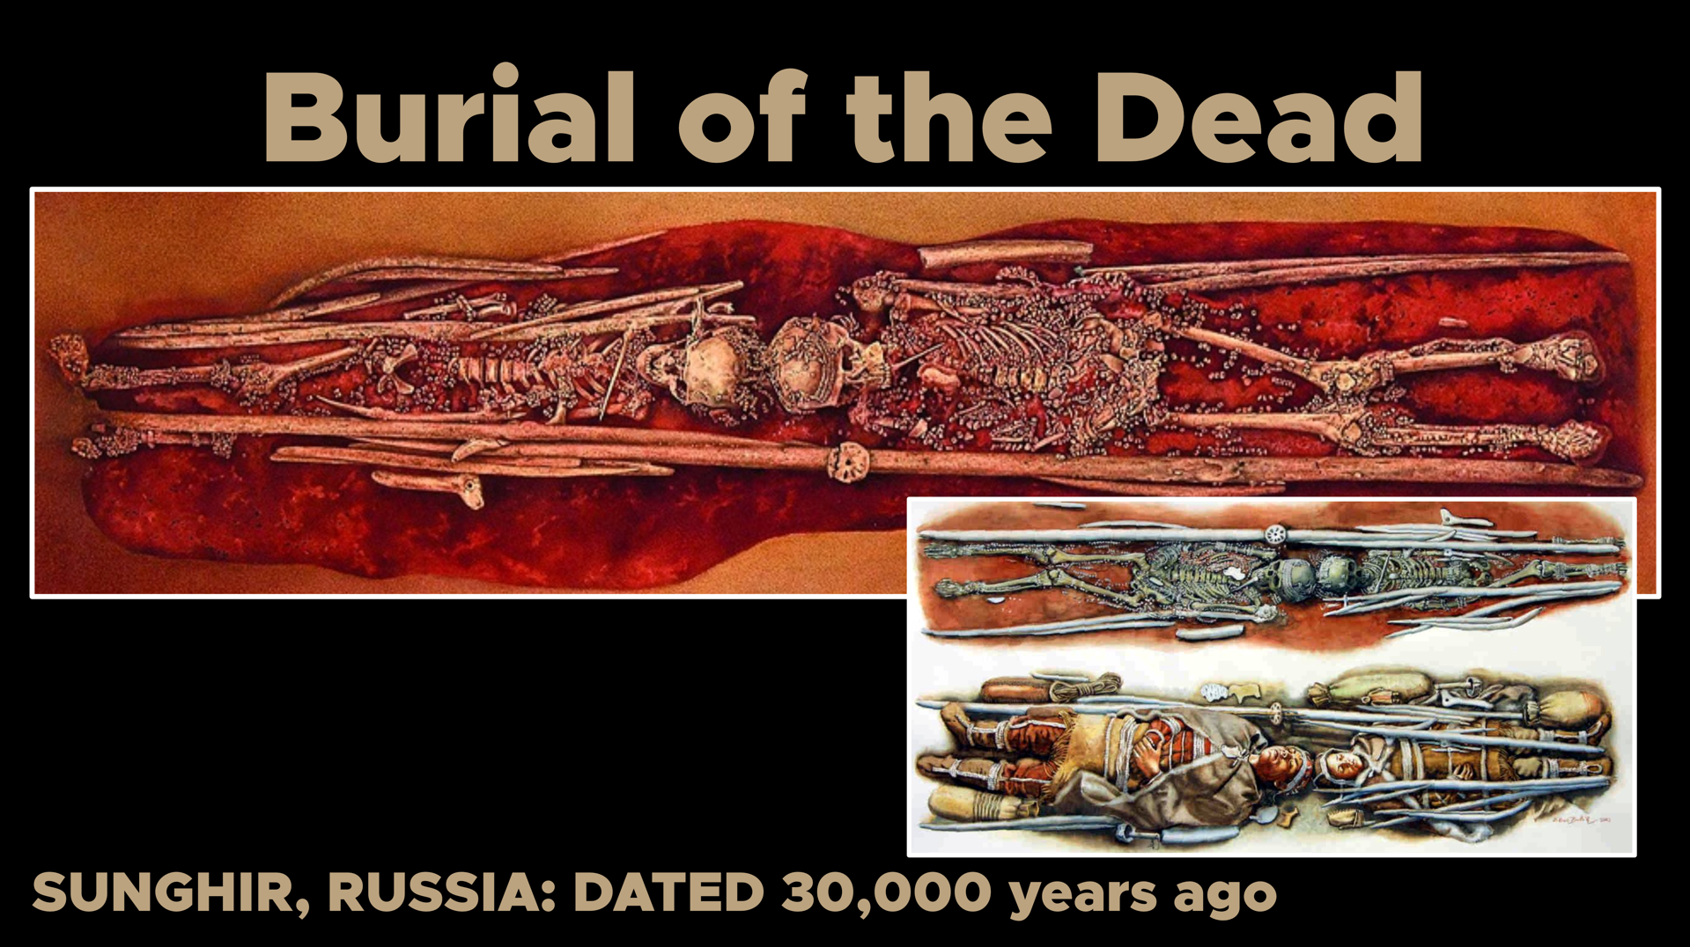
250 fox teeth and 5,000 ivory beads, which took ~2,500 hours to create.
“Most, if not all, of the world’s cultures maintain some sort of belief in life after death.”
(1973) 76% of Americans believed in life after death.
(2022) 82% of Americans believe in life after death.

Evidence of the Afterlife from Desire
Sehnsucht is German for “longing” or “life’s yearning.”
Augustine, Confessions (Book 1, Chapter 1), 4th c.
Aquinas, Summa Contra Gentiles (13th c.)
Blaise Pascal, Pensées VII (425), 1670.
G.K. Chesterton, The Everlasting Man pp.106-132, 20th c.
C.S. Lewis, “The Weight of Glory.” 20th c.
Completion of long-term dreams.
Gaining fame, fortune, notoriety.
Returning to your childhood home.
Nostalgia of music, photos, memories.
The sadness of beauty.
Grief that fictional worlds aren’t real.

Bertrand Russell: “The centre of me is always and eternally a terrible pain… a searching for something beyond what the world contains, something transfigured and infinite—the beatific vision, God—I do not find it, I do not think it is to be found—but the love of it is my life.”
Christopher Hitchens: “I admit it has evangelical overtones. But I do long for a higher love.” [Speaking of favorite song: Steve Winwood’s, “Higher Love.”]
C.S. Lewis: “A man may love a woman and not win her; but it would be very odd if the phenomenon called ‘falling in love’ occurred in a sexless world.”

Evidence of the Afterlife from Death Anxiety
If there is no afterlife, then humans have nothing to fear regarding death.
Death is natural—given naturalism. Could there be anything more natural? Animals avoid predators out of instinct.
You cannot fear death when you’re dead. Dying is sometimes painful, but death is not.
You were non-existent before birth.
Life is meaningful because it ends.
Eternal life is undesirable anyways.
Humans are terrified of death.
“Fear of death.”
“Death anxiety.”
“Abject terror.”
“Perfused with anxiety.”
“Offensive.”
“Horror of death.”
“Traumatic.”
“Disturbing and absurd.”
“Unimaginable.”
Therefore, there is an afterlife.

Episode 8: Evidence for the Soul

(1) Evidence from Scripture
(Lk. 23:43) Jesus said to [the thief on the cross], “Truly I say to you, today you shall be with Me in Paradise.”
(Acts 7:59) They went on stoning Stephen as he called on the Lord and said, “Lord Jesus, receive my spirit!”
Matthew 17:1-9; 22:32; Luke 8:55; 16:19-31; 2 Corinthians 5:1-10; 12:2-4; Philippians 1:23; Hebrews 12:23; Revelation 6:9-11

(2) Evidence from Direct Perception
If we are purely physical…
Free will is an illusion
Reason is an illusion
Morality is an illusion
Lifelong identity is an illusion

(3) Evidence from Philosophy
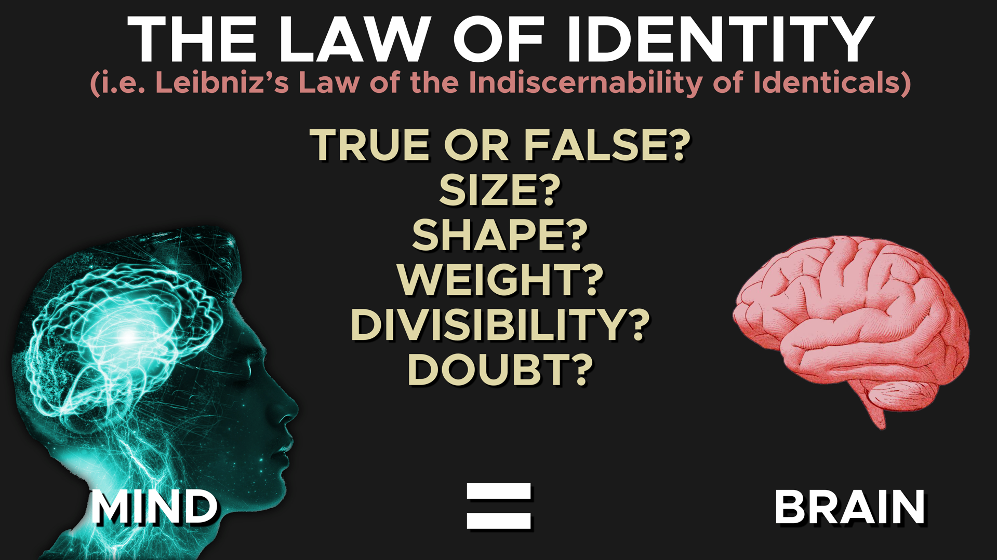

(4) Evidence from Neuroscience
Comatose patients with consciousness
Adrian Owen’s team asked questions to those in a persistent vegetative state and a control group of conscious subjects. Identical results in fMRI! If gibberish was spoken, the comatose patients showed no response. Adrian M. Owen et al., “Detecting Awareness in the Vegetative State,” Science 313, no. 5792 (September 8, 2006): 1402.
Adrian Owen: “15 to 20 percent of people in the vegetative state, who are assumed to have no more awareness than a head of broccoli, are in fact fully conscious.”
Able to distinguish between action and brain stimulation
Wilder Penfield: “When I have caused a conscious patient to move his hand by applying an electrode to the motor cortex of one hemisphere, I have often asked him about it. Invariably his response was: ‘I didn’t do that. You did.’ When I caused him to vocalize, he said: ‘I didn’t make that sound. You pulled it out of me.’”
Split-brains have one center of consciousness
They cut the hemispheres to reduce epilepsy. Severing the bundle of fibers in the corpus callosum. There were changes in visual perception, but consciousness. There were not two centers of consciousness.
Others showed a unified visual field.
Neuroplasticity: thoughts change the brain
Dr. Jeffrey Schwartz (a Research Psychiatrist at UCLA School of Medicine) documented success in using cognitive behavioral therapy in working with OCD patients.

Episode 9: Evidence from Near-Death Experiences
Common Experiences
1 in 25 people (US and Germany) claim a near-death experience (NDE).
Encountering a “being of light.”
Life review.
God is loving, good, and just.
Life change.
The NDE ends when the lesson is over.
The experience is “ineffable.”
Drastic increase of a belief in life after death.
Pam Reynolds
Hypothermic cardiac arrest. She had a highly dangerous brain aneurysm: They dropped core temperature to 60 degrees Fahrenheit. Drained the blood from her brain. No brain waves, no heartbeat, no breathing. Taped her eyes shut, and they monitored her anesthesia with 95-decibel clicks from speakers inserted into her ears (similar to a subway train or whistling teakettle).
She identified Midas Rex bone saw.
She recounted hearing that her “arteries [were] very small.”
“Katie”
Comatose 7-year-old who drowned. She described the paramedics, doctors and procedures.
“That’s the one with the beard. First there was this tall doctor who didn’t have a beard, and then he came in. First I was in a big room, and then they moved me to a smaller room where they did X-rays on me.”
They shoved a “tube down my nose.” She described what was happening to her family during the three days. For dinner, the family ate roast chicken and rice. Her siblings played with a G.I. Joe in a jeep. Her dad was crying in his office.
Blind sight
Dr. Kenneth Ring (a retired professor of psychology at the University of Connecticut) found that 80% of blind subjects in his sample had out of body experiences at clinical death where they could see the events around them.
Other Examples
A man learned about his real biological father. His mother confessed to an affair on her deathbed (10 years later).
A man knew where his dentures went. The nurse placed dentures in a specific drawer in a crash cart.
A woman recognized a painting of Heaven. A five-year-old girl had an NDE. At age 60, she gave a painting of what she saw to her physician. He placed it next to 10 other landscape paintings… Another NDEr recognized the geography.

Naturalistic Objections
They only explain a fraction of the data.
(1) Are NDEs a modern fad?

(2) Are NDEs pseudo-science?

(3) Are NDEs religious wish-fulfillment?

(4) Are people lying to get famous?

(5) Are people just guessing?

(6) Are NDEs chemical hallucinations or the result of a dying brain?

Theological Objections
(1) Do non-Christians claim to see their God (or gods) when they have NDEs?

(2) Why are NDEs of Heaven—not Hell?

(3) Are NDEs demonic deceptions?

(4) How can people come back from death in NDEs? Is this a second-chance?

(5) Why don’t people hear the gospel?

Conclusions
The Bible is the final authority on the afterlife—not NDEs. Minimally, the fact that anyone is having any experience at all is utterly bizarre if naturalism is true. Imagine a car that could drive even after you siphoned all of the gas out of the tank and pulled the keys out of the ignition. You’d consider it a possessed car.

Homework
Pray through two passages about Heaven by writing out your thoughts. When you apply this method, you are using the words of Scripture to generate prayer. As you read, tell God what you think about what he said.
To give you an idea of how this works, here is my demonstration of this method below with Romans 8:31-39.
“What shall we say about such wonderful things as these? If God is for us, who can ever be against us?” (Romans 8:31)
“God, first of all, you have said wonderful things to me in this chapter. Thank you that your words for me are wonderful. Today, I was struck by what you said in…”
“God, I know that you are always for me. Who in my life am I thinking about whose opinion is more important to me than yours? Even if they don’t like me, I’m so grateful that you are always for me.”
“Since he did not spare even his own Son but gave him up for us all, won’t he also give us everything else?” (Romans 8:32)
“God, I keep thinking about whether you are going to come through with my recent health issue. But if you gave me the most valuable gift you could give, I’ve got no reason to think you’re going to hold out on answering my prayers about my health. Even if the answer is, No, this must be for my ultimate good and your plans for eternity. Since you gave me the gift of Christ, I have no reason to doubt your goodness.”
“Who dares accuse us whom God has chosen for his own? No one—for God himself has given us right standing with himself” (Romans 8:33).
“Satan has been accusing me about my recent moral failure. I’m choosing to refuse to listen to him right now. I’m consciously turning my attention to you and the divine fact that you’ve declared me NOT GUILTY! I’m choosing to trust your words more than my guilty feelings.”
“Who then will condemn us? No one—for Christ Jesus died for us and was raised to life for us, and he is sitting in the place of honor at God’s right hand, pleading for us” (Romans 8:34).
“There is no condemnation for me because I’m ‘in Christ.’ I’m not living for the approval of people. They are just as flawed and broken as me. Why am I living for their verdict about me? Help me to live out of the verdict that you’ve already given me: NOT GUILTY!”
“Can anything ever separate us from Christ’s love? Does it mean he no longer loves us if we have trouble or calamity, or are persecuted, or hungry, or destitute, or in danger, or threatened with death?” (Romans 8:35)
“God, I’ve been anxious about the fact that my car needs a new transmission. I’m not sure how I’m going to get to work this week. But I’m glad that the most important issue in my life is solved. I’m never going to be separated from you. Ever! And I know that these bad circumstances have nothing to do with a lack of love on your part. Help me to cherish your love more than I focus on my lousy circumstances.”
“As the Scriptures say, ‘For your sake we are killed every day; we are being slaughtered like sheep’” (Romans 8:36).
“Thanks that I’m not suffering to the point of death!”
“No, despite all these things, overwhelming victory is ours through Christ, who loved us” (Romans 8:37).
“I don’t have overwhelming victory in my life. But I want it! I know that the key to this is Christ’s love. Fill my heart with a new understanding of his love today. Help me to conquer my suffering by accessing the peace and happiness that come from knowing that you love me.”
“And I am convinced that nothing can ever separate us from God’s love. Neither death nor life, neither angels nor demons, neither our fears for today nor our worries about tomorrow—not even the powers of hell can separate us from God’s love. No power in the sky above or in the earth below—indeed, nothing in all creation will ever be able to separate us from the love of God that is revealed in Christ Jesus our Lord” (Romans 8:38-39).
“God, my life is filled with a lot of insecurity. Thanks that the most important issues in my life are eternally secure. I’m grateful that I’ll never have to worry about you rejecting me or walking out on me.”

Your Turn: John 14
(John 14:1 NIV) “Do not let your hearts be troubled. You believe in God; believe also in me.”

(John 14:2) “My Father’s house has many rooms; if that were not so, would I have told you that I am going there to prepare a place for you?”

(John 14:3) “And if I go and prepare a place for you, I will come back and take you to be with me that you also may be where I am.”

(John 14:4) “You know the way to the place where I am going.”

(1 Peter 1:3-4 NLT) All praise to God, the Father of our Lord Jesus Christ. It is by his great mercy that we have been born again, because God raised Jesus Christ from the dead. Now we live with great expectation, and we have a priceless inheritance—an inheritance that is kept in heaven for you, pure and undefiled, beyond the reach of change and decay.

(1 Peter 1:5) And through your faith, God is protecting you by his power until you receive this salvation, which is ready to be revealed on the last day for all to see.

(1 Peter 1:6) So be truly glad. There is wonderful joy ahead, even though you must endure many trials for a little while.

(1 Peter 1:7) These trials will show that your faith is genuine. It is being tested as fire tests and purifies gold—though your faith is far more precious than mere gold. So when your faith remains strong through many trials, it will bring you much praise and glory and honor on the day when Jesus Christ is revealed to the whole world.

Episode 10: Eternal Rewards (Part 1)

Are eternal rewards biblical?
(Mt. 16:27) The Son of Man… will reward each person according to what they have done.
(Rev. 22:12) Look, I am coming soon! My reward is with me. I will give to each person according to what they have done.
(Mt. 19:30) Many who are first will be last, and many who are last will be first.
cf. Matthew 20:16; Mark 10:31; Luke 13:30
This refers to the next life—not this life.
(1 Cor. 3:14-15) If any man’s work which he has built on it remains, he will receive a reward. If any man’s work is burned up, he will suffer loss.”
“Reward” and “loss” are eternal.
The “crown” (stephanos) is the victor’s wreath—not the royal crown (diadēma).
1 Corinthians 9:25; 2 Timothy 4:8; James 1:12; 1 Peter 5:4
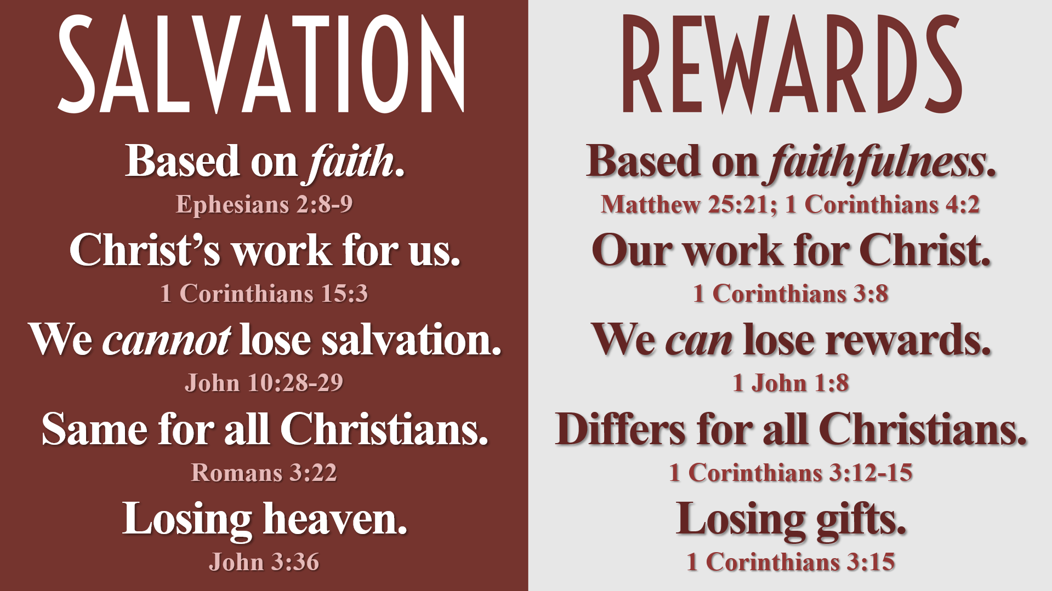

Are eternal rewards selfish?
(1) Not all self-interest is selfish.
e.g. breathing air, drinking water, marriage, children, etc.
God doesn’t have a lack of resources.
You can’t outgive God (Mark 10:29-31).
(2) It’s prideful to refuse free gifts.
(3) Eternal rewards keep us from selfishness in this life.

Why should we invest in eternity?
(1) It is the only intelligent investment.
“True riches” (Lk. 16:11).
“Treasures in heaven” (Mt. 6:20).
“Make yourselves money belts” (Lk. 12:33).
“The profit which increases to your account” (Phil. 4:17).
“Storing up for themselves the treasure of a good foundation for the future” (1 Tim. 6:19).

(2) It focuses our values on people—not possessions, pleasure, or prestige.
1 Thessalonians 2:19-20; 1 John 2:15-17; Revelation 21:21
If this life is all you have, you have the anticipation of knowing…

(3) It keeps us spiritually healthy.
Materialism (1 John 2:15-17; Matthew 6:19-20).
Forgiveness and bitterness (Rom. 12:17-21).
Humility (Matthew 19:30; 20:16; Mark 10:16; Luke 13:30).

(4) This life will be over very soon.
The average American lives about 78 years.
This is “a vapor” or “a breath” compared to eternity (James 4:14; Psalm 39:5).
(Ps. 90:12) Moses wrote, “Teach us to realize the brevity of life, so that we may grow in wisdom.”

(5) It’s motivating.

Episode 11: Eternal Rewards (Part 2)

How will we be judged?
(1) Based on what you actually did.
He didn’t say, ‘Well thought,’ ‘Well intended,’ or ‘Well planned.’ He said, ‘Well done!’” Mark Hitchcock, Heavenly Rewards, 104.

(2) Based on how much you know.
(Lk. 12:48) Someone who does not know, and then does something wrong, will be punished only lightly. When someone has been given much, much will be required in return. And when someone has been entrusted with much, even more will be required.

(3) Based on your own gifts and resources.
“What do you have that you did not receive?” (1 Cor. 4:7)
“Entrusted his possessions to them” (Mt. 25:14).
“Invest this for me while I am gone” (Lk. 19:13).
Counseling (1 Cor. 12:9)
Communication (Eph. 4:11)
Encouragement (Rom. 12:8)
Sharing about Christ (Eph. 4:11)
Prophetic voice (Rom. 12:6)
Faith (1 Cor. 12:9)
Financial giving (Rom. 12:8)
Serving (Rom. 12:7; 1 Cor. 12:28)
Hospitality (1 Pet. 4:9)
Knowledge (1 Cor. 12:8)
Leadership (Rom. 12:8)
Mercy (Rom. 12:8)
The 5-talent man and the 2-talent man receive identical praise!

(4) Based on a perfect analysis.
Psalm 11:4-5; 56:8; Proverbs 5:21

Will the judgment be public or private?
“Everything that is covered up will be revealed, and all that is secret will be made known to all” (Luke 12:2).

The Master announces rewards publicly.
“He said to the bystanders…” (Luke 19:24).

In Greco-Roman culture, the Bema Seat was public—not private.

Will we have regret?
(1 Cor. 3:15) If any man’s work is burned up, he will suffer loss. But he himself will be saved, yet so as through fire.
“Suffer loss” (zēmioō, TDNT, 2:888).
“Forfeit” (Mt. 16:26), “loss” (Phil. 3:7; Acts 27:10).

We will be proud of others—not jealous.
Philippians 2:16; 2 Corinthians 1:13-14

We will be surprised at God’s generosity.
1 Corinthians 4:5; Hebrews 11; Matthew 25:37; Luke 17:10

(1 Cor. 4:5) Do not go on passing judgment before the time. But wait until the Lord comes who will both bring to light the things hidden in the darkness and disclose the motives of men’s hearts. And then each man’s praise will come to him from God.

What are ways to gain rewards?
(1) Loving fellow believers
Hebrews 6:10; 10:24-25

(2) Financial Giving
Matthew 6:1-4; Luke 12:33-34; 14:13-14; 1 Timothy 6:17-19

(3) Perseverance through suffering
Matthew 5:11-12; Romans 8:17; 2 Corinthians 4:8-18; 2 Timothy 2:12; James 1:12; Hebrews 10:32-36; Revelation 2:10

(4) Evangelism
Daniel 12:3; 1 Thessalonians 2:19-20

(5) Leading and teaching others
James 3:1; 1 Peter 5:2-4

What rewards will we receive?
(1) Radiate God’s glory.
Daniel 12:3; 1 Corinthians 15:40-42

(2) Praise from God.
1 Peter 1:7; 1 Corinthians 2:7

(3) Crowns and clothes.
1 Corinthians 9:25; 2 Timothy 4:8; James 1:12; 1 Peter 5:4; Revelation 2:10; 3:4-5; 19:8

(4) Responsibility over “cities.”
Luke 19:11-27

(5) Being with many people we love.
1 Thessalonians 2:19-20; Philippians 4:1

Responses?

Adam Harwood, Christian Theology: Biblical, Historical, and Systematic (Bellingham, WA: Lexham Academic, 2022), 786.
Grant R. Osborne, Revelation (2002), 729-730; Leon Morris, Revelation (1987), 100; Randy C. Alcorn, Heaven (2004), 147-151.
Kittel, TDNT 3.447.
R.C. Sproul, Unseen Realities (2011), 98.
Nancey Murphy, Bodies and Souls or Spirited Bodies? (2006). Joel B. Green, Body, Soul, and Human Life (2008). Seventh-Day Adventists and Jehovah’s Witnesses.
Randy Alcorn, Heaven (Tyndale House, 2004), 43. Jerry L. Walls, Heaven, Hell, and Purgatory (2015), 30.
L. Coenen in New International Dictionary of New Testament Theology (Grand Rapids, MI: Zondervan, 1986), 206. “God” (theos) comes from the Germanic and Norse words for Pagan gods (“Gut” and “Guð”).
Joni Eareckson Tada, Heaven, 54 (cited Eccl. 3:21).
Randy C. Alcorn, Heaven, 397-409. Peter Kreeft, Everything You Ever Wanted to Know (1990), 45. C. S. Lewis, The Problem of Pain (1962), 138-39. Hank Hanegraaff, AfterLife, 45. Mark Hitchcock, 55 Answers (2005).
Thomas Aquinas, Summa Theologica (Question 81, Article 1). Alister E. McGrath, A Brief History of Heaven (2003), 38.
Thomas Aquinas, Summa Theologica (Question 81, Article 1). Erwin W. Lutzer, One Minute After You Die (1997), 74. Peter Kreeft, Four Views on Heaven (2022), 169.
John S. Feinberg, “A Traditional Evangelical Protestant Perspective,” in Four Views on Heaven, ed. Michael E. Wittmer (Grand Rapids, MI: Zondervan Academic, 2022), 35. Randy C. Alcorn, Heaven (2004), 253-256.
Bernard Williams, “The Makropulos Case: Reflections on the Tedium of Immortality.”
Peter Kreeft, Everything You Ever Wanted (1990), 49-50. Hank Hanegraaff, AfterLife, 30.
Paul Helm, The Last Things (1989), 92.
Ian McEwan in Richard Dawkins and Lawrence Krauss, The Unbelievers (December, 2013).
Geoffrey Parrinder, Jesus in the Qur’an (Oxford, England: Oneworld Publications, 1996), 16.
Sahih al-Bukhari.
Nigosian, World Religions (2000), 21.
Lewis M. Hopfe, Religions of the World (1987), 82.
Carmody and Carmody, Ways to the Center (Belmont, CA: Wadsworth Pub., 1984), 65.
Carmody and Carmody, Ways to the Center (Belmont, CA: Wadsworth Pub., 1984), 67.
Carmody and Carmody, Ways to the Center (Belmont, CA: Wadsworth Pub., 1984), 64, 92.
Pew Research Center, “Spirituality Among Americans.” December 7, 2023.
Ian Stevenson, Children Who Remember Previous Lives (University Press of Virginia, 1987).
Joseph Cevetell, New Catholic Encyclopedia, 11:1034.
See William Cathcart, The Papal System (1872), 263.
Philip Schaff, History of the Christian Church (86. Epitaphs).
CCC, 1471. Nikolaus Paulus, Indulgences as a Social Factor in the Middle Ages (1922).
CCC, 1476-79. Lea, A History of Auricular Confession and Indulgences in the Latin Church (1896), 35-38.
J.A. MacCulloch, Encyclopedia of Religion and Ethics, “State of the Dead.” (Edinburgh: T. & T. Clark), 1981, 817-819.
Philip Lieberman, Uniquely Human (Cambridge, MA: Harvard UP, 1993), 162-164. Paul Pettitt, The Palaeolithic Origins of Human Burial (New York, Routledge, 2011), 198-207.
Alan F. Segal, Life after Death (Doubleday, 2004), 18.
Ryan Burge, “Belief in an Afterlife is Increasing in the United States,” Graphs About Religion (2025). Data drawn from the General Social Survey.
Bertrand Russell, “Letter to Colette O’Neil (Lady Constance Malleson),” October 23, 1916, from The Selected Letters of Bertrand Russell: The Public Years 1914-1970, ed. Nicholas Griffin (London: Routledge, 2001), 148.
Larry Alexander Taunton, The Faith of Christopher Hitchens (Nelson, 2016), 4.
C.S. Lewis, “The Weight of Glory.” Preached originally as a sermon in the Church of St Mary the Virgin, Oxford (June 8, 1942). Published in Theology.
Shelley Kagan, Death (New Haven: Yale University Press, 2012), 290-291. Michael Cholbi, “Rationally Facing Death.” Philosophy Compass 18 (2023).
Stephen E. Rosenbaum, “How to Be Dead and Not Care: A Defense of Epicurus.” American Philosophical Quarterly 23, no. 2 (1986): 217-225.
Thaddeus Metz, Meaning in Life: An Analytic Study (Oxford Press, 2013). Samuel Scheffler, Death and the Afterlife (Ed. Niko Kolodny. Oxford Press, 2013).
Bernard Williams, “The Makropulos Case: Reflections on the Tedium of Immortality.” In Problems of the Self (Cambridge, 1973), 82-100.
Adrian Owen, “How Science Found a Way to Help Coma Patients Communicate,” The Guardian (September 5, 2017).
Wilder Penfield, The Mystery of the Mind: A Critical Study of Consciousness and the Human Brain (Princeton: Princeton University Press, 1975), 76.
Justine Sergent, “Processing of Spatial Relations within and between the Disconnected Cerebral Hemispheres,” Brain 114, no. 2 (1991): 1025-1043. Yaïr Pinto, et al. “The Split-Brain Phenomenon Revisited: A Single Conscious Agent with Split Perception,” Trends in Cognitive Sciences 21, no. 11 (November 2017): 835-51.
Jeffrey Schwartz, Brain Lock (New York, NY: Regan, 1996) and You Are Not Your Brain (New York: Avery, 2011).
Pim van Lommel, Consciousness Beyond Life (New York: HarperCollins, 2010), 9.
Janice Holden, “Veridical Perception in Near-Death Experiences,” in The Handbook of Near-Death Experiences (2009), 198-199. Michael Sabom, Light & Death (1998), 184-187.
Melvin Morse and Paul Perry, Closer to the Light: Learning from Children’s Near-death Experiences (New York: 1990), 4.
Kenneth Ring and Sharon Cooper, Mindsight: Near-Death and Out-of-body Experiences in the Blind (William James Center for Consciousness Studies, 1999), 75, 126-127.
Pim van Lommel, “Non-Local Consciousness…” Journal of Consciousness Studies 20, no. 1-2 (January 1, 2013): 21.
Pim van Lommel, Consciousness Beyond Life (New York: HarperCollins, 2010), 21.
Mally Cox-Chapman, The Case for Heaven: Near Death Experiences as Evidence of the Afterlife (2012), Kindle 433.

