Changing our Minds about Porn

Table of Contents
[Hold down CONTROL and click the link to jump to that page.]
Episode #1. Is Porn Harmless? 7
Episode #2. Changing our Minds about Porn 10
Episode #3. LIES: Cognitive Distortions 15
Episode #4. The Externalization of Voices 25
Episode #5. Cycle of Porn 30
Episode #6. Creating a Plan for Victory 34

How do I pass this class?
To pass this class, students need to:
(1) Attend all classes.
(2) Get at least a 70% on the final exam.
(3) Cease viewing porn and enjoy a happy life knowing and serving God.
You will only get out of this class what you put in. Put in the work. You won’t regret the time you spend on this. It will change your life!

Memory Verses
This is the complete list of memory verses for this course. Watch this short video to gain some guidance and motivation for learning how to memorize Scripture.
(1 Cor. 6:13, 18) “The body is not for immorality… Flee immorality (porneia)”
(Gal. 5:19) “The deeds of the flesh are evident, which are immorality.”
(Eph. 5:3) “Immorality… must not even be named among you.”
(Eph. 4:17-23) You must no longer live as non-believers, in the futility of their thinking. ¹⁸ They are darkened in their understanding and separated from the life of God because of the ignorance that is in them due to the hardening of their hearts. ¹⁹ Having lost all sensitivity, they have given themselves over to sensuality so as to indulge in every kind of impurity, with a continual lust for more… ²³ Be made new in the attitude of your minds.
(2 Cor. 10:5) We demolish arguments and every pretension that sets itself up against the knowledge of God, and we take captive every thought to make it obedient to Christ.
(Rom. 12:2) Don’t copy the behavior and customs of this world, but let God transform you into a new person by changing the way you think. Then you will learn to know God’s will for you, which is good and pleasing and perfect.
(2 Tim. 2:20-21) In a large house there are not only gold and silver vessels, but also vessels of wood and of earthenware, and some to honor and some to dishonor. ²¹ Therefore, if anyone cleanses himself from these things, he will be a vessel for honor, sanctified, useful to the Master, prepared for every good work.
(Heb. 12:1) Let us throw off everything that hinders and the sin that so easily entangles, and let us run with perseverance the race marked out for us.
(1 Cor. 6:12) All things are lawful for me, but not all things are profitable. All things are lawful for me, but I will not be mastered by anything.
(1 Thess. 4:3) It is God’s will that you should be sanctified: that you should avoid sexual immorality.
(1 Thess. 5:23-25) May God himself sanctify you through and through… ²⁴ The One who calls you is faithful, and He will do it.

Why so much Scripture memorization?
Scripture memorization is absolutely essential to make a break from a sinful pattern of porn use. Dr. Howard Hendricks had this to say about Scripture memorization in relation to sanctification and addictions: “Do you know what I’ve discovered from working with people for the last 30 to 40 years? Once I get a person on an intensive Bible memory program, we begin to see supernatural changes. It’s a miracle what God does. Your mind can only embrace one thing at a time. As long as you and I are spending our mind focused on other things, you can be sure not much is going to change. But the moment I can get you focused on what God promised you… God provides everything we need for life and godliness. Do you believe that?”

Cheat Sheet for the Exam
Porn is similar to which of the following drugs?
(a) Stimulant
(b) Hallucinogen
(c) Barbiturate

From 2002 to 2010, erectile dysfunction among men under 40 jumped from:
2% to 35%

What percentage of porn depicts violent or aggressive sex?
34% to 88%

Participants in the famous Bryant-Zillman study were asked how many months a rapist should be incarcerated. The “massive exposure” to porn group gave a judgment that was what percentage of the “no exposure” to porn group?
50% (94 months compared to 50 months)

“Porn helps me feel happy.”
No known scientific study supports this.
The unhappiest people I know are addicted to porn.

“Porn helps me have a sexual release.”
If this is true, why is our culture more sexually satisfied than ever before in history?

“Porn helps me when I’m stressed out.”
Are porn-users LESS stressed than people who don’t use porn?
Porn cripples the coping mechanisms that help you relieve stress.

“Porn helps me when I’m bored.”
Do you feel LESS bored after a long binge on porn?
Non-porn users pursue goals, have more confidence, enjoy better relationships, possess mental sharpness, etc.

“I just want to look at porn once in a while.”
Every single instance of falling back into a porn habit starts with this thought!

“I’ll quit eventually.”
If porn is so great for you, why quit at all?

What can I look forward to after quitting porn?
New open doors? (2 Tim. 2:20-22)
More freedom? (Heb. 12:1; 1 Cor. 6:12)
God growing me? (1 Thess. 4:3; 5:23-24)

What’s your plan for times of temptation? (2pts)
(a) Recognize the feeling.
(b) Remember why you quit.
(c) Rejoice that you quit.
(d) Replace your thoughts.
Set a timer for 10 minutes.

What if you have a fall? (2pts)
(a) Claim your identity in Christ.
(b) Learn from the fall.
(c) Continue to trust that God is making progress, and will bring about eventual victory!
(d) Reject fatalism and refuse to be discouraged by the Enemy.
(e) Keep your eyes on the future.

Pre-Homework: The Benefits of Porn and Difficulties of Quitting
(1) Write down everything that porn positively gives you. (Yes, you read that right.) Be as specific as possible with these thoughts: How does porn make your quality of life better? What does it give to you that you enjoy? What does it help alleviate in your life?

(2) Write down everything that would be difficult about quitting porn. (Again, you read that right.) Be as specific as possible with these thoughts: What would make it difficult to quit porn? What steps would you need to take that would be hard?

(3) Moving forward, do you want to give up porn? If so, why on Earth would you want to do so? Everything you wrote above sounds so great that you’d have to be insane to quit, right? After all, porn gives you a lot of benefits, and quitting will cost you a lot of difficulty. So, why do you want to quit? This is honestly not “reverse psychology,” or whatever you want to call it. If you can’t answer this question with strong answers, what hope will you have in getting free from porn?
(1)

(2)

(3)

(4)

Episode #1. Is Porn Harmless?

Iceberg illustration
1. Wrong actions
2.
3.
4. Right actions

#1. Porn is incredibly addictive

Kuhn and Gallinat Study (2014)

DOPAMINE DRUG
(1) Stimulant
(2) Hallucinogen
(3) Barbiturate
Valerie Voon

#2. Porn impedes our ability to enjoy sex

What percentage of men aged 16-24 experienced erectile dysfunction?

History of ED

Erectile dysfunction between older and younger men
(2001-2002)
(2011)

#3. Porn dehumanizes women
What percentage of porn depicts violent or aggressive sex?

#4. Porn raises our tolerance of aberrant sex
What percentage of people watch porn they previously found disturbing?
Regular porn users were more likely to…
(1)
(2)
(3)

Bryant-Zillman Study
No exposure | Questions | Massive exposure
 | “What percentage of Americans engage in group sex?”
 | “Is marriage an important institution?”
 | “How long should a rapist be incarcerated?”

Homework: Reflection Questions
Write down your reflections on these questions below:
(1) If you had a friend who was struggling like you are, what insights would you want God to reveal to him?

(2) What do you think he would need to understand about God? Why would these insights be helpful?

(3) What do you think would keep him from experiencing God?

Discussion Groups
Break into groups of two (or three).
How would you respond to someone who said this?
(1) “I only define porn as hardcore videos.”

(2) “I don’t care what the studies say. I haven’t experienced the negative effects of porn. I feel fine.”

(3) “I don’t look at hardcore videos… Just pictures. I don’t think it’s the same.”

Memory Verses
(1 Cor. 6:13, 18) “The body is not for immorality… Flee immorality (porneia)”
(Gal. 5:19) “The deeds of the flesh are evident, which are immorality.”
(Eph. 5:3) “Immorality… must not even be named among you.”
(1 Thess. 4:3) “This is the will of God, your sanctification. That is, that you abstain from sexual immorality.”

Episode #2. Changing our Minds about Porn

Iceberg Illustration
1. Wrong Actions
2. False Beliefs
3. True Beliefs
4. Right Actions

Noetic Effects of Sin

Main Thesis?
When you give up porn…
[Take notes on how to respond to these false beliefs below.]

“Porn helps me feel happy.”

“Porn helps me have a sexual release.”

“Porn helps me when I’m stressed out.”

“Porn helps me when I’m bored.”

“I just want to look at porn once in a while.”

“I’ll quit eventually.”

“I’ll quit when I get married.”

Homework: Reflection Questions
Write down your reflections on these questions below:
(1) What do you need to be honest to God about? (e.g. fears, thoughts, actions, omissions, etc.)

(2) What are you willing to do to experience freedom?

(3) Do you want to take a big step of faith or a small one?

(4) Every day this week, ask God to help you.

Memory Verses
(Eph. 4:17-23) You must no longer live as non-believers, in the futility of their thinking. ¹⁸ They are darkened in their understanding and separated from the life of God because of the ignorance that is in them due to the hardening of their hearts. ¹⁹ Having lost all sensitivity, they have given themselves over to sensuality so as to indulge in every kind of impurity, with a continual lust for more… ²³ Be made new in the attitude of your minds.

Homework: Building a Happy Life
Imagine a little kid whose mother keeps telling him, “STOP hitting your brother… STOP jumping on the couch… STOP raising your voice… STOP chewing with your mouth open…” Good parents know that they need to encourage good behavior—not just criticize bad behavior. The same is true for adults—only now you are the adult in charge of your life.
You simply can’t live your life based around what you shouldn’t do. This would get you out of damaging behavior, but it wouldn’t help you build a healthy and happy life. You not only need to make a break from porn, but you also need to fill your life with healthy goals and interests, replacing porn with love relationships, gratitude, hobbies, exercise, etc.

Values and Goals
Researchers have found that writing about our values is one of the most powerful psychological interventions ever studied. Simply writing out our values has been shown to “boost GPAs, reduce doctor visits, improve mental health,” and it helps us “persevere in the face of discrimination and reduces self-handicapping.” People who “write about their values once, for ten minutes, show benefits months or even years later.”
What are the highest values that you have in your life? For instance, if all else failed, what do you value the most? (e.g. God, family, relationships, career, ministry, hobbies, TV, social media, etc.)

(1)

(2)

(3)

Based on your values, create a list of what you’d like your life to look like three weeks from now. For example, if my value was knowing the Bible, I would love it if I could know the main point of each chapter in the book of Acts in the next three weeks. Think of values in various areas of life: spiritual, relational, emotional, physical, financial, etc.
(1)

(2)

(3)

What are THREE HABITS you can start in the next THREE WEEKS to move toward your goal? Make your habits obvious, attractive, easy, and satisfying. For example, if you want to grow studying the Bible, here’s a layout:
Obvious: “I am going to leave my Bible and journal sitting out on my desk where I eat lunch. I’m not going to hide it in my drawer. Otherwise, I won’t remember.”
Attractive: “I am going to buy a nice bag of coffee from Stauf’s—even though it’s expensive. I’m also buying myself a Yeti. I’m going to drink coffee when I read in the morning.”
Easy: “I am going to set up my coffee maker the night before, so it’s ready to brew in the morning. My goal is to read and write down my thoughts for a chapter of Acts. At the very least, I’m going to read for 2 minutes. No matter what happens, I can read for 2 minutes.”
Satisfying: “Normally, I play a game on my phone with my morning coffee. I’m going to wait on the game until I have my coffee and read the book of Acts. I’ll play the game after I read. I am going to record my progress in the book of Acts each day.”

HABIT #1.
What are you going to do to make this habit OBVIOUS?

What are you going to do to make this habit ATTRACTIVE?

What are you going to do to make this habit EASY?

What are you going to do to make this habit SATISFYING?

HABIT #2.
What are you going to do to make this habit OBVIOUS?

What are you going to do to make this habit ATTRACTIVE?

What are you going to do to make this habit EASY?

What are you going to do to make this habit SATISFYING?

HABIT #3.
What are you going to do to make this habit OBVIOUS?

What are you going to do to make this habit ATTRACTIVE?

What are you going to do to make this habit EASY?

What are you going to do to make this habit SATISFYING?

CONCLUSION: What are you going to do to celebrate if you begin one or all of these habits over the next three weeks?

Discussion Groups
Break into groups of two (or three).
(1) Do you want to change? Why?

(2) What quick fixes have you tried before? What do you think the solution is?

(3) In what ways do you minimize, excuse, blame-shift, or self-justify your porn use?

Episode #3. LIES: Cognitive Distortions
Life:

Interpretation:

Emotion:

Suffering:

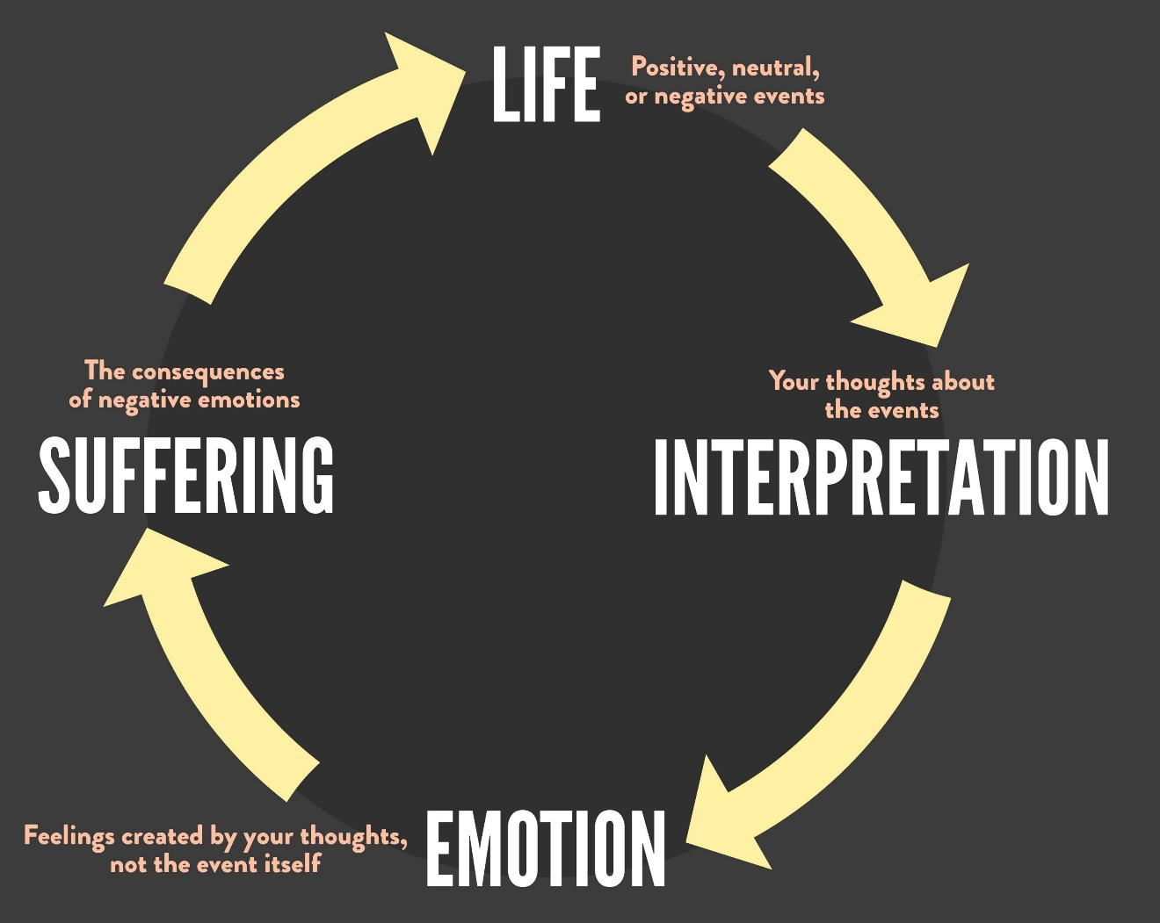

All-or-Nothing
Common with perfectionists

Negative Filtering
“Filter” out anything that’s positive

Fortune-Telling
Negative predictions that are unjustified or magnified.

Mind Reading
Thinking we know what others are thinking (about us).

Magnification (or Minimization)
Exaggerating negatives and minimizing positives

Emotional Reasoning
Feel = Real

Mislabeling
Identifying with my failures

Discussion Groups
Break into groups of two (or three). Identify the cognitive distortions in the statements listed in your handout.
(HINT: Some statements might be more than one.)

“I’ve made some progress. But I’m so far away from any sort of victory.”
“I have been out of porn for six months. But my recent fall brings me back to square one.”
“My spiritual life consists of how well I’m doing in porn.”
“I looked at a picture of a topless woman… I might as well binge!”
“No one is ever going to want to marry me. I’m going to be single for the rest of my life.”
“My porn problem is never going to go away. I’m going to have a fall every three months for the rest of my life.”
“Everyone has been judging me for this… They probably talk about me and think I’m a loser.”
“He’s only bringing this up because he’s disappointed in me.”
“I’ve taken some steps, but the overall picture is terrible.”
“Change is going to take forever.”
“10 minutes of prayer a day won’t help at all.”
“I am a failure.”
“No one else struggles with this.”
“I feel bored. Porn will help.”
“I don’t feel like getting started battling my porn problem… I’ll wait until tomorrow.”
“I’ll act on that truth when I sense that I’ve worked through my false beliefs.”
“I’m such a sinner.”
“I’ve been out of porn for three months… But most guys can do that.”
“I’m such an idiot.”
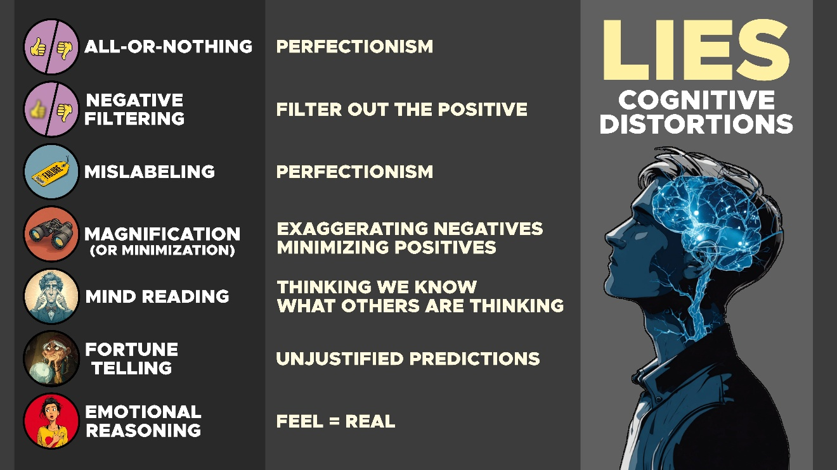

Homework: Biblical Meditation
Read the chapter from the forthcoming book The Means of Growth by James Rochford and Joseph Francisco. Do the interactive learning—learning biblical meditation.
Many hobbies teach you to slow down. If you’re learning to do woodworking, you’re told, “Measure twice and cut once.” If you’re cooking, you hear, “Haste makes waste.” In many areas of life, you progress faster by moving slower. The same is true when reading the Bible. The more you rush, the less you get out of it.
Our high-speed, modern world has changed the way we read and think. One study found that digital reading under time constraints resulted in poorer comprehension than relaxed print reading. Likewise, a cognitive neuroscientist found that skimming and browsing the Internet leads to a decline in concentration, critical thinking, and reading comprehension.
All of us have experienced the mind-numbing fog of scanning the Internet. Rather than connecting with the thoughts of another, we scan their words to find what we’re looking for. This blends the mental strain of casual reading and trying to find Waldo.
God wants you to linger long enough to hear his words. The psalmist prayed, “Open my eyes to see the wonderful truths in your instructions” (Psalm 119:18 NLT). God has plenty to say if you slow down to listen.
Biblical meditation won’t add something to your busy schedule. This is a break from your busy schedule. When you experience this, you’ll realize that convincing you to meditate is like convincing a marathon runner to take a drink of water or a young mother to take a nap. Meditation will lighten your load and carry your burdens—not add to them.

What is biblical meditation?
The first psalm states that the godly person “meditates” on God’s word “day and night” (Psalm 1:1-2). Eastern forms of meditation instruct people to empty their minds. Biblical meditation is just the opposite. According to the Bible, meditation isn’t the emptying of the mind but the filling of it. The term “meditate” (hāg̱āh) means to “murmur” or “mutter,” and the Bible translates this word as pondering, devising, and talking.
If you think you’re incapable of meditation, you’re wrong. You’ve already developed an expert ability to talk to yourself. You worry what your boss meant in his cryptic email, you ruminate over your credit card debt, and you deliberate over conflict at home. You already know how to meditate. You need to change your focus over what you meditate.
We’ve taught biblical meditation to many people over many years. They begin with thoughts racing through their mind. But after just a few minutes, they often visibly relax and say, “Wow, that feels good!” God changes you as you focus your mind on his character and his promises. Spend the next few minutes exploring these methods below.

Slow down
Most people read the Bible way too fast. Try this exercise below. Read this passage to yourself.
(1) “We demolish arguments and every pretension that sets itself up against the knowledge of God, and we take captive every thought to make it obedient to Christ” (2 Corinthians 10:5).
It’s very likely that you read this way too fast. Slow down. You’re not skimming an article online. You’re reading God’s words. Read this again—only 20% slower.
(2) “We demolish arguments and every pretension that sets itself up against the knowledge of God, and we take captive every thought to make it obedient to Christ” (2 Corinthians 10:5).
Don’t just run your eyes over the words. Take time to recognize what you’re reading. Slow down another 20%. This time, focus on each word.
(3) “We demolish arguments and every pretension that sets itself up against the knowledge of God, and we take captive every thought to make it obedient to Christ” (2 Corinthians 10:5).
Think about how much more you took from this passage on the third reading than the first. Each time you slow down, God will have more to share. When you find yourself skimming Scripture, try this exercise. You’ll discover a great paradox: Slowing down is the fastest way to connect with God.

Emphasize different words
Read this passage out loud.
(1) “Don’t copy the behavior and customs of this world, but let God transform you into a new person by changing the way you think. Then you will learn to know God’s will for you, which is good and pleasing and perfect” (Romans 12:2).
Read this passage out loud again. Only this time, emphasize the words that are underlined. For this exercise to work well, you really need to go overboard. In fact, if you feel like you’re being too intense, you probably aren’t even halfway where you need to be. As you emphasize certain words, ask yourself, “How does emphasizing these words change the meaning of the passage?”
(2) “Don’t copy the behavior and customs of this world, but let God transform you into a new person by changing the way you think. Then you will learn to know God’s will for you, which is good and pleasing and perfect” (Romans 12:2).
How does emphasizing these words change the meaning of the passage?

(3) “Don’t copy the behavior and customs of this world, but let God transform you into a new person by changing the way you think. Then you will learn to know God’s will for you, which is good and pleasing and perfect” (Romans 12:2).
How did emphasizing these words change the meaning of the passage?

(4) “Don’t copy the behavior and customs of this world, but let God transform you into a new person by changing the way you think. Then you will learn to know God’s will for you, which is good and pleasing and perfect” (Romans 12:2).
How did emphasizing these words change the meaning of the passage?

Personalize the text
The Bible was written for you, but it wasn’t written to you. The authors of Scripture wrote to specific audiences thousands of years ago, and it’s your role to figure out their original intent. God wants you to “correctly handle the word of truth” (2 Timothy 2:15 NIV), and he cannot speak to you if you don’t want to hear the meaning of his words.
Once you learn the meaning of a passage, you can connect with God by personalizing what you read or learned. Ask yourself this question: “If God wrote this message in a personal letter to you, what would it say?” This takes reflection, prayer, and practice. But see if you can get the hang of it by considering our paraphrase of this passage in Ephesians:
(Ephesians 1:17-19 NIV) I keep asking that the God of our Lord Jesus Christ, the glorious Father, may give you the Spirit of wisdom and revelation, so that you may know him better. ¹⁸ I pray that the eyes of your heart may be enlightened in order that you may know the hope to which he has called you, the riches of his glorious inheritance in his holy people, ¹⁹ and his incomparably great power for us who believe.
(MY PARAPHRASE) “James, I want to open your mind and heart so that you can know Me better. I love you so much. And I want you to know that deep in your heart. I want you to anticipate the great hope of heaven, the spiritual riches of your new identity in Christ, and the spiritual power that I have for you when you trust in Me.”
Now it’s your turn. Paraphrase these passages below, as though God was writing directly to you.
(Philippians 4:6-9 NIV) Do not be anxious about anything, but in every situation, by prayer and petition, with thanksgiving, present your requests to God. ⁷ And the peace of God, which transcends all understanding, will guard your hearts and your minds in Christ Jesus. ⁸ Finally, brothers and sisters, whatever is true, whatever is noble, whatever is right, whatever is pure, whatever is lovely, whatever is admirable—if anything is excellent or praiseworthy—think about such things. ⁹ Whatever you have learned or received or heard from me, or seen in me—put it into practice. And the God of peace will be with you.
(YOUR PARAPHRASE)

(Colossians 3:1-4 NIV) Since, then, you have been raised with Christ, set your hearts on things above, where Christ is, seated at the right hand of God. ² Set your minds on things above, not on earthly things. ³ For you died, and your life is now hidden with Christ in God. ⁴ When Christ, who is your life, appears, then you also will appear with him in glory.
(YOUR PARAPHRASE)

Squeeze it dry
The longer you meditate, the more insights you will grasp. For this exercise, write down 20 insights that you see in this text. Don’t quit until you record 20 insights.
Jesus said, “Come to me, all you who are weary and burdened, and I will give you rest. ²⁹ Take my yoke upon you and learn from me, for I am gentle and humble in heart, and you will find rest for your souls. ³⁰ For my yoke is easy and my burden is light” (Matthew 11:28-30 NIV).
(1)
(2)
(3)
(4)
(5)
(6)
(7)
(8)
(9)
(10)
(11)
(12)
(13)
(14)
(15)
(16)
(17)
(18)
(19)
(20)
What were some of your favorite insights from this passage? Did you get these insights at first glance, or did it take time?

Interactive Learning: A week of meditation
Over the course of the following week, use these principles to study these verses below. This should only take you about 15 minutes. But you’ll be surprised how much God speaks to you during this time.
(1) Slow down: Begin by reading the passage slowly until you hear what you’re reading.
(2) Emphasize different words: Write down how emphasizing these words gave you fresh insight.
(3) Personalize the text: Ask yourself this question: “If God wrote this message in a personal letter to you, what would it say?”
(4) Squeeze it dry: Write five insights that you learned about this passage.
Get out your study Bible and write down your reflections in your notebook or journal. If you’re reading this book with a friend or a small group, come prepared to share your thoughts next week.
DAY ONE: Romans 12:1-2
DAY TWO: 1 Peter 5:6-7
DAY THREE: 1 John 5:13-15
DAY FOUR: Romans 15:13
DAY FIVE: Colossians 3:1-3
DAY SIX: Hebrews 4:14-16
DAY SEVEN: 2 Corinthians 4:16-18

Episode #4. The Externalization of Voices

Iceberg Illustration
1. Wrong Actions
2. False Beliefs
3. True Beliefs
4. Right Actions

Origin of the Exercise
Dr. David Burns of Stanford University created this exercise. He uses 50+ tools for counseling, but he uses this more than any other.

Explanation
Write down specific thoughts that lead to porn use.

Rate your thoughts (0-100).

Have a friend play “the friend from hell.” (i.e. devil’s advocate)

Use acceptance or aggression.

Assess who won the exchange.

Switch roles if you’re struggling.

Rerate your thoughts (0-100).

Discussion Groups
As you watch an actual example, answer these questions:
(1) Who won the argument?
(2) What tactics did the “friend from hell” use? Did these work? How?
(3) What tactics did the person use to refute these thoughts?
What feedback would you have for him to help him improve?

Script
FRIEND FROM HELL: Hey man, how you doing?
BLUE SHIRT: I’m doing good.
FRIEND FROM HELL: Excuse me?
BLUE SHIRT: I said that I’m doing good.
FRIEND FROM HELL: Superman does good. YOU are doing well.
BLUE SHIRT: OK, I’m doing well.
FRIEND FROM HELL: Not off to a good start are you?
BLUE SHIRT: Not really…
FRIEND FROM HELL: Hey, do you have a minute?
BLUE SHIRT: Sure.
FRIEND FROM HELL: It’s clear that you’re looking out of it. I’d like you to feel better. You know, spending some time looking at porn would feel SO GOOD right about now!”
BLUE SHIRT: The Bible says to “flee from porn.” Not to engage with it.
FRIEND FROM HELL: “Really, where does it say that?”
BLUE SHIRT: I can’t remember. Romans, I think.
FRIEND FROM HELL: It doesn’t matter. That’s what the Bible says, but I’m not talking about the Bible. I’m talking about you. I want you to feel better because you’re in bad shape right now. Looking at a little porn would make you feel SO GOOD.
BLUE SHIRT: It wouldn’t make me feel good.
FRIEND FROM HELL: Why have you been looking at it every day this week? Clearly, you enjoy it.
FRIEND FROM HELL: “Besides, you really deserve some time to enjoy a little bit of porn later after the week you’ve had. Come on! You got fired, your girlfriend dumped you, and you overdrafted on your bank account. Don’t you think that you deserve a little happiness in your life for once?”
BLUE SHIRT: I deserved to get fired because—
FRIEND FROM HELL: Exactly! You can’t even hold down a simple job—or a girlfriend. Just take some time to unwind and feel better for a change.
BLUE SHIRT: Porn won’t make me feel better.
FRIEND FROM HELL: Seriously? You can already feel the excitement of what it would feel like!
BLUE SHIRT: But it won’t make me feel better for long.
FRIEND FROM HELL: True, but why not just take what you can get right now to take the edge off. Are you honestly saying that you’re never going to look at porn again? You’re never going to get a girlfriend—let alone get married. You’re not like other guys, and you don’t stand a chance. You might as well take care of yourself. After all, are you seriously going to go for the rest of your life without having a sexual release? How long do you think that’s seriously going to last?
BLUE SHIRT: Maybe I’ll get a girlfriend if I get back out there someday.
FRIEND FROM HELL: “Okay, maybe you will… Someday. But I’m talking about right now. Look, you’re a good guy. You don’t even need to watch a whole video. Just take a peek. Then, you’ll turn it off. Besides, you’ve already been deliberating about this for too long. It’s just a matter of time before you take a look. You can’t resist it.”
(1) Who won the argument?

(2) What tactics did the “friend from hell” use? Did this work? How?

(3) What tactics did the person use to refute these thoughts?

What feedback would you have for him to help him improve?

Your Turn
Break up into groups of 2-3. Write out your thoughts, rate them, and have one person volunteer to share these. Have another person play the “friend from hell” and argue. After an exchange, review what you saw and ask for ways you could improve and grow.

Externalization of Voices
False Belief | Rate  1-100 | What is false about this thought?  (1) What Scripture applies?  (2) What cognitive distortions do you see?  (3) How can you use aggression or acceptance to battle this thought? | Rate  1-100
“I’ll quit watching porn when I get married. My future wife will forgive me.” | 90% | (1) Sin is enslaving (Jn. 8:34). Marriage isn’t God’s solution for porn use (1 Cor. 6:12-18).  (2) Fortune telling  (3) “That’s a passive attitude toward a serious problem in my life. What if your future wife is bringing a porn problem into marriage? How would you feel about her saying this?” | 5%

Homework
Fill out the chart for the Externalization of Voices that you did in your discussion group. Each day, review your false beliefs and write down insights from Scripture that battle these thoughts. Aim to get your rating down to a 10% or lower. If you’re struggling, ask a friend for help with this.

Memory Verses
(2 Cor. 10:5) We demolish arguments and every pretension that sets itself up against the knowledge of God, and we take captive every thought to make it obedient to Christ.
(Rom. 12:2) Don’t copy the behavior and customs of this world, but let God transform you into a new person by changing the way you think. Then you will learn to know God’s will for you, which is good and pleasing and perfect.

Episode #5. Cycle of Porn
1. Hurting

2. Avoiding

3. Planning

4. Falling

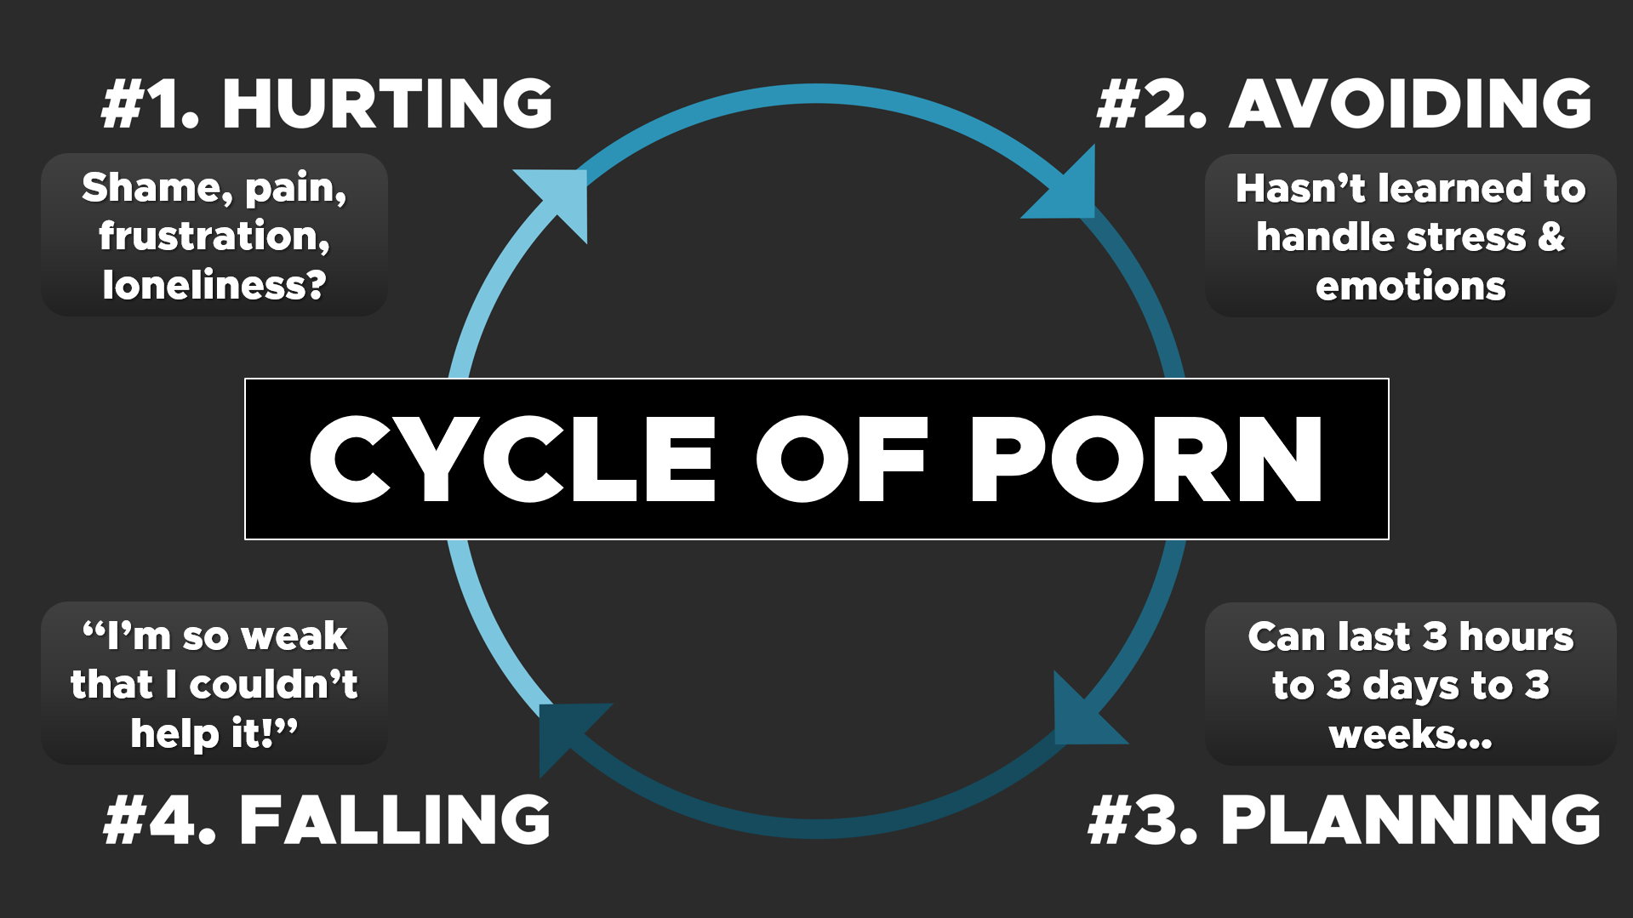

(1 Cor. 10:13) No temptation has overtaken you except what is common to us all. God is faithful. He will not let you be tempted beyond what you can bear. But when you are tempted, he will also provide a way out so that you can endure it.

Example 1
(1) You get written-up for coming to work late.

(2) You think about this all day. You feel angry and embarrassed.

(3) You grab McDonalds on the way home, and you play video games for two hours.

(4) You show up to HC and don’t participate or share.

(5) You go home early because you had a hard day and you’re tired.

Discussion Groups
Break into groups of two (or three). Write down the “way of escape” for each example on your handout.

Example 2
(1) You have a big argument with your roommate before leaving for school.
Where is the “way of escape”?

(2) You spend the whole day replaying the fight in your head. You feel guilty and resentful at the same time.
Where is the “way of escape”?

(3) You stop at a gas station and buy chips and energy drinks on the way home.
Where is the “way of escape”?

(4) You skip your men’s Bible study. Instead, you go straight to your room, telling yourself you’ll deal with it tomorrow.
Where is the “way of escape”?

Example 3
(1) You get a bill in the mail you weren’t expecting and can’t afford.
Where is the “way of escape”?

(2) You spend the day running the numbers over and over in your head. You feel stressed and hopeless.
Where is the “way of escape”?

(3) You drive to fellowship with your wife, but you don’t say much in the car.
Where is the “way of escape”?

(4) When you talk to the guys at fellowship, you keep the conversation superficial. You tell yourself the other guys have bigger problems.
Where is the “way of escape”?

(5) Your wife goes to bed early, but you stay awake and watch TV. You drink a couple of beers on the couch because it’s hard to fall asleep.
Where is the “way of escape”?

Example 4
(1) Your kid gets in trouble at school and your wife blames you for not being present enough.
Where is the “way of escape”?

(2) You spend the day feeling both defensive and guilty. You don't know how to fix it.
Where is the “way of escape”?

(3) You bury yourself in work for the rest of the afternoon to avoid going home.
Where is the “way of escape”?

(4) At dinner time, you turn the basketball game on in the background and eat in silence.
Where is the “way of escape”?

(5) You go to your office after dinner to do some late-night work.
Where is the “way of escape”?

Episode #6. Creating a Plan for Victory

Iceberg Illustration
1. Wrong Actions
2. False Beliefs
3. True Beliefs
4. Right Actions

Set yourself up for success

Focus on the positives

New open doors?
(2 Tim. 2:20-21) In a large house there are not only gold and silver vessels, but also vessels of wood and of earthenware, and some to honor and some to dishonor. ²¹ Therefore, if anyone cleanses himself from these things, he will be a vessel for honor, sanctified, useful to the Master, prepared for every good work.

Greater freedom?
(Heb. 12:1) Let us throw off everything that hinders and the sin that so easily entangles, and let us run with perseverance the race marked out for us.
(1 Cor. 6:12) All things are lawful for me, but not all things are profitable. All things are lawful for me, but I will not be mastered by anything.

God growing you?
(1 Thess. 4:3) It is God’s will that you should be sanctified: that you should avoid sexual immorality.
(1 Thess. 5:23-25) May God himself sanctify you through and through… ²⁴ The One who calls you is faithful, and He will do it.

Don’t focus on the difficulty

Set a Quit Date

Preparing for your Quit Date
(1) Clean up your devices
(2)
(3)
If you use Accountable2U, make sure that texts and email accountability is turned OFF.
https://accountable2you.com/
Accountable2U has a “blocker” option and accountability software.
https://www.covenanteyes.com/
Covenant Eyes has a “blocker” option and accountability software.
https://www.opendns.com/
(4) Create a growth journal
What is a growth journal? Each day, write down a zero or the number of times you fell. If you fall, write down what precipitated the fall.
Why use a growth journal? It’s a proven way to see results (e.g. exercise, lifting, weight loss, etc.). It helps identify patterns and thoughts to address and attack. It shows you that you’re growing and it’s very motivating!
(5)

What’s your plan for times of temptation?
(1) Recognize the feeling.

(2) Remember why you quit.

(3) Rejoice that you quit.

(4) Replace your thoughts.

What if you have a fall?
(1) Claim your identity in Christ.

(2)

(3) Continue to trust that God is making progress and will bring about eventual victory!

(4) Reject fatalism and keep your eyes on the future.
Short Lapse In Progress (SLIP)

(5) Confess to a close friend.

Effective Confession
James 5:16
(1) What did you watch?

(2) What Scripture applies?

(3) What happened before and after?

(4) What radical step will you take?

Homework
(1) Record your progress in your “Growth Journal” for three months.
(2) If you opt-in, meet with at least one guy weekly to share progress, pray together, and encourage one another.

Memory Verses
(2 Tim. 2:20-21) In a large house there are not only gold and silver vessels, but also vessels of wood and of earthenware, and some to honor and some to dishonor. ²¹ Therefore, if anyone cleanses himself from these things, he will be a vessel for honor, sanctified, useful to the Master, prepared for every good work.
(Heb. 12:1) Let us throw off everything that hinders and the sin that so easily entangles, and let us run with perseverance the race marked out for us.
(1 Cor. 6:12) All things are lawful for me, but not all things are profitable. All things are lawful for me, but I will not be mastered by anything.
(1 Thess. 4:3) It is God’s will that you should be sanctified: that you should avoid sexual immorality.
(1 Thess. 5:23-25) May God himself sanctify you through and through… ²⁴ The One who calls you is faithful, and He will do it.

Growth Journal
Monday | Tuesday | Wednesday | Thursday | Friday | Saturday | Sunday
“0” | “1”  Had a fall after failing a big exam at school

Externalization of Voices Journal
Thought that Leads to Porn Use | % Now | What is your Response to this Thought? | % After
“I’ll Quit Eventually.” | 90% | If it’s so great for you, why quit at all?  Do you think you’ll wake up one day and spontaneously want to quit?  Do you want to do this for the rest of your life? When do you think you’ll stop?

Howard Hendricks, “Building Character in the Life of Your Disciple,” XSI 2003 on 2 Peter 1.
Geoffrey L. Cohen and David K. Sherman, “The Psychology of Change: Self-Affirmation and Social Psychological Intervention.” Annual Review of Psychology 65 (2014): 333-71.
Kelly McGonigal, The Upside of Stress (New York, NY: Avery Publishers, 2015), p.71.
See James Clear, Atomic Habits: An Easy & Proven Way to Build Good Habits & Break Bad Ones (New York: Avery, 2018).
Pablo Delgado and Ladislao Salmerón, “The Inattentive On-Screen Reading: Reading Medium Affects Attention and Reading Comprehension under Time Pressure,” Learning and Instruction 71 (February 2021): 101396.
Maryanne Wolf, Proust and the Squid: The Story and Science of the Reading Brain (New York: Harper, 2007).
Gerald H. Wilson, Psalms, vol. 1, The NIV Application Commentary (Grand Rapids, MI: Zondervan, 2002), 96.
The term “meditate” (hāg̱āh) is translated in many ways. Unbelievers “plot” against God (Psalm 2:1 NIV) and his people (Proverbs 24:2 NIV). Wise people “ponder how to answer” (Proverbs 15:28 NASB), and they “utter wisdom” (Psalm 37:30 NASB) and “declare God’s righteousness” (Psalm 35:28 NASB).
David D. Burns, Feeling Good (New York: HarperCollins, 2000), p.469.

