Answering Objections to Christianity
Student Handout

Table of Contents

Episode 1: Is the Problem of Evil Illogical?

Introduction
The Greatest Argument against Christianity

What makes this such a powerful argument?

Responding to the Problem

(1) Evil is difficult for every worldview—not just Christianity.
Does karmic law answer the problem?

Does monism answer the problem?

Does atheism answer the problem?

Does Christianity answer the problem?

(2) Evil is evidence for the existence of God.
1. If God doesn’t exist, objective morality doesn’t exist.
2. Objective morality does exist.
Therefore, God exists.

(3) The coexistence of God and evil is not a contradiction.
Alvin Plantinga, God, Freedom, and Evil (1977)

Formulation #1
1. God is the author of everything.
2. Evil is something.
Therefore, God is the author of evil.

Formulation #2
1. If God is all good, He would destroy evil.
2. If God is all-powerful, He could destroy evil.
3. But evil is not destroyed.
Therefore, there is no such God.

Formulation #3
1. God made everything perfect.
2. Imperfection cannot come from perfection.
3. Perfectly created beings cannot be the origin of evil.
Therefore, God must be the origin.

Scripture Memorization
(2 Cor. 4:17-18) Our light and momentary troubles are achieving for us an eternal glory that far outweighs them all. So we fix our eyes not on what is seen, but on what is unseen, since what is seen is temporary, but what is unseen is eternal.
(Rev. 21:4) He will wipe every tear from their eyes. There will be no more death or mourning or crying or pain, for the old order of things has passed away.

Homework
How does each passage help give insight on the problem of evil?
(Rom. 8:18-23) I consider that our present sufferings are not worth comparing with the glory that will be revealed in us. For the creation waits in eager expectation for the children of God to be revealed. For the creation was subjected to frustration, not by its own choice, but by the will of the one who subjected it, in hope that the creation itself will be liberated from its bondage to decay and brought into the freedom and glory of the children of God. We know that the whole creation has been groaning as in the pains of childbirth right up to the present time. Not only so, but we ourselves, who have the firstfruits of the Spirit, groan inwardly as we wait eagerly for our adoption to sonship, the redemption of our bodies.
How does this passage attempt to explain why suffering and evil exist in the world? What solutions or answers are offered?
(Jn. 9:1-3) As he went along, he saw a man blind from birth.
His disciples asked him, “Rabbi, who sinned, this man or his parents, that he was born blind?”
“Neither this man nor his parents sinned,” said Jesus, “but this happened so that the works of God might be displayed in him.
How does this passage attempt to explain why suffering and evil exist in the world? What solutions or answers are offered?
(Lk. 13:1-5) Now there were some present at that time who told Jesus about the Galileans whose blood Pilate had mixed with their sacrifices. Jesus answered, “Do you think that these Galileans were worse sinners than all the other Galileans because they suffered this way? I tell you, no! But unless you repent, you too will all perish. Or those eighteen who died when the tower in Siloam fell on them—do you think they were more guilty than all the others living in Jerusalem? I tell you, no! But unless you repent, you too will all perish.”
How does this passage attempt to explain why suffering and evil exist in the world? What solutions or answers are offered?

Episode 2: Is the Problem of Evil Improbable?

(4) Christianity gives the best logical and emotional answers.

Background information?

(1) Freewill

(2) Fallen state

(3) Finitude

(4) Forgiveness

(5) Forever

Clear Communication

Scripture Memorization
(Gen. 50:20) You intended to harm me, but God intended it for good to accomplish what is now being done, the saving of many lives.
(Rom. 8:28) We know that in all things God works for the good of those who love him, who have been called according to his purpose.
(2 Cor. 4:8) We are pressed on every side by troubles, but we are not crushed. We are perplexed, but not driven to despair.

Homework
If someone was struggling with the problem of evil, would you focus on the intellectual answers given in class? What would be a wise and mature approach?

Episode 3: Is Hell Divine Overkill?
Student Handout

Are the flames of hell literal?
(1)

(2)

(3)

(4)

Does “weeping and gnashing of teeth” imply torture?

Weeping

Gnashing of teeth

How can a loving God judge us?

Why is judgment eternal for finite sins?

What about loved ones who are in hell?

Why should we believe in hell?

Why does judgment bother us so much?

Conclusions

Scripture Memorization
(2 Thess. 1:9-10) They will be punished with everlasting destruction and shut out from the presence of the Lord and from the glory of his might on the day he comes to be glorified in his holy people and to be marveled at among all those who have believed. This includes you, because you believed our testimony to you.
(Lk. 12:5) Fear him who, after your body has been killed, has authority to throw you into hell. Yes, I tell you, fear him.

Homework
Research these two alternative theological perspectives about Hell:
1. Annihilationism (aka “Conditional Immortality”)
2. Universalism
Summarize each perspective and evaluate each view using Scripture.

Episode 3: Is Religion Evil?

Three Central Arguments
See William T. Cavanaugh, The Myth of Religious Violence (Oxford University Press, 2009).
(1) Religious truth is absolute.

(2) Religion is divisive.

(3) Religion is not rational.

Are all religions created equal?
Mark 7:7-8; Mt. 18:6; Romans 1:20-23

Is evil consistent with Jesus’ teaching?
Matthew 5:44; John 18:36

What about evils in church history?
Crusades, Inquisition, Salem Witch Trials, modern scandals, etc.

What about evils in human history?
Nazi Germany, Chinese Communist Party, Soviet Gulag State, etc.
See R.J. Rummel, Death by Government (Transaction Publishers, 1994).

What has been Christianity’s impact on the world?
Alvin J. Schmidt, How Christianity Changed the World (2004)
Tom Holland, Dominion (2019)

Clear Communication

Scripture Memorization
(Mt. 15:8-9) These people honor me with their lips, but their hearts are far from me. They worship me in vain; their teachings are merely human rules.
(Mt. 23:27-28) Woe to you, teachers of the law and Pharisees, you hypocrites! You are like whitewashed tombs, which look beautiful on the outside but on the inside are full of the bones of the dead and everything unclean. In the same way, on the outside you appear to people as righteous but on the inside you are full of hypocrisy and wickedness.

Homework
What approach should we take when restoring and counseling those coming from unhealthy or hypocritical churches? List three ways to come alongside them. What questions would you ask? What approach would be helpful in restoring them?
1.

2.

3.

Episode 5: What about Those Who Never Hear the Gospel?

(1) God hasn’t revealed himself EQUALLY to humanity.

(2) God has revealed himself ENOUGH to humanity.
Don Richardson, Eternity in Their Hearts (Ventura, CA: Regal, 1984).

(3) God will reveal himself EXTRA to those who seek him.
Tom Doyle, Dreams and Visions (Nashville, TN: Thomas Nelson, 2012).

Why did God choose to use human agency?

Do people need to hear Jesus’ name to receive forgiveness?

If this is true, then why are there missionaries?

Clear Communication

Scripture Memorization
(Heb. 11:6) Without faith it is impossible to please God, because anyone who comes to him must believe that he exists and that he rewards those who earnestly seek him.
(Ecclesiastes 3:11) God has also set eternity in the human heart.

Homework
If we don’t need to hear Jesus’ name to be saved, then how do we interpret these passages below? Do these passages require that we hear Jesus’ name? Write your thoughts below:
(Rom. 10:14) How, then, can they call on the one they have not believed in? And how can they believe in the one of whom they have not heard? And how can they hear without someone preaching to them?
(Acts 4:12) Salvation is found in no one else, for there is no other name under heaven given to mankind by which we must be saved.

Episode 6: What about Difficult Old Testament Laws? (Part 1)

What sort of difficulties?
Selling your daughter into slavery? Exodus 21:7
Can’t cut the grass on Saturday? Exodus 35:2
No pigskin footballs, shellfish, beard-trimmers? Leviticus 11:7-8, 10; 19:27-28;
No cotton and polyester blends? Leviticus 19:19
Killing disobedient children? Deuteronomy 21:18-21

Legal Interpretive Principles
(1)

Circumcision? (Gen. 17:14; Acts 15:23-29)
False teaching? (Deut. 13:5; 18:20; Lev. 19:26; Ex. 22:18; Acts 8:9-13; 13:10-11)
Adultery? (Lev. 20:10; 1 Cor. 5)
Secular government? (Rom. 13:1; 1 Pet. 2:17; Jn. 18:36; Mk. 12:17; Phil. 3:20)

(2)

(3)

Hebrew Law | Hammurabi Law

(4)

(Ex. 22:1) If a man steals an ox or a sheep and slaughters it or sells it…
(Ex. 21:18) If men have a quarrel and one strikes the other with a stone or with his fist…
(Ex. 21:7) If a man sells his daughter as a female slave…
(Deut. 21:15) If a man has two wives…

(5)

Case Study
(Deut. 21:10-14) When you go to war against your enemies and the LORD your God delivers them into your hands and you take captives, ¹¹ if you notice among the captives a beautiful woman and are attracted to her, you may take her as your wife. ¹² Bring her into your home and have her shave her head, trim her nails and put aside the clothes she was wearing when captured. ¹³ After she has lived in your house and mourned her parents for a full month, you may go to her and be her husband and she shall be your wife. ¹⁴ If you are not pleased with her, let her go wherever she wishes. You must not sell her or treat her as a slave, since you have dishonored her.

Evaluation of Deuteronomy 21
(1)

(2)

(3)

(4)

What about Lex Talionis?
The Law of Retribution?
Exodus 21:23-25 (cf. Lev. 24:19-20; Deut. 19:21)
(1)

(2)

(3)

Scripture Memorization
(Mt. 5:38-39) You have heard that it was said, ‘Eye for eye, and tooth for tooth.’ But I tell you, do not resist an evil person. If anyone slaps you on the right cheek, turn to them the other cheek also.

Homework
Give two reasons why Old Testament cases laws are not still in effect for today.

Did Jesus disagree with Lex Talionis? (Mt. 5:38-39)

Episode 7: What about Difficult Old Testament Laws? (Part 2)

What about Capital Punishment?

Legislative Principles
(1)
Matthew 15:3-6; Acts 3:23; Hebrews 2:2-3

(2)

(3)

16 total capital crimes
Numbers 35:31 (compare with Exodus 21:29-30).
Walter C. Kaiser, Toward Old Testament Ethics (Grand Rapids: Zondervan, 1983), 91-92.
(4)

Case Studies
False teachers (Exodus 22:18; Leviticus 20:27; Deuteronomy 18:20)

Adulterers (Leviticus 20:10; Deuteronomy 22:22)

Non-virgin who gets married (Deuteronomy 22:13-22)

Disobedient kids (Deuteronomy 21:18-21; Leviticus 20:9)

Working on the Sabbath (Numbers 15:32-36; Exodus 31:14-15)

Flogging (Deuteronomy 25, e.g. Michael Fay 1994 Singapore)

What about the Arbitrary Laws?

#1. Medical reasons?
Leviticus 11 and Deuteronomy 14
Exodus 15:26; Deuteronomy 7:15
Fawver & Overstreet “Moses and Preventative Medicine.” Bibliotheca Sacra July-September 1990.

#2. Cultural reasons?

#3. Religious reasons?

Does God approve of Polygamy?

Does God approve of this?
(1)

(2)

(3)
Leviticus 18:18; Deuteronomy 17:17; Proverbs 5:15ff

(4)

The Imprecatory Psalms
(Ps. 58:10) The righteous will rejoice when he sees the vengeance, and he will wash his feet in the blood of the wicked.
(Ps. 137:9) How blessed will be the one who seizes and dashes your little ones against the rock.
(Ps. 109:12) Let there be none to extend lovingkindness to him, nor any to be gracious to his fatherless children.
(Ps. 69:27) Add iniquity to their iniquity, and may they not come into Your righteousness.

Scripture Memorization
(Mt. 19:8) Moses permitted you to divorce your wives because your hearts were hard. But it was not this way from the beginning.
(Lev. 19:18) Do not seek revenge or bear a grudge against anyone among your people, but love your neighbor as yourself.

Homework
Some people say that the “God of the Old Testament” is harsh, while the “God of the New Testament” is loving. Do you agree? What are New Testament passages that speak about God’s judgment? What are Old Testament passages that speak about God’s mercy and love?

Episode 8: What about the Canaanite Genocide?

(Deut. 20:16-17) You shall not leave alive anything that breathes. But you shall utterly destroy them, the Hittite and the Amorite, the Canaanite and the Perizzite, the Hivite and the Jebusite.
(Josh. 6:21) They utterly destroyed everything in the city, both man and woman, young and old.
(Josh. 10:40) Joshua struck all the land… He left no survivor, but he utterly destroyed all who breathed.

(1) The Canaanites committed unthinkable acts of evil.

Sacred Ritualized Prostitution
“None of the daughters of Israel shall be a cult prostitute, nor shall any of the sons of Israel be a cult prostitute” (Deuteronomy 23:17).
Herodotus Histories 1.199
Ba’al and his sister Anath

Infant Human Sacrifice
(1) Biblical texts
Leviticus 18:21; Deuteronomy 12:29-31; Psalm 106:37-38
2 Kings 16:3; Jeremiah 7:30-31; 19:5; 32:35

(2) Extrabiblical texts
Sophocles, Andromeda (fragment 122).
Cleitarchus, Fragments (137, F 9).
Diodorus Siculus, Bibliotheca (XX, xiv).
Plutarch, “De Superstitione” Moralia. Book 2.13.

(3) Egyptian temple drawings
Anthony J. Spalinger, “A Canaanite Ritual Found in Egyptian Reliefs,” Journal of the Society for the Study of Egyptian Antiquities 8 (1978), p.51.

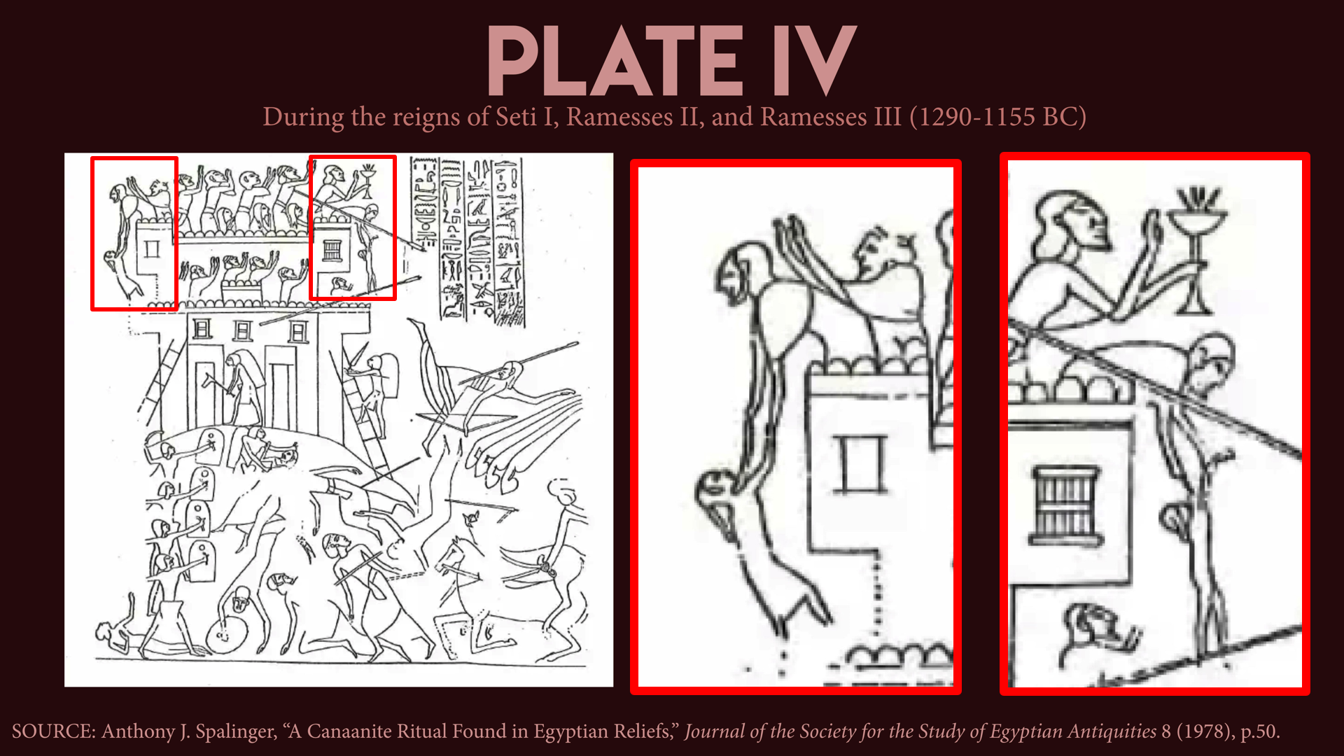
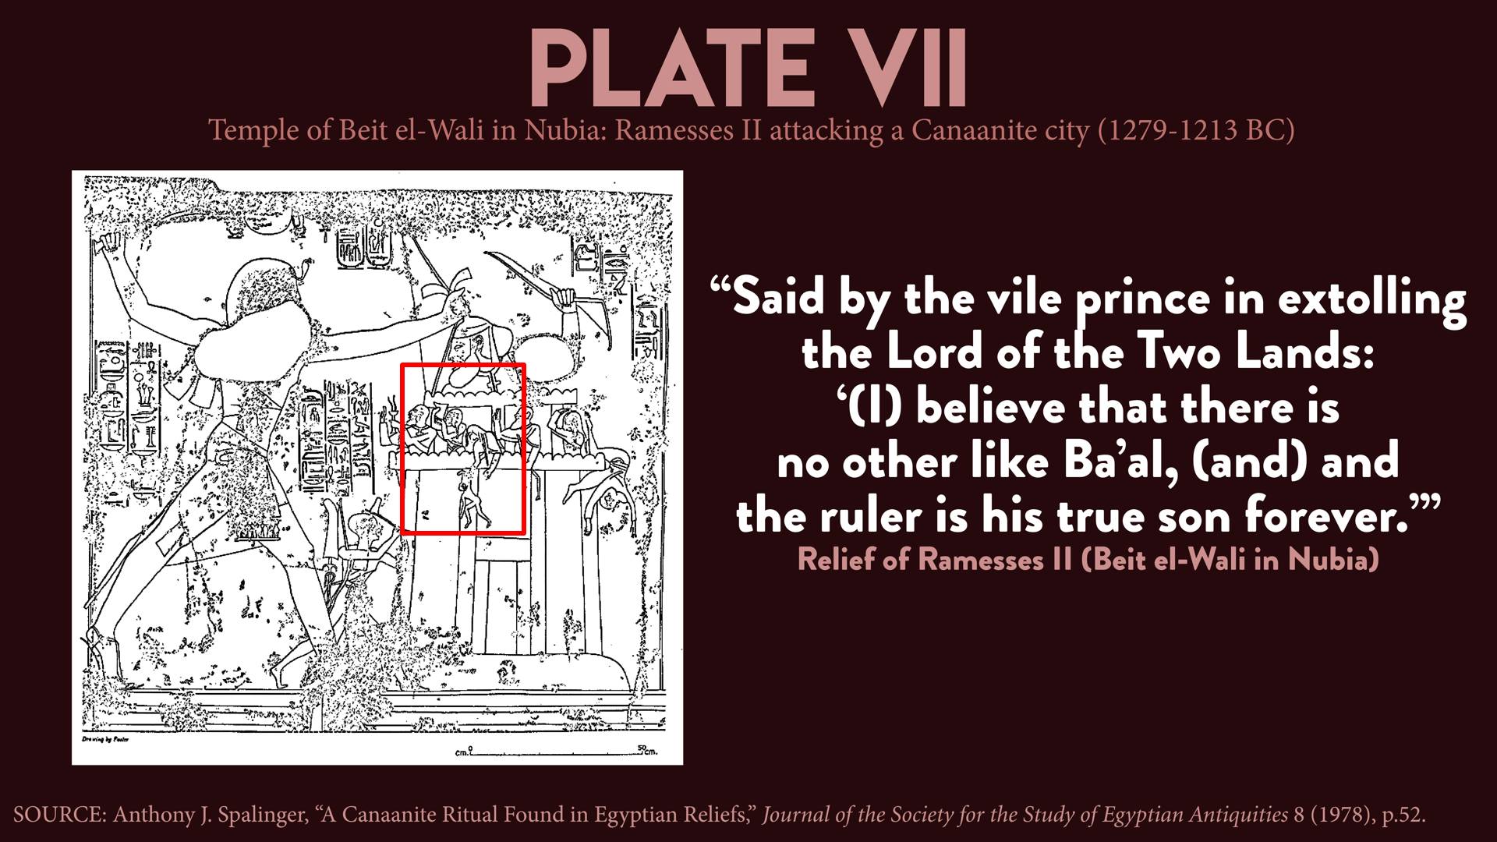

(4) Archaeological attestation
Philip J. King and Lawrence E. Stager, Live in Biblical Israel (London: John Knox Press, 2001), 360-361.
Mark Cartwright, “Tophet.” World History Encyclopedia (April 15, 2016).

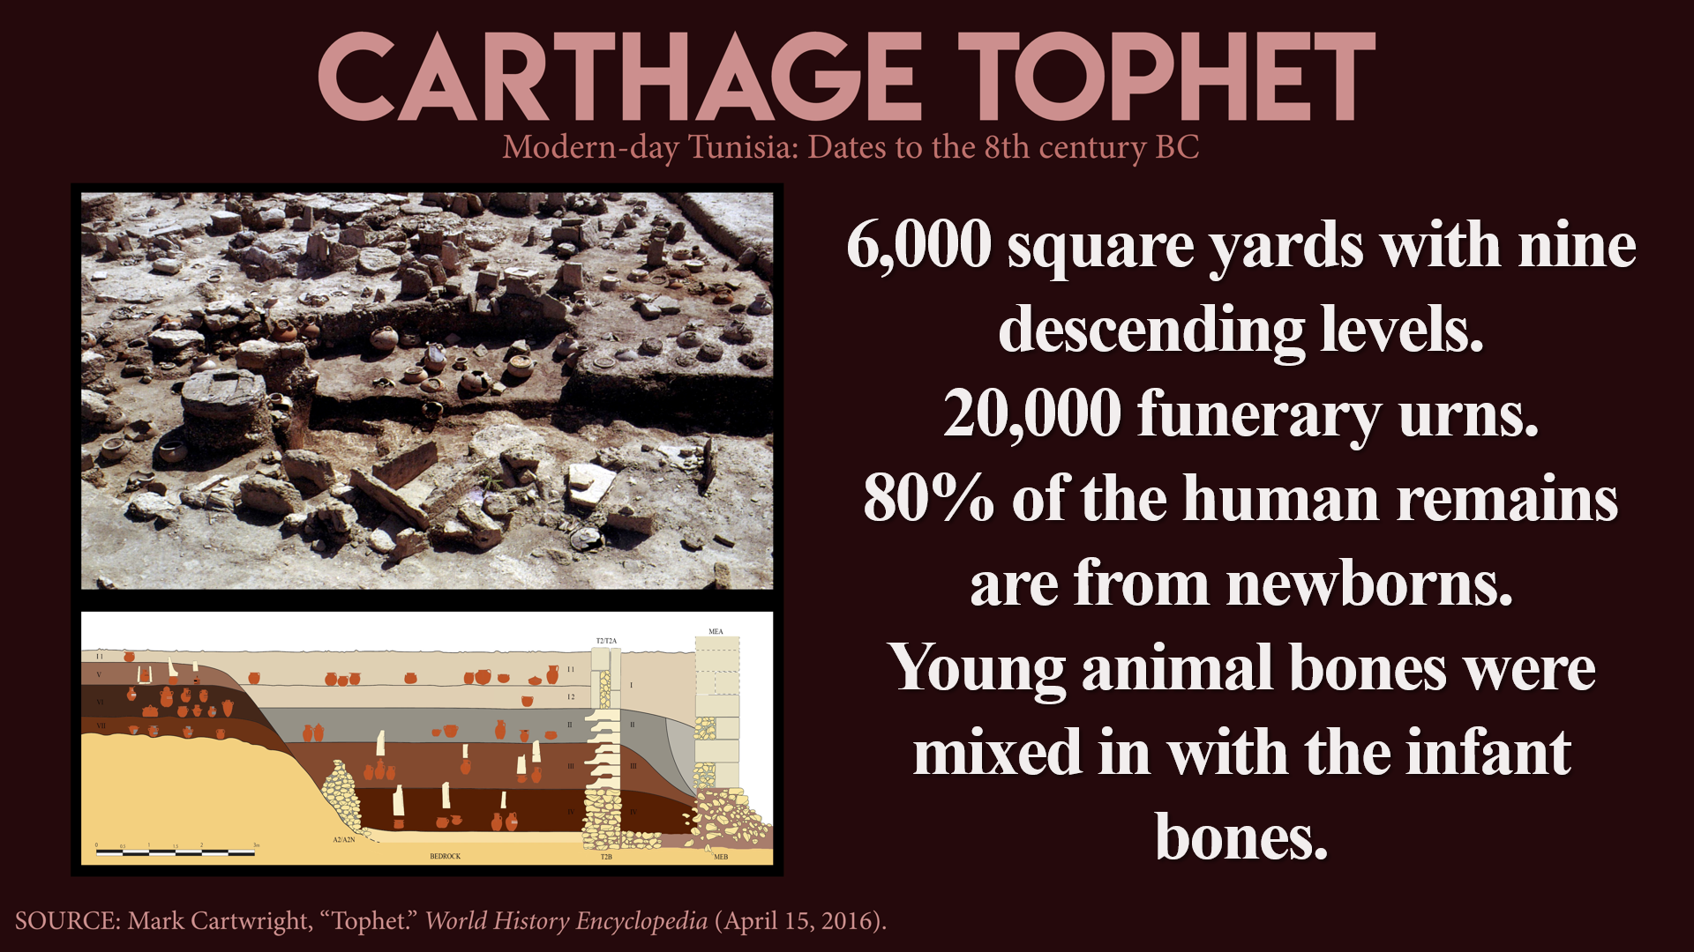

(2) This was ethical—not ethnic.

Was this genocide?

(3) The Canaanites rejected peace.

Refusal to surrender

(4) This is the only offensive war commanded by God.

(5) This could be hyperbolic language being used to describe “utter destruction.”

Hyperbolic Language?

“All” the Canaanites were killed, but later, many still survived.
Joshua 10:40; 11:12, 15, 20; 13:1-5, 13; Judges 1:21, 28; 1 Samuel 15:3, 8; 28:18; 30:1

Clear Communication

Scripture Memorization
(Heb. 11:30) By faith the walls of Jericho fell, after the army had marched around them for seven days.
(Acts 7:45) After receiving the tabernacle, our ancestors under Joshua brought it with them when they took the land from the nations God drove out before them.

Homework
How would you summarize the biblical account regarding the conquest of Canaan? How does this differ from the way skeptics characterize this event?
How would you respond to someone who claimed that God had told them to start a holy war today?

Episode 9: The Bible and Slavery

Roman Slavery
(1)

(2)

(3)

New Testament Slavery
(1)

(2)

(3)

(4)

(5)

Old Testament “Slavery”
“Slave” (ʿebed)

Indentured servitude was voluntary.
Leviticus 25:39-47; Deuteronomy 15:16-17; Exodus 21:5

Poverty could be avoided.
No interest on loans (Ex. 22:25; Lev. 25:36-37).
Free food and taxes (Lev. 19:10; Deut. 14:28-29; 24:20-21)

Debts were released every seven years.
Deuteronomy 15:1-2, 7-8, 12-15

Servants had value and legal rights.
Job 31:13-15; Exodus 21:26-27

Forced slavery was a capital crime.
Exodus 21:16; Deuteronomy 24:7
Commanded to harbor runaways (Deut. 23:15-16).

Clear Communication

Scripture Memorization
(Deut. 9:4-5) God brought judgment “because of the wickedness of these nations.”
(1 Cor. 7:21, 23) Were you a slave when you were called? Don’t let it trouble you—although if you can gain your freedom, do so. ²³ Do not become slaves of men.
(Lk. 4:18) The LORD… has sent me to proclaim that captives will be released… that the oppressed will be set free.
(Gal. 3:28) There is neither Jew nor Greek, there is neither slave nor free, there is neither male nor female. For you are all one in Christ Jesus.

Homework
Was slavery in the Bible the same as slavery in the United States before the Civil War? In what ways were these different?
What are key biblical teachings that help to undermine the institution of slavery?

Study Guide

Which of the following is a common logical response to the Problem of Evil?
A) Evil is an illusion created by the mind
B) God allows evil because it is a consequence of human free will
C) Evil is a punishment for not praying enough
D) Evil exists because God is not omnipotent

Answer: B) God allows evil because it is a consequence of human free will

Which Christian philosopher effectively solved the problem of evil with his book God, Freedom, and Evil in 1977?
A) William Lane Craig
B) William Alston
C) Alvin Plantinga
D) Lee Strobel
Answer: C) Alvin Plantinga

A)
B)
C)
D)

A)
B)
C)
D)

A)
B)
C)
D)

A)
B)
C)
D)

A)
B)
C)
D)

A)
B)
C)
D)

A)
B)
C)
D)

A)
B)
C)
D)

A)
B)
C)
D)

A)
B)
C)
D)

A)
B)
C)
D)

A)
B)
C)
D)

A)
B)
C)
D)

A)
B)
C)
D)

A)
B)
C)
D)

