**Satan**

Student Handout

# Table of Contents

1. Angels 2

2. What does the Bible teach about Satan? (Part One) 6

3. What does the Bible teach about Satan? (Part Two) 10

4. Why did Satan crucify Jesus? 13

5. Does Satan Exist? 16

6. Evidence for Demon Possession 21

7. The Occult? 24

8. Demonic Oppression 28

9. Put on the Full Armor of God 32

10. The Tactics of Satan (Part One) 35

11. The Tactics of Satan (Part Two) 38

12. The World System (Part One) 42

13. The World System (Part Two) 44

Scripture Memorization 48

# 1. Angels

#### Why should we study this subject?

(1)

(2)

(3)

One theologian refers to the study of angels as “the most unusual and difficult of all of theology.”[1]

#### What is an angel?

Angels are immaterial beings.

(Heb. 1:14; 13:2; Mt. 8:16; 12:45; Lk. 7:21; 8:2; 11:26; Acts 19:12; Eph. 6:12)

Angels are invisible beings.

(Num. 22:31; 2 Kin. 6:17; Col. 1:16)

Angels are personal beings.

Angels are moral (Lk. 8:2; 9:42; Mt. 12:45), rational (Acts 19:15-16), volitional (Jude 6; 2 Pet. 2:4), and emotional beings (Lk. 8:28, 31; 15:8-10; Mt. 8:28; Rev. 5:11-12).

Angels are finite beings.

Omnipresent (Lk. 1:26; Dan. 10:12-14; Job 1:7).

Omniscient (Mt. 24:36).

Omnipotent. Demons “cannot open the eyes of the blind” (Jn. 10:21), and even Satan cannot withstand a rebuke from God (Jude 9).

Peter S. Williams: Angels are “immaterial, purely spiritual creatures directly created by God.”[2]

#### How many angels exist?

There are “myriads of myriads” of angels (10,000).

Dan. 7:10; cf. Deut. 33:2; Ps. 68:17; Job 25:3

John writes that he saw “myriads of myriads” of angels (Rev. 5:11).

10,000 x 10,000 = 100,000,000

20,000 x 20,000 = 400,000,000

There are an “innumerable” number of angels (Heb. 12:22 ESV).

“Their number is greater than all material beings combined.”[3]

#### How many different types of angels are there?

Charles Hodge: “There is every reason to presume that the scale of being among rational creatures is as extensive as that in the animal world.”[4]

“This kind [*genos*] cannot come out by anything but prayer” (Mark 9:29).

Cherubim (Gen. 3:24; Ex. 25:22)

Seraphim (Isa. 6:2)

Living creatures (Ezek. 1:5-13; Rev. 4:8)

Archangels (Jude 9; cf. 1 Thess. 4:16; Dan. 10:13)

“Powers” (*kuriothtes*), “rulers” (*arcai*), and “authorities” (*exousiai*), and world-rulers (*kosmoskrators*). See Col. 1:16; 2:15; 1 Cor. 15:24; Eph. 6:12

#### What do angels look like?

Angels can appear in human form.

Gen. 18:2, 16, 22; 19:1, 5, 10, 12, 15, 16; Judg. 13:6; Mark 16:5; Luke 24:4).

“Some have entertained angels without knowing it” (Heb. 13:2).

Angels seem to always appear as male.

Zechariah 5:9-11?[5]

Angels never appear as winged humans.

The Bible gives examples of flying angels in human form, but it never mentions them having wings (Dan. 9:21; Rev. 14:6). Moreover, the seraphim (Isa. 6:2) and cherubim (Ex. 25:20) have wings, but these are clearly not non-humanlike creatures.

Angels are beautiful and terrifying!

It isn’t uncommon for people to faint in the presence of angels (Mt. 28:3-4; Dan. 8:17; 10:7, 9).

#### Do humans have guardian angels?

Jesus claimed that children have “their angels in heaven” (Mt. 18:10).

[Peter knocked at the gate, and Rhoda told the prayer meeting.] When Rhoda insisted it was Peter, they said, “It must be his angel” (Acts 12:15).

Is it “zone” or “man-to-man” protection?[6]

#### When did some of the angels fall and become demons?

We aren’t sure when angels fell, but it is clear that they fell.

2 Pet. 2:4; Jude 6

Angels weren’t created in a fallen state.

Job 38:4, 7; Ezek. 28:13-17; Gen. 1:31

Satan fell before humans existed.

Gen. 3:1

Was Satan enraged when God gave the Planet Earth to humans?

Job 38:4-7; Gen. 1:26-28; Heb. 1:14

#### Why can’t we (normally) see angels or demons?

We might be tempted to worship angels.

Rev. 22:8; Col. 2:18; people in the occult.

We might be tempted to fear angels.

Imagine if you could constantly see angels and demons all around you wherever you went.

We might be distracted by angels.

This might be why angels are rarely revealed (2 Kin. 6:15-17; Num. 22:31; Heb. 13:2).

#### Conclusion

#### Discussion Questions

(1) In three minutes, write down the most important points that you learned from this lecture. Don’t cheat and look at your notes! (This exercise will help you with retention.)

(2) Why do you think the study of angels is considered “the most unusual and difficult” area of theology?

(3) What are some misconceptions people commonly have about angels? What did you learn about angels that you didn’t realize before?

(4) Discuss the potential reasons why God typically prevents us from seeing angels and demons. Do you agree with these reasons? Do you have any more to add?

#### Homework

What would change in your life if you were more aware of the spiritual realm, including angels and demons? Be prepared to share your thoughts next week in class.

# 2. What does the Bible teach about Satan? (Part One)

#### Misconceptions about Satan

“Satan is red with horns and a pitchfork.”

“Satan lives in hell.”

“Satan can force us to sin.”

“Satan is just a symbol of evil.”

#### Biblical Data about Satan

Satan is known by various names.

Scripture calls him the evil one (Mt. 13:19, 38; 1 Jn. 2:13; 3:12; 5:18), our enemy (Mt. 13:39), our adversary (1 Pet. 5:8), the tempter (Mt. 4:3; 1 Thess. 3:5), the deceiver (Rev. 12:9), and the father of lies (Jn. 8:44).

The term “diabolical” comes from the Greek term for “devil” (*diabolos*).

Satan is a brilliant and deceitful being.

Revelation 12:3-4; Genesis 3:1-15

Genesis 3:1; John 8:44; Matthew 4:6

Satan is a malevolent being.

Satan “was a murderer from the beginning” (Jn. 8:44), and a lion who hunts down followers of Jesus (1 Peter 5:8-9).

Satan rules over the demonic realm.

When an evil regime arises, it is always ruled by a single dictator.

Matthew 12:24; 25:41; Mark 3:22; Lk. 11:15; Ephesians 2:2-3.

#### Isaiah 14

3 It will be in the day when the LORD gives you rest from your pain and turmoil and harsh service in which you have been enslaved, 4 that you will take up this taunt against the king of Babylon.

11 Your pomp and the music of your harps have been brought down to Sheol. Maggots are spread out as your bed beneath you and worms are your covering.

12 How you have fallen from heaven, O star of the morning, son of the dawn! You have been cut down to the earth, you who have weakened the nations!

13 But you said in your heart, “I will ascend to heaven. I will raise my throne above the stars of God, and I will sit on the mount of assembly in the recesses of the north.”

14 I will ascend above the heights of the clouds. I will make myself like the Most High.”

15 Nevertheless you will be thrust down to Sheol, to the recesses of the pit.

16 Those who see you will gaze at you, they will ponder over you, saying, “Is this the man who made the earth tremble, who shook kingdoms?”

#### Does this refer to Satan?

“Morning star” (hîlēl) isn’t “Lucifer.”

The root word “represents the giving off of light.”[7]

Latin Vulgate: “translucent, “lucid,” or “luminous”

Jesus is called the “morning star” (2 Pet. 1:19).

Context is the king of Babylon.

Verse 4

The king said, “I will…” (5x)

Verses 13-14.

The language describes a human.

“Maggots… worms are your covering” (v.11).

“Is this the man…?” (v.16)

#### Ezekiel 28

1 The word of the LORD came again to me, saying, 2 “Son of man, say to the leader (nāg̱îd) of Tyre…”

11 Again the word of the LORD came to me saying,

12 “Son of man, take up a lamentation over the king (malak) of Tyre and say to him, ‘Thus says the Lord GOD,

“You had the seal of perfection, full of wisdom and perfect in beauty.”

**Human leader?**

(1) This is a new oracle.

(2) This figure is the “king,” not the “prince” (v.2).

(3) The city worshipped Melkart, which was a “god” whose name means “King of the City.”[8]

(4) The language doesn’t describe a human ruler… (Verses 11-18)

13 You were in Eden, the garden of God. Every precious stone was your covering… And the gold, the workmanship of your settings and sockets, was in you. On the day that you were created they were prepared.

**Is “Eden” figurative language?**

“All the trees of Eden, which were in the garden of God, were jealous of it” (Ezekiel 31:9).

“This desolate land has become like the garden of Eden” (Ezekiel 36:35).

Ezekiel later uses personification, hyperbole, and simile.

14 You were the anointed cherub who covers, and I placed you there. You were on the holy mountain of God. You walked in the midst of the stones of fire.

15 You were blameless in your ways from the day you were created until unrighteousness was found in you.

16 By the abundance of your trade you were internally filled with violence, and you sinned. Therefore I have cast you as profane from the mountain of God. And I have destroyed you, O covering cherub, from the midst of the stones of fire.

17 Your heart was lifted up because of your beauty. You corrupted your wisdom by reason of your splendor. I cast you to the ground. I put you before kings, that they may see you.

18 By the multitude of your iniquities, in the unrighteousness of your trade you profaned your sanctuaries. Therefore I have brought fire from the midst of you. It has consumed you, and I have turned you to ashes on the earth in the eyes of all who see you.

#### What does this passage tell us about Satan?

(1)

(2)

(3)

(4)

(5)

#### Discussion Questions

(1) In three minutes, write down the most important points that you learned from this lecture. Don’t cheat and look at your notes! (This exercise will help you with retention.)

(2) Which common cultural misconceptions about Satan do you think are most dangerous or misleading? Why?

(3) What do the names and titles for Satan (e.g., deceiver, tempter, adversary) reveal about his nature and tactics?

(4) Do you believe Isaiah 14 and Ezekiel 28 are talking about Satan, human rulers, or both?

#### Homework

Read Isaiah 14:3-17 and Ezekiel 28:11-19. Write a short summary (3-5 sentences) of what each passage says. Then answer: Do you think either passage is talking about Satan? Why or why not? Support your answer with at least 2 specific verses.

# 3. What does the Bible teach about Satan? (Part Two)

#### Genesis 3

1 Now the serpent was more crafty than any beast of the field which the LORD God had made. And he said to the woman, “Indeed, has God said, ‘You shall not eat from any tree of the garden’?”

Is this merely a snake?

2 The woman said to the serpent, “From the fruit of the trees of the garden we may eat.

3 But from the fruit of the tree which is in the middle of the garden, God has said, ‘You shall not eat from it or touch it, or you will die.’”

4 The serpent said to the woman, “You surely will not die!”

5 “For God knows that in the day you eat from it your eyes will be opened, and you will be like God, knowing good and evil.”

6 When the woman saw that the tree was good (ṭôb) for food, and that it was a delight to the eyes, and that the tree was desirable to make one wise, she took from its fruit and ate. And she gave also to her husband with her, and he ate.

#### What does this passage tell us about Satan?

#### Job 1

1 There was a man in the land of Uz whose name was Job. He was blameless, upright, fearing God and turning away from evil.

6 Now there was a day when the sons of God came to present themselves before the LORD. And Satan also came among them.

**Is this God’s prosecuting attorney?**

(1) He is “the Accuser,” not “an accuser.” Contra Numbers 22:22

(2) The Accuser is clearly evil. Satan tried to “incite” God to “ruin [Job] without cause” (Job 2:3). In context, he kills the children, servants, and animals (Job 1:12; 2:6). “Satan… smote Job with sore boils” (Job 2:7).

(3) The NT authors transliterate “accuser” (*śāṭān*) as “Satan” (*satanas*).

(4) The NT authors use “Satan” (*satanas*) and the “Devil” (*diabolos*) interchangeably.

7 The LORD said to Satan, “From where do you come?” Satan answered the LORD and said, “From roaming about on the earth and walking around on it.”

8 The LORD said to Satan, “Have you considered My servant Job? For there is no one like him on the earth, a blameless and upright man, fearing God and turning away from evil.”

9 Then Satan answered the LORD, “Does Job fear God for nothing?

10 Have You not made a hedge about him and his house and all that he has, on every side? You have blessed the work of his hands, and his possessions have increased in the land.”

11 “But put forth Your hand now and touch all that he has. He will surely curse You to Your face!”

12 Then the LORD said to Satan, “Behold, all that he has is in your power, only do not put forth your hand on him.” So Satan departed from the presence of the LORD.

[The Sabeans, Chaldeans, fire, and wind kill Job’s livestock, servants, and children.]

20 Then Job arose and tore his robe and shaved his head, and he fell to the ground and worshiped…

22 Through all this Job did not sin nor did he blame God.

#### Job 2

1 There was a day when the sons of God came to present themselves before the LORD. Satan also came among them to present himself before the LORD.

2 The LORD said to Satan, “Where have you come from?” Satan answered the LORD and said, “From roaming about on the earth and walking around on it.”

3 The LORD said to Satan, “Have you considered My servant Job? For there is no one like him on the earth, a blameless and upright man fearing God and turning away from evil.”

“And he still holds fast his integrity, although you incited Me against him to ruin him without cause.”

4 Satan answered the LORD and said, “Skin for skin! Yes, all that a man has he will give for his life.”

5 “However, put forth Your hand now, and touch his bone and his flesh. He will curse You to Your face!”

6 So the LORD said to Satan, “Behold, he is in your power, only spare his life.”

7 Then Satan went out from the presence of the LORD and smote Job with sore boils from the sole of his foot to the crown of his head.

8 And he took a potsherd to scrape himself while he was sitting among the ashes.

9 Then his wife said to him, “Do you still hold fast your integrity? Curse God and die!”

10 But he said to her, “You speak as one of the foolish women speaks. Shall we indeed accept good from God and not accept adversity?” In all this Job did not sin with his lips.

#### What does this passage tell us about Satan?

#### Conclusions

#### Discussion Questions

(1) In three minutes, write down the most important points that you learned from this lecture. Don’t cheat and look at your notes! (This exercise will help you with retention.)

(2) In Genesis 3, how does Satan (the serpent) use truth and lies together to deceive Eve? What does this teach us about how temptation often works?

(3) Why do you think Satan targets Job in the way that he does? What does this suggest about Satan’s goals when he attacks believers?

(4) What do the Job passages reveal about Satan’s power—and his limitations?

#### Homework

Read Genesis 3:1-6 carefully. Write a paragraph explaining how Satan’s strategy in the Garden worked. Identify at least two lies or distortions he used.

How might this same strategy be used today?

# 4. Why did Satan crucify Jesus?

#### Satan was behind the betrayal, arrest, and execution of Jesus

Luke 22:3; John 13:2, 27; Revelation 12:4

#### Different Explanations

(1)

(2)

(3)

(4)

#### Human interpreters didn’t expect the Cross

No sources before Christ identified the Suffering Servant with the Messiah.[9]

#### God kept this a mystery

(1 Cor. 2:6) We do speak wisdom among those who are mature. This is a wisdom, however, not of this age nor of the rulers of this age, who are passing away.

(1 Cor. 2:7) We speak God’s wisdom in a mystery, the hidden wisdom which God predestined before the ages to our glory.

(1 Cor. 2:8) The wisdom which none of the rulers of this age has understood—for if they had understood it they would not have crucified the Lord of glory.

#### Satan didn’t expect the Cross

“A natural man does not accept the things of the Spirit of God, for they are foolishness to him. He cannot understand them, because they are spiritually appraised” (1 Corinthians 2:14).

“You have hidden these things from the wise and intelligent and have revealed them to infants” (Matthew 11:25).

#### God defeated Satan’s accusations at the Cross

Satan accuses God of being a tyrannical, unloving, self-serving control-freak, who is out for his own glory and worship!

“Jesus canceled the record of the charges against us and took it away by nailing it to the cross. In this way, he disarmed the spiritual rulers and authorities. He shamed them publicly by his victory over them on the cross” (Colossians 2:14-15 NLT).

#### What is Satan thinking now?

(1)

(2)

(3)

#### Conclusions

#### Discussion Questions

(1) In three minutes, write down the most important points that you learned from this lecture. Don’t cheat and look at your notes! (This exercise will help you with retention.)

(2) Why is it significant that God kept the plan of the Cross a "mystery" until after it happened? What does this tell us about God’s nature and his plans for human history?

(3) Colossians 2:14-15 says Jesus “disarmed the spiritual rulers and authorities.” What do you think this means practically for Christians today?

(4) What accusations does Satan make against God, and how does the Cross answer them? How should this shape your view of God’s character?

#### Homework

Write a 1-page essay answering the question, “Why did Satan crucify Jesus?” Put the argument of this class in your own words. Include at least two Scripture references and address the idea that Satan didn’t understand God’s plan.

# 5. Does Satan Exist?

Paul Tillich called belief in angels “crude mythology.”[10]

Rudolph Bultmann: “It is impossible to use electric light and the wireless to avail ourselves of modern medical and surgical discoveries, and at the same time to believe in the New Testament world of daemons and spirits.”[11]

### Evidence for the Existence of Satan

#### (1) Biblical Evidence

The Bible refers to angels 296 times (in the NASB).

116 in the OT and 180 in the NT.

Angels appear in 16 books in the OT and 17 books in the NT.

This includes early books such as Job and Genesis.

19 of the 27 NT books refer to Satan, and 23 of the 27 refer to demons.[12]

**Jesus affirmed Satan’s existence**

(Matthew 4:10) “Get away, Satan!”

(Matthew 12:26) “If Satan casts out Satan… how then will his kingdom stand?”

(Matthew 16:23) “Get behind me, Satan!”

(Mark 1:13) Jesus “was tempted by Satan” in the wilderness.

(Mark 3:23-26) Jesus talks of Satan casting out Satan.

(Mark 8:33) “Get behind me, Satan!”

(Mark 4:15) “Satan comes and takes away the word sown in their hearts.”

(Luke 4:8) “Get behind me, Satan!” during the temptation.

(Luke 10:18) “I saw Satan fall like lightning from heaven.”

(Luke 11:18) “If Satan is divided against himself…”

(Luke 13:16) “Satan has kept this woman bound…”

(Luke 22:3) “Satan entered into Judas.”

(Luke 22:31) “Satan asked to sift all of you as wheat.”

(John 8:44) Satan is “a murderer from the beginning.”

(John 14:30) “The prince of this world is coming…”

(John 13:27) “Then Satan entered into him”

(John 16:11) “The prince of this world now stands condemned.”

#### (2) Philosophical Evidence

(1)

(2)

(3)

#### (3) Historical Evidence

The highly critical Jesus Seminar affirmed that Jesus was a “charismatic healer and exorcist.”[13]

John-Dominic Crossan: “Jesus was both an exorcist and a healer.”[14]

(1)

(2)

(3)

(4)

#### (4) Sociological Evidence

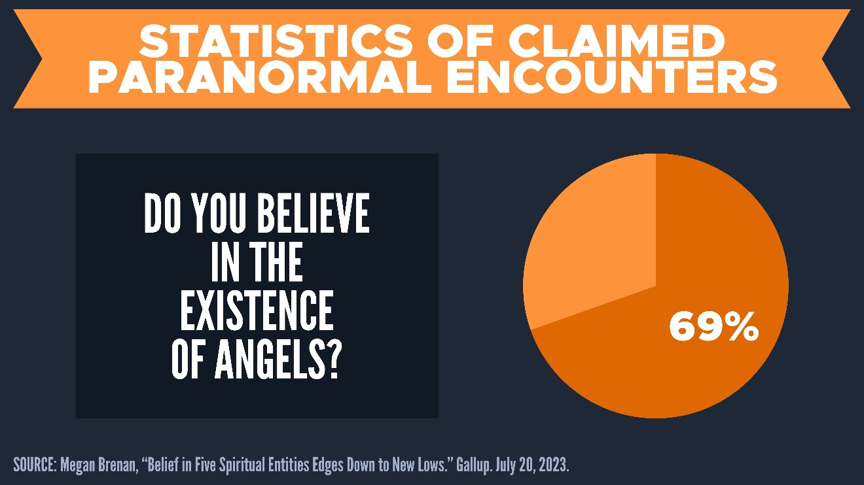

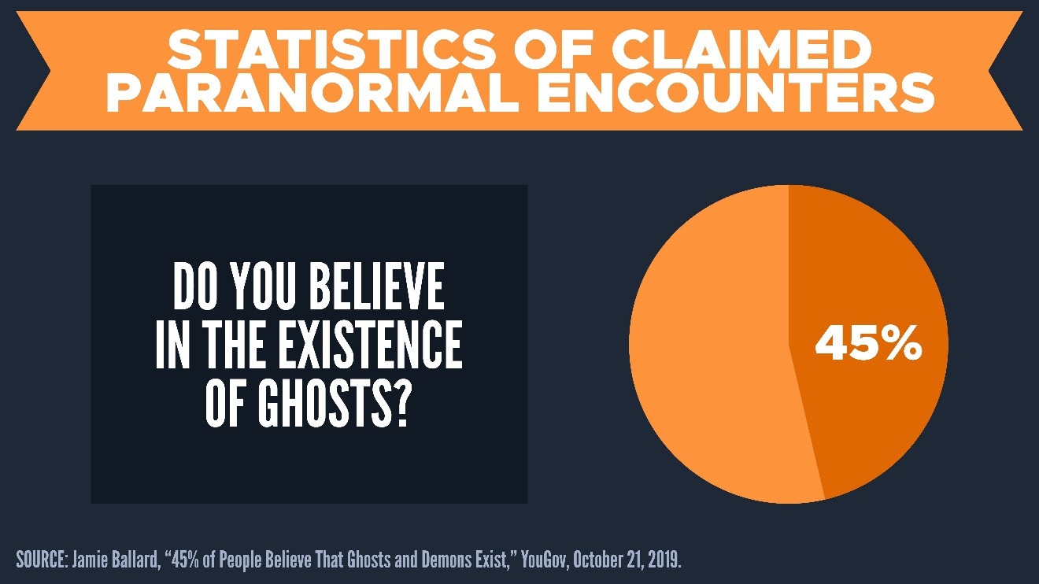

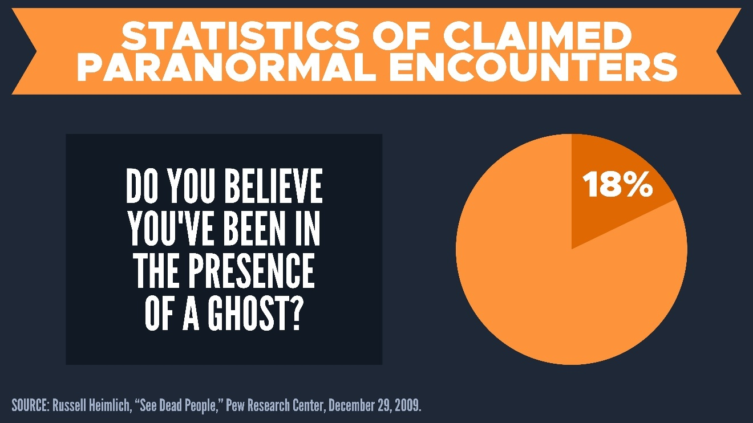

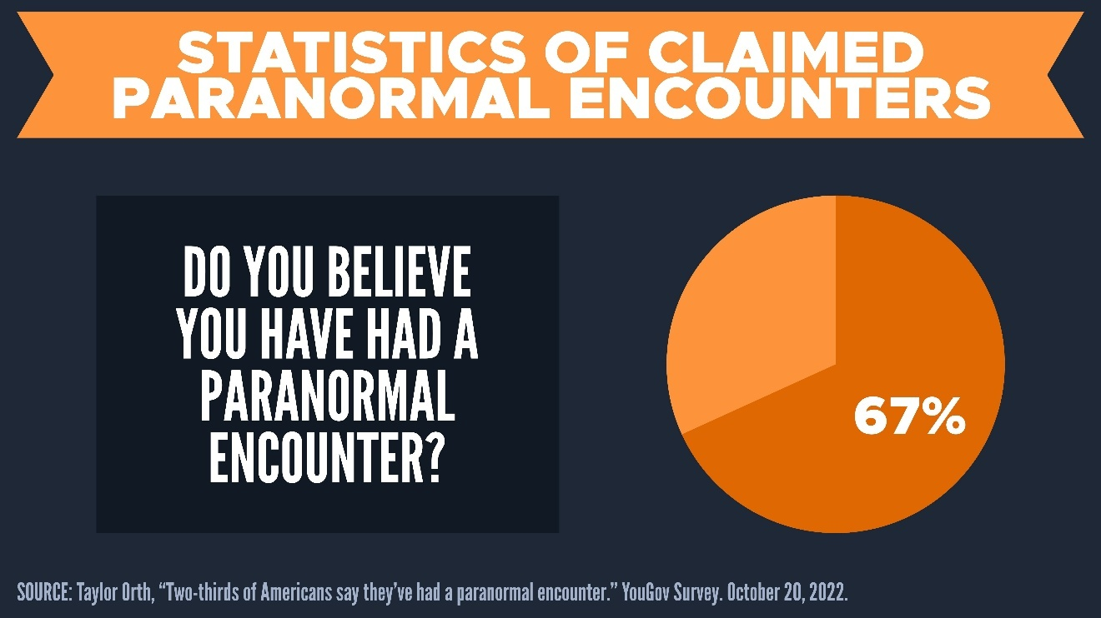

Dr. Erika Bourguignon “unearthed documented accounts of possession in about three-quarters of [the] 488 cultures she surveyed.”[15]

Greek others considered demon possession to be common (Plutarch, *Life of Marcellus*, 20.5; cf. Euripides, *Hippolytus*, 141).

#### (5) Experiential Evidence

“Anomalous Events That Can Shake One’s Skepticism to the Core.” *Scientific American* (September 16, 2014).

#### Conclusions

#### Discussion Questions

(1) In three minutes, write down the most important points that you learned from this lecture. Don’t cheat and look at your notes! (This exercise will help you with retention.)

(2) Why do you think modern thinkers like Paul Tillich and Rudolph Bultmann reject belief in Satan, angels, and demons?

(3) Which line of evidence for the existence of Satan did you find the most persuasive? Which did you find the least?

(4) Should belief in Satan be considered essential to a Christian worldview?

#### Homework

Identify a movie, TV show, book, or song that references Satan, demons, or spiritual evil. Offer your thoughts about:

(1) How Satan or evil is portrayed.

(2) How this depiction compares to the biblical description.

(3) Whether you think this representation influences how people view spiritual evil today.

# 6. Evidence for Demon Possession

#### (1) Documented cases from Dr. Richard Gallagher

Is he believable?

(1)

(2)

(3)

What are his examples?

#### (2) A well-evidenced case from journalist Marisa Kwiatkowski

We are going to move quickly through this material. For all of the details for this case, see [**“Evidence for Demon Possession.”**](https://evidenceunseen.com/theology/satanology/the-evidence-for-demon-possession)

#### (3) Common objections and objections

**Why are there less cases of demonic oppression in the western world?**

(1)

(2)

**Why aren’t any demon possessions ever caught on video?**

(1)

(2)

**Is demon possession simply a misdiagnosed psychiatric disorder?**

(1)

(2)

**Should exorcisms become an emphasis and a focus in our churches?**

(1)

(2)

#### Conclusions

#### Discussion Questions

(1) In three minutes, write down the most important points that you learned from this lecture. Don’t cheat and look at your notes! (This exercise will help you with retention.)

(2)

(3)

(4)

#### Homework

Christians fluctuate between various extremes: either *denying* Satan or *obsessing* over him. C.S. Lewis famously wrote,

“There are two equal and opposite errors into which our race can fall about the devils. One is to disbelieve in their existence. The other is to believe, and to feel an excessive and unhealthy interest in them. They themselves are equally pleased by both errors and hail a materialist [i.e. atheist] or a magician [i.e. occult practitioner] with the same delight.”[16]

(1) How would you know if you were *underestimating* Satan’s involvement in your life and ministry?

(2) How would you know if you were *overestimating* Satan’s involvement in your life and ministry?

(3) What are ways to be balanced in our thinking about Satan?

# 7. The Occult?

The term “occult” (Latin *occultus*) means “hidden, concealed, secret.”

“over” (*ob*) + “to hide” (*celare*)

**Dr. Kurt Koch (1913-1987)** earned his doctorate in theology from the University of Tübingen. He was an itinerant missionary in over 100 countries. He worked with over 20,000 people with occult bondage.

**Dr. Richard Gallagher** graduated from Yale School of Medicine. Professor of Psychiatry at New York Medical College.

#### Is the occult real?

Scripture claims that the occult is real (Deut. 18:9-14; Lev. 19:26, 31; 20:6, 27; 1 Sam. 15:23; 2 Kin. 17:16-18; 21:6; Isa. 8:19; Mic. 5:12; Zech. 10:2).

Paul and John warn against “sorcery” (Gal. 5:20; Rev. 9:21; 21:8; 22:15), and the book of Acts speaks about occult practices as well (Acts 8:9-13; 13:6-12; 16:16-18; 19:18-20).

Occult practices are universal throughout human cultures and history.[17]

#### What are examples?

#### Astrology

(Isa. 47:13-14) Where are all your astrologers, those stargazers who make predictions each month? …They are like straw burning in a fire. They cannot save themselves from the flame.

Astrology is Bad Science

Planets affect humans?

Zodiac signs?

There is no correlation between birth and personality.[18]

Natal charts?

152 expert astrologers guessed the natal chart of 12 people. They guessed 2.49 out of 12. Chance is 2.4 out of 12.[19]

Horoscopes?

In one experiment, participants thought their horoscopes were relevant to them, but they all received the same horoscope![20]

#### Witchcraft and sorcery

(Deut. 18:10) Do not let your people practice fortune-telling, or use sorcery, or interpret omens, or engage in witchcraft.

(Ex. 22:18) You must not allow a sorceress to live. (cf. Exodus 7:11)

#### Casting spells

(Deut. 18:11) There shall not be found among you anyone… who casts a spell.

Protection spells

Relationship spells

Prosperity spells

Healing spells

Banishing spells

Truth spells

Cursing spells

#### Psychics, mediums, or trying to contact the dead

(Deut. 18:10-11) Do not let your people practice fortune-telling… 11 Do not function as mediums or psychics, or call forth the spirits of the dead.

**Many are frauds**

Cold readings? High probability guesses, rapid-fire statements, retrofitting, nodding, etc.

Hot readings? Blue books, visiting graveyards, social media, sign-in sheets, etc.

Unintentional?[21]

Only God knows the future

(Isa. 41:22-23) Tell us, you idols, what is going to happen… Declare to us the things to come, tell us what the future holds, so we may know that you are gods. (cf. Isaiah 44:6-7; 46:9-10)

Best case scenario?

Worst case scenario?

#### Discussion Questions

(1) In three minutes, write down the most important points that you learned from this lecture. Don’t cheat and look at your notes! (This exercise will help you with retention.)

(2) Do you think Dr. Richard Gallagher’s documented cases of demon possession are credible? Why or why not?

(3) Why do you think reports of demon possession are more common in some cultures than others? What might this say about spiritual warfare in the Western world?

(4) How can we distinguish between genuine demonic possession and psychological or medical conditions? What role should doctors and spiritual leaders play in making that distinction?

#### Homework

Read the quote from C.S. Lewis again. Write a 1-page reflection addressing:

(1) What it means to underestimate Satan’s activity.

(2) What it means to overestimate Satan’s activity.

(3) What a biblically balanced approach looks like for you personally.

# 8. Demonic Oppression

#### Can demons cause physical or mental illness?

**Demons can cause illness.** Demons took away a person’s voice (Mk. 9:17), hearing (Mk. 9:25; 12:22), sight (Mt. 12:22), and even the ability to move (Acts 8:7). Demons can cause emotional distress (1 Sam. 16:14-23) and even convulsions (Mk. 1:26; 9:20; Lk. 9:39).

**Demons are not the *only* cause of illness** (Mt. 4:24; 10:8; Mk. 1:34; 6:13; Lk. 4:40-41; 9:1; 13:32).

(Mt. 4:24) People brought to Jesus all who were ill with various diseases, those suffering severe pain, the demon-possessed, those having seizures, and the paralyzed.

Methodological Naturalism:

Solution?

Evaluative Checklist

#### What are criteria for discerning demonic oppression?

(1)

(2)

(3)

(4)

(5)

(6)

(7)

(8)

#### How do we renounce demonic oppression?

Satan cannot read our minds, so we should pray out loud (1 Kings 8:39; 1 Corinthians 2:11).

Use Scripture in your prayers (1 John 5:14-15).

Use the name and authority of Jesus (John 14:13-14; 15:16; 16:23-24; Philippians 2:9-11; Acts 3:6; 4:29-30; 16:16-18; 19:13-19).

Bind Satan in prayer (Matthew 12:29).

(Mt. 12:28-29) Jesus said, “If I cast out demons by the Spirit of God, then the kingdom of God has come upon you. 29 How can anyone enter the strong man’s house and carry off his property, unless he first binds the strong man? Then he will plunder his house.”[22]

Christ has overcome Satan (Lk. 10:18; Heb. 2:14-15; Col. 2:15; 1 Jn. 3:8; 1 Cor. 15:57-58; Rom. 8:31-39; 16:20).

Believers in Jesus have overcome Satan (1 Jn. 2:13; 4:4; 5:4-5).

When we pray in Christ’s authority, Satan must flee (Jas. 4:7; Acts 16:18; Mt. 18:19-20).

Keep praying (Mk. 9:25, 28-29; Lk. 11:24-26; Colossians 4:12; Romans 15:30).

#### Can a true Christian be possessed?

No, true Christians cannot be possessed: Lewis Sperry Chafer, John Walvoord, R.C. Sproul, Graham Cole, Clinton Arnold.

(1)

(Ephesians 1:13-14; 4:30; 2 Corinthians 1:21-22; 2 Corinthians 6:15-16; 1 John 4:4).

(2)

(1 Corinthians 5:1-5; 1 Timothy 1:20; 2 Timothy 2:26).

(3)

“Having a demon” (*echōn daimoniou*)

“Being acted on by a demon” (*daimonizomai*).

**What about biblical passages to the contrary?[23]**

Anger can “give the devil a foothold” (Eph. 4:27).

Some believers are “ensnared by the devil” (2 Tim. 2:26).

**What about experiences to the contrary?[24]**

(1)

(2)

(3)

**Why can the Holy Spirit live with *us* but not with a *demon?*[25]**

Anger can “give the devil a foothold” (Eph. 4:27).

#### Conclusions

#### Discussion Questions

(1) In three minutes, write down the most important points that you learned from this lecture. Don’t cheat and look at your notes! (This exercise will help you with retention.)

(2) What dangers might come from either ignoring or overemphasizing the possibility of demonic oppression in someone’s life? How can we avoid both extremes?

(3) What does it practically look like to “bind Satan in prayer” as Jesus describes in Matthew 12:28-29? Do you think this is something Christians should regularly do?

(4) In your mind, do you believe a true Christian can be possessed? Why or why not? How important is our view on this issue?

#### Homework

Are there any areas of your life where you could be influenced by Satan, demons, or the occult?

Write a short prayer using Scripture that renounces Satan.

# 9. Put on the Full Armor of God

**(Eph. 6:10) Finally, be strong in the Lord and in the strength of His might.**

**(Eph. 6:11) Put on the full armor of God, so that you will be able to stand firm against the schemes of the devil.**

**(Eph. 6:12) For our struggle is not against flesh and blood, but against the rulers, against the powers, against the world forces of this darkness, against the spiritual forces of wickedness in the heavenly places.**

**(Eph. 6:13) Therefore, take up the full armor of God, so that you will be able to resist in the evil day, and having done everything, to stand firm.**

**(Eph. 6:14) Stand firm with the belt of truth buckled around your waist, with the breastplate of righteousness in place.**

How would you know if you were standing firm?

“The belt of truth.”

“The breastplate of righteousness.”

(1) Our righteousness?[26]

(2) Jesus’ righteousness?[27]

(1)

(2)

(3)

(4)

**(Eph. 6:15) Have your feet fitted with the readiness that comes from the gospel of peace.**

“Feet fitted… from the gospel.” Cleats (*caligae*) had “thick and sharp nails” (Josephus, *Jewish War* 6.1.85).

**(Eph. 6:16) In addition to all this, take up the shield of faith, with which you can extinguish all the flaming arrows of the evil one.**

“Shield of faith”

Soldiers panicked when their shields caught on fire (Livy, History 21:8).

**(Eph. 6:17) Take the helmet of salvation and the sword of the Spirit, which is the word of God.**

“Helmet of salvation.” This is crucial to ancient warfare.

“Sword of the Spirit.” What happens when we don’t know our Bible?

**(Eph. 6:18) Pray in the Spirit on all occasions with all kinds of prayers and requests. With this in mind, be alert and always keep on praying for all the Lord’s people.**

**(Eph. 6:19-20) Pray also for me, that whenever I speak, words may be given me so that I will fearlessly make known the mystery of the gospel, 20 for which I am an ambassador in chains. Pray that I may declare it fearlessly, as I should.**

Ancient soldiers understood the need to stand together.

#### Conclusions

What would happen if we were missing just one of these?

Knowing the schemes (v.11).

Truth and Scripture (v.14, 17).

Righteousness in Christ (v.14).

The message of grace (v.15).

Trusting God (v.16).

Security in our salvation (v.17).

Prayer (vv.18-20).

#### Discussion Questions

(1) In three minutes, write down the most important points that you learned from this lecture. Don’t cheat and look at your notes! (This exercise will help you with retention.)

(2) Which piece of the armor of God do you personally rely on the most—and which one do you most often neglect? Why do you think that is?

(3) What does “standing firm” against the devil’s schemes look like in your everyday life? Can you share a time when you stood firm—or when you failed to?

(4) Paul says our battle is not against flesh and blood. How does this truth change the way we view conflict with people in our lives?

#### Homework

Design a simple, daily prayer routine based on Ephesians 6:18-20. Include:

(1) Time of day you will pray

(2) What you will pray for (include specific names or groups)

(3) A short-written prayer using Paul's words from verses 19-20 as a guide.

# 10. The Tactics of Satan (Part One)

### Summary

Evidence for Satan’s existence.

Evidence for overt demonic oppression.

The reality of the occult.

### Satan uses repeated methods

“Put on the full armor of God, so that you will be able to stand firm against the schemes (*methodeias*) of the devil” (Ephesians 6:11).

“We are not ignorant of his schemes (*noēmata*)” (2 Corinthians 2:11).

### Why does Satan conceal himself rather than reveal himself?

If we knew the origin of the belief, we’d have our guard up.

### Satan twists God’s truth

Jesus said, “Whenever he speaks a lie, he speaks from his own nature, for he is a liar and the father of lies.” (John 8:44; cf. Rev. 12:3-4)

Satan twists God’s word (Genesis 3:1-7; Matthew 4:6; Psalm 91:11-12).

Satan uses false teachers and false doctrine (Galatians 1:8; 1 Timothy 4:1; 2 Corinthians 11:4, 14; 1 John 4:1).

#### Our Response?

### Satan wants to kill and harm people

Satan is a mass murderer (John 8:44; 10:10; 1 Peter 5:8; 1 John 3:12).

Satan can directly kill or harm people (Job 1-2; Mark 5:5; 9:22; Job 2:6; Lk. 22:31).

Satan can indirectly kill or harm people through thoughts (Luke 22:3; John 13:2, 27; Matthew 27:3-10).

Satan uses false worldviews. Idolatry led to child sacrifice (Ps. 106:35-37), self-harm (1 Kin. 18:28; Deut. 14:1), and ritual prostitution (Deut. 23:17).

#### Our Response?

### Satan tempts believers

The Bible calls him “the tempter” (Matthew 4:3; 1 Thessalonians 3:5).

Satan understands human psychology to an exquisite degree, and he has been using temptation effectively since the dawn of humanity (Genesis 3:1-7).

He tried this method on Jesus himself! (Matthew 4:1-3)

Pride and ego (Acts 5:3).

Sexual temptation (1 Corinthians 7:5).

#### Our Response?

#### Discussion Questions

(1) In three minutes, write down the most important points that you learned from this lecture. Don’t cheat and look at your notes! (This exercise will help you with retention.)

(2) How does Satan's use of false teachers and twisted doctrine impact the church today? Share examples of how doctrine has been distorted and how believers can discern the truth.

(3) In what ways do you think Satan uses "false worldviews" in our society to cause harm? Discuss current ideologies or cultural trends that could fall into this category.

#### Homework

Keep a journal for 3 days where you reflect on areas of personal temptation or spiritual attack. At the end of the 3 days, write a summary of patterns you noticed and what biblical truths helped (or could help) in resisting those temptations.

# 11. The Tactics of Satan (Part Two)

### Satan brings accusations in multiple different ways

#### 1. Satan accuses God

Satan brings accusations about God to humans (Genesis 3:1-7; Matthew 13:19).

#### How to Deal with Doubt

Doubt is not the same as unbelief (Jude 22).

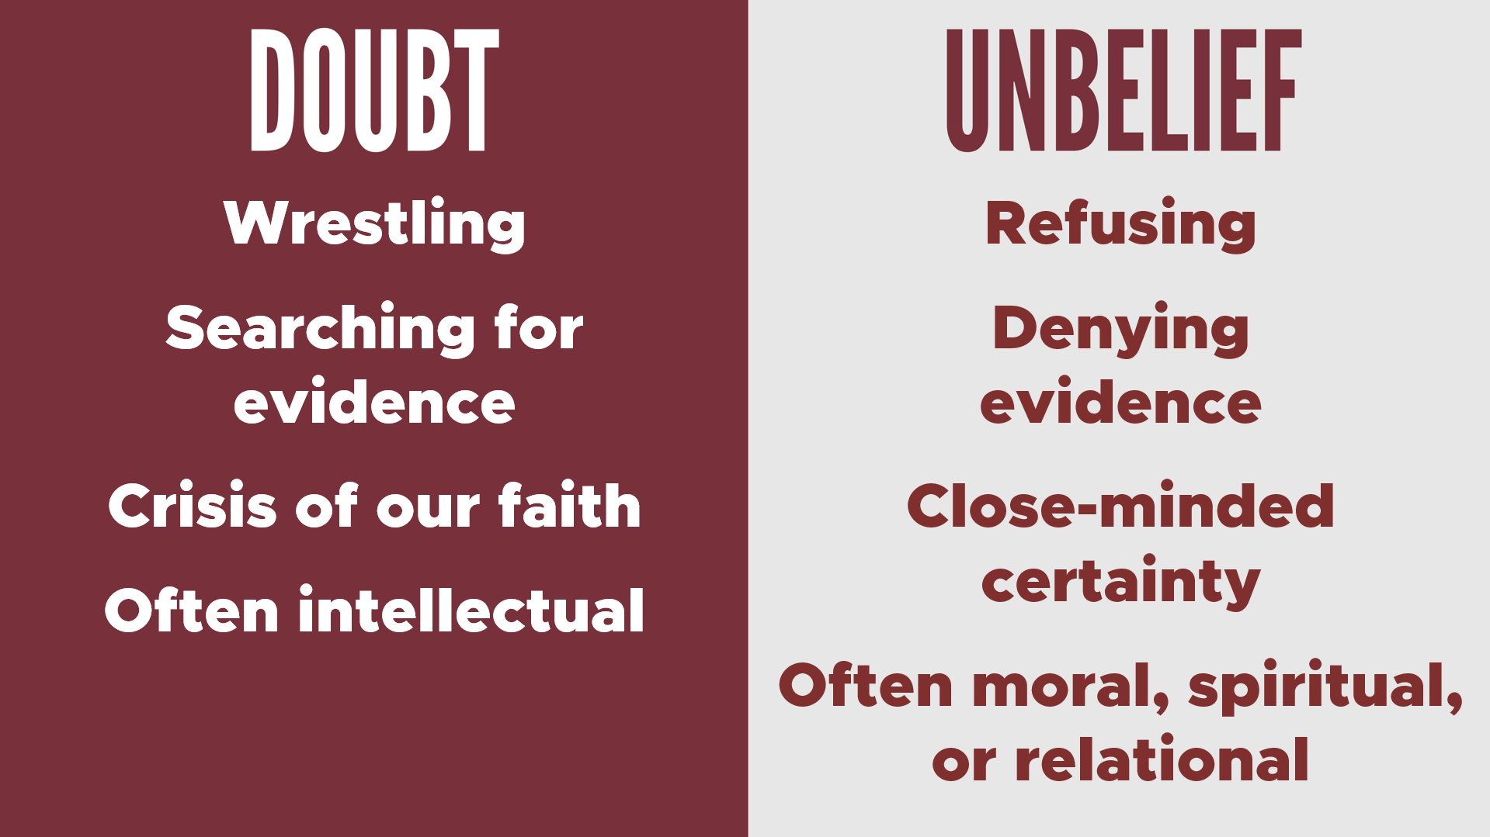

The object of our faith is more important than the amount of faith (Mk. 9:24).

Move toward doubt, not away from it.

No worldview has 100% certainty.

Explore your personal walk with Christ.

#### 2. Satan accuses us

#### How do we discern conviction from accusation?

(1) Obsesses on failures from the past? (Philippians 3:13)

(2) Makes God seem sadistic? (John 10:10)

(3) Contains a half-truth? (Acts 16:16-17; Genesis 3:5; Matthew 4:3, 6)

(4) Pushes you from God or others? (Genesis 3:8, 12; Hebrews 10:25)

(5) Leads to quitting or discouragement? (1 Corinthians 15:58; Galatians 6:9)

#### 3. Satan accuses fellow believers

Satan is “the accuser of our brothers and sisters” (Revelation 12:10).

“Gently instruct those who oppose the truth. Perhaps God will change those people’s hearts, and they will learn the truth. 26 Then they will come to their senses and escape from the devil’s trap. For they have been held captive by him to do whatever he wants” (2 Timothy 2:25-26).

Loving Christian community is one of the greatest apologetics (John 13:34-35; 17:21-23; 1 Corinthians 14:25).

Satan cannot “destroy the church,” so he aims to “discredit it.”[28]

This is why division is treated so seriously in Scripture (Titus 3:10-11; 1 Corinthians 12:25; 2 Corinthians 2:10-11; Ephesians 4:3, 26-27).

#### Our Response?

Overlook the offense (Proverbs 19:11; 1 Peter 4:8)

Get the log out of our own eye (Matthew 7:3-5)

Forgive unconditionally (Mark 11:25; Colossians 3:13; Ephesians 4:32)

Pray for the person (Lk. 6:28).

Correct your brother in love (Matthew 7:3-5; 18:15; Colossians 3:16)

Seek mediation if necessary (1 Corinthians 6:5-6; Philippians 4:2-3)

### Satan targets the spread the gospel

Satan confuses people (Matthew 13:19).

Satan blinds people (2 Corinthians 4:4).

Satan opposes believers directly (1 Thessalonians 2:18).

#### Our Response?

### Satan distracts us from prayer

Epaphras was “always laboring earnestly for you in his prayers” (Colossians 4:12).

“I urge you… to strive together with me in your prayers to God for me” (Romans 15:30).

“Pray at all times in the Spirit” (Ephesians 6:18).

Demons fear and tremble in the presence of prayer (Luke 8:28; James 2:19; Acts 16:18).

#### Our Response?

#### Conclusions

#### Discussion Questions

(1) In three minutes, write down the most important points that you learned from this lecture. Don’t cheat and look at your notes! (This exercise will help you with retention.)

(2) Why does Satan focus so much on bringing division among believers, and how can we practically protect unity in the church? Consider the role of forgiveness, correction, and humility in community.

(3) Have you ever experienced spiritual distraction in prayer or evangelism? How do you think Satan influences this, and how can we fight back?

(4) Why is a loving Christian community described as one of the greatest apologetics, and how does Satan work to undermine that? Explore how your group or church can actively pursue unity and healing.

#### Homework

Set a timer and spend 15 minutes each day in focused prayer for 3 days. Write a one-page reflection on how distractions came up and how you responded. What does this reveal about spiritual opposition in your prayer life?

# 12. The World System (Part One)

#### Summary

Biblical data for angels and demons.

Evidence for Satan’s existence.

Evidence for overt demonic oppression.

The reality of the occult.

Satan’s tactics.

(Mt. 13:22) Jesus said, “The seed falling among the thorns refers to someone who hears the word, but the worries of this life and the deceitfulness of wealth choke the word, making it unfruitful.”

#### The World System (*kosmos*)[29]

(1) “that which serves to beautify through decoration, adornment, adorning.”

Cosmetics and the decor of women (1 Peter 3:3; 1 Timothy 2:9; 3:2; Homer, *Iliad*, 14.187; LXX: Jer. 2:32; 4:30; Isa. 3:18; 61:10; Prov. 20:29).

(2) “condition of orderliness, orderly arrangement, order.”

The orderliness of rowers on a ship or soldiers in formation for battle (Homer, *Odyssey*, 13.76; *Iliad*, 2.554). The orderliness of human society and law (Plato, *De Legibus*, 8.846).

(3) “the sum total of everything here and now, the world, the (orderly) universe.”

The universe (Acts 17:24; Matthew 24:21; 25:34; 26:13; Luke 11:50).

The Earth (Mark 8:36; 1 Corinthians 5:10).

All of humanity (John 3:19; 2 Corinthians 5:19).

“In Greek philosophy kosmos is the basic term for the world-order, the world-system, the sum total of things preserved by this ordering.”[30]

**Definition?** “The *kosmos* is a cosmetically beautiful and orderly system that values temporal or transitory pleasures, distracting us from the love and eternal values of God.”

(1 Jn. 2:15) Do not love the world nor the things in the world. If anyone loves the world, the love of the Father is not in him.

(1 Jn. 2:16) All that is in the world, the lust of the flesh and the lust of the eyes and the boastful pride of life, is not from the Father, but the world.

(1 Jn. 2:17) The world is passing away, and also its lusts. But the one who does the will of God lives forever.

#### Satan is the mind behind the world-system

Satan is “the ruler of this world” (John 12:31; cf. 14:30).

“The whole world lies in the power of the evil one” (1 John 5:19).

Satan is “the god of this world” (2 Corinthians 4:4).

#### Loving God and the world-system are mutually exclusive

“No one can serve two masters. Either he will hate the one and love the other, or he will be devoted to one and despise the other. You cannot serve God and wealth” (Matthew 6:24).

“What this world honors is detestable in the sight of God” (Luke 16:15).

Peter warned of the “the corruption that is in the world by lust” (2 Peter 1:4).

“The wisdom of this world is foolishness before God” (1 Corinthians 3:19).

“You adulteresses, do you not know that friendship with the world is hostility toward God? Therefore whoever wishes to be a friend of the world makes himself an enemy of God” (James 4:4).

#### God will ultimately judge the world-system

“Judgment is upon this world” (John 12:31).

Revelation 18 gives graphic imagery of what it will look like to see the world-system being finally destroyed.

## How should believers react to the world-system?

#### Think critically about the world-system (Romans 12:1-2; 1 Timothy 6:9-11; Luke 12:15).

(Rom. 12:1-2) Do not be conformed to this world, but be transformed by the renewing of your mind.

(Lk. 12:15) “Beware! Guard against every kind of greed. Life is not measured by how much you own.”

“Greed” (pleonexia) comes from the words “more” (*pleon*) and “to have” (*echō*).[31]

(1 Tim. 6:9) People who long to be rich fall into temptation and are trapped by many foolish and harmful desires that plunge them into ruin and destruction.

(1 Tim. 6:10) For the love of money is the root of all kinds of evil. And some people, craving money, have wandered from the true faith and pierced themselves with many sorrows.

#### Think about life after death (Ecclesiastes 7:4; 1 Jn. 2:15-17; 1 Corinthians 7:30-31).[32]

(Eccl. 7:4) A wise person thinks a lot about death, while a fool thinks only about having a good time.

(1 Cor. 7:30-31 NEB) Buyers must not count on keeping what they buy, nor those who use the world’s wealth on using it to the full. For the whole frame of this world is passing away.

# 13. The World System (Part Two)

#### Make wise financial choices (e.g. debt, savings, school, career, big purchases, etc.).

(Prov. 30:8) Give me neither poverty nor riches! Give me just enough to satisfy my needs. 9 For if I grow rich, I may deny you and say, “Who is the LORD?” And if I am too poor, I may steal and thus insult God’s holy name.

#### A Christian View of Career

Intentional poverty is a sin (2 Thessalonians 3:10).

Intentional greed is a sin (1 Timothy 6:9).

Carrying our load (Galatians 6:2, 5).

Becoming a generous giver (Ephesians 4:28).

Providing for a family (1 Timothy 5:8).

Sharing our faith

#### Dave Ramsey’s Steps

(1) $1,000 emergency fund.

(2) Live extremely simply.

(3) Pay off all debt, starting with the smallest bills first.

(4) Save three months expenses.

(5) Save 15% for retirement.

(6) Pay off house early.

(7) Save and give generously.

#### Live simply and learn contentment (1 Timothy 6:6; Hebrews 13:5-6).

(1 Tim. 6:6) Godliness actually is a means of great gain when accompanied by contentment.

(Heb. 13:5) Make sure that your character is free from the love of money, being content with what you have. For He Himself has said, “I will never desert you, nor will I ever forsake you.”

#### Give generously and live for Christ (Luke 16:11; Genesis 2:15).

(Lk. 16:11) Jesus said, “If you are untrustworthy about worldly wealth, who will trust you with the true riches of heaven?”

(Gen. 2:15) Then the LORD God took the man and put him into the garden of Eden to cultivate it and keep it.

(1 Jn. 5:4-5) Everyone born of God overcomes the world. This is the victory that has overcome the world, even our faith. 5 Who is it that overcomes the world? Only the one who believes that Jesus is the Son of God.

#### Discussion Questions

(1) In three minutes, write down the most important points that you learned from this lecture. Don’t cheat and look at your notes! (This exercise will help you with retention.)

(2) What does it mean that Satan is “the ruler of this world” and “the god of this world”? How does this fit with the biblical teaching that God is sovereign and owns everything?

(3) How can Christians balance living responsibly in the world while not loving or being conformed to the world system?

(4) What are proactive steps to avoid being compromised and defeated by the world-system? (Where do you think you’re personally the most vulnerable to the world-system?)

(5) In what ways does living simply and contentedly (1 Timothy 6:6, Hebrews 13:5-6) serve as a spiritual weapon against the world system?

#### Homework

Keep a daily journal for one week noting moments when you felt discontent or tempted by “the lust of the eyes” or “boastful pride of life.” Reflect at the end of the week on how you can cultivate contentment and trust in God’s provision.

Write a 1-page reflection on how you see your career or future vocation as a way to serve God and others, referencing Genesis 2:15, 1 Timothy 5:8, and Ephesians 4:28. How does this view contrast with worldly attitudes about success and wealth?

# Scripture Memorization

(John 8:44) Jesus said, “He was a murderer from the beginning, and does not stand in the truth because there is no truth in him. Whenever he speaks a lie, he speaks from his own nature, for he is a liar and the father of lies.”

(Hebrews 1:14 NLT) Angels are only servants—spirits sent to care for people who will inherit salvation.

(1 Corinthians 2:7-8 NLT) The wisdom we speak of is the mystery of God—his plan that was previously hidden, even though he made it for our ultimate glory before the world began. 8 But the rulers of this world have not understood it; if they had, they would not have crucified our glorious Lord.

(Colossians 2:14-15 NLT) Jesus canceled the record of the charges against us and took it away by nailing it to the cross. In this way, he disarmed the spiritual rulers and authorities. He shamed them publicly by his victory over them on the cross.

(Deuteronomy 18:10-11) Do not let your people practice fortune-telling, or use sorcery, or interpret omens, or engage in witchcraft. 11 There shall not be found among you anyone… who casts a spell.

(Isaiah 41:22-23) Tell us, you idols, what is going to happen… Declare to us the things to come, tell us what the future holds, so we may know that you are gods. (cf. Isaiah 44:6-7; 46:9-10)

(1 John 2:15-17) Do not love the world nor the things in the world. If anyone loves the world, the love of the Father is not in him. 16 All that is in the world, the lust of the flesh and the lust of the eyes and the boastful pride of life, is not from the Father, but the world. 17 The world is passing away, and also its lusts. But the one who does the will of God lives forever.

(Romans 12:1-2) Do not be conformed to this world, but be transformed by the renewing of your mind.

(Ephesians 6:10) Finally, be strong in the Lord and in the strength of His might.

(Ephesians 6:11) Put on the full armor of God, so that you will be able to stand firm against the schemes of the devil.

(Ephesians 6:12) For our struggle is not against flesh and blood, but against the rulers, against the powers, against the world forces of this darkness, against the spiritual forces of wickedness in the heavenly places.

(Ephesians 6:13) Therefore, take up the full armor of God, so that you will be able to resist in the evil day, and having done everything, to stand firm.

1. Millard J. Erickson, *Christian Theology*., 2nd ed. (Grand Rapids, MI: Baker Book House, 1998), 458.
2. Peter S. Williams, *The Case for Angels* (Carlisle: Paternoster Press, 2002), xiii.
3. Thomas Aquinas, *Summa Theologica*, part 1, questions 50-52.
4. Charles Hodge, *Systematic Theology* (Eerdmans, 1952), vol. 1, p. 636.
5. Millard J. Erickson, *Christian Theology*, 2nd ed. (Grand Rapids, MI: Baker Book House, 1998), 464.
6. Wayne Grudem, *Systematic Theology* (Grand Rapids, MI: Zondervan, 1994), 400.
7. *Theological Wordbook of the Old Testament* (Chicago: Moody Press, 1999), 217.
8. Ralph H. Alexander, *Ezekiel* (Zondervan, 1986), 883.
9. G.K. Beale & D.A. Carson, *Commentary on the New Testament use of the Old Testament* (Apollos, 2007), 1034. Bart D. Ehrman, *Did Jesus Exist?* (HarperOne, 2012), 166.
10. Paul Tillich, *A History of Christian Thought* (New York: Harper & Row, 1968), 94.
11. Rudolph Bultmann, “The New Testament and Mythology” in H.W. Bartsch (ed.), *Kerygma and Myth* (London: SPCK, 1953).
12. Norman L. Geisler, “Satan, Reality Of,” in *Baker Encyclopedia of Christian Apologetics* (Grand Rapids, MI: Baker Books, 1999), 683.
13. Robert Funk and The Jesus Seminar, The Acts of Jesus: What Did Jesus Really Do? (San Francisco: HarperSanFrancisco, 1998), p.527.
14. John-Dominic Crossan, The Historical Jesus (New York: HarperCollins, 1991), p.332.
15. Richard Gallagher, Demonic Foes (HarperCollins Publishers, 2020), 159.
16. Lewis, C. S. *The Screwtape Letters*. New York, NY: HarperSanFrancisco, 2001. Preface ix.
17. Kurt Koch, *Occult Bondage and Deliverance* (Kregel: Grand Rapids, MI. 1976), 16.
18. Peter Hartmann, et al. (2006). The relationship between date of birth and individual differences in personality and general intelligence. *Personality and Individual Differences*. 40/7. 2006.
19. Spencer Greenberg and André Ferretti, “Can astrologers truly gain insights about people from entire astrological charts?”
20. Bertram R. Forer, (1949). The fallacy of personal validation: A classroom demonstration of gullibility. *Journal of Abnormal and Social Psychology*, 44, 118-123.
21. Karla McLaren, “Bridging the Chasm between Two Cultures,” *Skeptical Inquirer* (May 2004).
22. The “kingdom of God” has already arrived, and therefore, this “binding” is occurring before the Cross or the Church Age.
23. Merrill Unger, *What Demons Can Do to Saints* (Moody Publishers: Chicago, 1991), 60.
24. Kurt Koch, *Occult Bondage and Deliverance* (Kregel: Grand Rapids, MI. 1976), 68.
25. Merrill Unger, *What Demons Can Do to Saints* (Moody Publishers: Chicago, 1991), 60-61.
26. John MacArthur, *How to Meet the Enemy* (1996), 69. F.F. Bruce, *Ephesians* (Eerdmans, 1984), 408. Walvoord & Zuck, *The Bible Knowledge Commentary* (1983), 643. Francis Foulkes, *Ephesians* (InterVarsity, 1989), 180.
27. Graham A. Cole, *Against the Darkness* (2019), 169. Warren Wiersbe, *The Strategy of Satan* (1979), 129. Merrill Unger, *What Demons Can Do to Saints* (1991), 18. Dennis McCallum, *Satan and His Kingdom* (2009), 124. A. Skevington Wood, *Ephesians* (1981), 87.
28. J. Oswald Sanders, *Satan is No Myth* (Chicago, IL: Moody, 1975), 82.
29. William Arndt et al., *A Greek-English Lexicon of the New Testament and Other Early Christian Literature* (Chicago: University of Chicago Press, 2000), 561-563.
30. J. Guhrt, “Κόσμος,” in *New International Dictionary of New Testament Theology*, ed. Lothar Coenen, Erich Beyreuther, and Hans Bietenhard (Grand Rapids, MI: Zondervan, 1986), 521.
31. Colin Brown, *New International Dictionary of New Testament Theology* (Grand Rapids, MI: Zondervan Publishing House, 1986), 137.
32. Philip Conzzolino (2004). Greed, death, and values. *Personality and Social Psychology Bulletin*, 30(3), 278-292.

    Emily Lykins, et al. (2007) Goal shifts following reminders of mortality. *Personality and Social Psychology Bulletin*.