**Canonicity**

Student Handout

# Table of Contents

Pre-Homework 2

1. Defining the Canon 3

2. Internal Evidence for the New Testament Canon 6

3. External Evidence for the New Testament Canon 9

4. Disputed New Testament Books 13

5. What about the Gnostic Gospels? 22

6. Internal Evidence for the Old Testament Canon 28

7. External Evidence for the Old Testament Canon 34

8. Should we Accept the Apocrypha? 37

9. Rational Evidence against the Apocrypha 42

10. The Council of Jamnia 44

Study Guide 46

Scripture Memorization 48

# Pre-Homework

(1) What do you hope to gain from taking this course?

(2) What goals do you have to use this equipping that you’re going to receive?

(3) How do you hope to put this material into practice?

# 1. Defining the Canon

(Ezek. 42:16) [The angel] measured the east side with his measuring rod, and it was 875 feet long.

(Gal. 6:16) Those who will walk by this rule [kanōn], peace and mercy be upon them.

Canonicity is the study of which books are inspired and belong in the Bible.

**“The canon is the list of accepted biblical books.”**

**“In what church council did bishops create the Canon?”**

**“When did all Christians agree on which books belong in the Bible?”**

#### An Inadequate Definition of the Canon

The Canon is “the list of the writings acknowledged by the Church as documents of the divine revelation.”[1]

**(1) This would mean that Christians did not have a Bible for at least three centuries.**

**(2) The need for a canonical list leads to an infinite regress.**

**(3) This makes a philosophical error that confuses the BEING of Scripture with the KNOWING of Scripture.**

Nina Siegal, “A van Gogh’s Trip From the Attic to the Museum.” *The New York Times* (September 9, 2013).

**Revealed (1st century)**

**Recognized (2nd to 4th century)**

**Recorded (4th century)**

#### What are the CRITERIA for identifying canonical books?

The primary basis is

#### Questions to Consider

If you believe the Canon is a list of books accepted by leaders of the Christian Church…

Why should we accept this definition?

Did Christians not know what the Bible contained… for 1,500 years?

Do you really believe that these books BECAME inspired once a group of men wrote a list?

Did Christians determine Scripture… or discover Scripture?

## Discussion Questions

(1) In three minutes, write down the most important points that you learned from this lecture. Don’t cheat and look at your notes! (This exercise will help you with retention.)

(2) Imagine if someone said, “The teacher just arbitrarily created his own definition of the canon. Why we take his definition as authoritative?” How would you respond?

(3) Why is the definition of the canon so important? What could go wrong if we don’t accurately define the canon?

## Scripture Memorization

**(2 Pet. 3:2) You should remember the words spoken beforehand by the holy prophets and the commandment of the Lord and Savior spoken by your apostles.**

# 2. Internal Evidence for the New Testament Canon

#### Introduction

#### What are the New Testament Criteria for Apostleship?

(1) **Seeing** the risen Jesus (Acts 1:22; 1 Cor. 9:1; 15:7)

(2) **Selection** by Jesus (Mt. 10; Acts 1:24; Rom. 1:1; Gal. 1:1)

(3) **Signs** of Jesus (2 Cor. 12:12)

#### Did the NT authors believe they were writing Scripture?

**(1) The historical backdrop**

The OT Scriptures end with a cliffhanger![2]

Covenants implied writing (Ex. 24:7; 34:28; Deut. 4:13; 29:21; 2 Kin. 23:2).

The Jewish people read Scripture in their meetings (Lk. 4:17-20; Acts 13:15; 15:21; Col. 4:16; 1 Thess. 5:17; Rev. 1:3; 2 Cor. 10:9).

Justin Martyr, *Weekly Worship of the Christians*, chapter 67.

**(2) Authority of apostolic teaching**

How did the apostles view their spoken teaching?

(Mt. 10:20) It is not you who speak, but it is the Spirit of your Father who speaks in you.

(Mt. 10:40-41) He who receives you receives Me, and he who receives Me receives Him who sent Me. 41 He who receives a prophet in the name of a prophet shall receive a prophet’s reward.

(Acts 15:22-23; 16:4)

**(3) Authority of apostolic writing**

(1 Cor. 14:36-38) Was it from you that the word of God first went forth? Or has it come to you only? 37 If anyone thinks he is a prophet or spiritual, let him recognize that the things which I write to you are the Lord’s commandment. 38 But if anyone does not recognize this, he is not recognized.

(1 Thess. 4:2) You know what commandments we gave you by the authority of the Lord Jesus. 3 This is the will of God, your sanctification—that you abstain from sexual immorality… 8 He who rejects this is not rejecting man but God.

(2 Tim. 4:13) Bring the cloak… and the books, especially the parchments.

(Rev. 22:18) I testify to everyone who hears the words of the prophecy of this book: if anyone adds to them, God will add to him the plagues which are written in this book.

(Rev. 22:19) And if anyone takes away from the words of the book of this prophecy, God will take away his part from the tree of life and from the holy city, which are written in this book.

Deuteronomy 4:2; cf. 12:32

**(4) Authority to the apostles from Jesus to write Scripture**

(Jn. 14:26) The Holy Spirit will teach you all things, and bring to your remembrance all that I said to you.

(Jn. 16:13) The Spirit of truth will guide you into all the truth… He will disclose to you what is to come.

(Jn. 15:26-27) When the Helper comes, whom I will send to you from the Father, that is the Spirit of truth who proceeds from the Father, He will testify about Me, 27 and you will testify also, because you have been with Me from the beginning.

(Jn. 21:24) This is the disciple who is testifying to these things and wrote these things, and we know that his testimony is true.

**(5) Authority the apostles recognized in each other’s writings**

(1 Tim. 5:18) For the Scripture says, ‘You shall not muzzle the ox while he is threshing,’ and ‘The laborer is worthy of his wages.’

(2 Pet. 3:2) You should remember the words spoken beforehand by the holy prophets and the commandment of the Lord and Savior spoken by your apostles.

(Jude 17) You, beloved, ought to remember the words that were spoken beforehand by the apostles of our Lord Jesus Christ.

(2 Pet. 3:15-16) Our dear brother Paul also wrote you with the wisdom that God gave him. 16 He writes… in all his letters… His letters contain some things that are hard to understand, which ignorant and unstable people distort, as they do the other Scriptures, to their own destruction.

#### Questions to Consider

**If you don’t believe the NT authors thought they were writing Scripture…**

Why doesn’t this fit the Jewish culture and history?

If their teaching was inspired, why wasn’t their writing?

How do you understand their direct affirmations of calling NT books “Scripture”?

What did Jesus mean when he pre-authenticated the future writing of the NT authors? (Jn. 15:26-27; 21:24).

## Discussion Questions

(1) In three minutes, write down the most important points that you learned from this lecture. Don’t cheat and look at your notes! (This exercise will help you with retention.)

(2) Imagine if someone said, “This argument was using biblical passages to prove that these are biblical passages… This is circular reasoning!” Is this a valid criticism? How would you respond?

## Scripture Memorization

**(Jn. 14:26) The Holy Spirit will teach you all things, and bring to your remembrance all that I said to you.**

**(Jn. 16:13) The Spirit of truth will guide you into all the truth… He will disclose to you what is to come.**

**(2 Pet. 3:15-16) Our dear brother Paul also wrote you with the wisdom that God gave him. 16 He writes… in all his letters… His letters contain some things that are hard to understand, which ignorant and unstable people distort, as they do the other Scriptures, to their own destruction.**

# 3. External Evidence for the New Testament Canon

#### Introduction

Sir Leigh Teabing: “More than eighty gospels were considered for the New Testament, and yet only a relative few were chosen for inclusion—Matthew, Mark, Luke, and John among them.”[3]

Geoffrey Hahnemann: “Not until the fourth century did the church appear to define and restrict that New Testament collection.”[4]

#### The Church Fathers emphasized apostolicity

**Clement of Rome (AD 95)** emphasized apostolic authorship: “The apostles were made evangelists to us by the Lord Christ; Jesus Christ was sent by God. Thus Christ is from God, and the apostles from Christ… The Church is built on them as a foundation” (1 Clement 42).

**Ignatius (AD 110, Turkey)** writes, “I do not, as Peter and Paul, issue commandments to you. They were *apostles*; I am but a condemned man” (*The Epistle of Ignatius to the Romans*, chapter 4). He also tells his readers to follow the “decrees” and “ordinances” of the apostles (*Magnesians*, 13:1; *Tralles*, 7:1).

**Polycarp (AD 110, Smyrna)** places the NT “apostles” and OT “prophets” as equal in authority (*Philippians*, 6.3).

**Justin Martyr (AD 150, Israel)** wrote that Jesus spoke “through the apostles” (*1 Apology*, 42). Justin attributes Matthew 16:17 as “recorded in the memoirs of *His apostles*” (*Dialogue with Trypho* 103.8). To be clear, Justin used the expression “the memoirs of the apostles (*First Apology* 67) as synonymous with the “gospels” (66).

**Irenaeus (AD 180, Lyons, France)** held that those who denied Matthew, Mark, Luke, and John were denying “the companions of the Lord” (*Against Heresies*, 3.1.2). He writes, “Thus did the apostles… deliver to all what they had themselves learned from the Lord” (*Against Heresies*, 2.14.2).

**Tertullian (AD 210, Tunisia, North Africa)** refers to Luke as “an apostolic man,” and yet he still wrote of “Luke’s Gospel” (*Against Marcion* 4.2.5). He states, “A work ought not to be recognized, which holds not its head erect… *which gives no promise of credibility from the fullness of its title and the just profession of its author*” (*Against Marcion*, 4.2). He also wrote, “We lay it down as our first position, that the evangelical Testament has *apostles for its authors*” (*Against Marcion* 4.2).

**Clement of Alexandria (AD 215, Egypt)** uses the phrase “Law and Prophets and Gospels and apostles” (*Stromateis*, Miscellanies, 7.1, 16).

#### The Church Fathers abundantly cite the NT

**The Didache (AD 95)** quotes from Matthew’s version of the Lord’s Prayer in 8.2 (Mt. 6:5, 9-13).

**Ignatius (AD 110, Turkey)** refers to multiple epistles of Paul—specifically referring to “every epistle” (*Epistle to the Ephesians*, 12:2). Kruger writes, “The key point is that Ignatius not only has a Pauline letter collection, but mentions it to the Ephesian church with full expectation that they are also aware of it. The fact that Ignatius does not introduce, defend, or elaborate on Paul’s collection suggests that it is well known not only to Ignatius himself but also to his audience.”[5]

**Polycarp (AD 110, Smyrna)** is aware of Paul’s “letters” (*Philippians*, 3.2).

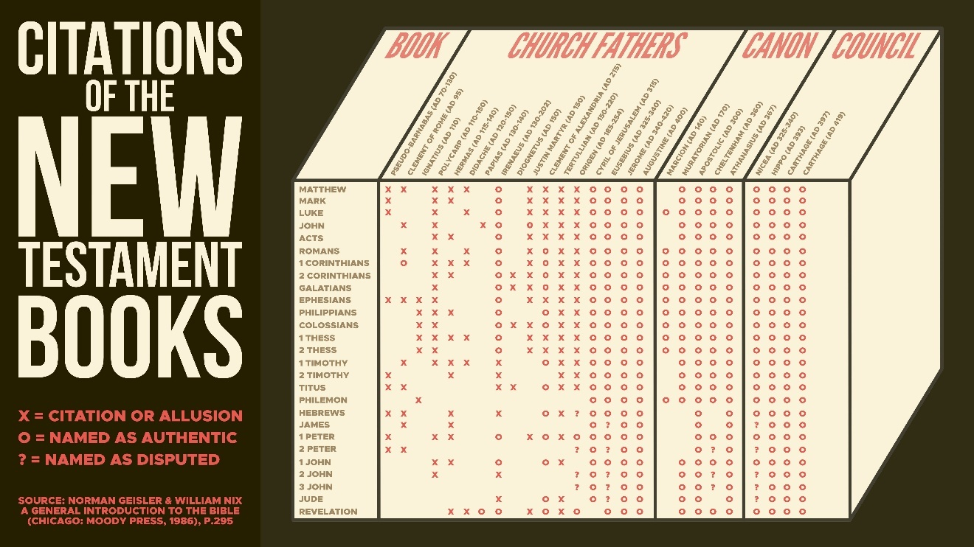

**Harmonizing Four Gospels.** Tatian’s *Diatessaron* (AD 170) and Theophilus of Antioch (Jerome Epistles, 121.6.15).

**Citing Four Gospels (+).** Irenaeus (AD 180, Haer. 3.11.8) and Clement of Alexandria (AD 198, EH, 6.14.5-7)

**Listing the NT Books.** Muratorian Fragment (AD 170). Origen (AD 250, *Hom. Jos.* 7.1). Athanasius (AD 367, *39th Paschal Letter*)

#### Christian scribes bound canonical books together

P46 (AD 200). Romans, Hebrews, 1 Corinthians, 2 Corinthians, Ephesians, Galatians, Philippians, Colossians, and 1 Thessalonians

Chester Beatty (P45 AD 250). Four gospels followed by Acts

P75 (AD 250). John and Luke

P53 (AD 250). Matthew and Luke

P72 (AD 250). 1 Peter, 2 Peter, and Jude

#### The Church Fathers treated the NT documents as inspired

**The Didache (AD 95)** is most likely the earliest extra-biblical manuscript.[6] It states that they didn’t feel the freedom to “add or take away” from the writings of the apostles (*Didache* 4:13),[7] using the language of Deuteronomy 4:2.

**Clement of Rome (AD 95)** stated, “Take up the Epistle of the blessed Paul the apostle, what did he write to you at the time the Gospel began to be preached? *Truly under the inspiration of the Spirit he wrote to you*” (*Letter to the Corinthians*, 47:1-3).

**Polycarp (AD 110, Smyrna)** cites Ephesians 4:26 and Psalm 4:4 as Scripture (*To the Philippians*, 12.1).[8] He also writes, “If you carefully peer into them, you will be able to be built up in the faith that was given to you” (*Philippians*, 3.2).

**Justin Martyr (AD 150, Israel)** wrote that the apostles spoke “the word of God” (*1 Apology*, 39.3).

**Dionysius of Corinth (AD 170)** distinguishes his letter from the “Scriptures of the Lord,” and he calls his letters “inferior” (Eusebius, *Church History*, 4.23.12).

**Theophilus of Antioch (AD 177)** wrote, “Concerning the righteousness which the law enjoined, confirmatory utterances are found both with the prophets and in the Gospels, because they all spoke inspired by one Spirit of God” (*To Autolycus*, 3.12). He also cites Titus 3:1, 1 Timothy 2:1-2, and Romans 3:7 as “the divine word” (*To Autolycus*, 3.14).

**Irenaeus (AD 180, Lyons, France)** writes, “The apostles, likewise being disciples of the truth, are above all falsehood… For the apostles… certainly did not address them in accordance with their opinion at the time, but according to revealed truth” (*Against Heresies*, 3.5.1-2). He refutes false teachers by writing, “When however, they are confuted from the Scriptures, they turn around and accuse these same Scriptures as if they were not correct nor of authority” (*Against Heresies*, 3.2.1).

#### Questions to Consider

**If the NT became Scripture in the 4th century…**

Why did the church fathers have harmonizations, lists, and commentaries of the NT books long before any council?

Why did they cite the NT writings 32,000 times?

Why did they treat the NT books as Scripture?

Why did they emphasize authorship as authoritative?

How do you explain the wide geographical distribution?

Why did scribes only bind NT books together?

## Discussion Questions

(1) In three minutes, write down the most important points that you learned from this lecture. Don’t cheat and look at your notes! (This exercise will help you with retention.)

(2) Imagine if someone said, “You don’t trust *everything* that the church fathers said. So, why are you appealing to the church fathers to support the canon?” Is this a valid criticism? How would you respond?

4. Disputed New Testament Books

Hebrews

**Why was Hebrews disputed?**

**Evidence for Paul’s Oversight**

(1) The letter dates before AD 70.

The author writes about ritual sacrifices in the present tense (Heb. 7:27-28; 8:3-5; 9:6-9, 25; 10:1-3, 8; 13:10-11).

Clement of Rome (AD 95) cites Hebrews 1:3-7, 13 (36:1-6).

(2) The author was in Paul’s inner circle.

“I want you to know that our brother Timothy has been released from jail. If he comes here soon, I will bring him with me to see you” (Heb. 13:23).

(3) Minimally, there is good evidence that Paul influenced the author’s theology.

Hebrews has 169 unique words and polished rhetoric. See Gareth Lee Cockerill, The Epistle to the Hebrews (2012), p.7.

However, see E. Linnemann, “A Call for a Retrial in the Case of the Epistle to the Hebrews,” (2002): 19-59.

(1) The “Body” is the Church

(Rom. 12:4-5; 1 Cor. 12:12-14; Heb. 13:3)

(2) Milk and meat of Scripture

(1 Cor. 3:1-3; Heb. 5:11-14)

(3) OT citations (Deuteronomy 32:35 and Habakkuk 2:4)

Both cite Deuteronomy with the same translation (Rom. 12:19; Heb. 10:30 and Rom. 1:17; Heb. 10:38).

(4) Old and New Covenant

(2 Cor. 3:4-11; Heb. 8:6-13; 10:15-18)

(5) Old covenant is a “shadow”

(Col. 2:17; Heb. 8:5; 10:1)

**Evidence for Hebrews**

Church Fathers cited the book early

1 Clement 36:1-6

Shepherd of Hermas (AD 100-150) 2.3.2.

Justin Martyr (AD 150) 1 Apology 12:9; 63:5, 10, 14

Tertullian (AD 200) On Modesty 20.

Church Fathers accepted the book early

Pantaenus (AD 180) founded the school in Alexandria.

Clement of Alexandria (AD 215). EH, 6.14.3.

Origen (AD 250). EH, 6.25.11-14.

Hebrews appears in early manuscripts

Hebrews appears in P46 (AD 200).

**Evidence against Hebrews**

The Marcionite Canon (AD 140).

This isn’t surprising,

because Marcion was so intensely anti-Semitic!

The Muratorian Fragment (AD 170).

This is only a fragment.

It also doesn’t include 1 Peter.

The Western Church was slow to accept.

Because the letter was anonymous, the Western Church was critical of accepting it. This shows how cautious the early Christians were in accepting a book or letter as canonical.

James

**Why was James disputed?**

(1)

(2)

(3)

(4)

**Evidence for James**

James (the half-brother of Jesus) is the author.

(Mt. 13:55; 1 Cor. 15:7; Gal. 1:19; 2:9; Acts 1:14; 12:17; 15:13; 21:18)

Church Fathers cited the book early.

Clement of Rome (AD 95) in 1 Clement 23.1-3; James 1:5-8.

The Shepherd of Hermas (AD 100-150) repeatedly.

Church Fathers accepted the book early.

Clement of Alexandria (AD 215) wrote a non-extant commentary on James. See Douglas Moo, James (1985), p.16.

Origen (AD 250) cited it 36x, he believed it was written by an “apostle,” and he called it “Scripture” (Select. in Ps. 30:6).

Eusebius (AD 340) cited it “frequently in his writings and apparently accords it canonical status.” Douglas Moo, James (1985), p.17.

2 Peter

**Why was 2 Peter disputed?**

**Authorship of 2 Peter**

Claims to be an “apostle” and an “eyewitness.”

1 Peter 1:1; 5:1; 2 Peter 1:1; 3:1, 15-16

The letter criticizes deceit (1 Pet. 2:1, 22; 3:10)

Claims to have direct revelation from Jesus.

2 Peter 1:14

Claims to be a friend of Paul whose letters are “Scripture.”

2 Peter 3:15-16

Calls this his “second letter.”

2 Peter 3:1

Church Fathers cited the book early.

1 Clement (AD 95) cites it (1 Clem. 23.3; cf. 2 Pet. 3:4).

Apocalypse of Peter (AD 132-135) cites it (Apoc. Pet. 1-2 cites 2 Peter 2:1)

Eusebius (AD 340) called it “disputed,” yet it was “known by most” (EH, 3.3.1, 4; 3.25.3).

Church Fathers accepted the book early.

2 Clement (AD 120-140) refers to it as “the prophetic word” (2 Clem. 11.2).

Epistle of Barnabas (AD 70-135) cites it (15.4; cf. 2 Pet. 3:8).

Origen (AD 250) cites it as “Scripture” six times (e.g. Homily on Joshua, 7.1).

Clement of Alexandria (AD 215) wrote a lost commentary on 2 Peter (EH, 6.14.1).

2 and 3 John

**Why were 2 and 3 John disputed?**

**Authorship of 2 & 3 John**

The author claims to be an eyewitness.

1 John 1:1-3

1 John is similar with the gospel of John.

(1 Jn. 1:1-3; Jn. 1:1, 14) “The beginning… the Word of Life”

(1 Jn. 1:4; Jn. 16:24) “Our joy may be made complete”

(1 Jn. 1:6-7; Jn. 3:19-21) “Walk in the darkness… light”

(1 Jn. 2:7; Jn. 13:34) “I am not writing a new commandment”

(1 Jn. 3:8; Jn. 8:44) “The devil has sinned from the beginning”

(1 Jn. 3:14; Jn. 5:24) “We have passed out of death into life”

(1 Jn. 5:12; Jn. 3:36) “He who has the Son has the life”

All three letters are similar with one another.

C.H. Dodd held that all three letters were too similar!

C. H. Dodd, Commentary on the Johannine Epistles, Moffatt New Testament Commentary (Hodder & Stoughton, 1946).

**Evidence for 2 & 3 John**

Church Fathers cited the book early.

Papias (AD 110) “used testimonies drawn from the former Epistle of John” (EH, 3:39.17).

Polycarp of Smyrna (AD 130) cited it: To the Philippians 7.1-2; cf. 1 John 2:24; 3:8; 4:2-3.

Irenaeus (AD 180) states that John the apostle wrote 1 John (Against Heresies 3.16.5, 8).

Clement of Alexandria (AD 215) states that John the apostle wrote 1 John (Stromata 2.15.66).

Church Fathers accepted the book early.

Muratorian Fragment (AD 170) mentions two (and maybe three) letters of John.

Jude

**Why was Jude disputed?**

Jude doesn’t cite 1 Enoch as inspired.

Paul cites non-Christian sources

Epimenides and Aratus (Acts 17:28)

Menander’s comedy, Thais (1 Cor. 15:33).

The “prophet” Epimenides, writing that his “testimony is true” (Titus 1:12-13).

Did Jude’s opponents use these books?

“Even (kai) Enoch…”

J.D. Charles, “Jude’s Use of Pseudepigraphical Source-Material as Part of a Literary Strategy.” New Testament Studies 37: 144.

Norman Hillyer, 1 and 2 Peter, Jude (1992), p.257.

Douglas Moo, 2 Peter and Jude (1996), pp.272-274.

Michael Green, Jude (1987), pp.192-193.

**Authorship of Jude**

“Jude, a bond-servant of Jesus Christ, and brother of James” (Jude 1).

Jewish men usually identified themselves by their father.

Gene L. Green, Jude (2008), p.46.

“Jude” never appears as a Gentile name, the content is Palestinian, and he never cites the Septuagint (LXX).

Richard Bauckham, Jude (1983), pp.7-16.

Historically, Jude was the final pastor of the church in Jerusalem.

Eusebius, Church History, 4.5.3; Epiphanius, Panarion, 66.20.1-2; The Apostolic Constitutions, 7.46.

**Evidence for Jude**

Church Fathers cited the book early.

2nd Century Attestation: Theophilus of Antioch, Athenagoras, Polycarp, Clement, the Martyrdom of Polycarp, the Didache, Hermas, and the Epistle of Barnabas.

See Gene L. Green, Jude (2008), p.5.

Church Fathers accepted the book early.

Jude’s letter was “accepted widely in the West and in Alexandria.” See Gene L. Green, Jude (2008), p.5.

Muratorian Fragment (AD 170).

Clement of Alexandria (AD 215) wrote a commentary on it.

Origen (AD 250) called Jude “Holy Scripture” (Commentary on Romans 3.6).

Eusebius accepted it and stated it was read widely in the churches (Church History, 2.23.25; 3.25.3; 6.13.6; 6.14.1).

Revelation

**Why was Revelation disputed?**

**Authorship of Revelation**

The author claims to be “John.”

Revelation 1:1, 4, 9; 22:8

It contains many linguistic similarities and differences.

1/8 novel words. “Lamb” (Jn. 1:29; Rev. 5:6), “the Word of God” (Jn. 1:1; Rev. 19:13), both cite Zechariah 12:10 (Jn. 19:37; Rev. 1:7), and “tribulation” (Jn. 16:33; Rev. 1:9).

The Church Fathers affirmed John’s authorship.

Justin Martyr (Dialogue 81.15), Irenaeus (Against Heresies 4.14.1, 5.26.1), Tertullian (Against Marcion 3.14.24), Clement of Alexandria (Miscellanies 6.106)

**Evidence for Revelation**

Church Fathers cited the book early.

Papias (AD 110) cited it, and Tertullian (AD 200) cited from 18 of 22 chapters. See Robert Mounce, Revelation (1997), p.23.

Church Fathers accepted the book early.

Melito of Sardis (AD 175) wrote a commentary on Revelation (Church History 4.26.2).

Muratorian Fragment (AD 170)

Clement of Alexandria (AD 215) called it “Scripture” (Paed. 2.119; Quis Div. Salv. 42; Strom. 6.106-7).

Origen (AD 250) called “Scripture” (Comm. in Joh. 5.3).

Questions to Consider

How many books were disputed?

Were the core books of the NT disputed?

Were these Christians quick to accept books?

Discussion Questions

(1) In three minutes, write down the most important points that you learned from this lecture. Don’t cheat and look at your notes! (This exercise will help you with retention.)

(2) What questions do you have about the material that we covered today?

(3) Imagine if someone said, “The early Christians were quick to accept books into the canon.” How would you respond? What was the methodology of the early Christians for allowing a book into the canon?

(4) What might happen to a Christian if they didn’t have strong convictions about the canon of Scripture? What if they had perpetual doubts about which books belonged in their Bible? How would that practically affect them?

Scripture Memorization

**(1 John 1:1 NIV) That which was from the beginning, which we have heard, which we have seen with our eyes, which we have looked at and our hands have touched—this we proclaim concerning the Word of life.**

**(2 Peter 1:16 NIV) We did not follow cleverly devised stories when we told you about the coming of our Lord Jesus Christ in power, but we were eyewitnesses of his majesty.**

Homework

Write a one-page essay summarizing the top three reasons you have for believing in the 27 books in the New Testament canon. (The goal of this exercise is for you to retain and remember the evidence that you’ve learned.)

5. What about the Gnostic Gospels?

**Where were they discovered?**

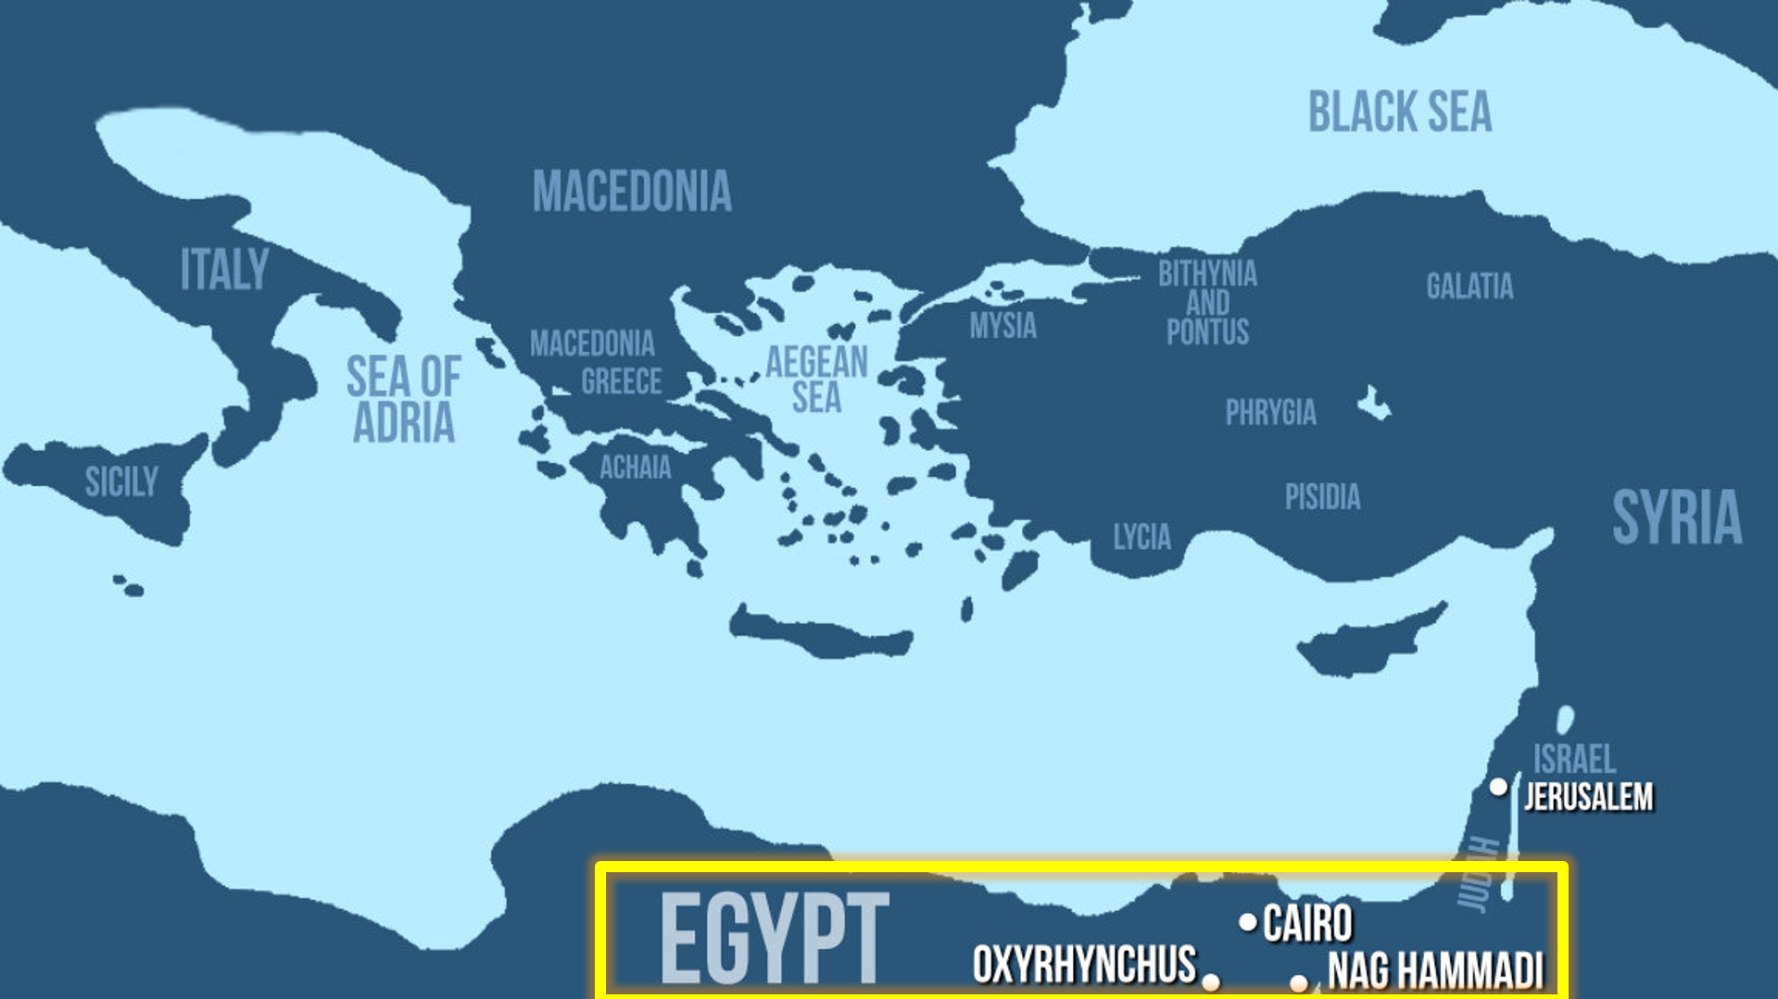

These texts were mentioned by the Church Fathers

Gospel of Truth (Against Heresies, 3.11.9)

Gospel of Judas (Against Heresies, 1.31)

Apocryphon of John (Against Heresies, 1.29.1-4)

Discovered in late 19th and mid-20th century.

A huge cache was discovered in Nag Hammadi, Egypt (1945) and translated by 1977.

**What is Gnosticism?**

The term is not ancient, but the concept is very ancient. The term comes from Henry More (1669).

Paul told Timothy to turn away from those who have what is “falsely called knowledge” (1 Tim. 6:20).

No formal organization, no formal creeds, no formal customs.

Gnostics had a “parasitic quality” to their beliefs and practices.

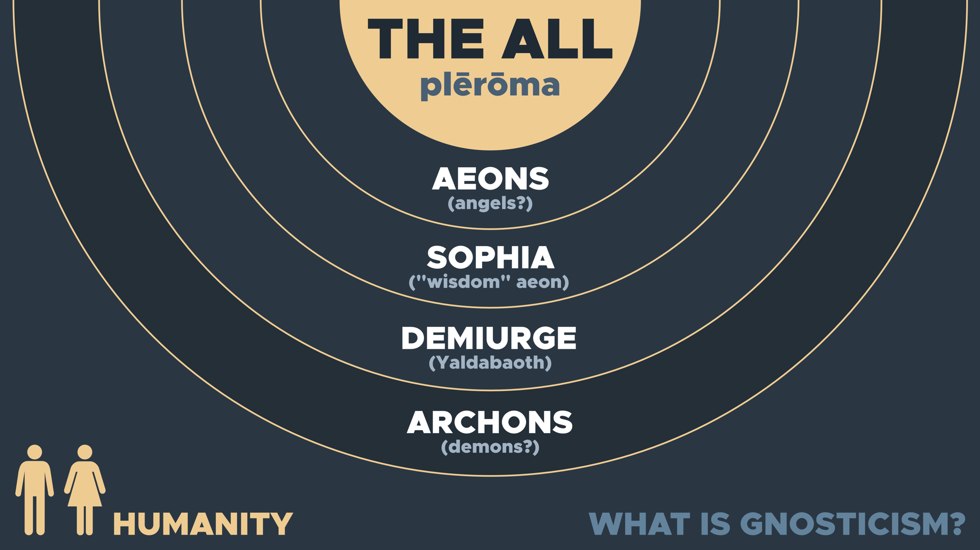

**Why should thinking people reject the Gnostic Gospels?**

**When were these documents written?**

What is the earliest Gnostic Gospel?

The Gospel of Thomas (AD 150)

How many Gnostic Gospels are there?[9]

Gospel(s) of Bartholomew—5th century

Gospel of Judas—2nd century

Gospel of Mary Magdalene—2nd century

Gospel of Peter—mid-2nd century

Gospel of Philip—late 2nd century

Gospel of the Egyptians—3rd century

Gospel of the Savior—2nd century

Gospel of Thomas—2nd century

Thomas the Contender—early 3rd century

Gospel of Truth—mid-2nd century

**Were Gnostic texts considered for the canon?**

**Does Gnosticism have a high view of women?**

Gospel of Thomas, saying 114.

**Do Gnostic texts deny the deity of Jesus?**

Gospel of Thomas, saying 77.

Gospel of Thomas, saying 13.

The Gospel of Philip, 56:32-34; 57:3-8

**Do the Gnostic texts tell us good history?**

**What is the best evidence against Gnosticism?**

Gospel of Peter 9:35-42

Infancy Gospel of Thomas

Questions to Consider

Why are the Four Gospels the only biographies that fit a Jewish background?

Why should we prefer the Gnostic Gospels when they date roughly a century (or more) after the Four Gospels?

Why do we have only one example of someone citing a Gnostic gospel for the first 300 years after Christianity?

Why do the consensus of historians agree that the Gnostic gospels give us no authentic historical data about Jesus?

Have you ever read the Gnostic gospels?

Discussion Questions

(1) In three minutes, write down the most important points that you learned from this lecture. Don’t cheat and look at your notes! (This exercise will help you with retention.)

(2) What else have you heard about the Gnostic Gospels that you want to discuss further? What do you want to look into this week for further study?

(3) Imagine if someone said, “Church councils picked which gospels they wanted at the Council of Nicea in AD 325.” How would you respond in a way that is winsome? What points would you make? What questions would you ask them?

Homework: Was Jesus married?

Some say that the Gnostic Gospels claimed that Jesus was married to Mary Magdalene. The Gospel of Philip (63:33-36) and the Gospel of Mary (17:10-18:21) mention Jesus “kissing” Mary often. However, a number of counterpoints can be made:

**First, celibacy was not looked down upon in first-century Judaism.** Many Jewish Essenes were known for their celibacy (Josephus, *Jewish War* 2.8.2.121-122; Philo, *Hypothetica* 11.14-17), and Josephus states that the Jews admired the celibacy of the Essenes. He writes:

It also deserves our admiration, how much they exceed all other men that addict themselves to virtue, and this in righteousness; and indeed to such a degree, that as it hath never appeared among any other men... There are about four thousand men that live in this way, and neither marry wives. (Josephus, *Antiquities* 18.1.5.20-21)

From this passage, we can infer that the Jews found it a “virtue” of “righteousness” to remain unmarried. Therefore, Jesus’ celibacy was not unusual for his culture; in fact, it was extolled as virtuous. In addition, Jesus’ actions were often countercultural. So even if celibacy were not widely practiced, it is possible that Jesus was carving out a different path.

**Second, there is no mention of Jesus being married in any ancient source—Christian or non-Christian.** In fact, the silence is deafening. For instance, Paul makes an argument for his right to take a wife. He writes, “Do we not have a right to take along a believing wife, even as the rest of the apostles and the brothers of the Lord and Cephas?” (1 Cor. 9:5) Here, Paul appeals to Cephas (or Peter) having a wife to show that he has the right to take a wife too. If Jesus had been married, why wouldn’t Paul appeal to Jesus’ marriage instead?

Indeed, we have only two references to Jesus kissing Mary and no references to Jesus being married in all of extra-biblical literature. Post-Constantinian Christianity (~AD 325) venerated Jesus’ mother, Mary, to an extraordinary degree. Many scholars believe that this was a cultural phenomenon—having a female figure of veneration, which was common in the Greco-Roman world of that time. However, if there were any historical record of Jesus having a wife, why wouldn’t she have been venerated instead? And yet, there is no trace of Mary being married to Jesus in early Christian history whatsoever. Scholar Darrell Bock writes:

In my office, there are thirty-eight volumes of early church documents, each of several hundred pages, double columns, in small print. The fact that out of all of this material, only two texts can be brought forward as even ancient candidates for the theory shows how utterly unlikely it is.[10]

Therefore, we have both a strong motive for finding a wife of Jesus (due to post-Constantinian veneration of Jesus’ mother) and yet no mention of a wife of Jesus—even in non-Christian sources. The sinful woman of Luke 7 is never identified as Mary Magdalene or as a prostitute. Mary Magdalene is introduced in Luke 8:2, but Luke does not connect her with the woman in the previous chapter. If Mary Magdalene were the sinful woman of Luke 7, surely Luke would have mentioned this. The first mention of Mary Magdalene being a prostitute comes from Pope Gregory in 591—not from the Bible.[11]

**Third, these Gnostic texts are dated hundreds of years after the canonical gospels.** For instance, the Gospel of Philip dates to the second half of the third century (~200 years after Matthew, Mark, Luke, and John). The Gospel of Mary dates at least to the middle of the second century (~100 years after). The four canonical gospels are more historically reliable for this reason.

**Fourth, these passages about Jesus kissing Mary (from the Gnostic gospels) could refer to the “holy kiss.”** The New Testament describes a “holy kiss” between believers in Christ (Rom. 16:16). In the Gospel of Philip, we read:

“And the companion of the [...] Mary Magdalene. [...] loved her more than all the disciples, and used to kiss her often on her mouth” (63:33-36).

However, earlier in the Gospel of Philip, a kiss is described as a symbolic means of sharing grace:

“For it is by a kiss that the perfect conceive and give birth. For this reason we also kiss one another. We receive conception from the grace which is in one another” (58:34-59:4).

**Fifth, for all these reasons, even highly critical scholars do not believe Jesus was married.** For instance, Darrell Bock writes, “One of the few things on which a vast majority of liberal and conservative Jesus scholars agree is that Jesus was single.”[12] Even Jesus Seminar scholar John Dominic Crossan writes:

“There is an ancient and venerable principle of biblical exegesis which states that if it looks like a duck, walks like a duck, and quacks like a duck, it must be a camel in disguise. So let’s apply that to whether or not Jesus was married. There is no evidence that Jesus was married (looks like a duck), multiple indications that he was not (walks like a duck), and no early texts suggesting wife or children (quacks like a duck)... So he must be an incognito bridegroom (camel in disguise).”[13]

For these reasons, we reject the idea that Jesus was married.

**Independent Study: A fourth century manuscript?**

In 2012, an ancient papyrus fragment from the fourth century was discovered that was dubbed, “The Gospel of Jesus’s Wife.” One of the lines stated: **“Jesus said to them [his disciples], my wife…”**

For homework this week, explore the evidence for this ancient manuscript and the controversy surrounding it. Specifically, look into the involvement of Walter Fritz and Karen King. Write 3-4 main points that summarize your findings.

6. Internal Evidence for the Old Testament Canon

How did the Israelites recognize Scripture?

(1)

(2)

(3)

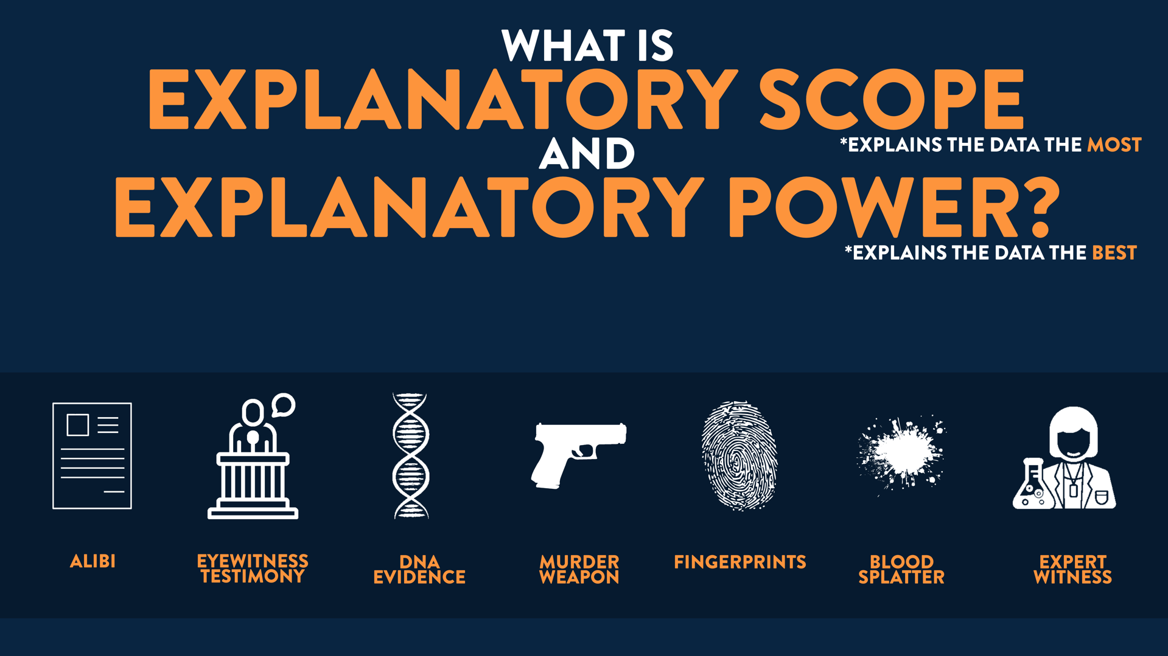

**How could they identify a true prophet?**

**(1) Accurate doctrine**

(Deut. 13:1-5)

**(2) Accurate predictions**

(Deut. 18:21-22)

**Accurate Prophetic Predictions**

Moses

Moses predicted the 40-year exodus in the wilderness (Num. 14:33).

Samuel

1 Samuel 3:19-20; 9:6

David

2 Samuel 7:11-16

Solomon

1 Kings 3:13-14

Isaiah

Death of Sennacherib three years later (2 Kings 19:32-35)

Destruction of Ephraim 65 years later (Isa. 7:8)

Rise of Cyrus ~150 years later (Isa. 44:28-45:1)

Babylonian Exile ~150 years later (2 Kings 20:14-18)

Jeremiah

Jeremiah predicted the doom of Jerusalem (Jer. 26:8-15), the 70 year exile (Jer. 25:11), and the death of Hananiah within the year (Jer. 28:16).

Jeremiah 14:14-15; Jeremiah 29:9;

Ezekiel

Ezekiel predicted the destruction of Jerusalem in the short-term, and predicted the destruction of Tyre (Ezek. 26:3-11).

Ezekiel 2:5; 13:9; 33:33

Daniel

Daniel predicted the correct succession of world empires after Babylon. 135 fulfilled predictions in Daniel 11 alone!

Zechariah

Zechariah predicted Alexander the Great’s conquest of the ancient Near East (Zech. 9).

Micah

Micah predicted that “Jerusalem will become a heap of ruins” (Micah 3:12) over 150 years in advance.

**Moses was the first prophet**

Numbers 12:7-8; Deuteronomy 18:15-18

(Ex. 17:14) The LORD said to Moses, “Write this in a book as a memorial and recite it to Joshua.”

(Ex. 24:4) Moses wrote down all the words of the LORD.

(Ex. 34:27) The LORD said to Moses, “Write down these words, for in accordance with these words I have made a covenant with you and with Israel.”

(Deut. 31:24) Moses finished writing the words of this law in a book until they were complete.

**Joshua**

Joshua viewed Moses’ writings as inspired (Joshua 1:8; 23:6).

(Josh. 24:26) “Joshua wrote these words in the book of the law of God.”

**Judges & Ruth**

Samuel (or a close associate) was the author (Baba Bathra, 14b).

(1) Samuel was against the kingship (1 Sam. 8).

(2) Mentions David (Ruth 4:17, 22).

The composition is singular authorship.[14]

**1 & 2 Samuel**

Samuel was a prophet or “seer” (1 Sam. 9:9).

(1 Sam. 3:20-21) “All Israel… knew that Samuel was confirmed as a prophet of the Lord… The Lord revealed Himself to Samuel at Shiloh by the word of the Lord.”

(1 Sam. 10:25) “Samuel told the people the ordinances of the kingdom, and wrote them in the book.”

(1 Chron. 29:29) The acts of King David, from first to last, are written in the chronicles of Samuel the seer, in the chronicles of Nathan the prophet and in the chronicles of Gad the seer.

**1 & 2 Kings**

Multiple prophets wrote portions (970-562 BC)

(2 Chron. 9:29) The acts of Solomon, from first to last, are they not written in the records of Nathan the prophet, and in the prophecy of Ahijah the Shilonite, and in the visions of Iddo the seer concerning Jeroboam the son of Nebat?

(2 Chron. 12:15) The acts of Rehoboam, from first to last, are they not written in the records of Shemaiah the prophet and of Iddo the seer…?

(2 Chron. 20:34) The rest of the acts of Jehoshaphat, first to last, behold, they are written in the annals of Jehu the son of Hanani, which is recorded in the Book of the Kings of Israel.

Jeremiah was most likely the author (562 BC)

(1) Historical affirmation from ancient Judaism (Baba Bathra, 15a).

(2) Theologically similarities and “prophetic standpoint.”[15]

(3) Literary similarities (Jer. 53 & 2 Kings 24-25).[16]

Jeremiah used prophetic works such as:

“The Book of the Acts of Solomon.” (1 Kings 11:41)

“The Book of the Chronicles of the Kings of Israel.” (1 Kings 14:19; mentioned 17x)

“The Book of the Chronicles of the Kings of Judah.” (1 Kings 15:23; mentioned 15x)

**1 & 2 Chronicles, Ezra, and Nehemiah**

(1) Ezra 7-10 uses the first person (“I”).

(2) Jewish tradition held that Ezra wrote both Ezra and Nehemiah (Baba Bathra, 15a).

(3) The style, language, and contents of Ezra and Chronicles are similar.

(4) The final verses of Chronicles are identical to the opening verses of Ezra (2 Chronicles 36:22-23; Ezra 1:1-3a).

**Esther**

Esther? Mordecai? Great men of the synagogue? (Baba Bathra, 15a)

Anonymous authorship.[17]

R. Laird Harris: “[Esther] is found among the Prophets, and there is no reason to object to claiming their authors also as prophets.”[18]

Josephus (AD 90) viewed it as canonical (Antiquities of the Jews, 11.282, cf. 11.247, 259, 268, 280). Rabbis at Jamnia (AD 90). Aquila (AD 135). Mishnah cited Esther with Scriptural formulae (M. Megillah 2.3). Clement of Rome (1 Clement 55). Clement of Alexandria (Pedagogue 3.12.5; Stromata 1.21). Hippolytus (Commentary on the Psalms 1-25.)

**Job**

Spoke directly with God and placed alongside other prophets (Job 38-42; Ezekiel 14:14, 20; Ecclesiasticus 49:9).

**Psalms**

David was a prophet (2 Samuel 23:2; 1 Chronicles 28:19; Acts 2:30).

Asaph was a “seer.” (2 Chronincles 29:30)

**Proverbs, Ecclesiastes, Songs**

Solomon wrote “3,000 proverbs” (1 Kings 4:32).

**Major and Minor Prophets**

Written by self-proclaimed prophets

**Immediate Acceptance of the OT Scriptures**

Joshua affirms Moses (Josh. 1:8). Joshua added to Scripture (Josh. 24:26), though Moses told his successors not to add or take away from Scripture (Deut. 4:2; 12:32).

Daniel affirms Jeremiah (Dan. 9:2).

Ezra affirms Jeremiah as a prophet.

(Ezra 1:1) Now in the first year of Cyrus king of Persia, in order to fulfill the word of the LORD by the mouth of Jeremiah… (See Jeremiah 29:10)

Ezra affirms Haggai and Zechariah as prophets (Ezra 5:1; 6:14).

Ezra affirms two Davidic Psalms (Ezra 3:10-11; Ps. 106:1; 107:1).

Micah affirms Isaiah. Isaiah and Micah accepted each other’s writings as scripture contemporaneously (Isa. 2:2-4; Micah 4:1-3).

Jeremiah affirms Micah. Jeremiah regarded Micah’s writings (125 years earlier) as being from God (Jer. 26:18), citing Micah 3:12-4:1.

Ezekiel affirms Job & Daniel. (Ezek. 14:20) As surely as I live, says the Sovereign LORD, even if Noah, Daniel, and Job were there, they wouldn’t be able to save their own sons or daughters. They alone would be saved by their righteousness.

**Questions to Consider**

Discussion Questions

(1) In three minutes, write down the most important points that you learned from this lecture. Don’t cheat and look at your notes! (This exercise will help you with retention.)

(2) What are problems with the idea that books were included in the canon simply because they were old?

(3) Imagine if someone said, “I’m not going to believe in the OT canon because I think the evidence for Esther is weak.” How would you respond in a way that is winsome? What points would you make? What questions would you ask them?

Scripture Memorization

**(Deuteronomy 13:1-5) Don’t memorize this, but know that this makes *sound doctrine* a criterion for being a prophet.**

**(Deuteronomy 18:21-22) Don’t memorize this, but know that this makes *fulfilled predictions* a criterion for being a prophet.**

7. External Evidence for the Old Testament Canon

**Evidence from the Dead Sea Scrolls**

The Manual of Discipline

The Damascus Document

DSS Commentaries

Non-Canonical Books?

R. Laird Harris: “Apocryphal and pseudepigraphal literature is found and is referred to, but is never quoted as authoritative.”[19]

Roger Beckwith: “Texts of all the books of the Hebrew Bible have been found at Qumran, with the exception of Esther.”[20]

**Josephus**

*Against Apion* 1.8

“We do not have an innumerable multitude of books among us, disagreeing from and contradicting one another… but only twenty-two books, which contain the records of all the past times. These books are justly believed to be divine.

Of them, five belong to Moses, which contain his laws, and the traditions of the origin of mankind until his death. From the death of Moses until the reign of Artaxerxes king of Persia… the prophets wrote down what was done in their times in thirteen books. The remaining four books contain hymns to God, and precepts for the conduct of human life.

From Artaxerxes to our own time the complete history has been written but has not been deemed worthy of equal credit with the earlier records because of the failure of the exact succession of the prophets. Although such long ages have now passed, no one has ventured to add, or to remove, or to alter anything, and it is an instinct with every Jew, from the day of his birth, to regard them as decrees of God.”

22 books or 39 books?

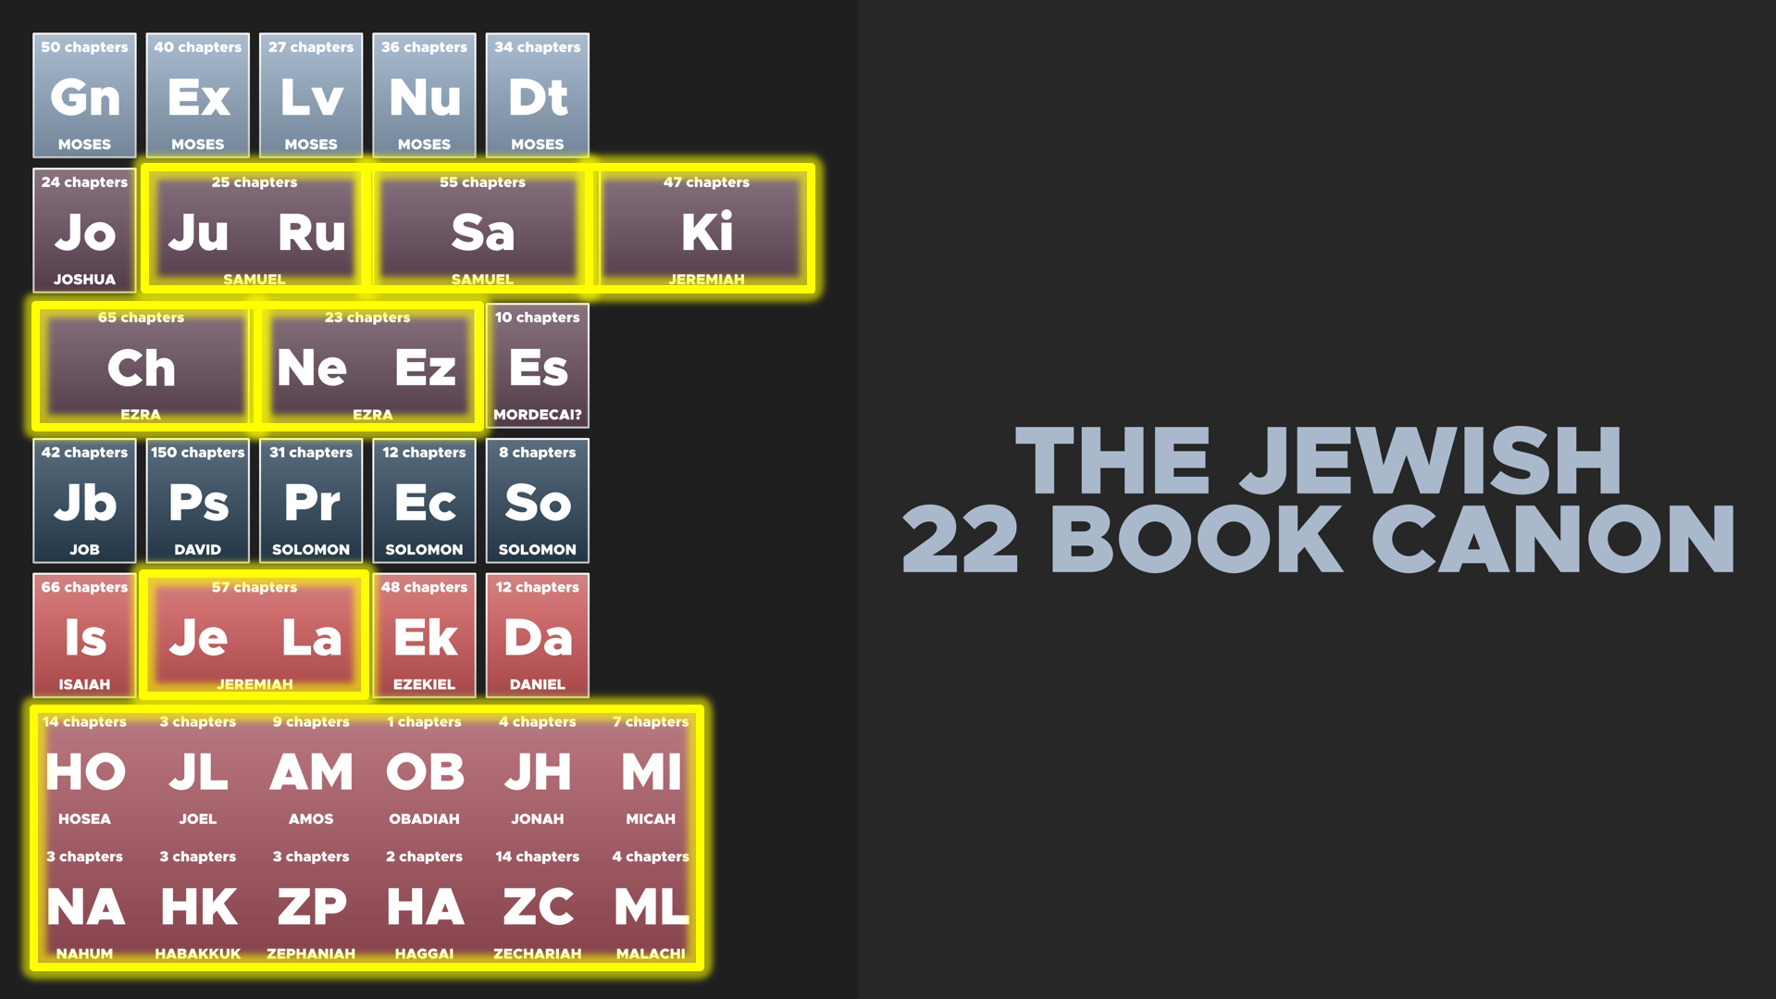

**Baba Bathra**

“The rabbans taught: The order of the Prophets is Joshua (and) Judges, Samuel (and) Kings, Jeremiah (and) Ezekiel, Isaiah (And) the Twelve… The order of the Hagiographa is Ruth and (the Book of) Psalms and Job (and) Proverbs, Ecclesiastes (and) the Song of Songs and Lamentations, Daniel and the Scroll of Esther, Ezra and Chronicles (Baba Bathra 14b).”

Roger Beckwith: “[24] is the number always used in the rabbinical literature.”[21]

**New Testament**

The Hebrew canon was settled. Romans 3:2; Matthew 22:29-31

Prophets lasted until ~400 BC. Luke 11:49-51

Cite almost all OT books. Judges, Chronicles, Esther, and Song of Solomon

The NT makes 250 citations of the OT and 600 allusions.[22] The NT only uses Scriptural formulae for the OT, and it never cites non-canonical books as Scripture.

**Questions to Consider**

Discussion Questions

(1) In three minutes, write down the most important points that you learned from this lecture. Don’t cheat and look at your notes! (This exercise will help you with retention.)

(2) We covered a lot of content. What questions do you have about what we covered in this lecture?

(3) What do these sources tell us about the canon?

The Dead Sea Scrolls

Josephus

The early rabbis

The New Testament

Scripture Memorization

**(Romans 3:1-2) What advantage, then, is there in being a Jew, or what value is there in circumcision? Much in every way! First of all, the Jews have been entrusted with the very words of God.**

**(Luke 11:51) From the blood of Abel to the blood of Zechariah.**

8. Should we Accept the Apocrypha?

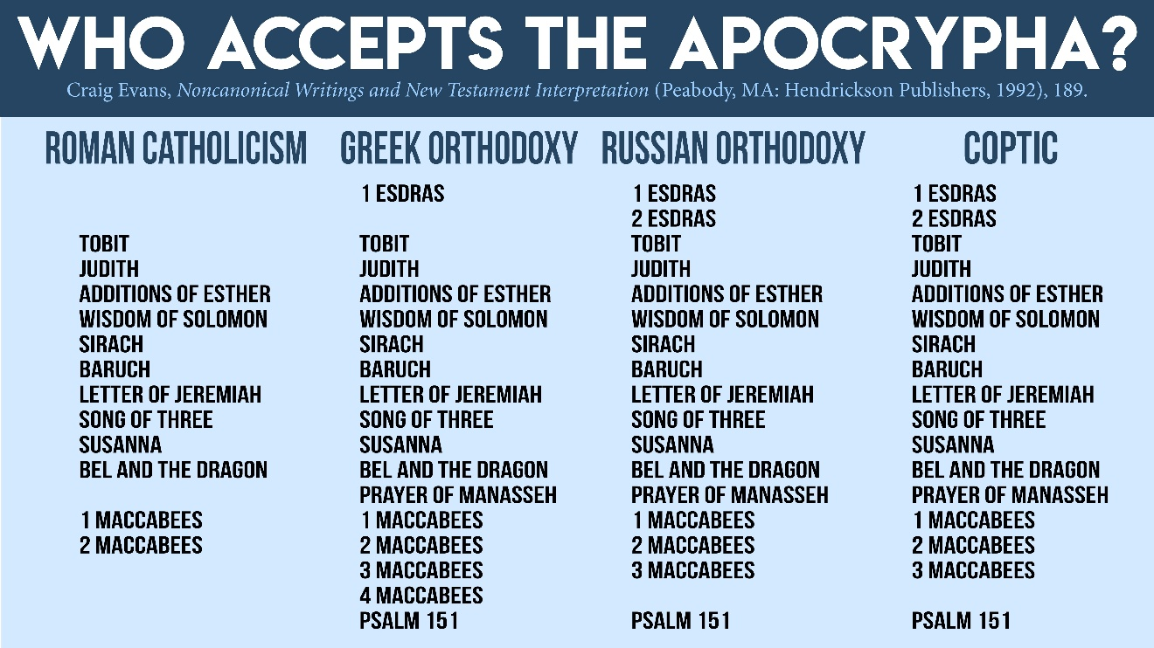

Internal Evidence

(1) The Apocrypha never claim to be inspired.[23]

(2) The Apocrypha reject prophetic authorship.

(1 Maccabees 4:46) “They laid up the stones in the mountain of the temple… until there should come a prophet.”

(1 Maccabees 9:27) “There was a great tribulation in Israel, such as was not since the day, that there was no prophet seen in Israel.”

(1 Maccabees 14:41) “The Jews, and their priests, had consented that he should be their prince, and high priest forever, until there should arise a faithful prophet.”

“After the latter prophets Haggai, Zechariah… and Malachi, the Holy Spirit departed from Israel.”[24]

External Evidence

**#1. The Jewish community universally rejected the Apocrypha**

1. The Dead Sea Scrolls (~150 BC)

R. Laird Harris: “Apocryphal and pseudepigraphal literature is found and is referred to, but is never quoted as authoritative.”[25]

2. The Book of Jubilees (2.23, 2nd century BC) has a 22 book canon.[26]

3. Philo of Alexandria (AD 40) lived in Alexandria where the LXX was translated (and which contains the Apocrypha), and he cites the OT over 2,000x. Yet he “never once quotes an uncanonical Jewish book.”[27]

4. Josephus (AD 75-99) received a complete copy of the Hebrew Bible from the Roman General Titus (Josephus, *The Life*, 75; 418). Josephus held a 22-book canon, and states prophetic succession ended in the 5th century BC (Josephus, *Against Apion*, 1.8).

5. Aquila (AD 135) was a convert to Judaism, and he was a pupil of Rabbi Akiba.[28] He produced a literal translation of the Hebrew Scriptures (~AD 128).[29] Yet, in the surviving fragments, there is “no hint of it including any apocryphal book,” and it “included all five of the disputed books.”[30]

**#2. The NT authors never cite the Apocrypha as Scripture**

Jesus affirmed his audience knew the Scriptures (Matthew 22:29-31; Romans 3:2). He affirmed the “prophets… from Abel…to Zechariah” (Luke 11:49-51). That is from Abel (Gen. 4) to Zechariah (2 Chron. 24)

The NT cites the OT 250x and alludes to it 600x, but it never cites the Apocrypha as Scripture.

Dave Armstrong (RC apologist): “The New Testament does not quote any of these books directly.”[31]

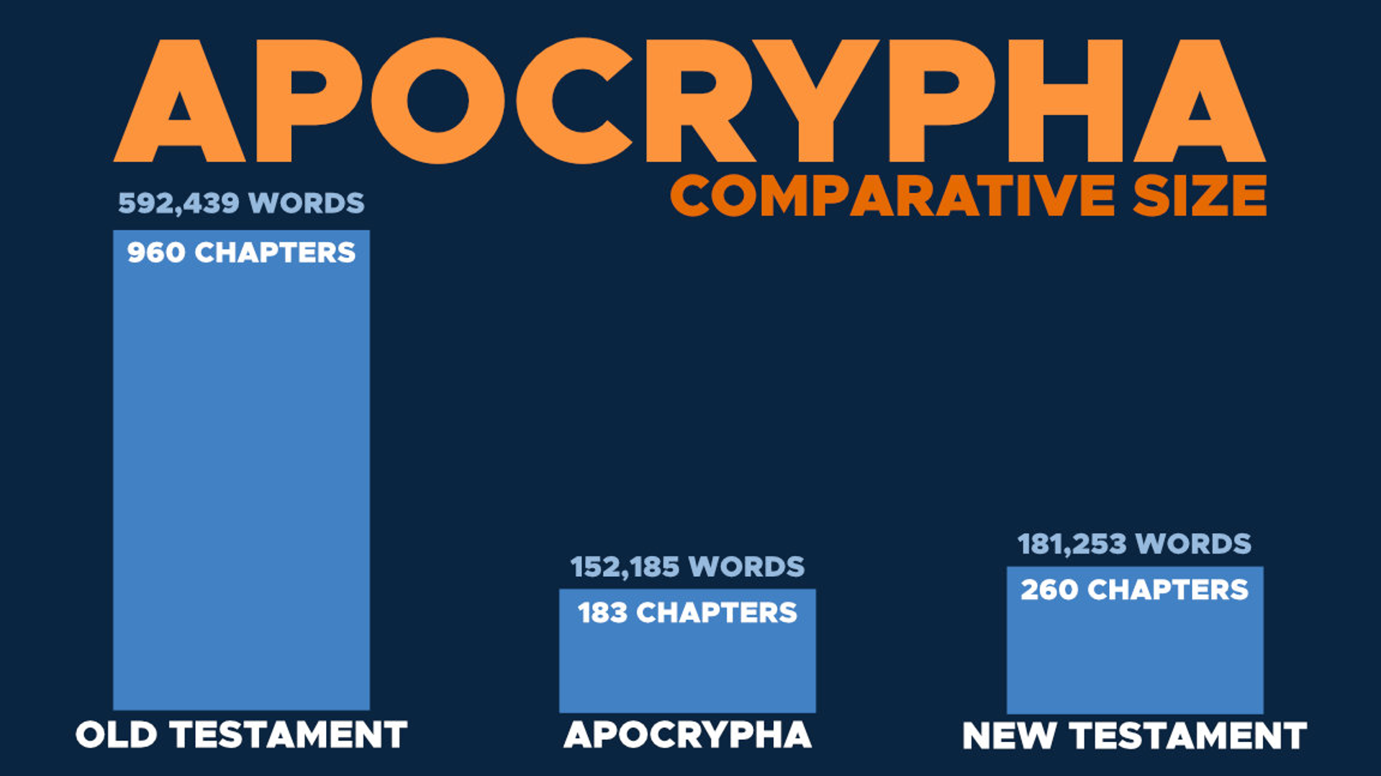

**#3. The most qualified early Christian scholars and theologians rejected the Apocrypha**

Melito was the Bishop of Sardis (AD 170).

Melito travelled to Palestine to discover “an accurate statement of the ancient books, as regards their number and their order.” He wrote out our modern canon (minus Esther). Melito’s letter to Onesimus is preserved in Eusebius, Ecclesiastical History, 4.26.7.

Origen of Alexandria was a theologian and Hebrew scholar (AD 250).

Origen’s disciples “all have a 22-book Old Testament like the one Origen had attributed to the Jews.” See for example Cyril of Jerusalem, Athanasius, Hilary of Poitiers, Gregory of Nazianus, Rufinas.[32]

Eusebius was a bishop and historian in Caesarea (AD 317). He agrees with Josephus’ 22-book canon (Ecclesiastical History, 3.10.1-5).

Athanasius was a bishop of Alexandria (AD 367). He listed all Old Testament books as Scripture (minus Esther). Athanasius, Paschal Letter Letter 39. He also included the Letter of Jeremiah and Baruch.[33]

Jerome was a theologian and Hebrew scholar (AD 400). Jerome was a Hebrew scholar who studied under a Jewish rabbi in Israel. He held to a 22-book canon.[34] Pope Damascus commissioned Jerome to translate the Apocrypha into Latin (AD 383).

**What about Augustine?**

(1) Augustine didn’t know Hebrew.

(2) Augustine based his case on tradition.

(3) Augustine based his case on the Septuagint—not the Hebrew text.[35]

(4) Augustine urged the Council of Carthage to canonize 3 Esdras.

**What about the Septuagint?**

(1) The LXX was translated *before* the Apocrypha were written.[36]

(2) LXX isn’t in any one codex.[37]

Codex Vaticanus omits 1 & 2 Maccabees

Codex Sinaiticus (Tobit, Judith, 1 and 2 Maccabees, Wisdom, and Ecclesiasticus).

Codex Alexandrinus contains all the apocryphal books plus 3 and 4 Maccabees and the Psalms of Solomon.

**#4. Roman Catholic popes and scholars rejected the Apocrypha**

**Gregory the Great (Roman Catholic pope, 6th century AD)**

“With reference to which particular we are not acting irregularly, if from the books, though not Canonical, yet brought out for the edification of the Church, we bring forward testimony. Thus Eleazar in the battle smote and brought down an elephant, but fell under the very beast that he killed (1 Macc. 6.46).”[38]

**John Damascene (AD 675-749)**

“It must be known that there are two and twenty books of the Old Testament, according to the alphabet of the Hebrew language.” (John Damascene, Lib. IV. c.18.)

**Hugh of St. Victor (AD 1133-1141)**

“There are also in the Old Testament certain other books which are indeed read [in the church] but are not inscribed in the body of the text or in the canon of authority: such are the books of Tobit, Judith and the Maccabees, the so-called Wisdom of Solomon and Ecclesiasticus.” (Hugh of St. Victor, On the Sacraments, I, Prologue, 7.)

**Cardinal Ximenes (AD 1436-1517)**

Pope Leo X approved Cardinal Ximenes’ Bible called the Complutensian Polyglot (1514-17). Ximenes wrote that Tobit, Judith, Wisdom, Ecclesiasticus, the Maccabees, the additions to Esther and Daniel were not canonical Scriptures.

If he had written these words only 30 years later, he would’ve been anathematized!

**Cardinal Cajetan (AD 1469-1534) was a Roman Catholic philosopher, theologian, cardinal.**

[He dedicated this book to Pope Clement VII…] “Here we close our commentaries on the historical books of the Old Testament. For the rest (that is, Judith, Tobit, and the books of Maccabees) are counted by St Jerome out of the canonical books, and are placed amongst the Apocrypha, along with Wisdom and Ecclesiasticus. These books… are not canonical, that is, not in the nature of a rule for confirming matters of faith. Yet, they may be called canonical, that is, in the nature of a rule for the edification of the faithful.”[39]

**#5. The RCC didn’t officially canonize the Apocrypha until the 16th century**

Not until the Council of Trent (AD 1545-1563) were the Apocrypha declared to be Scripture by the RCC.

Questions to Consider

9. Rational Evidence against the Apocrypha

Magic incantations (Tobit 6:7-18).

Prayers for the dead (2 Maccabees 12:46).

Denial of creatio ex nihilo (Wisdom of Solomon 11:17).

Neo-Platonic view of the body and soul (Wisdom of Solomon 9:15).

Salvation by works (Tobit 12:9-10).

**Historical inaccuracies**

Tobit’s lifespan

Tobit is called “a young man” (Tob. 1:4).

(922 BC) Split of the Northern Tribes

He is alive 182 years later.

(740-731 BC) During the deportation

“Tobit died in peace when he was 112 years old” (14:2).

Historical problems in Judith

Historical problems in Baruch

Dated to 180-120 BC.[40]

Baruch is in Egypt—not Babylon. Jeremiah 43:6 (Egypt) versus Baruch 1:1.

The book states that the Temple vessels came back to the Jews (Baruch 1:8-11).

Baruch states that the Exile would last seven generations (Baruch 6:3).

Historical problems in the additions to Esther

Mordecai serves Artaxerxes, but he was a captive of Nebuchadnezzar (112 years). Esther 11:2-12:6.[41]

Historical problems in Maccabees

Antiochus’ death. 1 Maccabees places this AFTER the rededication of the Temple. 2 Maccabees places this BEFORE the rededication of the Temple.

Judas purifying the Temple. Judas purifies the Temple THREE YEARS after the altar had been desecrated (1 Macc. 4:52; 1:54-59). Judas purifies the Temple TWO YEARS after the altar had been desecrated (2 Macc. 10:3).

3 Maccabees is “historical romance” or “Greek Romance.”[42]

Questions to Consider

Discussion Questions

(1) In three minutes, write down the most important points that you learned from this lecture. Don’t cheat and look at your notes! (This exercise will help you with retention.)

(2) What questions do you have about what we covered today?

(3) Which arguments do you find to be the most persuasive for why we shouldn’t accept the Apocrypha as Scripture? Which arguments do you find the least persuasive? Why?

(4) Imagine if someone said this, “Christians all have different books in the Old Testament. There’s no way to know who is right and who is wrong.” How would you respond in a way that is winsome? What points would you make? What questions would you ask them?

10. The Council of Jamnia

In 1871, H.H. Graetz (a Jewish writer) asserted the theory that the Jewish canon was officially closed by various rabbis at Jamnia in AD 90.[43]

**Did rabbis hold a council to close the OT canon?**

“No evidence to support it.”[44]

“Should be relegated to the limbo of unestablished hypotheses.”[45]

This theory suffered “complete refutation.”[46]

**Who met at Jamnia?**

Rabbi Johanan ben Zakkai

Rabbi Akiba

The Sanhedrin

(1) Beth ha-Midrash. Teaching school that met daily

(2) Beth Din. Sanhedrinist court that met far less frequently—perhaps annually—to keep the festivals/calendar.

Recorded in the Mishnah (AD 200).

**Counter Evidence?**

(1) Debated over several centuries—not in AD 90.

(2) Rabbis affirmed both the age and authorship of the books.

(3) No official decree was ever handed down.

(4) Not adding new books, but questioning existing books.

## The Most Disputed Books of the Old Testament

(1) Ecclesiastes: SKEPTICAL

Debated the most and officially charged with heresy. M, Eduy. 5.3, Yad. 3.5; BT, Shabb. 30, Meg. 7a; MR, Lev. 28.1, Eccli. 1.3.1, Song 1.1.11.

Response? Solomon was arguing the perspective “under the sun,” and he opens and closes the book with the Law. BT, Shabb. 30b.

(2) Song of Songs: SEXY

Questioned for erotic content. M, Yad. 3.5; BT, Meg. 7a; MR, Song 1.1.11.

“He who, at a banquet, renders the Song of Songs in a sing-song way, turning it into a common ditty, has no share in the world to come.” Tos., Sanh. 12.10.

(3) Proverbs: SELF-CONTRADICTORY

It was argued that it contained apparent contradictions. Bab. Shabbath 30b.

Proverbs 26:4-5 was quoted. BT, Shabb. 30b.

(4) Ezekiel: SEPARATE

Contradicted the sacrifices of the Law. The third Temple was considered separate from the first Temple (Ezek. 40-48). BT, Shabb. 13b.

(5) Esther: SECULAR

The book doesn’t contain God’s name, and the protagonist marries a Gentile king.[47]

Questions to Consider

Discussion Questions

(1) In three minutes, write down the most important points that you learned from this lecture. Don’t cheat and look at your notes! (This exercise will help you with retention.)

(2) What questions do you have about what we covered today?

(3) If the Old Testament wasn’t officially canonized until AD 90, what problems would that raise for followers of Jesus?

(4) Imagine if someone said this, “I can’t believe in the Old Testament if the rabbis disagreed on some of the books.” How would you respond in a way that is winsome? What points would you make? What questions would you ask them?

# Study Guide

**What did the word “canon” originally mean?** It was used for a measuring rod.

**What were the seven books that were disputed for the NT canon?** Hebrews, James, 2 Peter, 2 John, 3 John, Jude, and Revelation.

**How many Gnostic gospels were there? Were they ever considered for the canon?** Only 10 Gnostic gospels, and they were never considered for the canon.

**How many NT books does the Muratorian Fragment include and when does it date?** 22 out of 27 NT books, and it dates to AD 170.

**If Christians need a universally accepted list of books affirmed by an ecumenical council before they knew the canon, they would be waiting until when?** The Council of Trent in AD 1546.

**What are three reasons why we should NOT require a list in order to define the canon?**

(1) This would mean that Christians did not have a Bible for at least three centuries.

(2) The need for a canonical list leads to an infinite regress.

(3) This makes a philosophical error that confuses the BEING of Scripture with the KNOWING of Scripture.

**Humans did not determine the canon, but they… what?** (Discovered the canon)

**How do we know the NT authors believed they were writing Scripture?**

The apostles believed that their apostolic teaching was inspired. So, these written teachings would also be inspired.

Jesus pre-authenticated the apostles to write Scripture.

**Respond to this statement with citing two passages: “The NT authors never referred to other NT books as ‘Scripture.’”** 1 Timothy 5:18 and 2 Peter 3:15-16.

**Respond to this statement with citing a passage: “Paul didn’t believe that his own writing was Scripture.”** 1 Thessalonians 4:2-8 or 1 Corinthians 14:36-38.

**Where did Jesus pre-authenticate the fact that the disciples would write Scripture?** John 14:26 and John 16:13.

**Write down a memory verse that responds to this statement: “The Israelites had no way of knowing who was a true prophet.”**

(Deuteronomy 13:1-5) Sound doctrine.

(Deuteronomy 18:21-22) Fulfilled predictions.

**Write down a verse that responds to this statement: “The Jewish people didn’t know the canon until AFTER the time of Jesus.”**

(Romans 3:1-2) What advantage, then, is there in being a Jew, or what value is there in circumcision? Much in every way! First of all, the Jews have been entrusted with the very words of God.

(Luke 11:51) From the blood of Abel to the blood of Zechariah.

Matthew 22:29-31

**We have 39 books in the Old Testament Canon. What are three ancient sources that support that these books (and no others) belong in the Old Testament?**

The Dead Sea Scrolls

Josephus

Baba Bathra

Philo

The New Testament

**What are two reasons for rejecting the Gnostic gospels as authentic biographies of Jesus’ life?**

The earliest Gnostic gospel dates to AD 150—not the 1st century.

Even critics of the Bible agree that the Gnostic gospels offer no credible history of Jesus.

The Gnostic gospels were never considered for the canon—even by Gnostics.

The Gnostic gospels have a very low view of women. The Four Gospels are countercultural in this regard.

**What are the five OT books that were most disputed by ancient rabbis?**

(1) Ecclesiastes

(2) Song of Songs

(3) Proverbs

(4) Ezekiel

(5) Esther

**What are two reasons that could help explain why Esther wasn’t quickly accepted in the canon?**

(1) The author might have omitted God’s name for stylistic reasons.

(2) Apocryphal additions to Esther appear in the LXX.

(3) The book doesn’t contain God’s name, and the protagonist marries a Gentile king.

# Scripture Memorization

(2 Pet. 3:2) You should remember the words spoken beforehand by the holy prophets and the commandment of the Lord and Savior spoken by your apostles.

(Jn. 14:26) The Holy Spirit will teach you all things, and bring to your remembrance all that I said to you.

(Jn. 16:13) The Spirit of truth will guide you into all the truth… He will disclose to you what is to come.

(2 Pet. 3:15-16) Our dear brother Paul also wrote you with the wisdom that God gave him. 16 He writes… in all his letters… His letters contain some things that are hard to understand, which ignorant and unstable people distort, as they do the other Scriptures, to their own destruction.

(1 John 1:1 NIV) That which was from the beginning, which we have heard, which we have seen with our eyes, which we have looked at and our hands have touched—this we proclaim concerning the Word of life.

(2 Peter 1:16 NIV) We did not follow cleverly devised stories when we told you about the coming of our Lord Jesus Christ in power, but we were eyewitnesses of his majesty.

(Deuteronomy 13:1-5) Don’t memorize this, but know that this makes sound doctrine a criterion for being a prophet.

(Deuteronomy 18:21-22) Don’t memorize this, but know that this makes fulfilled predictions a criterion for being a prophet.

(Romans 3:1-2) What advantage, then, is there in being a Jew, or what value is there in circumcision? Much in every way! First of all, the Jews have been entrusted with the very words of God.

(Luke 11:51) From the blood of Abel to the blood of Zechariah.

1. F.F. Bruce, *The Canon of Scripture* (Downers Grove, IL: InterVarsity Press, 1988), p.17.
2. Testament of Moses. 10.1-10; Wisdom of Solomon. 3.7; The Rule of the Blessing, 1QSb, 5.23-29.
3. Dan Brown, *The Da Vinci Code* (New York, Doubleday, 2003), p.195.
4. Geoffrey Mark Hahnemann, *The Muratorian Fragment and the Development of the Canon* (Oxford: Clarendon, 1992), p.129.
5. Michael Kruger, *The Question of Canon* (Downers Grove, IL: IVP Academic, 2013), p.190.
6. The Didache was edited and redacted considerably. However, Kurt Niederwimmer writes that the material dates “most likely **toward the end of the [first] century.**” Kurt Niederwimmer, *The Didache: A Commentary: Hermeneia Commentary* (Minneapolis, MN: Fortress Press, 1998), p.52.

   Clayton Jefford dates the material in the Didache anywhere from **AD 80-110**. Clayton Jefford, *Reading the Apostolic Fathers: A Student’s Introduction* (Grand Rapids, MI: Baker Academic, 2012), p.29.
7. The Didache is arguably the earliest non-biblical writing from Christian writers. In 4:13, we read, “Thou shalt not forsake the commandments of the Lord, but thou shalt keep what thou didst receive, ‘Adding nothing to it and taking nothing away.’
8. Critical scholars claim that Polycarp is merely citing Psalm 4:4 as Scripture, but the full verse does not exist in Psalm 4:4 and must be referring to Ephesians 4:26.
9. Darrell Bock, *The Missing Gospels* (2006), p.249.
10. Darrell L. Bock, *Breaking The Da Vinci Code: Answers to the Questions Everyone’s Asking* (Nashville: Nelson, 2004), 27.
11. Darrell L. Bock, *Breaking The Da Vinci Code: Answers to the Questions Everyone’s Asking* (Nashville: Nelson, 2004), 28.
12. Darrell L. Bock, *Breaking The Da Vinci Code: Answers to the Questions Everyone’s Asking* (Nashville: Nelson, 2004), 33.
13. John Dominic-Crossan “Why Jesus Didn’t Marry.”

    http://www.beliefnet.com/Entertainment/Movies/The-Da-Vinci-Code/Why-Jesus-Didnt-Marry.aspx.
14. See Mark F. Rooker, *The World and the Word* (2011), 289.
15. D.J. Wiseman, *1 and 2 Kings* (1993), p.56. Gleason Archer, *A Survey of Old Testament Introduction* (1994), p.319.
16. Andrew Hill and John Walton, *A Survey of Old Testament Introduction* (2000).
17. Gleason Archer, *A Survey of Old Testament* (1994), p.464. F.B. Huey, *Esther* (1988), p.776. Karen Jobes, *Esther* (1999), p.28.
18. R. Laird Harris, *Inspiration and Canonicity of the Scriptures* (Greenville, SC, 1995), p.169.
19. R. Laird Harris, *Inspiration and Canonicity of the Scriptures* (Greenville, SC, 1995), p.141.
20. Roger T. Beckwith, *The Old Testament Canon of the New Testament Church and Its Background in Early Judaism* (Grand Rapids, MI: Wipf & Stock Publishers, 1986), 291.
21. Roger T. Beckwith, *The Old Testament Canon of the New Testament Church and Its Background in Early Judaism* (Grand Rapids, MI: Wipf & Stock Publishers, 1986), p.240.
22. R. Laird Harris, *Inspiration and Canonicity of the Scriptures* (Greenville, SC, 1995), p.316.
23. Ecclesiasticus 50:27-29 is referring to the “prophecy” of the Pentateuch.

    Roger T. Beckwith, *The Old Testament Canon of the New Testament Church and Its Background in Early Judaism* (Grand Rapids, MI: Wipf & Stock Publishers, 1986), 377.
24. Babylonian Talmud, Yomah 9b, repeated in Sota 48b, Sanhedrin 11a, and Midrash Rabbah on Song of Songs, 8.9.3. Translation from Michael L. Rodkinson, *Babylonian Talmud*, VII–VIII, 24.
25. R. Laird Harris, *Inspiration and Canonicity of the Scriptures* (Greenville, SC, 1995), p.141.
26. Roger T. Beckwith, *The Old Testament Canon of the New Testament Church and Its Background in Early Judaism* (Grand Rapids, MI: Wipf & Stock Publishers, 1986), 235-240.
27. Roger T. Beckwith, *The Old Testament Canon of the New Testament Church and Its Background in Early Judaism* (Grand Rapids, MI: Wipf & Stock Publishers, 1986), p.384.
28. Jerome, *Commentary on Isaiah*, on 8:11ff.
29. Epiphanius, *De Mensuris et Ponderibus*, 113-16.
30. Roger T. Beckwith, *The Old Testament Canon of the New Testament Church and Its Background in Early Judaism* (Grand Rapids, MI: Wipf & Stock Publishers, 1986), 277.
31. Dave Armstrong, *A Biblical Defense of Catholicism* (Manchester, NH: Sophia Institute, 2003), 262.
32. Roger T. Beckwith, *The Old Testament Canon of the New Testament Church and Its Background in Early Judaism* (Grand Rapids, MI: Wipf & Stock Publishers, 1986), 395.
33. Gregg Allison, *Historical Theology* (Grand Rapids, MI: Zondervan, 2011), 48.
34. Jerome, *Preface to the Books of Proverbs, Ecclesiastes, and the Song of Songs*, NPNF2, 6:492.
35. Augustine, *Letter* 28.2; Jerome, *Letter* 105, 112; Augustine, *The City of God*, 18.43-44.
36. David A. deSilva, *Introducing the Apocrypha* (Grand Rapids, MI: Baker Academic, 2002), Kindle Location 313.
37. D.A. Carson, “The Apocryphal/Deuterocanonical Books: An Evangelical View.” in *The Parallel Apocrypha* (Oxford University Press, 1997), xlvii.
38. Gregory the Great, *Morals on the Book of Job*, vol. II, Parts III and IV, Book XIX. 34 (Oxford: Parker, 1845), p. 424.
39. Cardinal Cajetan, *Commentary on all the Authentic Historical Books of the Old Testament*. 1532. Cited in William Whitaker, A Disputation on Holy Scripture (Cambridge University Press, 1849), p.48.
40. David A. deSilva, *Introducing the Apocrypha* (Grand Rapids, MI: Baker Academic, 2002), 204.
41. David A. deSilva, *Introducing the Apocrypha* (Grand Rapids, MI: Baker Academic, 2002), 110-111.
42. David A. deSilva, *Introducing the Apocrypha* (Grand Rapids, MI: Baker Academic, 2002), 310.
43. H.H. Graetz, *Kohelet* (Leipzig, Winter, 1871). Herbert Edward Ryle, *The Canon of the Old Testament* (Harvard, 1892), pp.182-183. Otto Eissfeldt, *The Old Testament* (New York: Harper and Row, 1965), p.565. Georg Fohrer, *Introduction to the Old Testament* (Nashville: Abingdon Press, 1968), p.486. Stephen Harris, *Understanding the Bible* (Palo Alto, California: 1985), p.10.
44. Cross & Livingstone, eds., *The Oxford Dictionary of the Christian Church* (Oxford University Press, 1985) p. 726.
45. Jack P. Lewis in *The Anchor Bible Dictionary* (New York 1992), pp.634-637.
46. Roger T. Beckwith, *The Old Testament Canon of the New Testament Church* (Grand Rapids: 1986), 276.
47. Robert C. Newman, “The Council of Jamnia and the Old Testament Canon.” *Westminster Theological Journal*, 38.4 (Spr. 1976) 340.

    Roger T. Beckwith, *The Old Testament Canon of the New Testament Church and Its Background in Early Judaism* (Grand Rapids, MI: Wipf & Stock Publishers, 1986), 288.