Does God Exist?
Student Handout

Table of Contents
Pre-Homework 3
Week 1: Introduction to Apologetics 4
Discussion Questions 7
Scripture Memorization 7
Homework 7
Week 2: The Cosmological Argument 8
Discussion Questions 10
Scripture Memorization 10
Homework 10
Week 3: The Fine-Tuning of the Universe 12
Discussion Questions 13
Scripture Memorization 13
Homework 14
Week 4: Evidence from Morality 15
Discussion Questions 16
Scripture Memorization 16
Homework 17
Week 5: Evidence from Free Will 18
Discussion Questions 19
Scripture Memorization 20
Homework 20
Study Guide 21

Pre-Homework
(1) What do you hope to gain from taking this course?

(2) What goals do you have to use this equipping that you’re going to receive?

(3) How do you hope to put this material into practice?

Week 1: Introduction to Apologetics

What is faith?
(Heb. 11:1) Faith is the assurance of things hoped for, the conviction of things not seen.

What is apologetics?
(1 Pet. 3:15) Sanctify Christ as Lord in your hearts, always being ready to make a defense to everyone who asks you to give an account for the hope that is in you, yet with gentleness and respect.

(1)

(2)

An Apologetic for Apologetics
(1)

(2)

(3)

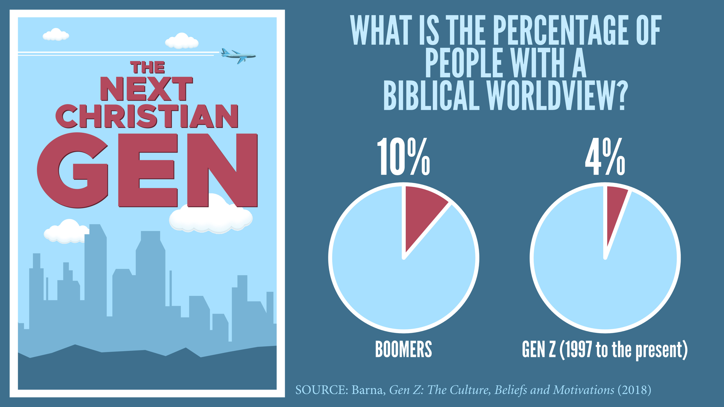

(4)

Biblical Objections
(Mk. 10:15) “Whoever does not receive the kingdom of God like a child will not enter it at all.”

(Jn. 20:29) Jesus said to Thomas, “Because you have seen Me, have you believed? Blessed are they who did not see, and yet believed.”

(2 Cor. 5:6-8) While we are at home in the body we are absent from the Lord—for we walk by faith, not by sight—we are of good courage, I say, and prefer rather to be absent from the body and to be at home with the Lord.

“You can’t argue someone into the kingdom.”
(1)

(2)

(3)

(4)

“I’m not an intellectual person.”

(1)

(2)

(3)

“What if I struggle with doubt?”
(1)

Doubt | Unbelief

(2)

(3)

(4)

(5)

Discussion Questions
(1) What role does personal experience and our testimony play in apologetics? How can they be used to complement rational arguments?
(2) In what ways can apologetics be used to strengthen and encourage fellow believers, especially those struggling with doubts or questions?
(3) How can we prepare ourselves to engage in apologetics without falling into the trap of winning arguments rather than winning hearts?

Scripture Memorization
(Heb. 11:1) Faith is the assurance of things hoped for, the conviction of things not seen.
(1 Pet. 3:15) Sanctify Christ as Lord in your hearts, always being ready to make a defense to everyone who asks you to give an account for the hope that is in you, yet with gentleness and respect.

Homework
Record your thoughts below. Come prepared to discuss next week: What might happen if your church neglects or minimizes apologetics in these key areas?
(1) Youth ministry (ages 13-18)

(2) Evangelism

(3) Building the faith of Christians in your church

Do you neglect or minimize apologetics? What step could you take to grow in this area?

Week 2: The Cosmological Argument

The beginning of the universe is a historically unique view

What is the evidence that the universe had a beginning?

2nd Law of Thermodynamics

The Theory of General Relativity
Einstein (1917), Friedmann (1922), Lemaître (1927)

Hubble’s Red Shift
Edwin Hubble (1929)

Cosmic Background Radiation
Arno Penzias and Robert Wilson (1965)

NASA’s COBE Satellite
George Smoot (1989)

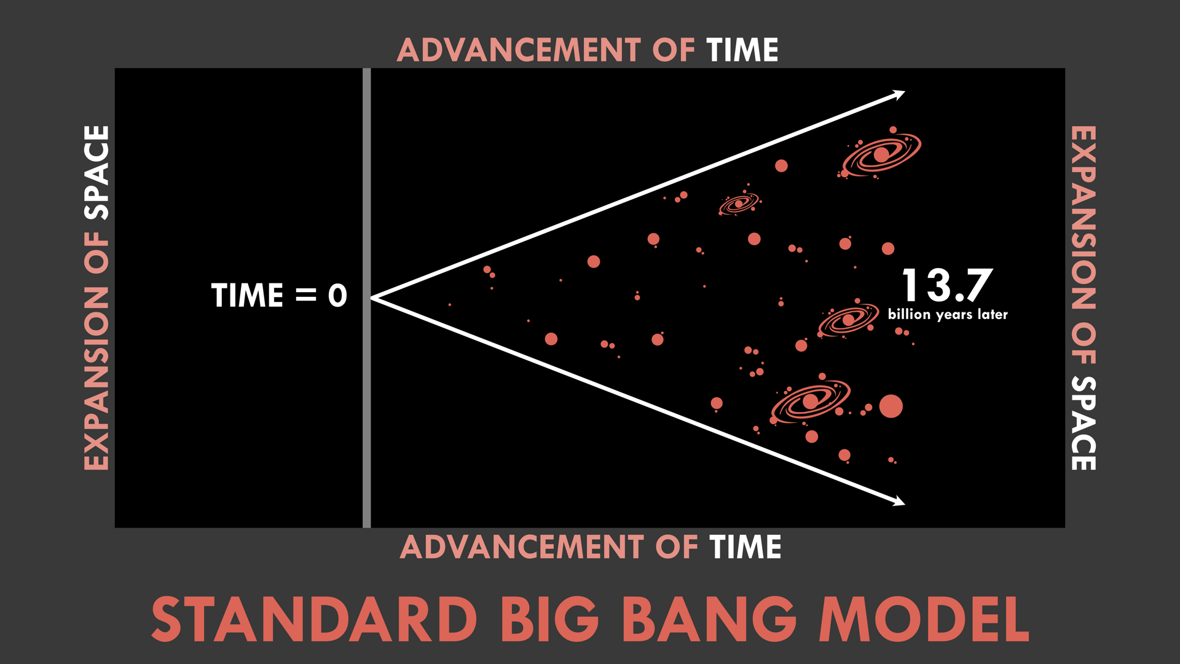

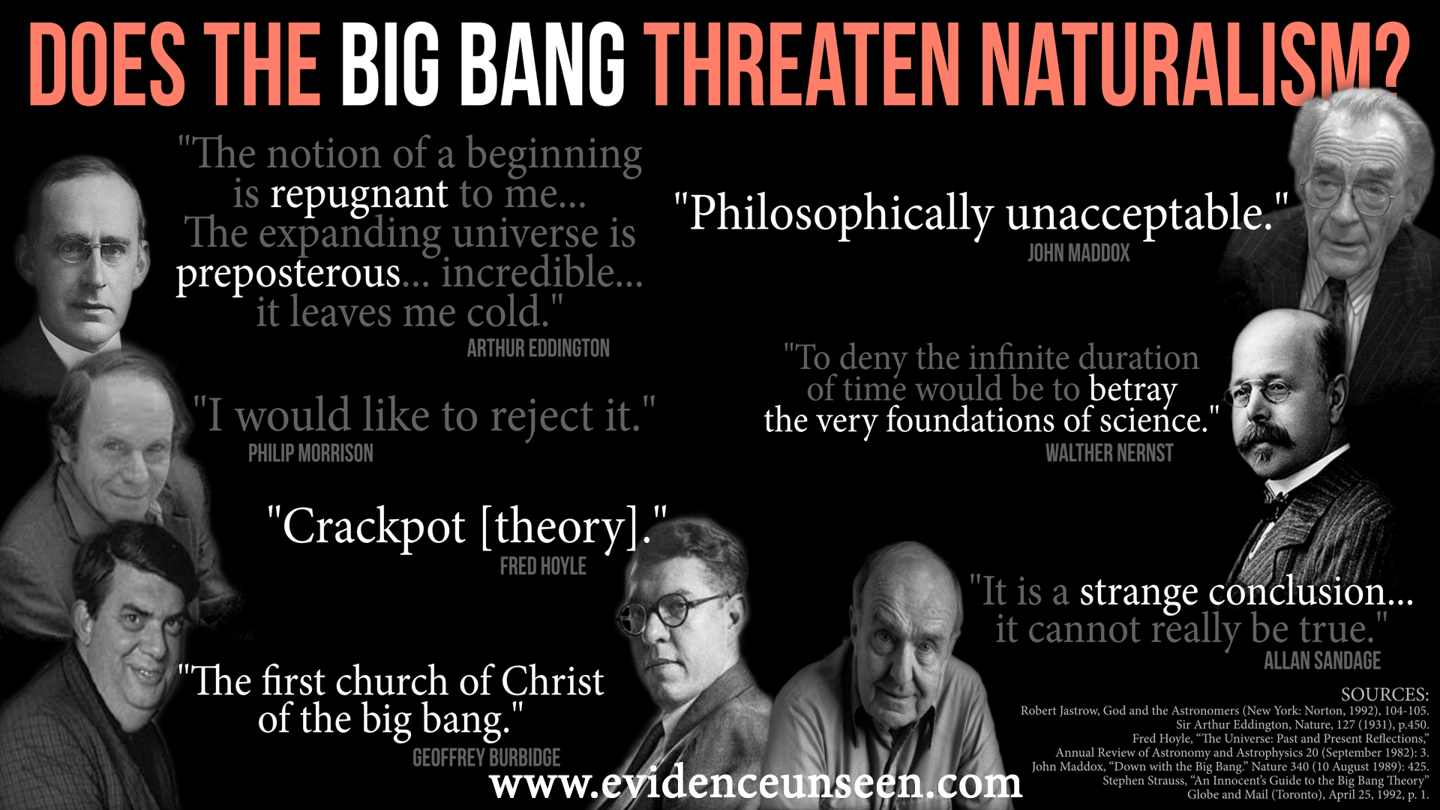

How can we communicate this in a clear and concise way?

Discussion Questions
(1) How could you use this argument in everyday conversation? How can we present it in a way that is respectful and approachable?
(2) What are ways that we could exaggerate or overstate this evidence for God? What should we say instead?
(3) What are some of the responses to the cosmological argument from skeptics? (List these out.) How would you respond to each of these?

Scripture Memorization
(Jn. 1:1-3) In the beginning was the Word, and the Word was with God, and the Word was God. ² He was in the beginning with God. ³ All things came into being through Him, and apart from Him nothing came into being that has come into being.

Homework
Record your response to these objections below, considering each objection with thoughtful reflection and common sense. If you get stuck, consider talking to a fellow Christian who knows apologetics well, read an apologetics website that answers the objection, or buy a good introductory book to apologetics. Here are the objections below. Come prepared to discuss next week.
(1) “The cosmological argument might show that there is a Creator. But it doesn’t show us that the Creator’s son was Jesus, or that God exists as a Trinity.”

(2) “If God created the universe, then who created God?”

Week 3: The Fine-Tuning of the Universe

What is fine-tuning? The laws, constants, and initial conditions of the universe could have been different, but are exquisitely finely tuned for the possibility of life to exist.

What are examples of fine-tuning?
Q (Uniform temperature of the Cosmic Microwave Background)

Weak nuclear force

Ω: Mass-density of the universe

Ratio of electrons to protons

N: Electromagnetism to gravity

Gravity (G) balanced with the weak force (g_{w})

Gravitational constant: One part in 10³⁵

Λ: Cosmological constant

Low-entropy of the universe

How many examples of fine-tuning are there?

How can we communicate this in a clear and concise way?

Discussion Questions
(1) How could you use this argument in everyday conversation? How can we present it in a way that is respectful and approachable?
(2) What are ways that we could exaggerate or overstate this evidence for God? What should we say instead?
(3) What are some of the responses to the argument from fine-tuning that you’ve heard from skeptics? (List these out.) How would you respond to each of these?

Scripture Memorization
(Rom. 1:19-20) They know the truth about God because he has made it obvious to them. ²⁰ For ever since the world was created, people have seen the earth and sky. Through everything God made, they can clearly see his invisible qualities—his eternal power and divine nature. So they have no excuse for not knowing God.
(Ps. 19:1-2) The heavens proclaim the glory of God. The skies display his craftsmanship. ² Day after day they continue to speak; night after night they make him known.

Homework
Record your response to these objections below, considering each objection with thoughtful reflection and common sense. If you get stuck, consider talking to a fellow Christian who knows apologetics well, read an apologetics website that answers the objection, or buy a good introductory book to apologetics. Here are the objections below. Come prepared to discuss next week.
(1) “Why do you think God created the fine-tuning of the universe? How do we know that an advanced alien civilization didn’t create the fine-tuning of the universe?”

(2) “If God designed the universe, then who designed God?”

(3) “Scientists think that an infinite multiverse explains the fine-tuning problem.”

Week 4: Evidence from Morality

The Moral Argument
(1) If naturalism is true, objective morality doesn’t exist.
(2) Objective morality exists.
Therefore, naturalism is false.
[God is a far better explanation for objective morality.]

(1) If naturalism is true...
(a) Everything is natural.

(b) Human beings are clearly and obviously unequal.

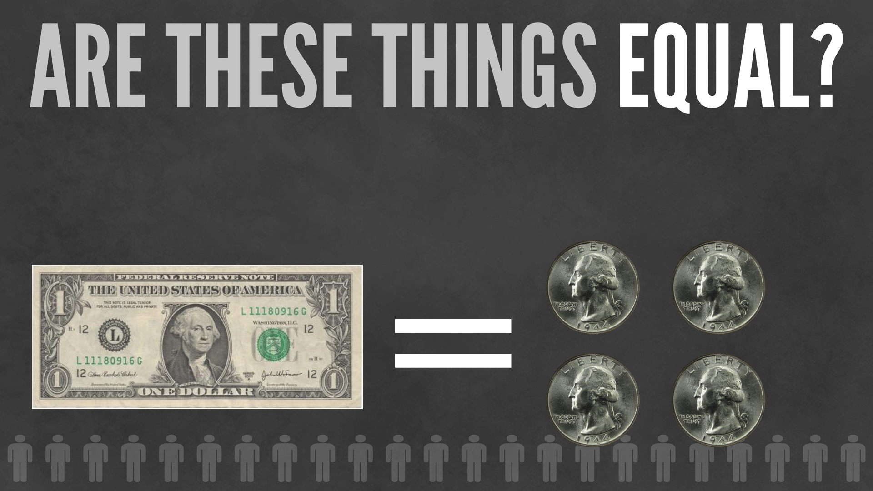

(c) Human beings are not morally unique.

(2) Objective morality exists.

(3) Therefore, naturalism is false.

Clear Communication

Discussion Questions
(1) How could you use this argument in everyday conversation? How can we present it in a way that is respectful and approachable?
(2) What are ways that we could exaggerate or overstate this evidence for God? What should we say instead?
(3) What are some of the responses to the argument from morality that you’ve heard from skeptics? (List these out.) How would you respond to each of these?

Scripture Memorization
(Rom. 2:14-15) Even Gentiles, who do not have God’s written law, show that they know his law when they instinctively obey it, even without having heard it. ¹⁵ They demonstrate that God’s law is written in their hearts, for their own conscience and thoughts either accuse them or tell them they are doing right.

Homework
Record your response to these objections below, considering each objection with thoughtful reflection and common sense. If you get stuck, consider talking to a fellow Christian who knows apologetics well, read an apologetics website that answers the objection, or buy a good introductory book to apologetics. Here are the objections below. Come prepared to discuss next week.
(1) “Objective morality comes from evolution—not God.”

(2) “Objective morality comes from our culture and society—not God.”

(3) “Objective morality comes from bring pleasure—not pain. Everybody knows that!”

Week 5: Evidence from Free Will

The Free Will Argument
(1) If naturalism is true, free will doesn’t exist.
(2) Free will does exist.
Therefore, naturalism is false.
[God is a far better explanation for free will.]

(1) If naturalism is true, free will doesn’t exist.
(a) Every event in the universe is determined by natural laws.
(b) Our thoughts and decisions are events in the universe.
(c) Therefore, our thoughts and decisions are determined by natural laws.

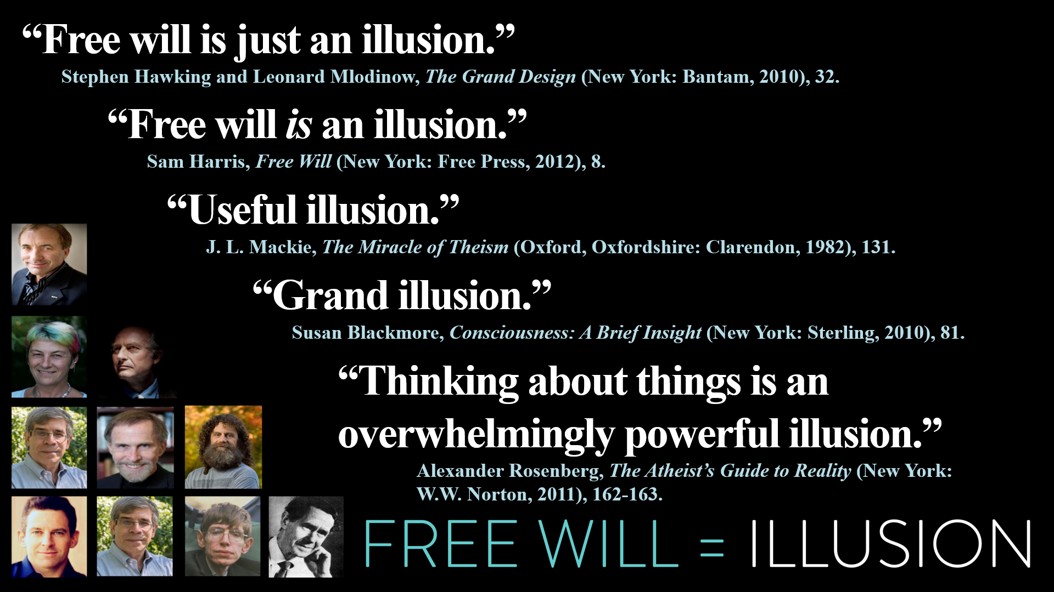

(2) Our direct perception of free will is far more likely than naturalism being true
Our thoughts are an illusion.

Reason is an illusion.

Morality is an illusion.

Lifelong identity is an illusion.

Clear Communication

Discussion Questions
(1) How could you use this argument in everyday conversation? How can we present it in a way that is respectful and approachable?
(2) What are ways that we could exaggerate or overstate this evidence for God? What should we say instead?
(3) What are some of the responses to the argument from free will that you’ve heard from skeptics? (List these out.) How would you respond to each of these?

Scripture Memorization
(2 Cor. 10:3-5) Though we live in the world, we do not wage war as the world does. ⁴ The weapons we fight with are not the weapons of the world. On the contrary, they have divine power to demolish strongholds. ⁵ We demolish arguments and every pretension that sets itself up against the knowledge of God, and we take captive every thought to make it obedient to Christ.

Homework
Record your response to these objections below, considering each objection with thoughtful reflection and common sense. If you get stuck, consider talking to a fellow Christian who knows apologetics well, read an apologetics website that answers the objection, or buy a good introductory book to apologetics. Here are the objections below. Come prepared to discuss next week.
(1) “As a Christian, you believe that God knows the future. So, he knows everything that you will ever do. That means that you don’t believe that humans have free will either.”

(2) “Maybe I don’t have free will. But that’s not evidence for God. Maybe we just need to face the depressing fact that we’re biological machines. I’d rather do that than believe in God.”

Study Guide
What is a good synonym for biblical faith? Trust.
Define apologetics. Giving a rational defense of our faith.
Why are apologetics important?
(1) Apologetics is both a biblical teaching and a biblical emphasis.
(2) Apologetics is to be mastered by all believers—not just leaders or pastors.
(3) We don’t accept blind faith in other important areas of life.
(4) Apologetics build your confidence.
Does Mark 10:15 mean that we should be ignorant like children? No, the context states that we should be humble and dependent like children—not ignorant.
Does John 20:29 mean that we shouldn’t have evidence? No, the context states that Thomas was seeing Jesus—not evidence in general. Other people need to come to faith based on the evidence given in the gospel according to John.
What are points we can make with those who are struggling with doubt?
(1) Doubt is not a sin.
(2) Faith isn’t “proof” or “certainty.”
(3) All worldviews require faith.
(4) All worldviews have difficulties.
What are two scientific lines of evidence for thinking that the universe had a beginning? The second law of thermodynamics and big bang cosmology.
What are concise statements that can help us explain the cosmological argument?
I don’t have enough faith to believe that nothing created everything.
The origin OF the material universe cannot come from WITHIN the material universe.
A natural cause cannot be the explanation for the origin and existence of Nature.
A Big Bang requires a Big Banger!
What is fine-tuning? The laws, constants, and initial conditions of the universe could have been different, but are exquisitely finely tuned for the possibility of life to exist.
Give one example of fine-tuning? The gravitational constant is the strength of gravity. It is finely tuned to 1 in 10³⁵. The universe is only 10²⁸ inches across.
Explain the difference between subjective and objective morality. Subjective morality refers to the me—the subject. Objective morality refers to the action in question—the object. Subjective morality refers to my opinions about moral issues, but objective morality refers to whether moral issues are real—even if I didn’t believe in them.
Can atheists be moral people? Yes. We don’t need to believe in God to have objective morality. But there needs to be a God to have objective morality.
How do we know objective morality is real? We have a first-person moral perception. This is similar to sensory perception. Even if people are color blind, that doesn’t mean that colors aren’t real. Similarly, even if some people disagree on morality, that doesn’t mean that morality is an illusion. Moreover, moral perception is incredibly difficult to deny in practice.
What are concise ways to explain the moral argument?
Did morality come from matter or from a Mind?
How could moral duties come from determinism?
Can you live consistently with the idea that morality is an illusion?
If free will is an illusion, then what else is an illusion—given a naturalistic worldview?
Our thoughts are an illusion.
Reason is an illusion.
Morality is an illusion.
Lifelong identity is an illusion.
What are concise ways to explain the evidence from free will?
If matter and energy do not think or make decisions, what makes humans different?
If you cannot know something as basic as your own thoughts, then what can you know?
If free will is an illusion, who or what is being deluded?

Scripture Memorization
(Heb. 11:1) Faith is the assurance of things hoped for, the conviction of things not seen.
(1 Pet. 3:15) Sanctify Christ as Lord in your hearts, always being ready to make a defense to everyone who asks you to give an account for the hope that is in you, yet with gentleness and respect.
(Jn. 1:1-3) In the beginning was the Word, and the Word was with God, and the Word was God. ² He was in the beginning with God. ³ All things came into being through Him, and apart from Him nothing came into being that has come into being.
(Rom. 1:19-20) They know the truth about God because he has made it obvious to them. ²⁰ For ever since the world was created, people have seen the earth and sky. Through everything God made, they can clearly see his invisible qualities—his eternal power and divine nature. So they have no excuse for not knowing God.
(Ps. 19:1-2) The heavens proclaim the glory of God. The skies display his craftsmanship. ² Day after day they continue to speak; night after night they make him known.
(Rom. 2:14-15) Even Gentiles, who do not have God’s written law, show that they know his law when they instinctively obey it, even without having heard it. ¹⁵ They demonstrate that God’s law is written in their hearts, for their own conscience and thoughts either accuse them or tell them they are doing right.
(2 Cor. 10:3-5) Though we live in the world, we do not wage war as the world does. ⁴ The weapons we fight with are not the weapons of the world. On the contrary, they have divine power to demolish strongholds. ⁵ We demolish arguments and every pretension that sets itself up against the knowledge of God, and we take captive every thought to make it obedient to Christ.

Evidenceunseen.com, Reasonablefaith.org, Crossexamined.org, Coldcasechristianity.com.
James Rochford, Evidence Unseen: Exposing the Myth of Blind Faith (Columbus, OH: New Paradigm Publishing, 2013). Norman Geisler and Frank Turek, I Don’t Have Enough Faith to be an Atheist (Crossway, 2021). Gregory Koukl, Street Smarts (Zondervan, 2023).
Evidenceunseen.com, Reasonablefaith.org, Crossexamined.org, Coldcasechristianity.com.
James Rochford, Evidence Unseen: Exposing the Myth of Blind Faith (Columbus, OH: New Paradigm Publishing, 2013). Norman Geisler and Frank Turek, I Don’t Have Enough Faith to be an Atheist (Crossway, 2021). Gregory Koukl, Street Smarts (Zondervan, 2023).
Evidenceunseen.com, Reasonablefaith.org, Crossexamined.org, Coldcasechristianity.com.
James Rochford, Evidence Unseen: Exposing the Myth of Blind Faith (New Paradigm Publishing, 2013). Norman Geisler and Frank Turek, I Don’t Have Enough Faith to be an Atheist (Crossway, 2021). Gregory Koukl, Street Smarts (Zondervan, 2023).
Evidenceunseen.com, Reasonablefaith.org, Crossexamined.org, Coldcasechristianity.com.
James Rochford, Evidence Unseen: Exposing the Myth of Blind Faith (Columbus, OH: New Paradigm Publishing, 2013). Norman Geisler and Frank Turek, I Don’t Have Enough Faith to be an Atheist (Crossway, 2021). Gregory Koukl, Street Smarts (Zondervan, 2023).

